Chapter 12: The Making of Olympians

Through my work, I have met many great athletes. Three of the older ones were Al Oerter, 4 time Gold medalist in the Discus throw, Bill Toomey, the Gold medalist in the Decathlon in Mexico City and Russ Hudge, a decathlete who held the world record in the Decathlon for various years and was a competitor of Bill Toomey.
Bill Toomey invited me to the University of California at Irvine to demonstrate my methods of athletic evaluation based on the system he had seen me use with the Olympic throwers at Dartmouth College. We became really good friends and Bill came to visit me a number of times in Amherst and even was involved with our business.
It was in one of these meetings with Bill Toomey that the first idea of an Olympic Training Center was born. I often used to mention my visit with the East Germans and how the United States lagged behind in their athletic training. I used to say that the United States relied strictly on DNA to win events. There is so much talent in the US but noone optimizes the athletes’ abilities since they miss harnessing science into their training.
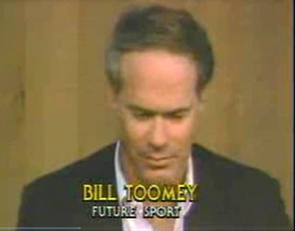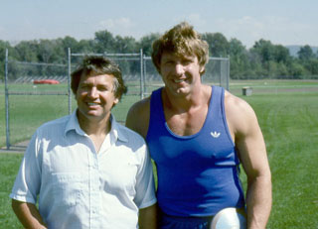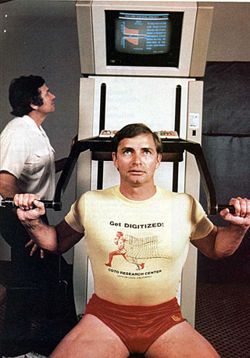
Bill, Al and Russ
For hours we discussed the future of sports in the United States. Bill and Russ both realized the advantages in the technology that I had to offer. Al Oerter, as an athlete, had publicly stated to a reporter, “When I was 42, sports scientist Gideon Ariel determined that I could throw 75 meters without any problem, if I just maintained the acceleration that I began with in the actual throw. In 1984, at the age of 47, I went even further using his technology. I was working with him and it was very hot and I started to get more and more angry because of camera problems that day. I pushed harder and harder for every throw and started landing the discus on the hill and then on the other side. They tried to measure it and found that it was 217 feet to the base of the hill, which was 15 feet high, and finally measured my throw to be around 245 feet long!”
So, Bill asked: “So what are we going to do to make a Training Center come about? We need to approach the United States Olympic Committee’s director, Colonel Miller. Maybe if we proposed it as a Sports Medicine Center for the US Olympians, it would fly. We need to find a doctor to come in with us.”
It just so happened I knew a doctor who had been an Olympian athlete. I had met him in Israel in 1957 when I competed in the Macabean Games. These games are held every 4 years as a Jewish Olympics. Jews from all over the world come to compete in this meet. At that time I was still in high school, but competed in the youth class and won the discus throw. The shot put was won by the then famous Bill Hubner from New York. The 400 meters race was won by a medical student by the name of Irwin Dardik. I had met him and we had various conversations.
Bill Toomey and Russ Hudge also knew Dr. Dardik, who was by now a famous cardiac surgeon. In fact, he had been nominated, with his brother Herbert and Ibrahim Ibrahim, MD, for a Nobel prize for his invention of developing a coronary bypass graft technique using human umbilical cords. But, medical doctor that he was, he was still very much an athlete at heart. He had almost made it to the 1956
Olympics in Melbourne in the 400-meter dash, and planned to try again the next time around, at the 1960
Rome Games. But in 1958 he entered medical school, and that ended his dream of competing in the
Olympics. "In those days, you couldn't just leave medical school for something like that," he used to say. So
instead of achieving fame as a quarter-miler, he achieved fame as a vascular surgeon.
We invited him to Amherst and he came, out of his love for the Games. He is a tall, handsome man,
with a sharp face and an inventor’s mind. We got along almost immediately. I gave him a full
presentation of what we were doing, and Al Oerter reiterated how much the scientific methods had
helped him to throw much better, even at an older age.
Dr. Dardick liked the idea of better training for the US athletes, he liked the technology, and
similarly to me, he was committed to the health of athletes. He foresaw medicine as being
preventive, even before everyone else did, and so he liked the idea of a center where athletes were
working toward optimum health. Some of the ideas developed there could flow out to the general
public, while we were helping the US athletes achieve their victories.
At the end of the meeting, we all decided that we should meet with Colonel Miller. We contacted
him and because of our renown in each of our fields, he agreed to meet with us.
So one sunny day, at the Algonquin Hotel in Manhattan, we pled our vision.
Colonel Miller, a tall, handsome athletic man, of military bearing but warm and upbeat, listened to
our story. I once again talked about how scientifically the East Germans were approaching training and
all the possibilities we could bring to our own athletes. It turned out Colonel Miller became extremely
excited about the idea.
He did not want the American athletes to continue being beaten. The US athletes had dropped to a
third in the overall medal standings. His job was to keep the US strong. But there were questions.
“Where are we going to establish this center?” he asked. “Where is the money going to come from?
Where will we get the necessary equipment?”
These were questions, we said, we would figure out. Dr. Dardik was appointed as the Chairman of
Sports Medicine and, in his first official act, requested that I put together a proposal of how our
biomechanical system would work with the Center.
That was not so difficult for me to figure out. I thought that we could either establish a
laboratory there by acquiring the necessary equipment and staff or we could use the existing
CBA facility to analyze the athletes.
I deemed that each analysis would include a comprehensive report for the athlete with a
specifically prescribed training program for performance improvement. Also, corrections would
be given, where needed, and computerized optimization programs would allow the athlete to
estimate his potential. In addition, we’d include comparisons to world class athletes. The
coach would receive a separate report with special considerations for the specific athlete.
Seminars would be held at the training centers to address the athletes and the coaches on the
findings in their particular sport. In addition, we’d offer seminars for coaches to facilitate
inclusion of the scientific method of analysis into their coaching procedures.
At the same time that I sent this to Dr Dardik and Colonel Miller, I was conducting research on
ski booths. In order to collect the data for the Salomon Corporation that had contracted us to do the
research, we had to go to Squaw Valley, the site for the 1960 Winter Olympics. There I met with the
owner of the Valley, Alexander Cushing. His manager, Mr. Black from South Africa, helped me conduct
my experiments. While we were having lunch one day, I thought I’d pull out a wild card and ask him
about the potential of Squaw Valley becoming a location for an Olympic Training Center. He did not rule
it out and told me that he would discuss the matter with Mr. Cushing.
I called Dr. Dardik and he immediately made contact with Mr. Cushing. We set a meeting and things
started progressing very quickly. After a few more meetings in New York with Colonel Miller and a visit
to Amherst to my Laboratory, the dream came true. An official Olympic Year round Training Center in
Squaw Valley.
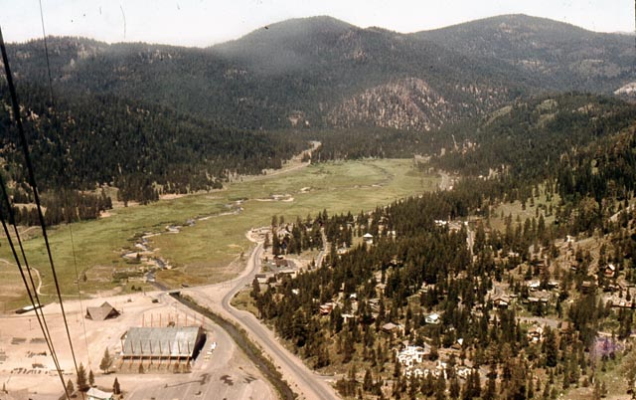 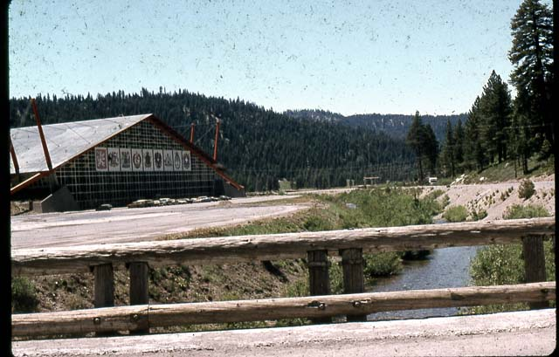
Squaw Valley Olympic Training Center
We immediately went into action. The Squaw Valley dormitories were refashioned to accommodate more than 300 athletes. A spacious dining room was opened for business. Billiard and ping pong tables and a small outdoor swimming pool were set to be in almost constant use and a Coca-Cola machine dispensed free drinks. “It’s quite a bit like a mini Olympic Village, without the tremendous pressure of the Games,” said Whiting, the camp director, who was a 50 year old retired Army colonel who once ran the Modern Pentathlon training camp in San Antonio.
The plan was for athletes to come to Squaw Valley for a two-to-three week session. A lot could be achieved in that time, using our technology, along with the exercise physiology department run by Dr. Fritz Hagerman.
I contacted Harold Zinkin, the President of Universal Gym, and told him what an opportunity this was for Universal to have their equipment in the official USA Olympic Training Center with top athletes training on his machines. He immediately said Yes. After a few months, under the supervision of Ed Burke, we established one of the most sophisticated Exercise Training Rooms in the world at Squaw Valley.
We kept talking to people, especially in corporations, and we were able to get almost any equipment we wanted. Companies like Universal, Yager from Germany, Cybex, and others donated their best equipment to the Center. Obviously, they were permitted to advertise the fact that the USOC
selected their equipment to train the best U.S. athletes. Dr. Dardik, with his Gold Medal in Medical Achievement, gave tremendous credibility and confidence to our concept. We were interviewed by a number of magazines to tell our story of what our vision was.
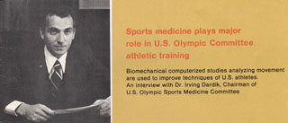
Dr. Irwin Dardik
As we had planned it, one of the Olympic Sports Medicine Committee’s major roles was to analyze and study the body as it related to stress and then apply it to areas of sports medicine. Naturally, I was specifically assigned to the area of Biomechanics. Dr. Fritz Hagerman was assigned to the field of physiology. One of the purposes of the Training Center was to bring together various experts from all over the country with different areas of expertise and pool their resources. Also, the center would be used as an educational institute. Medical and scientific people would continually rotate through Squaw Valley. They would bring knowledge to the center and in turn take back with them new knowledge that they picked up.

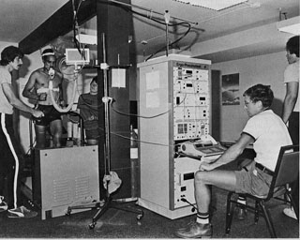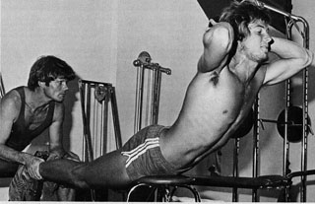
Cardio Pulmonary equipment Training on the Universal Gym Equipment
After a few months of successful operation with various teams that came to the training center and a staff hired to run the camp, Dr. Dardik was assigned to choose his Sports Medicine Committee. I was selected to be in charge of Biomechanics. Since we did not have computers on site, I used C.B.A., my company, to analyze the athletes. We took high speed film at the Training Center and then flew it
to Amherst for quick analysis and returned a report to the coaches to present to their athletes. One important requirement was that the athletes and coaches would get the reports before leaving so that they could conduct a seminar for each team to discuss the results and a training program for the future.
At the first meeting of the Sports Sciences Committee under the chairmanship of Dr. Dardik, we established the following guidelines:
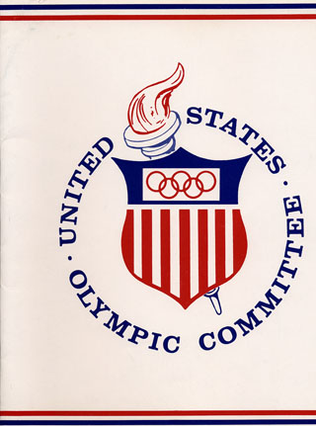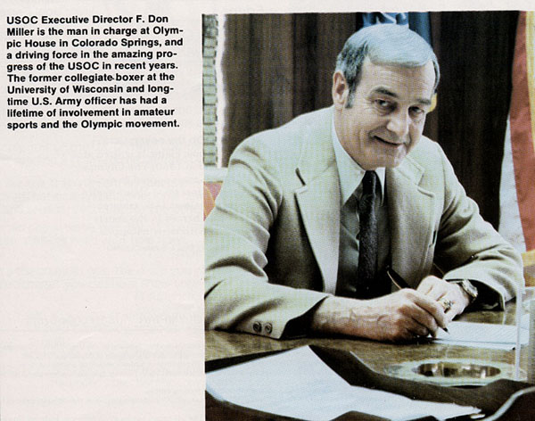
Executive Director Colonel F. Don Miller
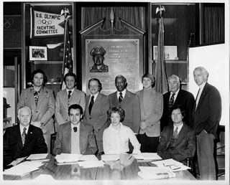
The first United States Sports Medicine Committee
UNITED STATES OLYMPIC COMMITTEE
Sports Medicine Committee
Irving Dardik Chairman
Tenley Albright President Council of Physical Fitness
Allan Rayn Physician
Tony Daly National Governing Body
Dave Costill College of Sport Medicine
Alan Singer Sports Psychology
Leroy Walker A A H P E R.
Don Hanley I 0 C
Gideon Ariel Biomechanics and Computer Scientist

- The USOC would open three regional training centers by the end of 1977. Squaw Valley, California, was the initial center with other sites being considered in the East and Midwest.
- Athletes would be selected from all levels of ability (elite, juniors, novice, introductory level) and they would be screened at the pilot project level for participation in a training center.
- Activities that would be included in the training center concept were: short-term intensive training of athletes who were members of teams readying for competition, clinics with practical experience opportunities for athletes, coaches, judges, and officials, specialized development camps for athletes, competition (both domestic and foreign) for athletes training at the site
- In addition, the regional training centers would be the hub of gathering and disseminating information related to the newly introduced USOC Sports Medicine Program. The Sports Medicine Concept would include studies, research, and programs in exercise physiology, biomechanics and kinesiology, nutrition, sports psychology, and medical services (orthopedic and internal medicine). Studies and research at the regional centers would provide factual information concerning the use of Bee Pollen, anabolic steroids, blood doping, and other elements that presumably have a beneficial effect on performance.
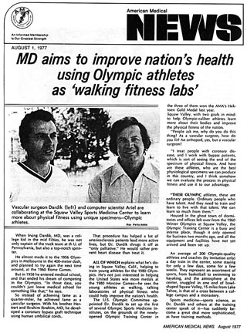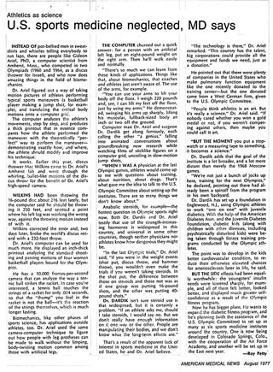

For a whole year we operated very successfully in Squaw Valley.
As the official Chairman of Biomechanics for the United States Sports Medicine Committee, my assignment was enormous: to biomechanically analyze every sport and every athlete who came to the training center.
I conducted hundreds of studies for many teams and athletes.
One of the first studies was to analyze the Women’s Basketball team.
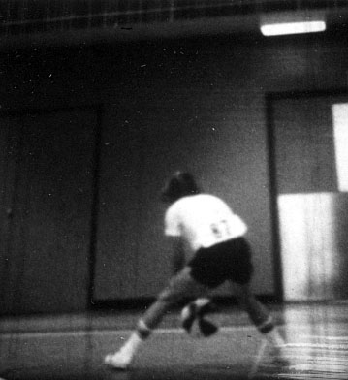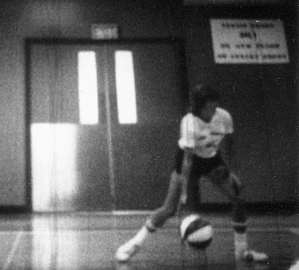
Single frame 2 of many

In fact, my team and I analyzed various team sports such as volleyball, baseball, soccer and others, in addition to individual sports such as the shotput, the hammer throwing and the javelin. I will cursorily cover these three below since the USA were dominant in these events and in the 70’s we lost the lead. Specifically, I will address what happened at the training camps to help the athletes regain their superiority. And in some cases, we were successful in breaking world records and receiving Olympic medals.

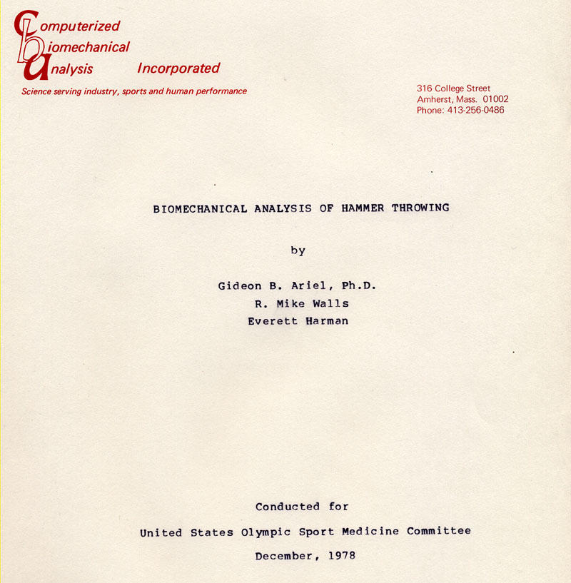

The United States used to hold the world records for many years in the Hammer Throw with Hal Connolly. As the last American to win the Olympic gold, Harold Connolly dedicated his life to the event. It was his goal to see America once again among the world's best in the event. His athletic career was amazing; he transformed from a young handicapped child outside of Boston to becoming a household name around the world.
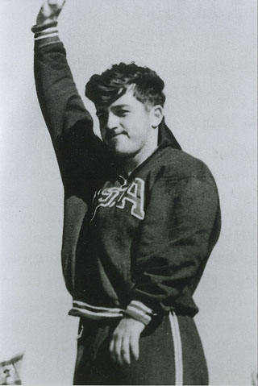
Hal Connolly
A point of fact is that American throwers dominated most field events, including the hammer throw. But in the 70s, American hammer throwers had failed to produce distances comparable to those of their Soviet and Eastern bloc counterparts. At the Montreal Olympic games, no American exceeded the qualifying standard of 226 feet, while the Russians had more than twenty-five athletes capable of heaving the hammer that distance.
One reason for this discrepancy was the use of scientific analysis by the USSR. Application of Newtonian physics is perhaps the cornerstone of modern Eastern and Russian sport groups.
In August of 1978 a group of national class American throwers were invited to Houston by the U.S. Olympic Committee for a hammer throwing clinic. Attending the clinic were some of the best American throwers competing in that event: Arcaro, Berry, Bessette, McArdle, McKenzie, Midles, Perkins, Satchwell, and Silvario. We compared the throws of these athletes with those of the top six finishers in the 1976 Montreal Olympics. The Olympic athletes analyzed in order of finish, beginning with the gold medalist, were: Syedikh, Spiridonov, Bondarchuk, Riehm, Schmidt, and Sachse.
We performed two separate studies on the throwers. The first compared the single support phases of the third turn and release of the Olympic throwers with those of the athletes at the U.S.O.C. Houston clinic.
Another important question considered in this study was the hip-shoulder relationship during the turns. The cinematographical approach to this problem involved consideration of segment length. We also performed separate digitization of the implement itself (the hammer head). This process allowed for determination of the instantaneous linear velocity, acceleration, and angle of release.
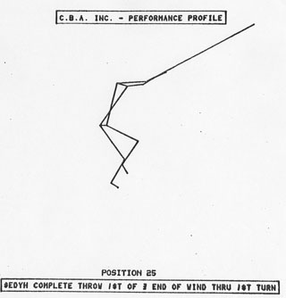

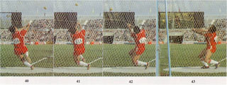
World Record Holder Yuriy Sedykh
The results were clear.
Compared with the Olympians, the American throwers averaged .19 seconds (29%) slower in completing the first turn, .10 seconds (20%) slower in the second turn, and .07 seconds (15%) slower in the final turn. However, several clinic throwers achieved as much acceleration from the second to the third turn as did the world class throwers with Berry and Silvarro producing the highest values.
All of the Olympic athletes spent more time in the double support phase of the first and second turns than in the single support phase. Syedikh's double support phase was longer than his single support phase in the last turn and during release. Syedikh achieved this extended double support phase by placing his right foot in a toe to heel relationship with his left foot, while the other throwers placed their feet adjacent to each other as shown.
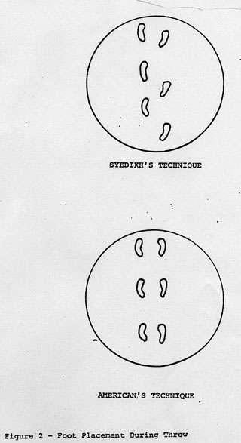
It is clearly evident that the Olympians, especially Syedikh, established a positive center of gravity displacement in the direction of the throw and maintained this displacement throughout the turns and the release.
Syedikh obtained his center of gravity displacement as a result of many specific movements. Throughout the turns, he kept his left leg deeply flexed and leaned forward at the waist towards the hammer head, thereby increasing the radius of the hammer's path. Other throwers leaned away from the hammer head.
Among the five athletes with the longest throws, Syedikh and Schmidt showed minimal leading of the hips.
Velocities of the Olympic throwers were greater than those of the Americans. Linear accelerations of the hammer itself showed a trend contrary to the linear velocity findings. The three top Olympians released the implement at approximately a 40 degree angle, while most of the Americans released at an angle greater than 42 degrees. Means for the two groups are 40.9 and 43.4 degrees, respectively.
The shorter throws of the American athletes were paralleled by relatively low velocities during the turns and low linear velocities of the hammer during the delivery phase. Somewhat unexpected, however, were their frequently high turning accelerations and consistently high linear accelerations of the hammer during delivery.
The extended double support phase exhibited by the Olympic athletes, most notably by Syedikh, probably contributed to the acceleration of the hammer. The longer both feet are on the ground, the more that force can be applied to accelerate the turning body.
Continued movement of the athlete's center of gravity in the direction of the throw, as evidenced by the Olympic competitors, is an extremely important component of throwing technique. If the body-hammer system moves forward early in the throwing sequence, it can ultimately reach a higher horizontal velocity.
The low vertical center of gravity held by Syedikh throughout the throwing movement reflects his deep leg flexion and forward trunk lean.
The tangential velocity of the hammer head is a product of its angular velocity and the effective radius of its path. Thus, it is important that the radius be as large as possible. Syedikh's lean toward the hammer head, counterbalanced by deep flexion of the left leg and toe-to-heel placement of the right foot maximizes the effective radius of the hammer's path. Most of the other throwers lean away from both the hammer and the direction of the throw.
The minimal hip lead exhibited by Syedikh and Schmidt has been called by Bondarchuk the most important aspect of Syedikh's "contemporary technique". It probably plays an important part in maintaining the body's forward lean.
This short description is just a miniscule part of the study made with my student staff. We provided detailed analyses of every possible motion in every athlete. You can imagine how much my students loved these courses. They were working on “real life” situations with the best athletes in the world.
We were able to restructure the hammer throw of the Americans so they could win the medals.
In the next example I will present the Shot-put analysis that we did on another occasion.

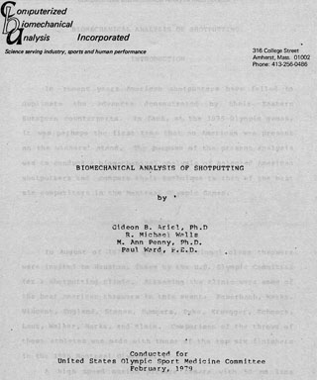
In recent years, American shot putters had also failed to duplicate the advances demonstrated by their Eastern European counterparts. In fact, at the 1976 Olympic games, it was perhaps the first time that no American was present on the winners' stand.
The following figures represent the best European Shotputter at the time. These figures were made with the computer technology of 1976. It is ironic that what was at the time done on a million dollar mainframe can now be done on a 100 dollar computer or I-Pad or even on the new smart phones.
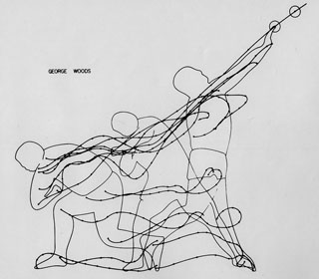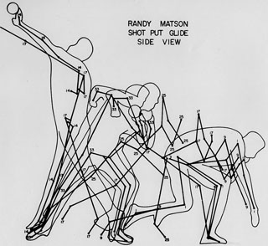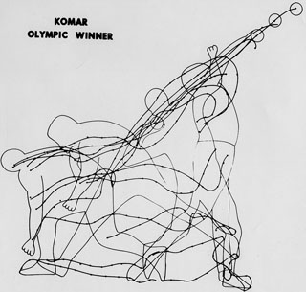
In August of 1978 a group of national class throwers were again invited to Houston, Texas by the U.S. Olympic Committee for a shotputting clinic. Attending the clinic were some of the best American throwers in this event: Feuerbach, Weeks. Vincent, England, Stones, Summers, Pyka, Kruegger, Schmock, Laut, Walker, Marks, and Klein. Again we compared the throws of these athletes with those of the top six finishers in the 1976 Montreal Olympics.
The biomechanical analysis, which in reality was 200 pages, revealed that the most important factor in shotputting is the velocity of the shot at release. This factor is more important than either the height or the angle of release.
The most striking result of the force platform analysis was a discovery concerning the roles of the rear push-off leg and the front breaking leg. In the push-off phase, there was only a small horizontal force (approximately 70 pounds) on the rear leg, while the vertical force reached approximately 560 pounds. This shows that the rear leg provides a lifting force but little pushing force in the direction of the throw.
Various biomechanical characteristics of the shotput analysis distinguished the clinic throwers from the Olympic competitors. All American throwers, except Feuerbach, employed a gliding phase which required too much time.
Another characteristic which differentiated the US from Olympic competitors was the pattern of the vertical center of gravity. In most cases the clinic throwers raised the body prematurely during the gliding and transitional phases.
The acceleration curves show that the clinic throwers are low in dynamic strength relative to their Olympic counterparts.
We recommended exercises and attention to the most efficient ways of throwing and this completely changed the athletes’ prowess, resulting in many new wins.
And lastly, a glimpse of our Javelin report.
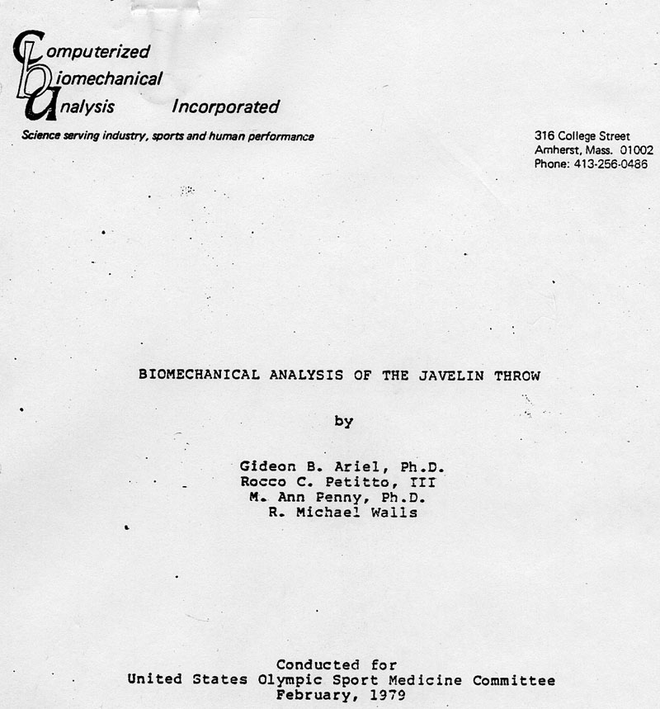

The great world records of the past were held by Cantello, Alley and Murro. Not since 1971 has any American javelin competitor exceeded 91 meters and only a handful have even thrown as far as 85 meters. America is the land of baseball pitchers and football quarterbacks---a nation of throwers. However, the small European countries, such as Finland and Hungary with greater national interests in kicking sports, excel as javelin throwers and dominate the Olympic winners stand.
In addition to these differences in attitudes towards sports, American javelin throwers do not conform to the typical physique pattern that found in their European counterparts. As a whole, the Americans are larger and stronger. It can, therefore, be assumed that skill, technique, and strength in the plane of motion have an exceptional effect upon the final ballistic motions of hand and javelin.
In August of 1978, a group of national class American throwers were invited to Houston, Texas by the U.S. Olympic Committee for a javelin throwing clinic. Attending the clinic were some of the best American throwers currently competing in this event: Derwin, Petranoff, Schmidt, and Roggy. This time we compared the throws of these athletes with the six top finishers in the 1976 Montreal Olympics. The Olympic athletes were analyzed in their order of finish, beginning with the gold medalist: Nemeth, Siitonen, Megalea, Bielczyk, Hovinen, and Colson.
Graphs were made of each individual's throw and release using the length of hips and shoulders to indicate rotation of the body about the vertical axis.
Another aspect of the study was the javelin itself. Compared with the Olympians, the American throwers decreased the velocities of their centers of gravity during the throw more rapidly than any of the finalists at Montreal. The Olympic finalists averaged a 43 percent decrease in velocity from the time of rear foot impact during the release step phase until the moment that the javelin was actually released. The Houston clinic throwers, however, averaged a 55 percent decrease in velocity for this same phase of the throw.
We observed a pronounced difference in the relationship between upper arm and forearm segment velocities between the two groups of athletes. Our examination of the velocity curves for the Olympic throwers and those of the Houston athletes revealed dissimilar patterns.
The second area of study was the relationships between the hip and shoulder systems of the two groups. Considering just the hips and shoulders in the throwing position, most of the Olympic athletes positioned their shoulders 90 degrees and their hips 45 degrees out of the plane of the throw.
Another important factor is the velocity of the javelin. We expected the velocities of the Olympic throwers to be greater than the Houston throwers, and we were right. All the velocities produced by the Olympians at the moment were greater than 28 meters per second.
The source of the difference between the two groups was found to be in the method or style of delivery. The Houston throwers achieved a constant velocity from the time they initiated the throw until the release. Therefore, they did not produce any acceleration of the javelin. The Olympic athletes, however, achieved tremendous accelerations.
The two distinct styles of throwing can be-likened to spiking a volleyball (American) or throwing it (Olympians). It should be noted, however, that Sam Colson's initial run velocity was less than the final center of gravity velocity at release of all other Olympic throwers.
In all the three cases listed above, as well for every analysis we did, we suggested exercises to remedy the differences.

Our analyses yielded fantastic results. In a matter of few months 100 percent of the athletes improved in all events that we analyzed. Our success was very significant.
But our training center was getting too small. The Squaw Valley Training Center’s living accommodations could not handle the number of athletes who wanted to attend, nor could the dining room serve them, and the location was too far for the Eastern Athletes. The US Olympic Committee began looking for a better site.

At one point, Colonel Miller was contacted by the US Air force Academy in Colorado Springs and they proposed a Military Camp location as an Olympic Training Center. This Military Camp was supposed to be closing soon and it had a lot of the necessary facilities for a better training camp than Squaw Valley.

We went to see it and we could see that there was room to grow there. In fact, the Colorado Springs site is still in existence and provides housing, dining, recreational facilities and other services for up to 557 coaches and athletes at one time on the complex.

Back then, when we were searching, we all knew it was the right place. And, thus the Olympic Complex, former home of ENT Air Force Base and the headquarters of the North American Defense Command, became the USOC official administrative headquarters in July 1978.
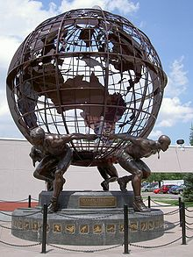
Modern Entrance to the USOC Training Center

The first job we had was to move the laboratories from Squaw Valley to the new location. Committees and various leaders in the field gathered together to plan the move and select the proper staff. These included administrators, coaches and scientists to be able to start the operation.
Dr. Dardik continued his function as the Chairman of Sports Medicine and I was elected now for a full quadrennial of 4 years to be the Chairman of Biomechanics. This appointment continued until 1984.
We had as many projects as we could possibly handle at the Training Center, but we did not have the proper equipment. For one thing, we needed an inside computer to run the analyses. It was no longer efficient to collect the data in one place and ship it to my laboratory in Amherst. We needed a computer and a very powerful computer. How were we going to get it with no budget?
I came up with a solution. At that time we were using the Data General Nova-3 computer in our laboratory in Amherst. I was taking courses at the Data General headquarters in Worchester Massachusetts on Route 9. It basically was the same Route 9 that our office was located on in Amherst but 50 miles to the East. Data General was introducing a new computer at that time, the Eclipse.

One day after class, I thought I would try to see the president of the company, Mr. De Castro. I did not ask anyone and had not made an appointment. I just went to his office on the 3rd floor and knocked on the door. A secretary or administrative assistant opened the door and I asked her if I could see Mr. De Castro. She looked at me as if I was crazy.
“Do you have an appointment?” she asked me.
“There is no time for an appointment. The United States Olympic athletes need his help. I am the Chairman of Biomechanics for the United States Olympic Committee and I need to talk with Mr. De Castro.”
She told me to wait for a minute and she went to “God’s” office. She came back and invited me in. I was in De Castro’s office. He was the chief engineer who had envisioned the Eclipse and it was to be a great performer for them, even though he did get himself into some lawsuits. But as far as I can see, If you accomplish anything in the US, you get yourself into some lawsuits.
He asked me to sit down and asked me what he could do for me.
I began,”Mr. De Castro, I am using your Nova-3 computer to conduct studies for the U.S. athletes and recently we moved our Training Center from Squaw Valley to Colorado Springs. We need the best computer possible, and I think the Data General new Eclipse would be perfect.” He politely listened to me, took my phone number and address and told me that I would be contacted by his staff. I thanked him very much and left, not expecting anything to happen.
But he saw a wonderful opportunity to get the word out.
The next day I received a call from Mr. Howard Steiner, the Public Relations Manager of Data General. He told me that he was familiar with the article about me in Sports Illustrated and would like to visit me. We met 2 days later and he liked what he saw. He asked me if it was okay to call Colonel Miller at the US Olympic Committee for more details of our plans. By that time I had already talked with Colonel Miller and he was waiting for the call. The call took place and Colonel Miller must have been convincing. Data General sent him the following letter:
May, 7, 1979
Colonel F. Don Miller
Executive Director
United States Olympic Committee
1750 East Boulder Street
Colorado Springs, Colorado 80909
Dear Colonel Miller:
Thank you for taking time out from your busy schedule to meet with us last week. We are very pleased and enthusiastic about your response to our concerns about the planned implementation of the Data General Computer System.
We believe that your decision to make Gideon Ariel responsible for the implementation of the S/250 Computer system insures that it will be operational in the shortest amount of time.
I have received your executed copies of the Data General field service and program license agreement. I have been in touch with our field service organization and it will be handling-this installation on a priority basis.
It's my understanding that the installation of air conditioning equipment will begin because the computer room was measured last week at 30 degrees F. Given the substantial heat dissipation from the computer and related peripheral equipment the installation of air conditioning equipment will be essential to the reliable operation of the equipment.
With the time required for this preparatory work as -well as the development work going on at Dr. Ariel's laboratory, the System will be operational in Colorado Springs by approximately July 15.
We would like the USOC to announce our donation on June 4 in New York; City in conjunction with the National Computer Conferences Also, we would like very much for you to participate with us in making this announcement at the 21 Club of The Four Seasons. In July, we then could follow this up with a press tour of the laboratory. If this proposal is agreeable to you, I would like to immediately begin planning with your staff.
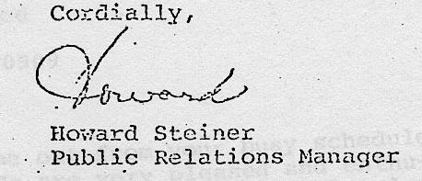
So, the United States Training Center received a very powerful computer. But it was not totally free. I had to go around the world to tell the Data General story. And I did it with love.
The International announcement from Data General appeared in their next newsletter to their distributors:
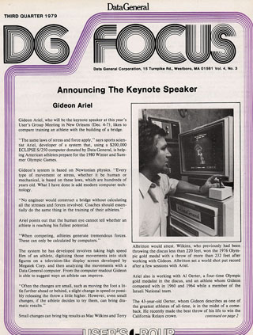
The publicity trip started with some conventions, at which I was a speaker for Data General.
In Tracy Kidder’s book “The Soul of a new Machine,” she described the race for the construction of the best and most powerful mini computer of the time. Part of it describes the introduction of the machine at the National Computer Show in New York City where Al Oerter and I were present at the Data General booth showing how the computer helped the American Athletes in their quest at future Olympics.
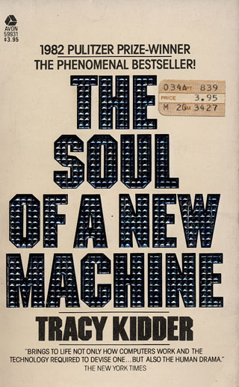
The donation of the Data General computer to the USOC immediately was in the news.
The Data General marketing machine was nothing short of miraculous. NBC introduced the donation by inviting Colonel Miller and myself to talk with Tom Brokaw on the Today Show .
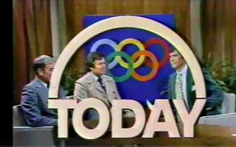
It was a win win for everyone. Fantastic advertising for Data General, and the best computer for the Training Center in Colorado Springs.
We continued meeting with Data General and Tom Brokaw in New York. In fact we took the time to also analyze Tom as compared to the famous runner of the time, Bill Rogers.
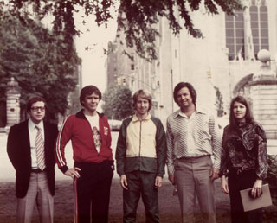
Mr. Steiner, Tom Brokaw, Bill Rogers, Myself and Ann
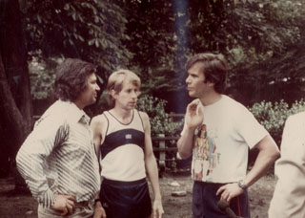
After the run, in an interview with Tom Brokaw

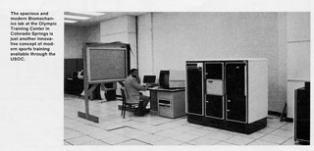
Rocco Petito, my student, running the Biomechanical Lab at Colorado Springs with the Data General Computer the Eclipse S/250

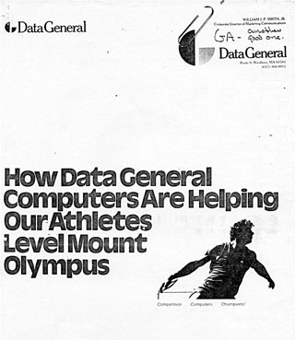
Al Oerter in the Data General Advertisement
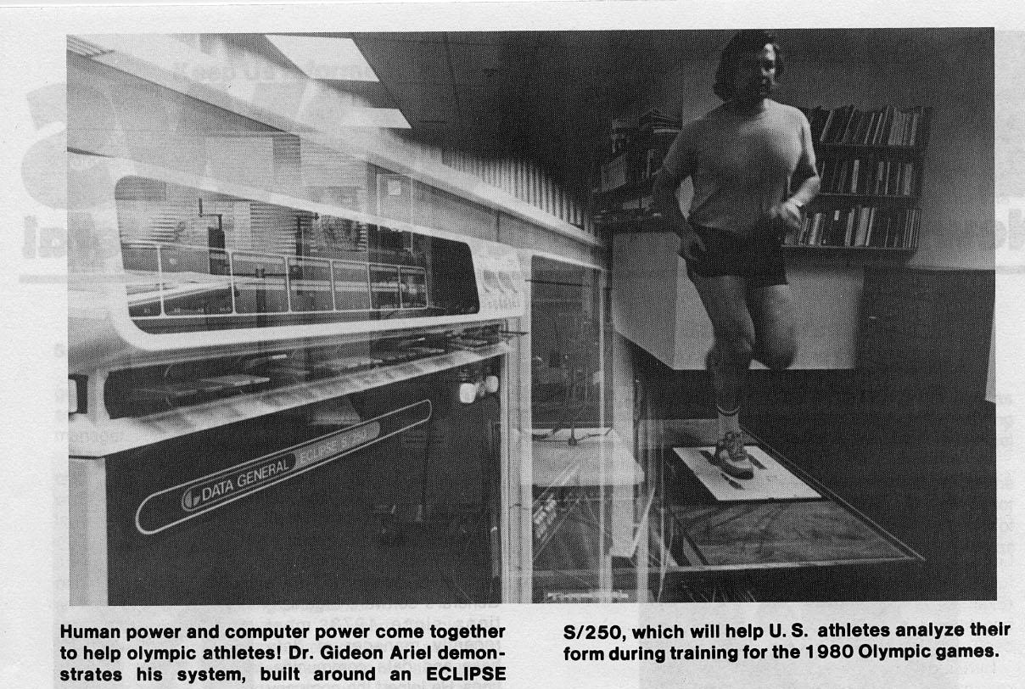
Since Data General had announced their donation to the world, it was easier to receive equipment donations from other companies. I will just mention one here out of many since this one was also crucial for the analysis. Megatek Corporation, which had a terminal that could calculate 3D coordinates “on the run,” donated one of their machines. This speeded up the analysis significantly and showed the athlete, in almost real-time, their motions in 3-dimensions on the screen.
All was going well at the Olympic Training site, but I did not have much time to help with the research. I had to “pay” my due to Data General. “A deal is a deal.” I had to appear at numerous presentations and even travel around the world for them. Here was a typical Data General agenda:
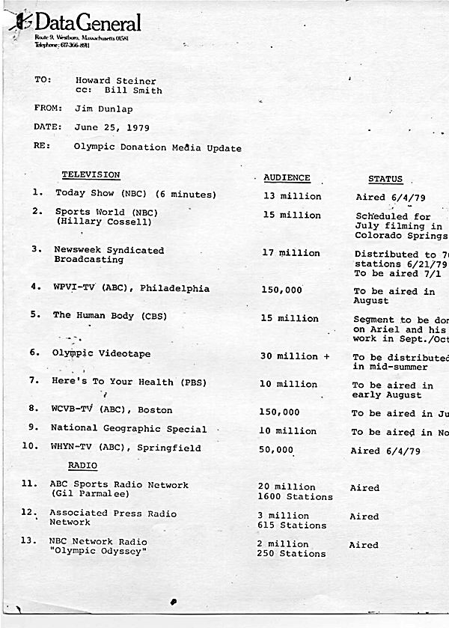
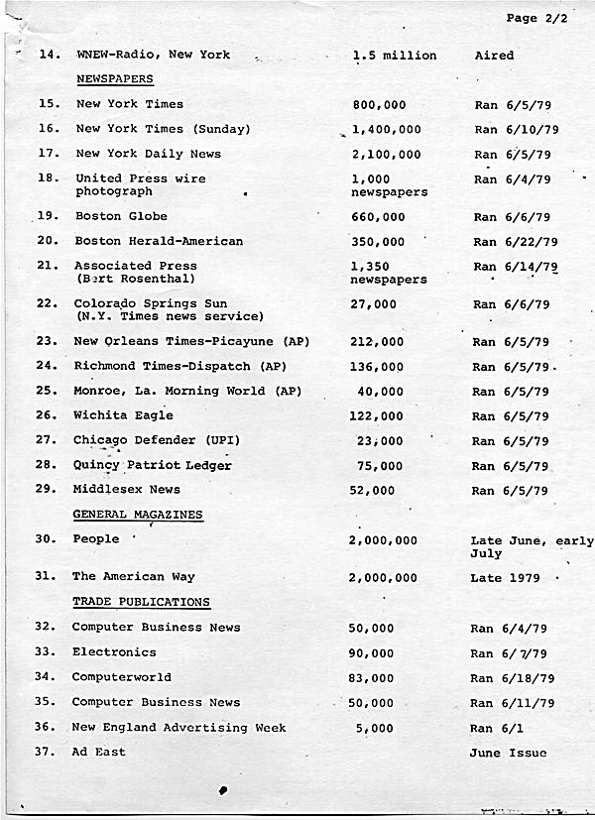
Needless to say that these presentations were fantastic for my own company. I really did not plan it this way, I was not a commercial genius….but with this sort of advertisement of my system by a 3rd party, and they were paying for all of it, some think that I should have been in business, not in science. I had managed to get all this exposure for free.
But nothing is 100 percent free. Some of the “geniuses” at various universities started complaining of a conflict of interest. For example the biomechanic head at Penn State, Richard Nelson, complained to the USOC that it was a total conflict of interest what Ariel is doing as Chairman of Biomechanics for the Olympic Committee while running his company at C.B.A. Another Professor at UCLA, Bob Gregor, who was Nelson’s student, claimed the same as did all the other University scientists who seemed to only accomplish writing books for their students to purchase or else they would fail them in their course. They, also, did not know that all my work with the USOC was totally voluntary. I did not ever get one cent from them.
Well, now I was sent to European countries. Here is a sample itinerary:
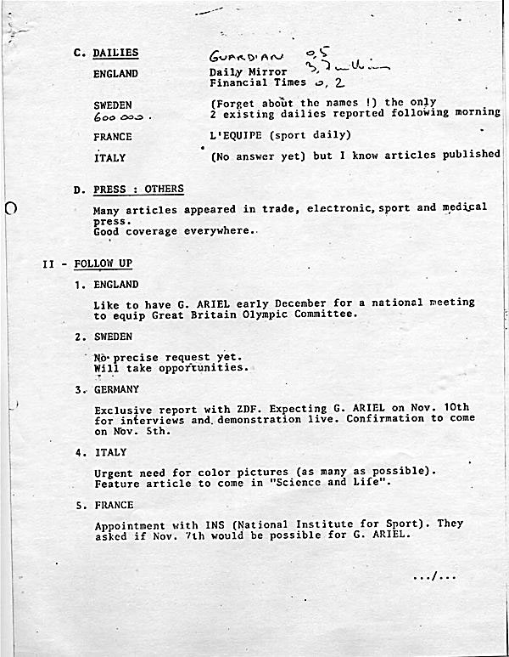
I was meeting with the Data General marketing department and we were planning my trip to Europe. I was told by Mr. Bill Smith, the marketing director, that I would fly to London where Francoise Lindecker would pick me up at the airport, holding a sign with my name so I could spot her. She would take me to the hotel to rest for a day since from then on, there would be meetings every day all day long. Bill explained to me that Francoise is a relatively old lady in her 60’s , but very energetic and would make all the travel and accommodation plans for me.
I arrived at London Airport and looked for someone with a sign to meet me. I kept looking around for an old lady, only to see a gorgeous young lady in her twenties with a sign in her hand. I could not believe it. So, I approached her and asked her if Mrs. Lindecker sent her to pick me up.
“I am Francoise Lindecker,” she told me. Well I could see those guys at Data General now laughing their guts out.
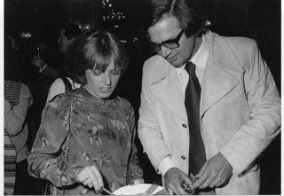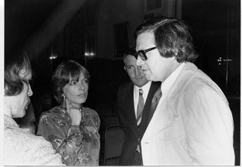
Francoise and I at one of the many meetings

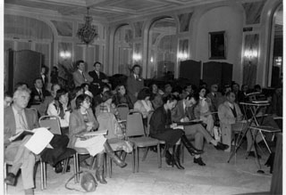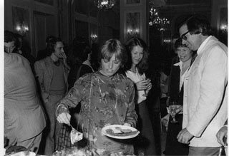
At least 50 seminars in various countries
My talks were all relatively the same and of course in English. We stayed in 5 star hotels, all flights were first class and of course we had two rooms in each hotel. At night when we went to dinner, if we were alone, I was afraid even to look at Francoise since I did not trust my left side of the brain. She would come to dinner in the most sexy clothes and I could see that all present in the restaurant were envious of me. If they just knew the truth they would consider me the most stupid guy on earth, or gay. We only talked business and after dinner had a drink in the bar and then went to sleep. Each one in their own room. It was hard to fall asleep, so I would watch CNN for a while. There were no PCs at the time. You could not just work on your notebook like today. It is either go to sleep, watch CNN or go knock on her door. Well I would not dare do that.
After London we flew to Stockholm Sweden where I was giving a few talks. The talks basically covered how we were using the Data General to improve our athletes’ performance and to also learn what our competitors were doing so we could prepare for future competitions. My talks would last for about 60 minutes and then there was a 15 minute question and answer session.
The second day in Sweden was a shorter agenda, and we had time to go back to the hotel in the afternoon before dinner. While in my room, there was a knock on my door. It was Francoise. She asked me if I wanted to join her in the sauna on our floor. I asked her where the sauna was located and I told her that I would come in a few minutes.
I arrived at the sauna with my bathing suit and a towel. I opened the door, and there Francoise was, totally naked. I think I had a hard time talking but I made sure to keep looking up at the ceiling.
She told me: “Hey Gideon (the first time she had called me by my first name). It is okay. Here in Europe we all go to the sauna naked.” I nodded but said nothing. It is not that I have never seen a beautiful girl naked and that I did not have my share of love experiences with exquisite ladies, but in this case “on the job” I just did not know how to react. After all by that time I had been through my share of women, Yael, beautiful Esti, Loren, others. But let me tell you, the body on this French Francoise was something else. And the way she moved her body in the sauna was even harder to ignore. I knew I would have to have more than one drink that coming evening.
We had dinner at the Stockholm Sheraton, a 5 star hotel at the top of the hotel looking over the beautiful city. There was live piano romantic music playing in the background. I had a steak and had to be convinced by Francoise to have a dessert. Well, I decided to stop saying no on this wonderful evening. After dinner we went to the bar and had a drink. I think I had a sambuca with coffee beans. And after the second drink I could not say no to the third drink. It was funny and we laughed a lot. It was already 11PM and I had to get up at 7AM so I suggested that we go back to our rooms. I think we were on the 5th floor. We approached my room first, I kissed her on the cheek and thanked her for a wonderful evening. While I was opening the door with my key, Francoise decided to walk me to bed. And so this was the first night that one of our rooms remained empty. From then on, we always made sure that we got two rooms, but one room remained empty. We had to follow corporate procedures. Francoise could not file the trip report and show that I was living in the street.
So we had a great time together basically, a dream trip. Years later I used to ask Ann if I really went to Europe or it was my imagination.
And now you ask how did I do all this with my long term relationship with Ann. And how did it never affect my romantic and business partnership with her? This is a mystery and probably an entire book should be written on this subject. Ann would say, she just loved me and understood my nature. And there is truth to that. Also, she is a very secure person and loved her work and her attitude was, well if he leaves me for another woman, I will just carry on. She simply stayed by my side. I told every woman I was with that I could never be with them long term because of Ann. That of course caused problems with the women.
But I could never resist a beautiful woman, or an intelligent beautiful woman. And Ann, for some remarkable reason, understood this. And I always came back to her. And there were times she put up with quite a lot of madness. I would fall in love with other women but she must have known in her heart that, ultimately, she was the only long term match for me.
I would not be where I am today without Ann, without her patience and unselfish love. It is a lesson for all of us. It’s not about what you get, but what you put into a relationship. And she always put in her best. And I ended up being a very lucky man.
But back to business. The trip to Europe for Data General was a tremendous success for the Data General Corporation and for C.B.A, as well. And, let’s not forget, it was already a great success for the US Olympic Committee since they possessed one of the most powerful minicomputers at that time.
The reports from Europe about what we were doing were amazing.
In France, our work was placed on the national evening news watched by 5 million people. L'Express (circulation 1 million) did a story on us. In addition to the press conference, I met with sports doctors, including top level representatives of the Ministry for Sports, the rehabilitation research center, and the Olympic Committee.
In Italy, a large press conference drew medical and scientific press, women's magazines, TV and radio stations.
In Sweden, representatives from the National Sports Association, various sports associations for all types of sports, medical people, and representatives from national, local and trade press, radio and TV, came to a press conference which was later covered with a 2-minute item on the news, and a further 4 minutes on the sports program. Both national dailies in Sweden mentioned the event on the front page, with long articles on the sports pages.
A press conference in the United Kingdom led to announcements on BBC news, on Capitol Radio, on LBC (who repeated the item four times). BBC radio nationally and locally also picked up the event.
West Germany gave an exclusive interview to the ZDF TV channel, where I was on "Sports Studio" for a live show seen by 20 million viewers. The whole trip had been a giant success for Data General and CBA.

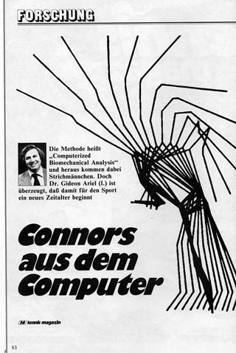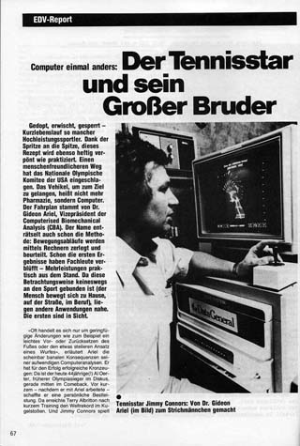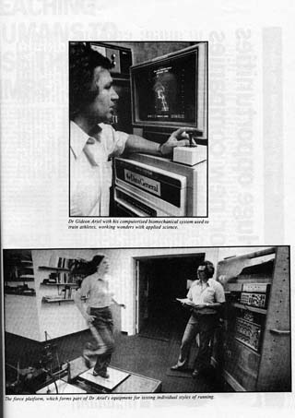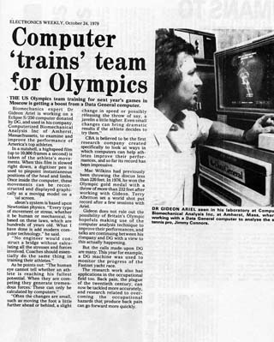
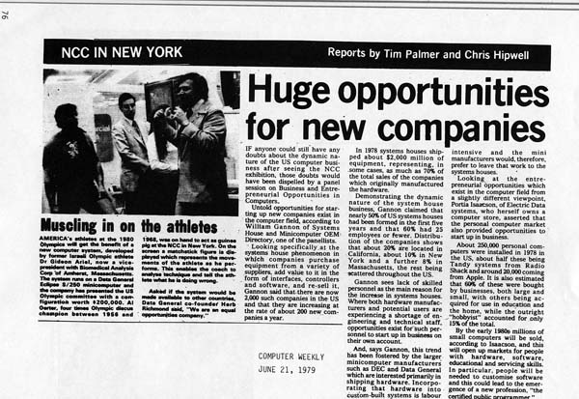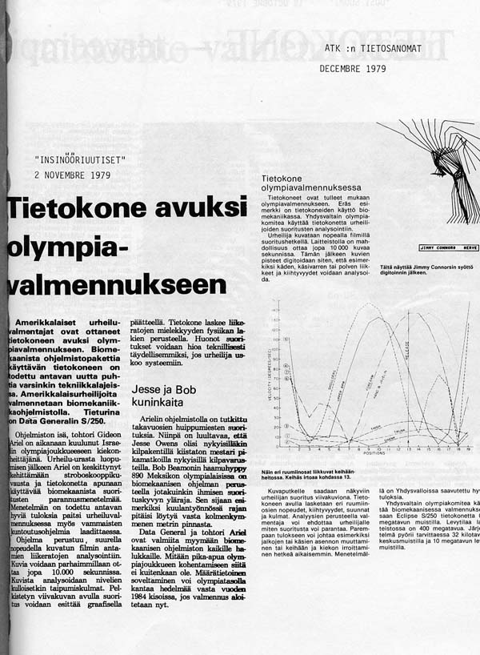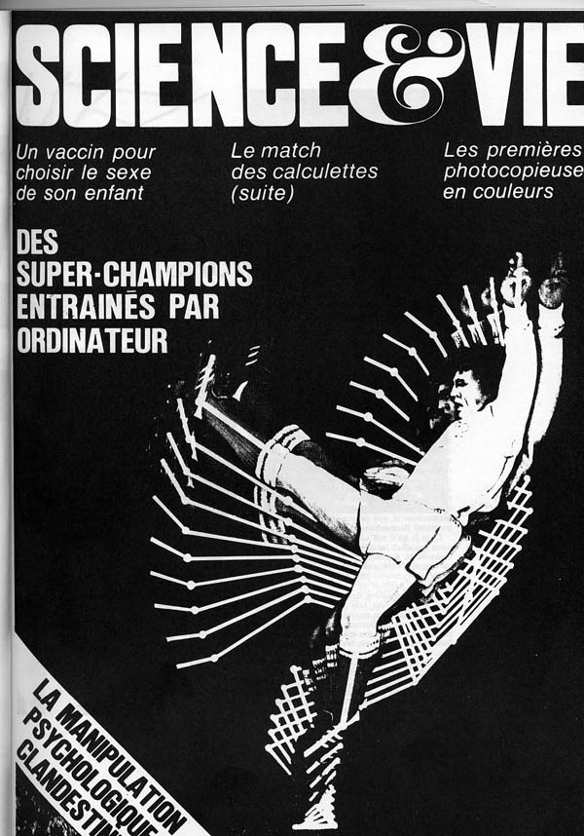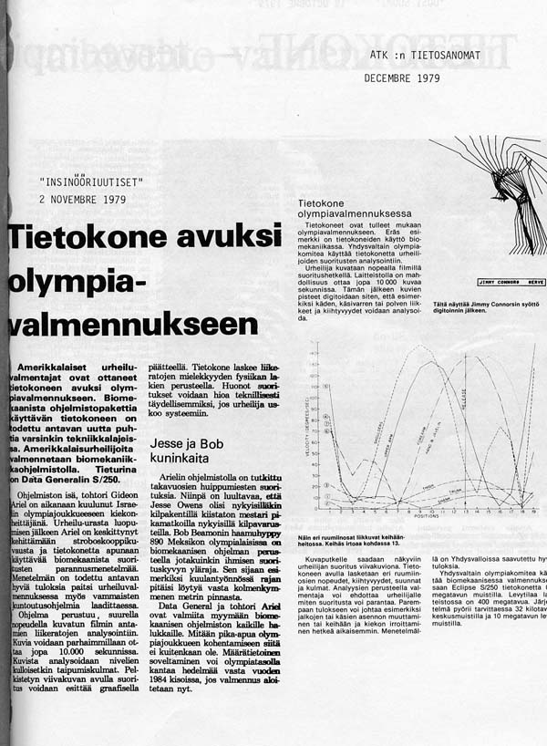
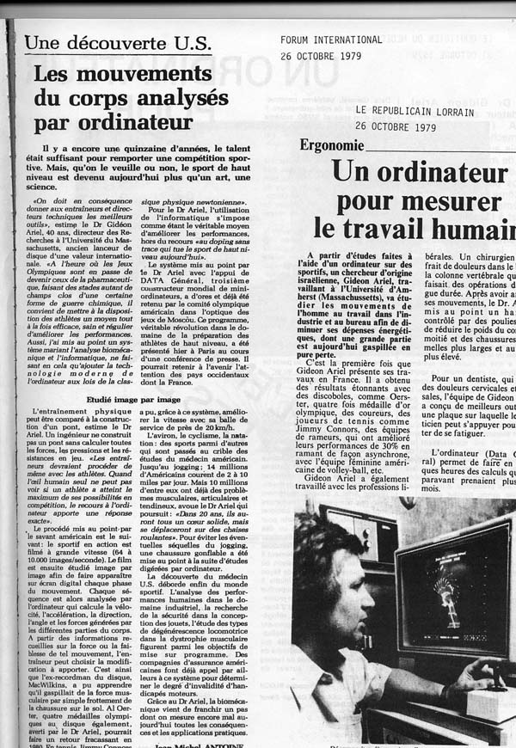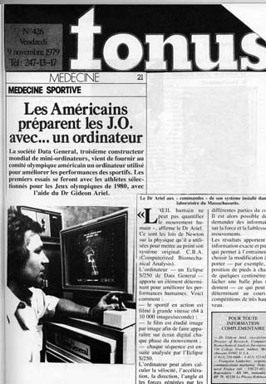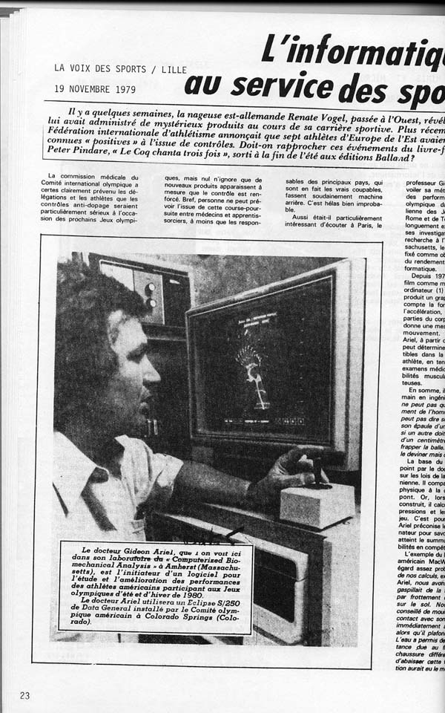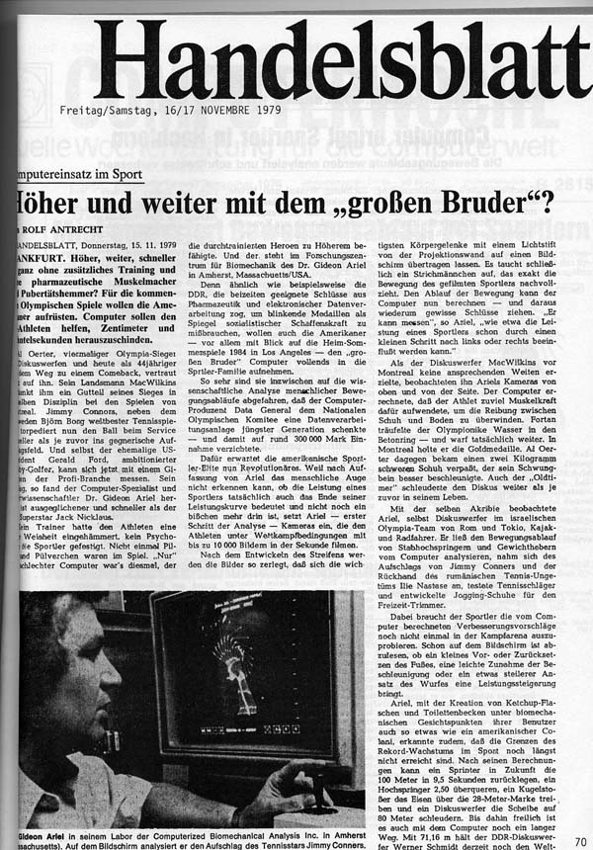
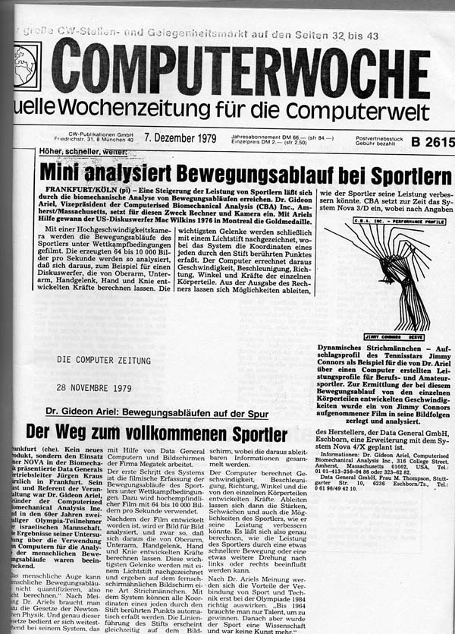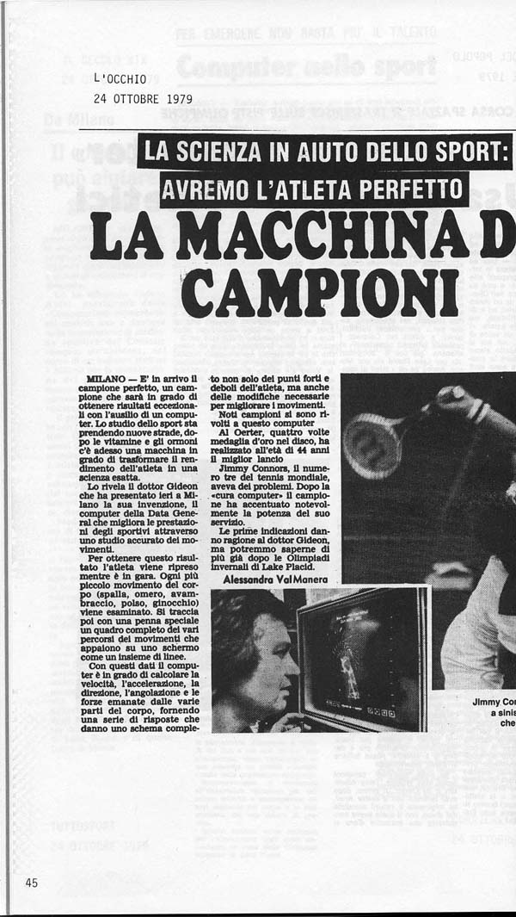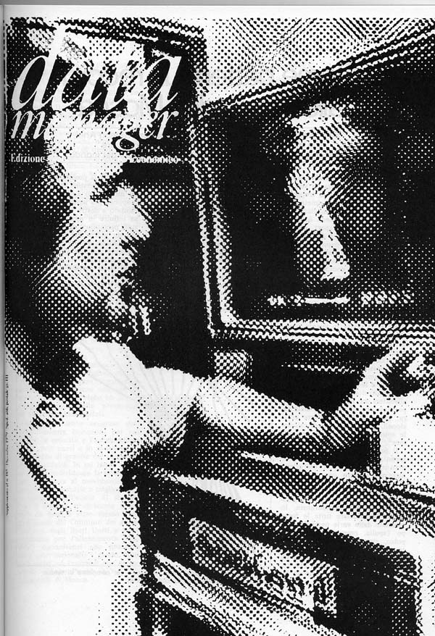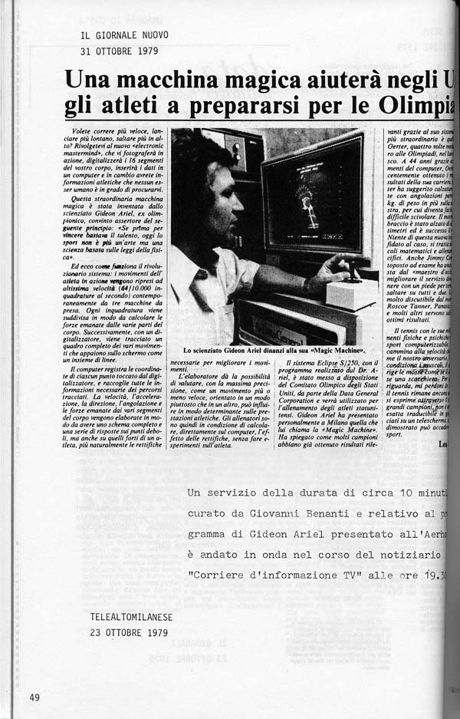
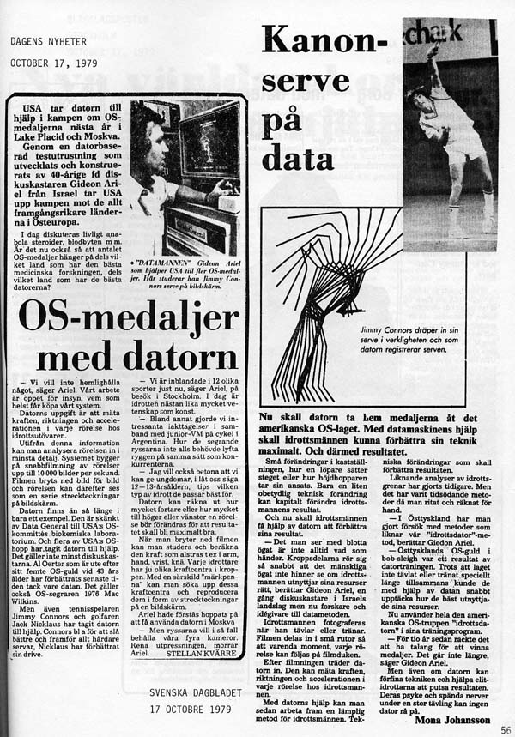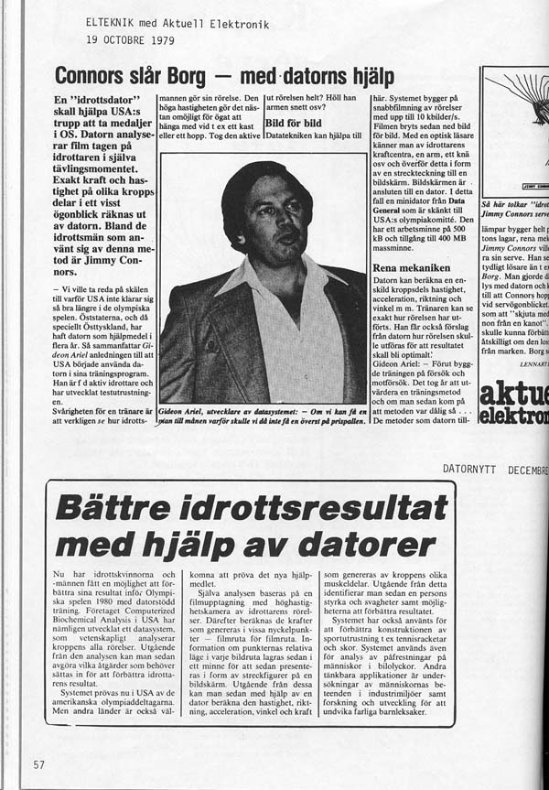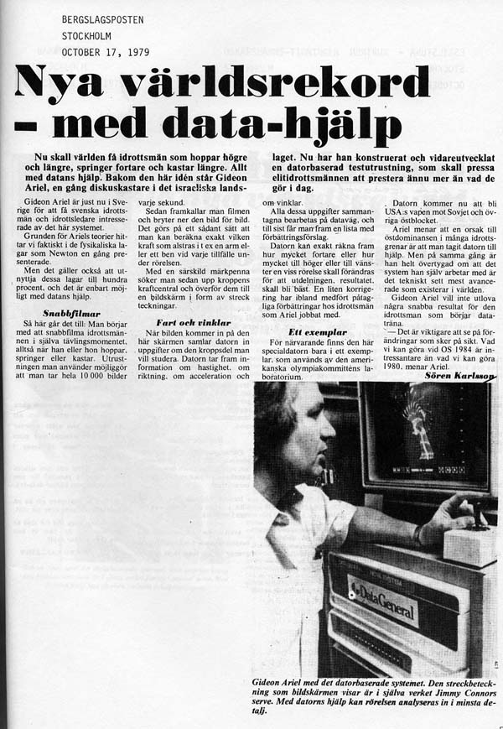
The Laboratory at Colorado Springs started operating with a new staff. I was only a volunteer and could not be present all the time since I had to run my company which was loaded up with at least 10 new projects that needed to be done at once. We hired Dr. Chuck Dillman from the University of Illinois. Chuck was a well known biomechanist in the field. In addition, since Dr. Dardik was a volunteer like me, he needed some administrative assistance. He hired Cassey Clark who was also from the University of Illinois. Also, a few students came as helpers from various Universities.
Later on, Dr. Dillman hired two biomechanists from New Zealand, Phil Cheetham and Gary Scheirman. With all this help, the Laboratory of Biomechanics was working at full speed. We conducted studies on all the sports and fulfilled many special requests by coaches and administrators.
Here are some photographs of performances with the data integrated.
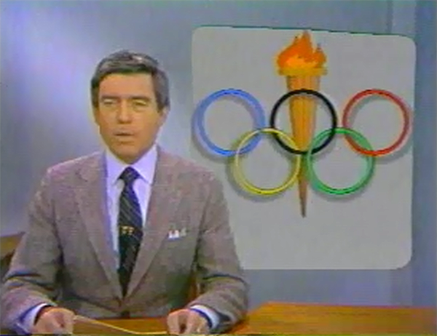
Dan Rather reporting on the US Olympic Training Center in Colorado Springs
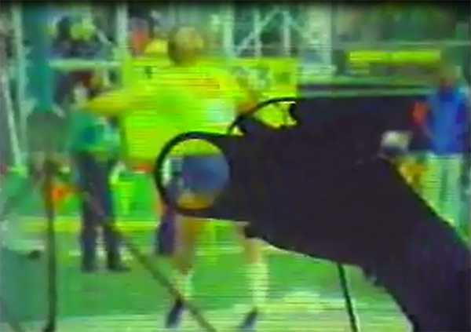 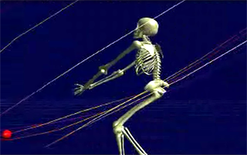
Analyzing Al Oerter Hammer Throwing
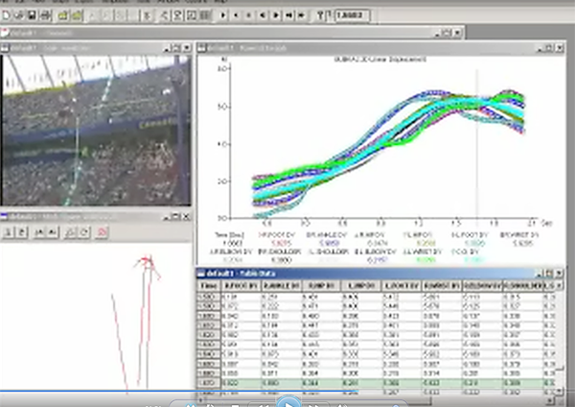 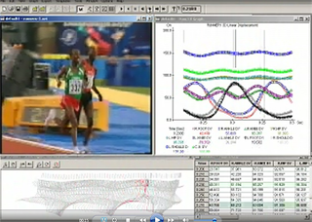
Pole Vaulting Running
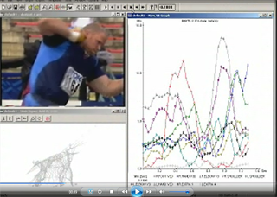 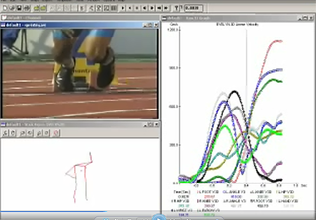
Shot-Put Sprint Start
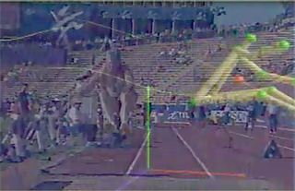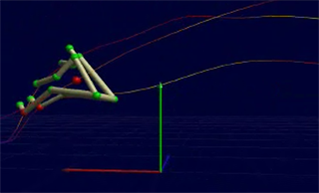
Triple Jump (World Record Performance)
The end of my quadrennial term was approaching. It had started in 1977 in Squaw Valley and ended in Colorado Springs. We had achieved the impossible. A dream that started with Bill Toomey, Russ Hudge and myself, and then bringing in Dr. Dardik, produced the most advanced sports training center imaginable. I was prepared to hang my hat up now and move on and be proud of our accomplishment.
But, to my surprise I was contacted by Colonel Miller and Dr. Dardik, indicating to me how important it was to the Olympic System in Colorado Springs that I accept another Chairmanship of Biomechanics for the Quadrennial of 1979 to 1984. It was a hard decision for me. I had so many projects at CBA and I was involved with my new project of building the Computerized Exercise Machine.
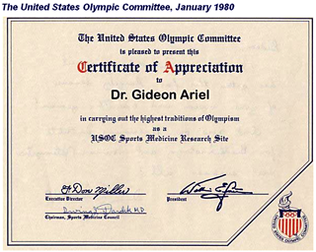

There was one factor that was not working well though with our biomechanic lab at Colorado Springs. We did not have enough money to run all the projects and pay all the staff. Dr. Dardik and I were volunteers, but everyone else was on salary. I had to find more money for the Lab or we would cease to exist in no time.

One day, while sitting in the lab with Rocco and reviewing some of the studies, Colonel Miller happened to walk in to tell us to get ready for some visitors. Many visitors often came from various countries to see the laboratory.

Just out of the blue, I asked Colonel Miller, “Excuse me, Colonel Miller, what if a shoe company would pay one dollar per pair of shoes to have the Olympic Rings on the shoe?”

“What company?” he asked.

I told him that I did not know, but I thought I could get a company that sold at least 50 million pairs of shoes per day to go with this idea. They could pay one dollar per shoe for having the Olympic Rings on it and the shoe could be called “The Olympic Shoe.”

He was quiet for a while, but smiling when he walked out. Immediately I called Roberto and asked him to make a contact for me with Jona Santor, the “King of Shoes” at the time. Every shoe that was made in Korea was under his company control under exclusive imports to the USA.

Roberto was worried. “What about Pony? All the money we paid you to make the shoes for us and now you are going to jump ship?”

“Roberto, this won’t be the same quality shoe. It will be for the general public.”

“I will let you know,” he replied on the phone.

I received a message from Mr. Medow, the administrator for Mr. Santer, and he discussed with me the details and was very enthusiastic about the idea of an Olympic Shoe. They would be happy to pay the one dollar per shoe. I had to arrange a meeting with Colonel Miller, which I did. We all met in Colorado Springs, and they decided to go with the deal. Two brands were selected and they both would be made for Mr. Santer. One was the J-C-Penny shoes which had a huge distribution, and the other was with my old friend Spalding which made shoes under a company name of San Shoe.

From then on, I was not privileged to the detailed contract between the organizations but I was assigned to come up with a shoe design for this market of “Olympic Shoes.” Not performance shoes, but every day comfortable shoes.

I had to conduct research on existing shoes and come up with recommendation for the “Olympic Shoes.” While no USA Olympics shoe demonstrated superiority in all categories, certain USA Olympics shoes compared quite favorably to the competition in the areas of stiffness, energy absorption, and flexing force. The performance characteristics of the women's USA Olympics running shoes were no competition, however, for the Nike Columbia shoe. We decided to implement Nike's use of air bladders in the shoe sole in later designs.

But the shoe that I came up with sold phenomenally well. This successful project raised millions of dollars for the United State Olympic Committee, and supported the Biomechanical Laboratory for many years.
My contribution was clear. A powerful computer and laboratory setting for the Colorado Springs Biomechanic Laboratory. Millions of dollars raised based on my effort and innovation to get it. It required a lot of work. But I loved it.
But a leopard, as they say, doesn’t change his spots and I was ready now for my own thing.

