Chapter 8: Munich Olympics 1972

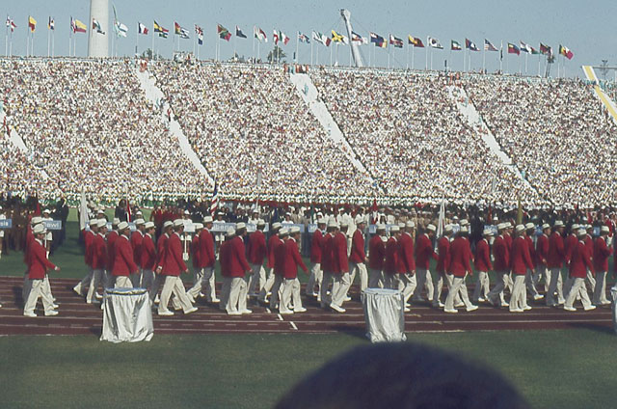
The United States Olympic Trials are held every four years approximately two to three months prior to the beginning date of the Games. The purpose of the trials is to select, based on the best performances of the athletes, the team members who will represent America in the Olympics. All of the summer sports have these team selection events but I am most familiar with the track and field trials. Without a doubt, the U.S. Olympic Trials is the best national track meet in the world. There is no other athletic meeting quite like them as far as performance level and the enthusiasm of the participants and the spectators. The Olympic Games and the World Championships may have higher overall standards of performance, but no other national track championships can compare with the quality of the U.S. It is not just the statistical performances but rather the intense competitive process of the sudden-death form of selection that heightens the excitement. Make the top three in your event and you are on the team. Have an off day and you become an observer.
My first participation at the U.S. Trials was in 1972 in Eugene, Oregon. The city of Eugene has a fantastic history for sports and especially for track and field. For example, jogging was introduced to the U.S. through Eugene. It was brought from New Zealand by Bill Bowerman, who wrote the best-selling book "Jogging", and who coached the champion University of Oregon track and cross country teams. During Bowerman's tenure, his "Men of Oregon" won 24 individual NCAA titles, including titles in 15 out of the 19 events contested. During Bowerman's 24 years at Oregon, his track teams finished in the top ten at the NCAA championships 16 times, including four team titles. Bill Bowerman also invented the waffle sole for running shoes and, with Oregon alumnus Phil Knight, founded shoe giant Nike, Inc.
The environment of the Eugene area is rich with knowledgeable fans and supporters of track and field events. There is an excitement that seems to vibrate in the air and communicates to the athletes and coaches almost as soon as they step onto the field. Eugene is home to the University of Oregon's Hayward Field track. I was lucky enough to be at Hayward Field when the stands were alive with the crowd shouting “Pre! Pre! Pre!” for their home-town hero, Steve Prefontaine. Prefontaine was a middle and long distance runner who had both amazing good looks and an exciting style of running. For many members of the track and field world, Prefontaine is one of those legends who gave a magnificent performance every time he stepped onto the track and whose spirit continues to hover over Hayward Field. He was a joy to watch and it is one of my special memories of that time.
It was to this amazing track-crazy town, filled with some of the best athletes, that I arrived in the summer of 1972. My friend, George Dales, had invited me to attend the Trials and perform our biomechanical analyses on as many events as possible. He would then publish the results in the Track and Field Quarterly Review where he had printed other articles which I had submitted. One of my most recent articles was about the Training camp for Throwers is sited below.
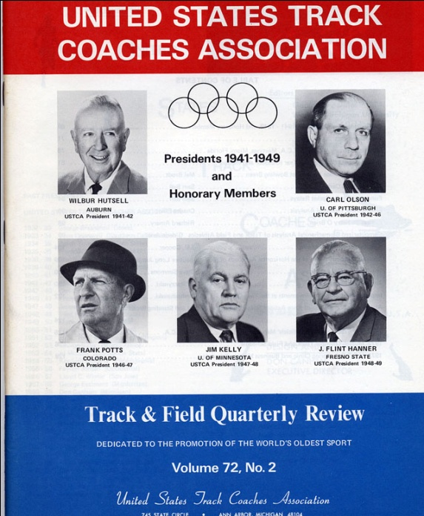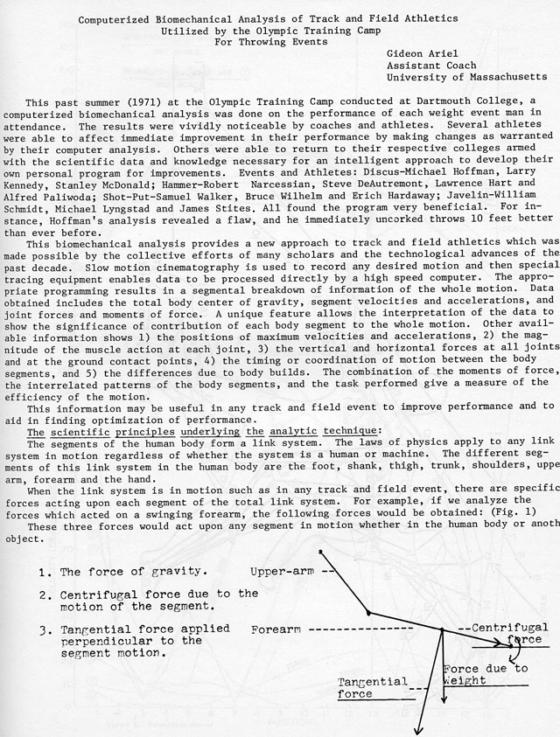
Published Results of the Dartmouth US-Training Camp for Throwers
Ken Weinbel, one of my CBA partners and the Head Coach of the Dartmouth College Track and Field team, and I flew to Eugene with all of our photographic gear. At that time, movie cameras only used 16 mm film. The current digital movie cameras were not available in the consumer-level market until 1994. Therefore, in 1972, the entire filming process was quite lengthy and tedious during those early years of biomechanical analysis. The Olympic Trials follow the same schedule that the Games use, so Ken and I were able to film many of the events. We usually had to wait two or three days for the film to be developed, but, at least, we could watch the films to verify that we were capturing the events correctly. We had to include the entire activity, the scale factor for converting the athlete to full size, and the names, dates, and sequences for identification purposes. This involved different filming arrangements for each activity since the 100 meter sprint might only focus on the start while the run-up in the javelin required more complicated camera placements.
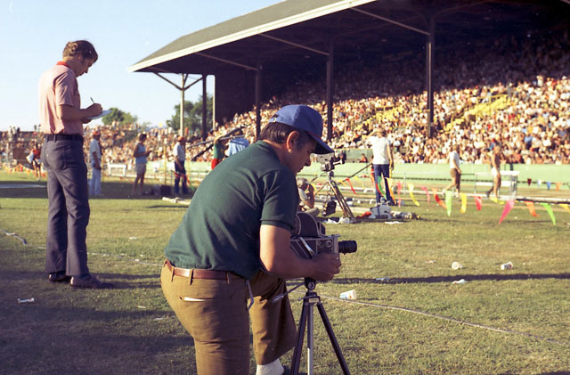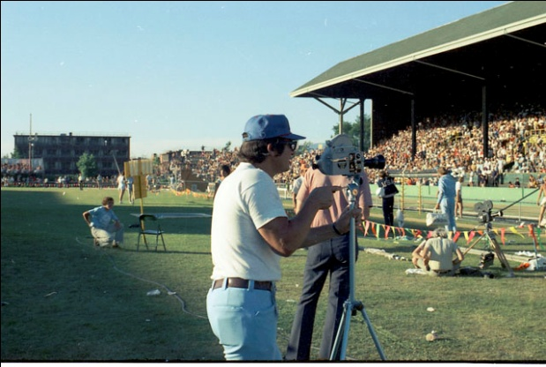
Ken Weinbel and I filming the Pole Vault with 2 cameras for 3D analysis

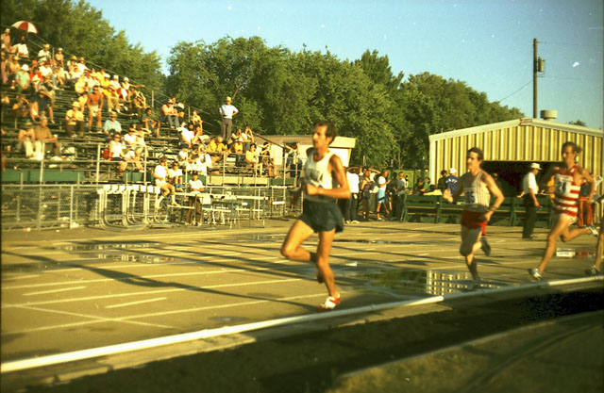
Frank Shorter, Olympic champion, in the 1972 Olympic Trials
We spent all day, every day, filming each of the Olympic Trial events so we were able to collect an enormous amount of data. In fact, we had so many reels of film, that I had to buy an extra suitcase to take all of them back to the Amherst office. George had requested several specific events that he wanted me to analyze quickly so he could include them in the next issue of the Track and Field Quarterly Review which would be published prior to the start of the Games.
One study I conducted was on the Pole Vault jump. The question that we needed to resolve with our technological process was what does the fiberglass pole contribute to the jump? The most important characteristics of the pole are strength and flexibility since it must support the athlete as well as providing a “whip” to propel the vaulter over the bar. The pole must have the capability to store energy and release it at the proper phase of the jump. Originally, poles had been made of ash and then bamboo but the modern ones were appearing with different materials, such as aluminum and fiberglass. The poles of the 21st Century employ even more sophisticated composites including carbon-fiber and E-glass and S-glass materials in order to create poles which are less heavy.
In the past when the poles were made of bamboo, they actually functioned like the subsequent fiberglass models. As pole materials, both fiberglass and bamboo possess similar characteristics for storing energy during the beginning phase of the jump and then, like a catapult, the energy is returned to the athlete to pass over the bar. Cornelius Warmerdam used the bamboo pole and held the pole vault world record for seventeen years, from 1940 to 1957. During the 1972 trials, the vaulters used only aluminum and fiberglass for their poles. Thus, George’s question was “is there an advantage or difference between poles?” If there were differences, George wanted to know what they were. The biomechanical analysis revealed that the fiberglass, while similar to the bamboo, exhibited better energy storage during the beginning phase and subsequently “whipped” or “threw” the vaulter over the bar. Aluminum was too stiff and lacked the flexibility necessary for reaching extraordinary heights.
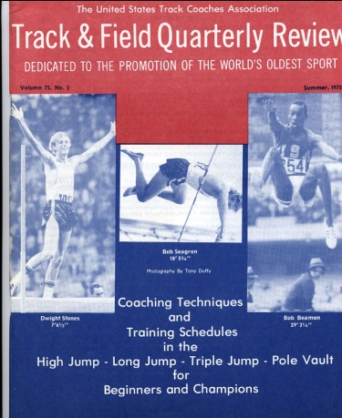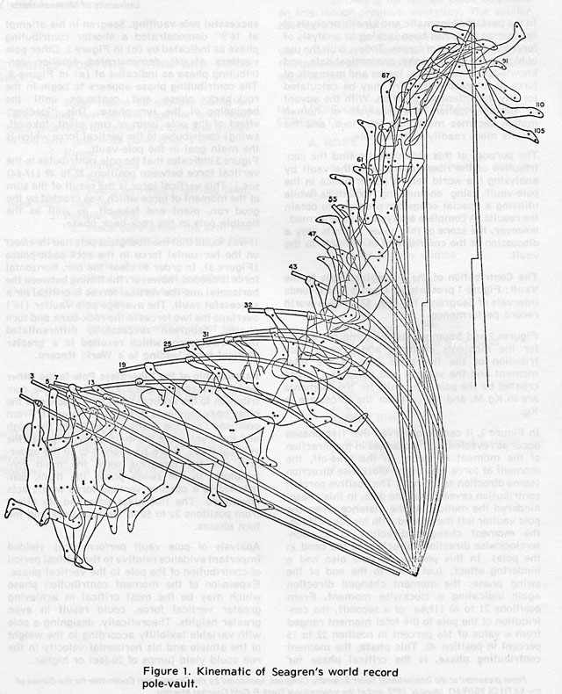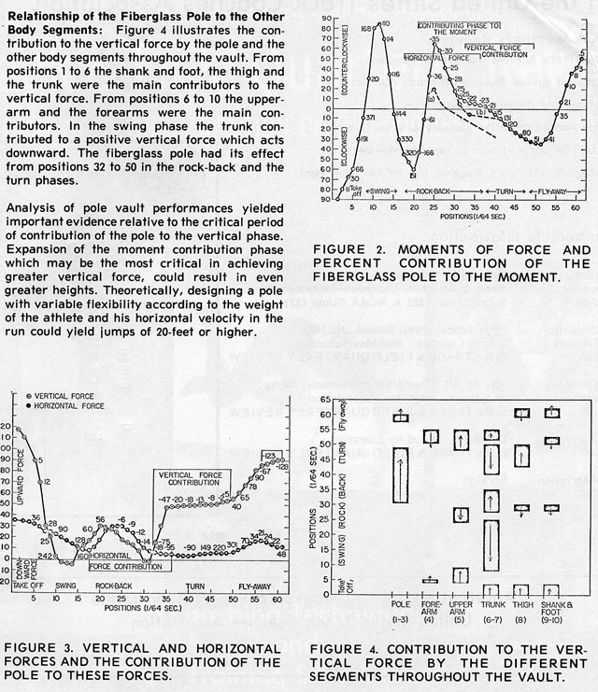
Contribution of the Pole to the Vault
George Dales published the results of that study in the Track and Field Quarterly Review. Additionally, he suggested I submit the same paper to the International Scientific Olympic Congress for presentation in Munich. The Scientific Congress was held every four years during the Games. This scheduling allows many people to attend both the Congress as well as the Games. I submitted “The contribution of the Pole to the Vault,” as well as another paper, “Biomechanical Analysis of Javelin Throwing.” Both papers were accepted for presentation and would be included in the publication of the Scientific Congress for that year.
In his position as the president of the International Track and Field Association and the editor of Track and Field Quarterly Review, George asked me if I could collect data on the field at the Olympics in Munich for later publication in his journal. Since he had already published my article about Bob Bemon’s legendary Gold medal Long Jump in the Mexico City Olympics in 1968 as well as the studies from the Olympic Trials of 1972, I eagerly agreed. Now was a time of intense planning for all of the equipment that would be needed for this first major overseas event for me and for CBA. George also arranged for housing, participation in the Scientific Congress, and a special pass to get onto the field in the Olympic stadium for filming.
On August 23rd, I left Amherst and drove to JFK airport in New York City. By this point in my life, JFK did not seem nearly as daunting as it had in1963 when I had first arrived in America. With several suitcases packed with cameras and film, I boarded the plane for Munich filled with the excitement which accompanies each Olympic Games. In addition to the thrill of attending the Olympics, I was also excited about the anticipated reunion with my old friends on the Israeli team.
Most of the Israeli athletes who were participating, as well as their coaches in Track and Field and Weight Lifting were friends of mine from the past. After all, I had trained with many of these people in Israel, such as with track coach, Amizure Shapira, and Weight Lifting coach, Yakov Springer. Many of the athletes from my era were now coaches but old friends nonetheless. We had been together in the 1960 and 1964 Olympic Games in Rome and in Tokyo.
Israelis are extremely gregarious and friendly by nature and these old friends and colleagues were no exceptions. They insisted that I stay with them in the Olympic Village. What a grand beginning with everyone talking at once, smiles and back-slapping each other. The early stages of every Olympic Games are always filled with the anticipation and joy, companionship with other athletes, and hoped-for success in performances. Every athlete dreams of standing on the top of the podium and receiving the Gold medal. Even if that dream is beyond what, in your heart you know is unrealistic and unattainable, it is still a dream that everyone has. I stayed with my friends in the Village for the first two days and everyone in the Olympic Village bubbled with excitement amidst the tension and thrill of the upcoming competitions.
My presentation at the Scientific Congress was scheduled for September 6. George Dales suggested that I spend the few nights before the presentation in his hotel in town. From the hotel, we would be able to maneuver about the city more easily and we would be closer to the Conference location. The Scientific Congress was held in one of the main convention centers in Munich. Although the Germans had constructed an elaborate, modern subway system to move athletes, coaches, and fans around the city, it would be more convenient for George and me to stay in the hotel, rather than the Village, during the Congress. But it was a happy meeting with my old friends and I will always cherish those two days I was able to spend with them.
As it transpired, had I not been scheduled to give that presentation on pole vaulting, I would not be alive today. George’s idea of moving to the hotel was a live-saving request for me. The very night that I moved was the night the Arab terrorists broke into the complex where the Israeli athletes were sleeping and took them hostage.
The German Olympic organizers had planned meticulously for every aspect except security. Their goal had been of creating a “friendly” image in an atmosphere of harmony among the participants of so many different countries. They hoped and planned to dispel the old, historic image of Prussian aggression and the militaristic image of the 1936 Berlin Games exploited by Adolf Hitler. History now knows better that such an idea was a beautiful dream but did not anticipate the evil of the world.
Much has been written of that time and Steven Spielberg produced a movie that also accurately showed what happened. But to briefly recap the events, five Palestinian terrorists, calling themselves Black September, wore track sweat suits and climbed the six foot six inch fence surrounding the Olympic Village. They were seen by several people but no one paid particular attention to them since athletes had been routinely hopping over the fence. These five were joined by three more men who are presumed to have obtained credentials to enter the village, if asked at all.
The terrorists used stolen keys to enter the apartments one of which was the room where I had stayed only the day before. The Israeli wrestling referee, Yossef Gutfrend, answered the knock on the door and, when he saw the masked men, yelled “Hevre Tistalku! Guys, get out of here!” He threw his considerable weight against the door to stop the terrorists from coming into the room. In the meantime, many of the other athletes hid, tried to escape, or looked around for some kind of defensive weapon. The wrestling coach, Moshe Weinberg, also attacked the terrorists which enabled one of his wrestlers, Gad Tsobari, to escape. Unfortunately, Moshe was shot as was Yossef. The Arab terrorists then succeeded in rounding up nine Israelis to hold as hostages.
At 9:30 in the morning, the terrorists announced that they were Palestinians and demanded that Israel release 200 Arab prisoners and that they be given safe passage out of Germany. Golda Meir, the Prime Minister of Israel, refused to negotiate with the terrorists and told the German authorities that they should handle the situation.
After a grueling day of tense negotiations, the Palestinians agreed to a plan the Germans offered whereby the terrorists and hostages were to be taken by helicopter to the NATO air base at Firsstenfeldbruck where they and their hostages could fly to Cairo. The world’s press and television coverage had shown in extensive and repetitive details where all of the hostage takers and German sharpshooters were positioned. Unfortunately, all of the coverage was watched by the terrorists on the television sets in the Israeli’s rooms. The perpetrators were aware of everything that was happening outside of the buildings in addition to what all the plans were for the future.
The Israelis hostages and their Palestinians captors were taken by bus to the helicopters and flown to the airfield. In the course of the transfer, in what was to be a day full of ineptness, the Germans discovered that there were eight terrorists instead of only the five they expected. Suddenly, the Germans realized that they had not assigned enough marksmen to carry out the plan to shoot the terrorists at the airport. In addition, there were no means of communication among their snipers so the whole mess became increasingly worse each moment.
When the helicopters landed at the airbase around 10:30 pm, the German sharpshooters attempted to kill the terrorists and a bloody firefight ensued. At eleven o’clock in the evening, the media was mistakenly informed that the hostages had been saved and the news was announced to a relieved but much wounded Israeli public. However, nearly an hour later, new fighting erupted and one of the helicopters holding the Israelis was blown up by a terrorist grenade. The remaining nine hostages, restrained in the second helicopter, were shot to death by one of the surviving terrorists.
At 3 o’clock in the morning, a drawn and teary-eyed Jim McKay, who had been reporting throughout the day as part of ABC’s Olympic coverage, announced: “They’re all gone.” It was devastating announcement and broke the heart of many of those who had been watching the whole episode as it had unfolded.
The terrorists had killed eleven Israeli athletes and coaches and one West German police officer. Five of the eight members of the Black September were killed by German police officers during the failed rescue attempt. The three surviving terrorists were captured, but later released by West Germany following a Black September hijacking of a Lufthansa airliner. Israel allegedly responded to the massacre with Operation Spring of Youth and Operation Wrath of God as well as a series of airstrikes and killing of those suspected of planning the kidnapping. There have been highly placed sources within the government who deny these programs of retaliation but that is for future historians to unearth.
Fortunately or unfortunately, on that day, I awoke completely oblivious to the events underway at the Olympic Village. George Dales and I joined a tour to visit Saltsburg, Austria. It was only when we returned to the hotel that evening that we learned about the terrorist activities which were ongoing.
I was shocked and dismayed about these events. In Israel, we had learned how to cope with such terrorist activities by providing security within the country and for groups or teams when they traveled abroad. For the Olympic Games, Israel had relied on the German security at the athletes’ venue and had not provided their own protective measures. This false sense of security had backfired badly for the Israeli athletes and the host country Germany.
As events unfolded during the remaining few hours of the tragedy, all of us, within and outside of Israel, crossed our collective fingers, prayed, and clustered in groups for emotional support. Our collective hopes were soon dashed as the news of the violent, tragic results were transmitted across the airwaves. My own sense of despair deepened as I realized the scope of the massacre. In what seemed like the blink of my eyes, I had gone from the joy of again sharing the Olympic experiences to the loss of many of my good friends and coaches. Perhaps it is a type of survivor’s guilt, but I wished that I could have been with them and done something to help. I do not think I would have surrendered; I think I would have fought. After all, I was big, strong, and very fit. But who knows? Those who tried to fight were shot and the ones who initially fought back were as big and strong as I was.
One of the men who was able to escape was my friend Avraham Melamed. Avaham was the Israeli 200 meter butterfly champion for Israel. When the initial shouting began to lock the doors, Avaham did just that and then he escaped by climbing out of the window, walking along a small ledge, and jumping to the ground. Many months later, we learned that after Avraham jumped out the window and was creeping along the window ledge, he remembered that his camera was in the room. He hurried back, scrambled back into the room to retrieve his camera, and then retreated out of the window for the second time. In spite of this seemingly reckless behavior, his escape was successful. Avraham later became my student at the University of Massachusetts where he received his Master’s Degree.
Other developments from this tragedy surfaced in odd and unrelated ways. One of my friends in the class below me at Hadassim worked for Mossad. One of his assignments involved finding and disposing of the remaining living terrorists. Unfortunately, his directors sent him to Norway. The information provided to him was incorrect and he killed the wrong person. He became distraught and, at one time, came to stay with Ann and me. Another Hadassim connection was that Gila Almagor, a famous actress who was in my class at Hadassim, played one of the main characters, the mother, in Steven Spielberg’s film, Munich.
The Olympic building complex where we stayed
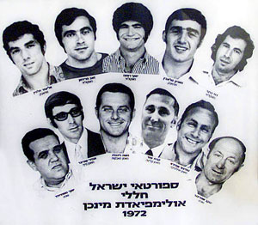
The Israelis Athletes and Coaches murdered at the Munich Olympics
After the murders, decisions were made for the Olympic Games and the other conferences to proceed with the scheduled activities. The idea underlying this decision was that this kind of violent behavior should not be encouraged by allowing it to interfere with all of life’s activities and events. The decision was to proceed legally against the terrorists through the courts of law but not to give media attention to senseless murders. From my perspective, I do not know if this was a correct idea or only a pacifier for the times, but it was extremely difficult to go forward with such a heavy weight on the heart. However, there was nothing to do but continue, so I presented my talk at the Congress with tears in my eyes. I was hardly able to talk. When I finished giving my paper, however, I looked up and all the attending members in the Hall were giving me a standing ovation. I am sure it was because I was an Israeli and the participants wanted to show their respect for our athletes and for what I was suffering.
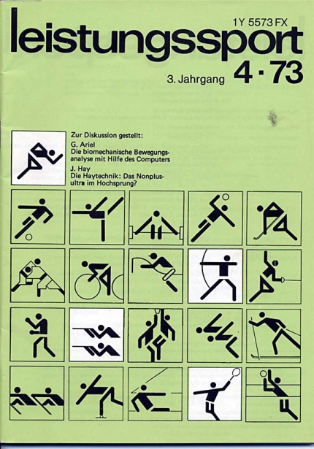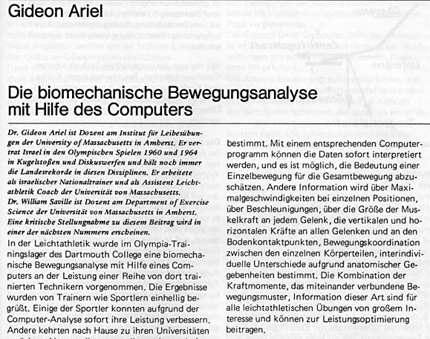
One of my presentations at the Scientific Congress
After the Congress, as is common at scientific meetings, there were many gatherings and invitations to continue discussions about the topics presented. Not infrequently, many of the conversations continued with ample lubrication from the delicious German pitchers of beer where friends and foes joined with respect, camaraderie, and shared interests. One meeting I was invited to attend was with the East German and Russian coaches. Some of them I knew through the literature having read their published studies and others I had known when I was an Olympic competitor. At that time, the East Germans and the Russians were the most well-known sports scientists. This opinion of excellence was based on the athletic results they were able to produce on the playing field, in the gym, and in the swimming pool.
The tiny country of East Germany and the massive Soviet Union controlled their athletic training by having specific locations for the athletes to live, specially proscribed diets, unique training techniques, and, reportedly, specialized pharmaceutical “enhancements”. All of these systems were hidden from public view. It was rumored that the children were removed from their parents at very young ages and raised at these special training camps. There they focused all day on training and practicing their sport, physical fitness, and, presumably, some academic instruction. There was little, or no, media coverage and few visitors from the outside were ever allowed to see what and how they were training their athletes. In this way, the myths grew exponentially among those on the outside. Unable to see what was actually occurring on the other side of the opaque wall, the mystery deepened.
I was pleasantly surprised to learn how impressed these coaches and scientists were with my method of using high speed cameras and the computer to analyze events. During our conversations, I learned that they had neither main frame computers nor the programming ability that I was able to access. They were very curious and our discussions lasted for hours.
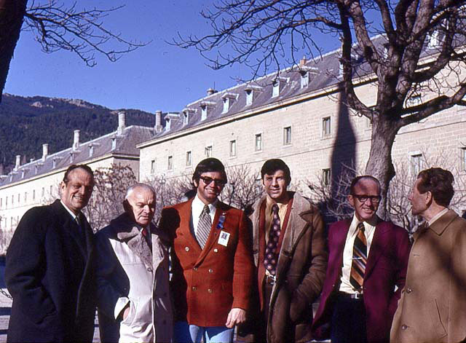
Some East German and Russian Sports Scientists and me
The conversations and scientific dialog were fascinating but I struggled to concentrate since I was unable to forget about my murdered friends. One of the very famous East German coaches, I recall that his name was Hochmouth, asked me if I would be willing to come with him to Leipzig, the East German city where their Sports labs were located. I liked the idea of leaving Munich and all the heartbreak that was around. Everyone knew that the East Germans currently dominated world sports but how were they able to this accomplished? What were their secrets? It was such a tiny country and yet such a major athletic power. What were they doing that the rest of the world was not?
One consideration was whether I could enter East Germany on my passport. At that time, I was still an Israeli citizen although I had an American Green Card. They told me that there would be no problem since I had the Participant card and, for the Olympics, the East German and West German border was basically open to Germans with the correct papers. George Dales was invited to travel with me. Unfortunately, because he was an American, entry into East Germany was forbidden by the American authorities. I was able to go only because I could use my Israeli passport.
Although George had to remain in Munich, his time was well spent. It took him 2 days of persistent dialing to the US, before he was able to connect to his wife in Kalamazoo, Michigan. When he was finally able to make phone contact with her, George brought her up to date with all of the events that had transpired in Germany. Of course, she had been watching the news coverage from Munich and had suffered through the agonizing events along with the rest of the world. She was quite relieved to hear from him since she was aware of the plans to stay with the Israeli team. He asked her to call Ann in Amherst and let her know that I was safe. Ann also knew of my plans to stay with my Israeli friends in the Village. In addition, during some of our trips to Israel, she had been acquainted with a few of the athletes who had been killed. Needless to say, Ann was a nervous wreck with worry so it was a tremendous relief to hear that I was safe and sound. After hearing the news from George, she could finally breathe. Ann had been shouldering an additional emotional burden during this time. While I had been in Germany, she was caring for my daughter, Geffen, who was eight years old at that time. It was quite a daily task to make sure that Geffen remained unaware of the activities taking place in Munich. Fortunately, for all concerned, there was a great sense of relief with the news that George and I were safe. Of course, by traveling into East Germany may have been a wonderful opportunity for me, but now Ann had another thing to worry about.
So, while George remained in Munich, off I went with Hochmouth and other East Germans. We drove for many hours at night in Coach Hochmouth’s old Mercedes sedan. I must have fallen asleep in the car since I have no recollection of crossing the border from West to East Germany.
After we arrived in Leipzig in the morning, I was given a tiny room in a small hotel. Everyone was very tired so the first order of business was a long afternoon nap. We met later for a quite dinner in the hotel. Of course, the conversations lasted late into the night, but we were also inspired by the subject matter. In the morning one of the scientists, picked me up at the hotel and we went to the Sports Center complex for breakfast. The food was delicious, well-prepared, and beautifully presented.
The athletes ate in a dorm-like restaurant, similar to what I remembered from my Wyoming days. The food was plentiful and very carefully orchestrated to be rich with specific vitamins as well as appropriately balanced for proteins and carbohydrates. The athletes were seated according to their events and the girls were separated from the boys. I asked the scientist why they were separated and he explained that the diet of the females was different from the males. He also said that each sport has its own specific diet composition which was specially designed by health and nutritionist scientists. Not only was the nutrition specific for each sport but it was further tailored for each athlete within that activity. For example, if one of the swimmers needed more protein, his or her portions were adjusted accordingly. This was completely different than my own Olympic training table in Israel! At that time, our food was rationed and routinely we received protein once a week rather than daily as did the East German athletes.
After breakfast, I met one of the scientists, Dr. Schmidt. He told me that he would not be able to reveal all of the secrets involved in the German Democratic Republic’s (GDR) athletic system. Obviously, he was unwilling to disclose all the secrets that had allowed the GDR to excel during the previous 10—15 years of athletic competitions. The record number of victories in World Championships and the Olympic Games reflected their successful selection and training of athletes. These successes indicated that they were doing something that the other countries were not.
“Well, what can you tell me?” I asked.
“Okay,” he smiled. “First of all, we start training the children at very young ages. All children have physical education in kindergarten. The physical education teachers in elementary and secondary schools have been thoroughly trained in our State Institution for Physical Education in Leipzig. These teachers know how to evaluate young children as well as how to encourage these young, talented athletes. There is tremendous emphasis, as well, on school sports clubs and athletic associations. It is in these sporting groups that we are able to identify young adolescents who are particularly suited for sprinting, jumping, flexibility, and other basic skills. From the 9th and 10th class onwards, the training becomes more focused and intense for their event. Once individual children are selected for training, they are placed in one of our sports centers to live, study, and train. All of the financial support for these sport training facilities is from the government.”
I nodded. So far, I had not heard anything that was different from my own experience as a discus and shot put thrower. No magic bullet had been revealed yet!
Dr. Schmidt continued, “By 12 or 13, a child is familiar with the whole range of exercises. The exercise routines are harmonized, of course, with the biological development. As they get older, we add resistive training with weights, squats, presses, and so on. These talented athletic kids attend school classes until 2 o’clock in the afternoon and then spend the next 4 or 5 hours working with a fitness trainer and practice the sport itself with a coach. Success usually results from the enthusiasm with which the trainer can attract these young promising athletes and their dedication to their activity.”
“But this was my story in Israel. I worked every day to increase my strength and I threw the shot and discus every day. I practiced between classes, after classes, and every other moment that I could find.” I told Dr. Schmidt.
He responded to my comment by providing additional insight in to the rationale of the system. “But I generated the idea for the GDR’s sporting program on the basis of our Marxist philosophy for children and young people. There is a paragraph from Engels’ book which describes ‘the role of work in the humanization of monkeys’ and this is a factor in the implementation of our sports system. In other words, at a young and tender age, we can develop a young person through very specific training methods which are designed to shape and train the body in that particular direction.” I recall thinking that this was an unusual attitude about children which compared them to monkey and trying to “humanize” them. I have often wondered what he felt in his heart about the individual children and their welfare. It certainly diverged from my own sensitivities of loving and caring for children. As I reflect on this meeting, these many years later, I have yet to know what he really felt about young people.
Dr. Schmidt believed that training was the key. Thus, enormous attention was focused at every athletic training camp on exercise and fitness. So far, I had not seen anything that was different from my own experience of focus and training that was making the GDR athletes so successful. Perhaps there would be some new revelations as the day proceeded.
Dr. Schmidt and I went to the main conference room and, to my surprise, I saw all my published studies in Biomechanics and Anabolic Steroids on the table. Each study had a German translation next to it. This was quite a shock. One of my studies, which was of particular interest to Dr. Schmidt, was the analysis of the East German Shot Putters published in the Track and Field Quarterly Review. East Germany held the world record in this event and I had tried to understand how and why they were so accomplished.
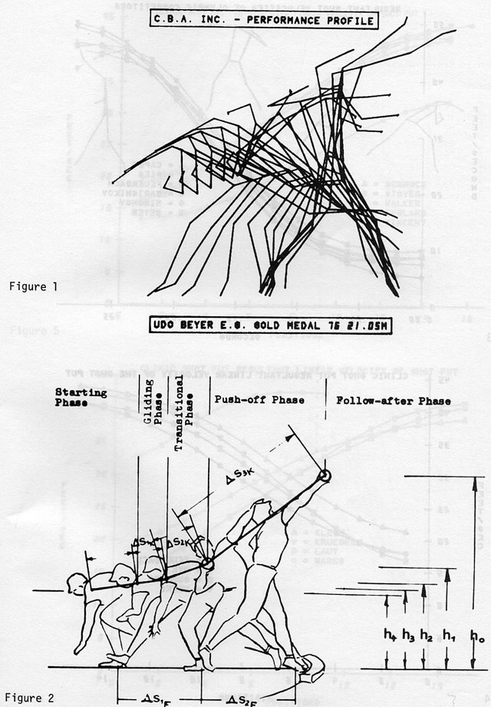
My Analysis of the East German Shot-putters
What perplexed these East German scientists was that I had calculated exactly what their throwers were doing which resulted in Gold Medals. They had developed a technique with no deceleration of the front leg prior to its initial hitting the toe board. In other words, the front leg continued to accelerate until it was stopped by hitting the toe board. After the front leg contacted the toe board, the back leg touched down. This was similar to driving a car into a wall without applying the brakes. In this case, the driver would be propelled through the windshield. For the shot put, the front leg block was the car hitting the wall and the shot put was the driver. The results produced many world records and Olympic medals.
The scientists were impressed with the technique I utilized since it was so much more advanced than the accurate, but elementary, procedures they employed. Their calculations were accomplished with the use of slide rules, paper and pencil, and hand calculators, but they applied the same basic Newtonian equations which I used. I had discovered what the East German throwers were actually doing without being there. My technological tools surpassed the more primitive methods that they used. We both employed the same Newtonian equations, but I was able to execute them faster, more accurately, and with greater detail. They were extremely impressed by the computerized system.
The tour proceeded to the resistive training facility. As I entered the weight training room, I received another surprise. There, in the center of the room, was my Universal machine.
“Wow!” I said. “Where did you purchase this and how did you get it here?” I asked.
The weight coach smiled. “It was made in East Germany.” He answered.
They had copied my machine precisely in every detail including the proper Cam. It was an exact duplicate with every one of the details described in my patent.
“I see there are no secrets anywhere,” I laughed. They laughed too and asked, “What about the secret machine you are working on with Universal which has a computer on it. The Intelligent Exercise Machine?”
I said, “You’ll have to wait for that.” As it turned out, in 1995, one of their scientists, Dr. Zinner, purchased my computerized intelligent machine. By then, there was no longer a division between East and West Germany since they had reunited after the destruction of the Berlin Wall. Until today, they continue to use the computerized exercise machine for research and to train some of their athletes. In 1995, I was invited to the Olympiastutzpunkt (OSP) Berlin for a two-day working visit. They published a description of my visit in their newsletter praising my accomplishment as well as my contributions to their own work at their Center. This report, “Simply the best”, can be found in its entirety in the appendix.
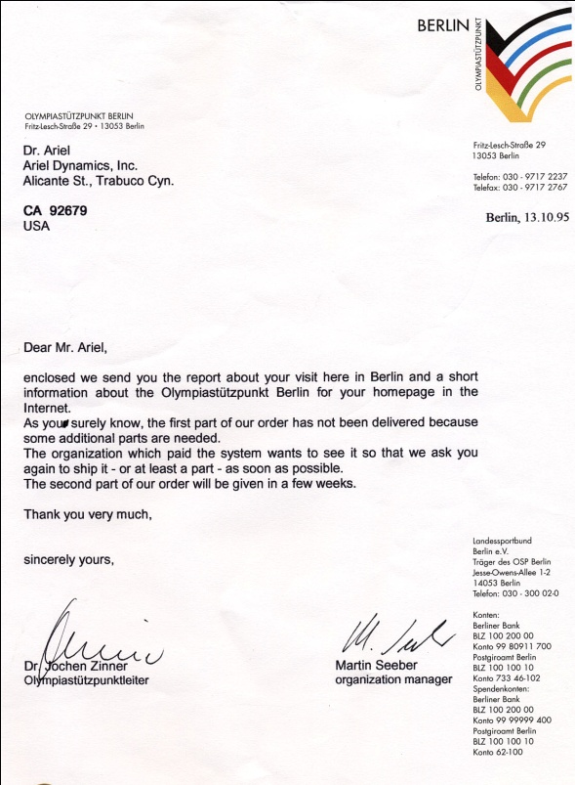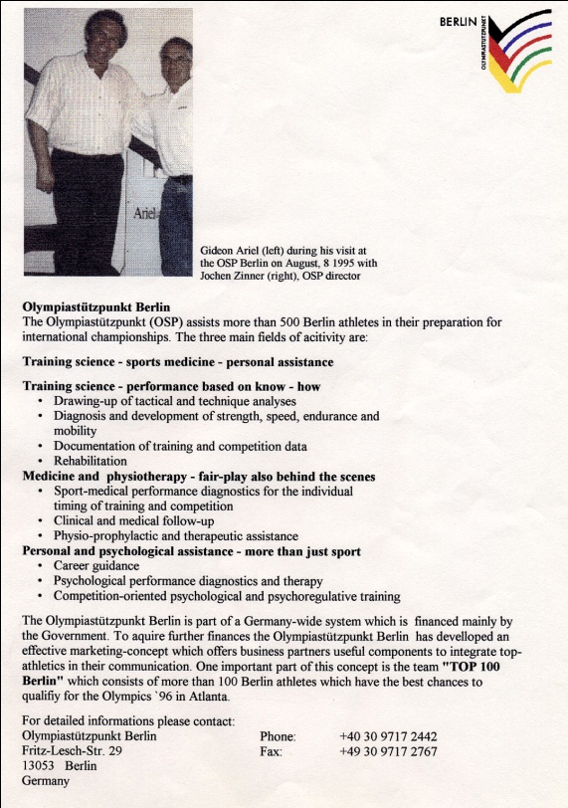
After they showed me the duplicate of my Universal weight machine, the tour of the 1972 facility continued. From the weight room, we walked down the hall and I was introduced to one scientist, whose name I do quite clearly remember since it was Dr. Israeli.
“Are you Israeli?” I immediately asked.
“No.”
“Are you a Jew?”
Again it was “No”.
I have always wondered how he happened to have this Hebrew name. Shortly after meeting Dr. Israeli, I learned that he was the head of the pharmaceutical system for all of the training centers. This, I was to learn later, was of significance.
We returned to the room where all of my articles, in English and German, lay on the table. The discussions with all of the various scientists, as well as Dr. Israeli, continued for hours. They particularly interested in discussing my studies on Anabolic Steroids which had been published in the Journal of Applied Physiology. Their specific interest was whether Anabolic Steroids caused augmentation in performance because of the muscular system or because of the nervous system. My research had shown the effect on muscular strength and the effect on motor integration. The neural muscular interaction was a function of the nervous system’s effect on increasing the speed of the stimulation of the motor units of the muscles. This finding indicated that the nervous system was able to activate and/or stimulate more of the motor units at the muscle and caused the subsequent contraction of the muscle fibers to be quickened. Thus, the time of muscular contraction following the arrival of the nervous system signals from the spinal cord, or “Motor Time,” was much faster under the influence of the steroid drug. Strength is important but speed was a more important factor. In order to generate power, force and velocity are essential but velocity is the most critical.
In 1972, Anabolic Steroids were legal for athletic usage. The East Germans had been using them, in what they believed were scientific methods. Of course, it was revealed at a much later date that the East Germans were manufacturing a steroid, artificial epitesterone, and administrating it to 14 year old athletes. These young people were unaware of the contents of the many pills which they ingested daily. They were given vitamins and supplements in addition to the anabolic steroids but they lived in a controlled environment in which they trusted everyone who worked with them. They had no reason to distrust the individuals nor the contents of the pills they were given. Unfortunately, the side effects of the anabolic steroids had lifelong damaging consequences. When the doctors were finally taken to court, they claimed to have been forced to give the athletes these drugs by the STASI, the secret police.
However, from what I observed during my visit to Leipzig, these scientists knew exactly what they were doing. In their defense, they may have been unaware of the long term consequences of these steroids but there is no doubt that they recognized the advantage of the short term effects. Unfortunately, females were particularly vulnerable to the adverse side effects of these anabolic steroids. On the one hand, their performances may have been spectacular: greater, in fact, than those of the men but the risks were substantially higher. Among the typical side effects resulting from administering these hormones to women were retarded growth, serious disturbances in fertility and fetuses, and heart disease. Other problems included deepening of the voice (mostly an irreversible situation), an increase in body hair on the legs, pubic hair extending to the navel and beyond, and more dangerously the enlargement of the clitoris.
Using drugs to enhance performance was nothing new in Germany. During World War II, Hitler issued vast quantities of steroids to the SS and the Wehrmacht so that his troops would better resist combat fatigue and be more ruthless in following any order. As early as 1941, Soviet Red Army observers had noted an unusually passionate fighting spirit among German soldiers, who often seemed eager to die for the glory of the Third Reich.
Now these girls were to be physically maimed for the glory of the German Democratic Republic. The doctors had taken the scientific knowledge gleaned in the Nazi era to carry this human engineering experiment a giant step forward. Their program had a single goal: to transform the GDR from a lackluster Soviet satellite into a giant in the global arena of competitive sport. Within this context, the quadrennial Olympic Games were the summit of ambition and the maximum, in effort and financial resources, was dedicated toward amassing Olympic medals.
Sadly, the researchers also discovered that the drugs affected the mind as well as the body. Sometimes after taking these drugs, the athletes – like the shock troops of Hitler’s elite SS unit – reported a sense of invincibility, unlimited energy, and an uncontrollable libido. Early in the program, female athletes as young as fourteen embarked on sexual rampages in the sports complexes which their trainers, coaches, and physicians ignored as long as the girls performed well in the pool or on the track.
So, as it transpired, the key to East German dominance and Gold Medal successes was the doping control laboratory in Kreischa. The laboratory was built in 1977 and this brain trust served to secure and to conceal the use of all performance enhancing medications. I personally did not visit that particular laboratory facility and, like everyone else, learned about it only after it was finally closed and outlawed.
Ignoring for the moment their drug program, what I had observed was that the East German program was systematized, scientific, and efficient. One thing was abundantly clear and irrefutable. The United States, or any other “free” country, would be unable to successfully perform against the GDR’s highly regulated, efficient, medicated system with the sports structure that currently existed in the US. In the US, we relied on DNA and talent but had no organized program to augment or increase performance skills or raise the levels of achievement. No athlete in the US was able to improve or enhance their own physical abilities to their optimal capacity as the East Germans successfully achieved with their athletes.
I returned from the visit to East German and now gathered with my Israelis friends to mourn the losses of our friends and colleagues who had been senselessly murdered. We stood in the sun, in an open field with all the athletes from around the world, and everyone on the entire field wept. My old friend Gilad, from Wyoming days, was on one side of me, and Yariv, my first coach and mentor, stood on the other. The grief among all of us was intense and palpable. This one moment in time with all the countries joined together to mourn was very moving. We were all athletes, not countries competing against each other. Each man and woman knew what our Israeli athletes went through to participate and how they had been senselessly murdered in their prime.
The Arab countries and Soviet Union were the only countries who refused to lower their flags. An additional insult was that the dead terrorists were welcomed as heroes when their coffins arrived in Libya. It was a disgusting display of insensitivity as well as an unfortunate form of victory. Rather than relentlessly pursuing peaceful solutions, murder had become a preferred victory.
The remaining days of the Olympics were very difficult for me and the other Israelis. I would have preferred that they cancel the remaining competitions. I heard the argument that cancelling the competitive schedule would prove to the terrorists that they had won their victory. Perhaps, from this perspective, it was the correct decision to continue with the Games. However, for me and for my friends, it was terribly difficult to be in the Olympic venues surrounded by ordinary daily events but covered with an umbrella of grief. I remember that Jim Murray of the Los Angeles Times wrote, “Incredibly, they’re going on with it. It’s almost like having a dance at Dachau.”
After I returned to the US, I knew I had to do something after what I had learned in East Germany. Our training system had to change if we wanted the American athletes to win future Olympic medals. At that time, the US had no training centers. All the athletes were trained at Universities, clubs, or at camps such as we conducted at Dartmouth College. The US could do better than that. We may have had superior athletes at that time because we were such a large population pool from which to select the best performers. But these athletes were severely hampered by the lack of a system to help them achieve their optimum performance level. American had the best technologies and the best equipment but now we needed a system to amalgamate technology with DNA.
In addition, there was the disadvantage of financial support. In the East German and Soviet Union, athletes were in the Army or some other government department so they were “paid” to do their job. In this way, they were not paid to play and could retain their amateur status as defined by the Olympic rules. Because no such system existed in the US, athletes had to find jobs to support their own athletic endeavors in order to be recognized as amateurs. It was difficult and inherently unfair, but it meant that the Americans had to find a clever way to overcome this imbalance. We needed to develop our own unique system so our athletes could excel to their maximum and defeat the Eastern Bloc countries at the next Olympics.
This was my mission. Now I had to find connections in order to make my case to the authorities who actually controlled Olympic Sports in the US. (Unfortunately, I was not able to work fast enough. At the next summer games in Montreal in 1976, East Germans dominated the gold medal count, especially in swimming, sweeping eleven out of a possible thirteen first place finishes.) But, tenacity is one of my most dominate characteristics, so I was determined to continue searching and working on the goal of improving the training system for US Olympic athletes. After Ann and I brought CBA up to date on our projects and my University duties were being satisfactorily addressed, I would track down the heads of the Olympic sports. I was confident that we could improve the situation. Although this was a burning issue for me, it would have to be on a back burner for the immediate future.
Now, my first order of business was to return to Amherst and take care of things there. I had classes to teach at the University and I had to help Ann with our CBA projects. We had a several important projects to complete which she had been working on while I had been in Munich. Our company was working well and we needed to continue our business progress. Things had been more successful than we had dreamed they could be and now we needed to maintain the initiative.

