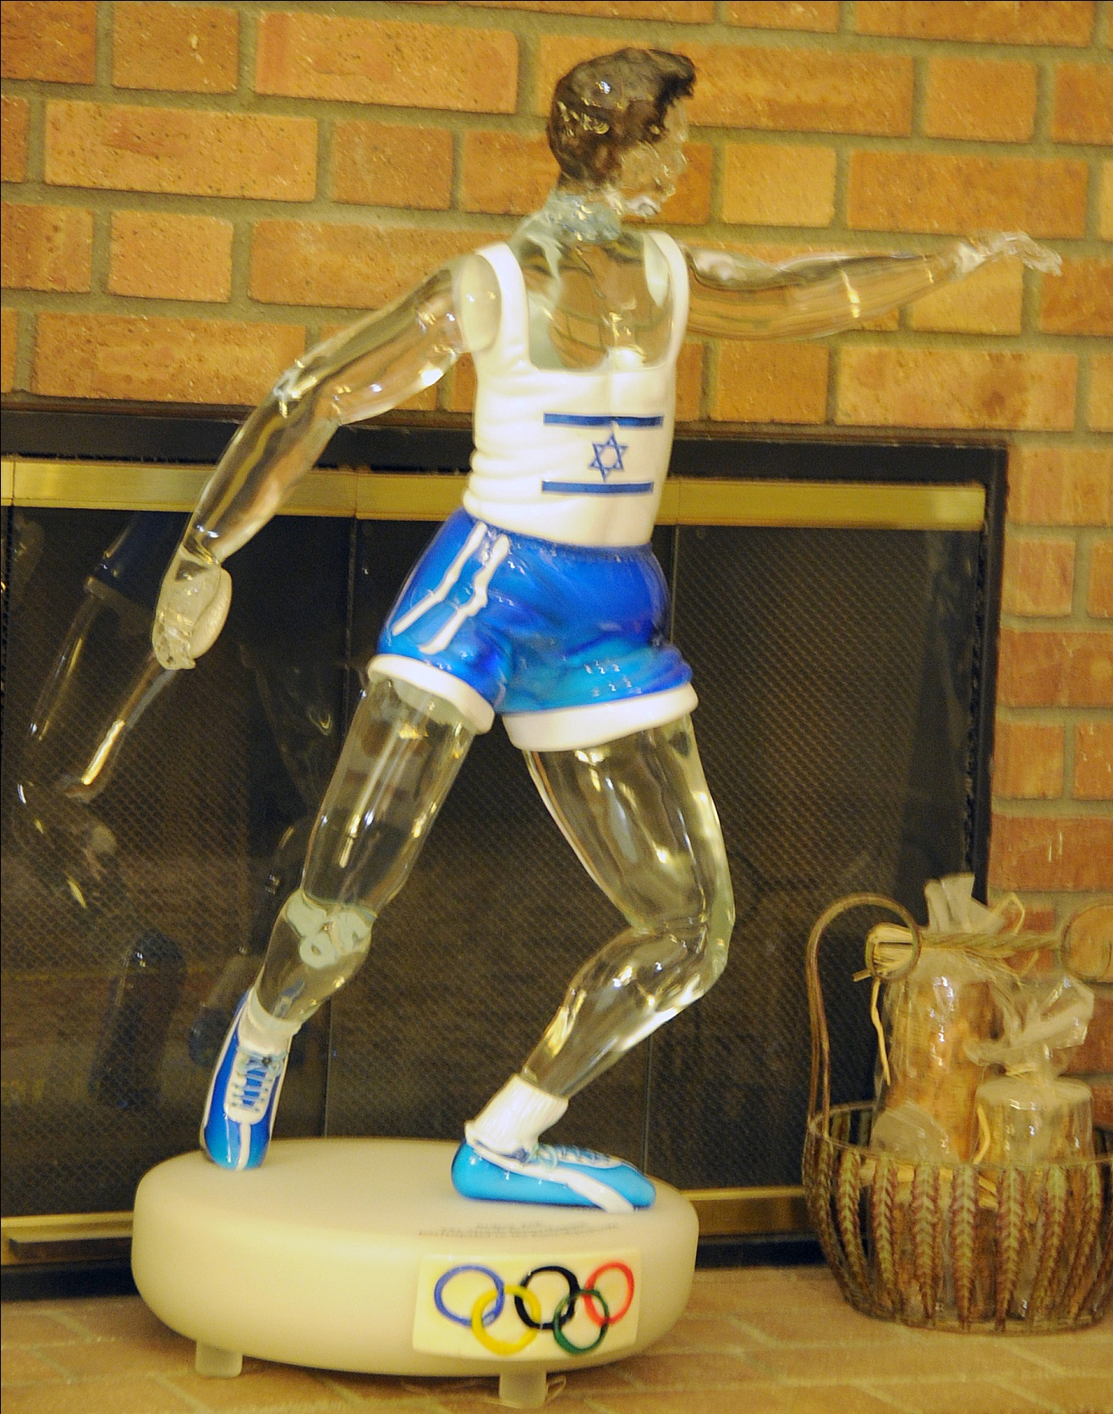`
THE DISCUS THROWER AND HIS DREAM FACTORY

By

Gideon Ariel, Ph.D.

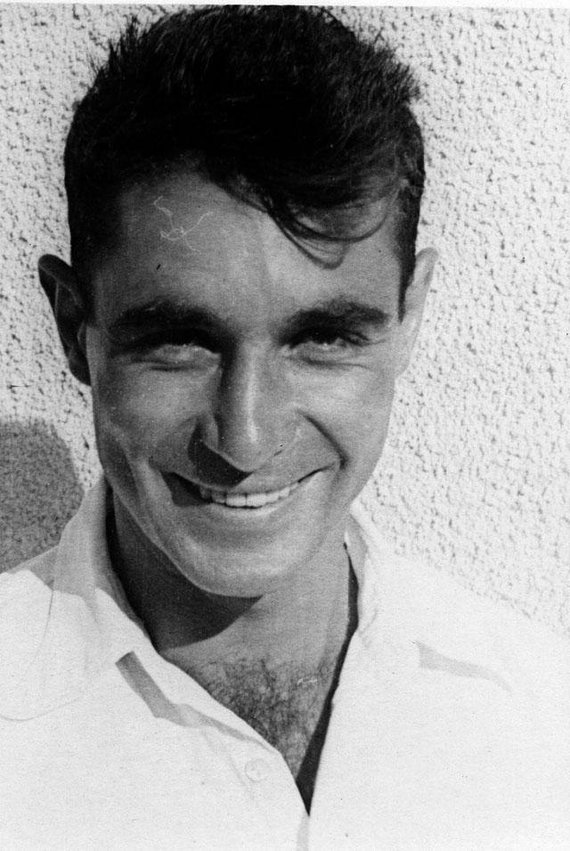
This book is dedicated to three beloved people, without whose influence t would now be trapped in a black hole rather than fulfilling my dreams:

To, my childhood hero, Dani Dasa: a creator of folk dances and my sports instructor at hadassim Dani introduced me to the discus, and strengthened my belief, as a child, that I could .one day represent Israel in the Olympics. It was only by virtue of my athletic skills that a scholarship for ; study in America -- and the infinite possibilities thereafter - was granted to me. I have never looked back.

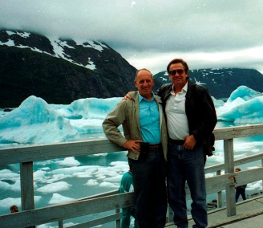

To Yariv Oren (of blessed memory), my mentor and coach who befriended me as
a young athlete, who encouraged me to overcome my shyness, and who gave me perhaps
the greatest gift of all: self-confidence and hope.
To Ann Penny, without whom I would never have reached the mountaintop.
After 35 years of a creative collaboration I finally married her, and for the last two
years she has been — to my everlasting joy — Ann Ariel,

Introduction

What a crazy title for a book. How do sports and fantasy share the same planet let alone merge into a book? It is easy for me to tell you because this is all about me – I am that discus thrower and my mind is that factory where all of those dreams were created. To explain, you should know that with one sailing, floating throw of a discus in a single competitive event propelled me to become the successful person that I am today. Throwing the discus saved me from a life as a juvenile delinquent and one fantastic victorious throw set me on the path to become a world renowned biomechanist and operate my own dream factory.
In 2012 I received the highest award in Biomechanics as you read below:
The Geoffrey Dyson Recipient for 2012

The recipient of the Geoffrey Dyson Award for the ISBS2012 conference will be Dr. Gideon Ariel. Gideon is well known in the field of sports biomechanics due to his extensive knowledge of how physics applies to human motion, as well as his expertise in computer science. He is a former Olympic athlete, and completed his graduate and post-doctoral work at the University of Massachusetts, where he received a PhD in Exercise and Computer Science. He has published numerous scientific papers, founded an independent laboratory devoted to biomechanical research relating to human performance, and was chairman of the U.S. Olympic Biomechanical Committee.
My special discus result sent me to the Rome Olympics in 1960. From there, it is as though the discus threw me to America, the land of dreams. Once I reached the great, vast, vistas that the United States offered someone like me, a young simple athlete from a tiny country, my horizons were limitless. Suddenly, that discus throw which had launched me into a world where dreams can come true, life became full of opportunities without end. No longer was I perceived as a skinny, shy, young boy who would probably never succeed. Now, I had been an Olympic competitor. There were no limitations to what one could learn or do in the magnificent land of dreams.
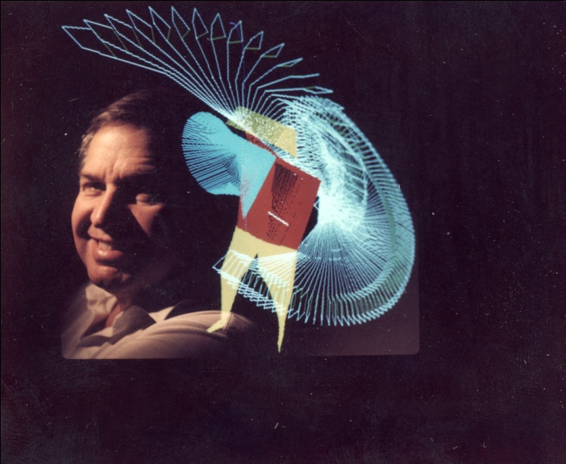
My first big dream grew from a seemingly miraculous discovery I made while in Graduate School. I learned that human motion could be scientifically measured. It was possible to combine the mechanics of Isaac Newton with the biology of people. What a fabulous tool! This dream of mine was no longer just a bubble on a wish list. Suddenly, I realized that a Coach could assist a discus thrower without looking where the discus landed. The combination of scientific quantification and the rapid processing of the computer meant that sporting activities could be assessed accurately and quickly. The concept was mind-boggling and floated on air almost more as a mirage than just a dream. Could such dream really come true?
The answer resided in the sophisticated computer programming that I developed. The enhancements of sports techniques and performance analyses knew no bounds. “If it moves, it can be measured” became a legitimate mantra. So what could I do with this marvelous, newly computerized analysis system? In America, anything is possible. So I created a company.
Surprisingly for me, before we opened our office doors for the first time, we were swamped with projects. We had sporting goods companies clamoring for design assistance with golf balls and clubs, basketball structure and color designs, tennis balls and rackets, and ski boot release mechanisms. Owners of horses asked how to select the special yearling who would grow up to win the Kentucky Derby. A shoe company sought help with athletic performance shoes while another company wanted to improve their line of nursing and surgical shoes. These studies led my dream factory brain to invent an air shoe in 1974.
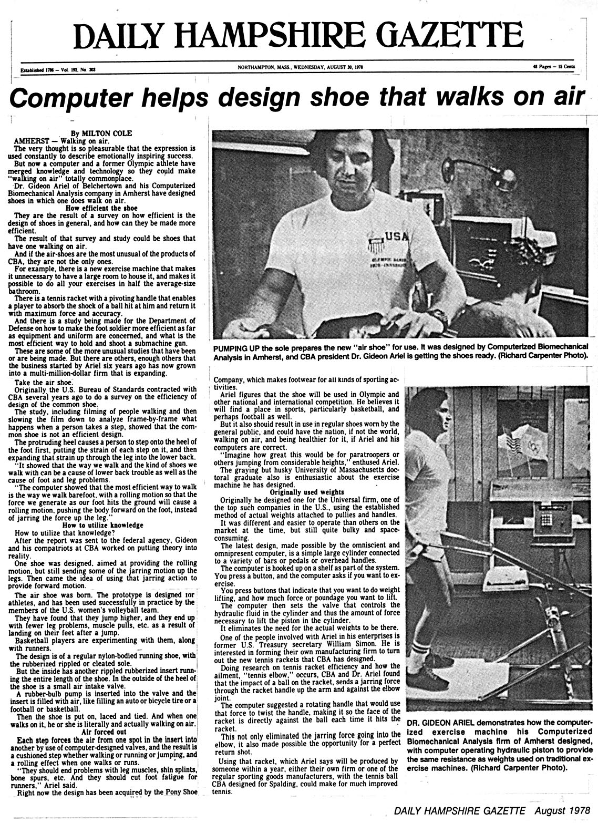
NASA posed many questions regarding performance and equipment needs for work in micro-gravity. How should astronaut suits be designed, what could be done to reduce or eliminate bone loss, and were there exercises and equipment for use in Space?
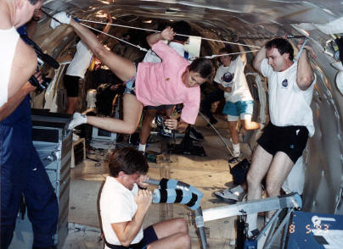
ACES trains muscles to contract fast. The faster the muscles contract, the faster the limb moves, the faster the limb moves, the faster a person can run, the higher a person can jump, the harder they can hit, the further they can throw. The better they can functionally perform ... - Dr. Gideon Ariel, Ph.D.
The list of applications seemed virtually endless. We worked on air bags for car safety, contributed to the development of prosthetic joints, performed forensic analyses in legal cases, and provided information for personal hygiene products as well as for baby diaper design.
Sports Illustrated in Appendix 1 described some of our activities.
My sophisticated analytic program grew and morphed into bigger and better dreams. Not just my dreams, but for everyone who worked with them. My dream factory, like the Sorcerer’s Apprentice, gave birth to more ideas, concepts, and dreams.
Eventually, the US Olympic Committee followed my recommendation to emulate the East German model for training athletes, without the drugs, of course. We established the first Center in Squaw Valley, CA and then moved it to a large facility in Colorado Springs, CO where it continues today.
After I had developed my dream to quantify movement, I wondered whether it would be possible to use the computer to train my muscles. Needless to say, the answer was “Yes” and what a fantastic device it is. The Computerized Exercise System (CES) is currently used to train athletes, rehabilitate injuries, and develop strength. Soon you will learn more about that big dream.
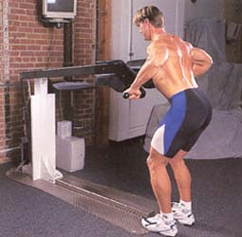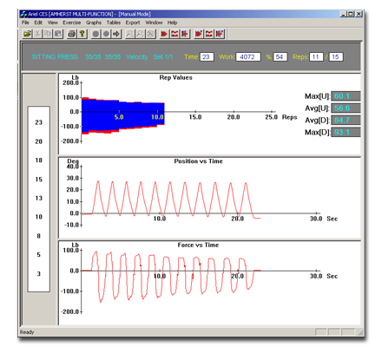
Dreams have no boundaries if you follow them. Imagination, luck, and hard work are necessary ingredients for success. But, if your mind bubbles, creates, and breathes life into dreams, then dreams can become real. The mind is the factory which forges the dreams.
So this is how sports and fantasy can combine to create real life. Dreams can come true if you try.

Appendix 1 – The Sports Illustrated Article of 1977.
