Chapter 17: The Coto Research Center

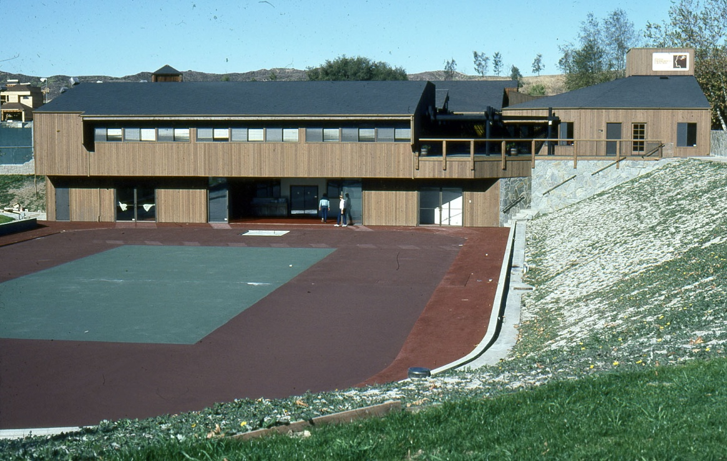

In 1975 I had a visit from one of the leading tennis professional in the World, Mr. Vic Braden. Vic a professional psychologist was a leading tennis professional that was himself a tennis pro in the 50’s. with Jack Kramer and Saguaro.
Vic Braden turned pro immediately after graduating college during a time when there were only a few professional tournaments. In his short professional career, he was invited three times to play in the World Tennis Championships. He reached the round of 16 twice, in 1953 and 1954.
Braden has become a celebrity in the sports world. Jack Kramer, the 1947 Wimbledon champion, calls him "the world's best all- around tennis coach," who can improve the game of anyone "from a beginner to a champion." Braden was featured on the cover of the August issue of Tennis magazine. In television commercials he is touting Tennis Our Way, a videotape he made with Arthur Ashe and Stan Smith, and millions of sports fans have chuckled at his commentaries on cable and network TV. The best known of his five books, Vic Braden's Tennis for the Future, has sold 200,000 copies.
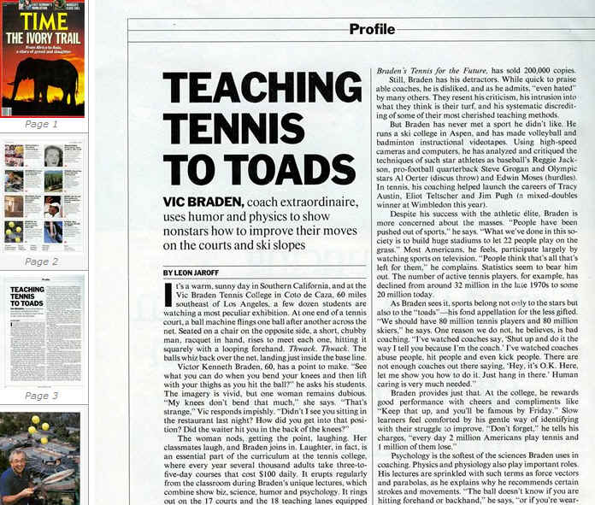
This caliber celebrity came to visit with me in my lab on Routh 9 at Amherst Massachusetts.
One of the reason he came to visit with me is referred to a statement I had made in one of the Tennis Magazines, that “top spin” is made by tangentially hit the ball with the racket moving up. Not by “rolling” the racket over the ball. In fact, my statement continued to say: “If you role the racket over the ball, the ball will hit you right at the big toe of your foot.” Well, I knew that this will not be the case, but, I tried to send the message that the ball is on the racket only few milliseconds and there is no way in the World that you can effect the flight of the ball by having time to role the racket over it. In fact, by the time the ball hit the racket, it is bounce back too fast to do anything about it. It is only 3 to 4 Milliseconds on the racket.
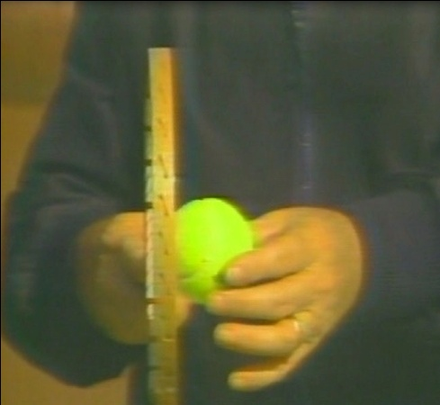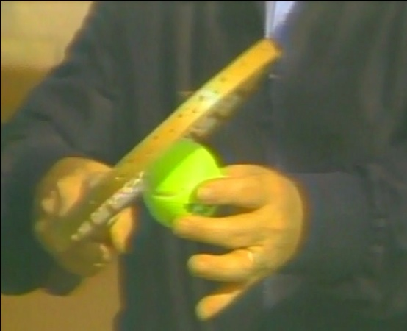
I guess, Vic was fascinated by my statement especially knowing that I did not play tennis at all. How did I know all that. Well, I showed Vic, some of the research I did for Spalding and AMF using high speed film up to 10,000 frames per second, to prove my point.
Vic was very impressed. Ann and Melody, Vic’s wife and Vic and me went to dinner together at the Yankee Paddler. This is the restaurant that brought me so many projects before.
We were discussing all the research we did for the Spalding Corporation and the AMF Corporation. I told him how we came with the idea of the large tennis racket head to allow the “Center of Percussion” to be closer to the hand for better control. Vic was very impressed and especially when I showed him the data rolled off my new Data General Nova-3 Computer.
We were seating in the restaurant to late hour and I think we were the last one to leave. Vic invite me to his place by the name Coto De Caza where he told me he has a tennis college for people from all over the World coming to take lessons from him and his staff. I told him, that I need to go to see the Universal Gym Company in Fresno and at that time I will arrange to rent a car and will come to visit with him.
Approximately one month latter I was in Fresno California and called Vic to arrange the meeting. He explained me how to reach Coto De Caza. At the same time, I was supposed also to meet my friend Bill Toomey. I used to stay in Bill’s home when I was visit with him in Southern California at his beautiful house in Laguna Beach. Bill was married at the time to Marry Bignal/Rand, the beautiful lady that won the long jump competition in the Tokyo Olympics for the Gold Medal and the World Record. She met oarsman Sid Rand in 1961. Three days after meeting she agreed to marry him and they married five weeks later. They had a daughter, Alison. The marriage lasted five years. In December 1969, she married her second husband, American Bill Toomey, the 1968 Olympics' decathlon champion. This marriage lasted 22 years and they had two daughters, Samantha and Sarah.
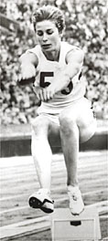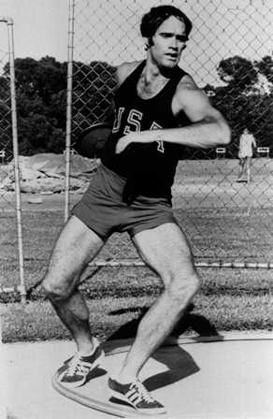
Marry Bignal and Bill Toomey
Bill was such a good friend and did call Vic to make him aware that he will take me to Coto De Caza to meet with him. At that time you had to go through all kinds of side roads to reach Coto. We were thinking that we lost our way, since the road became un-paved. We had to pass through the famous “Cooks” Corner. Cooks corner is described as follows:
“Leave your normal lifestyle and enter our world of "laid back". Bikes, babes, cars and stars govern at the oldest roadhouse in South Orange County. Our world-famous atmosphere brings people from all walks of life together for fun and good times. Enjoy some of the most spectacular bikes in the county. If you're not into engines, we have breathtaking trails for mountain biking and horse back riding, nice scenic roads for street biking, an outdoor patio with a horseshoe gaming and an indoor pool table to keep you occupied.”
The “Hell’s Angles” used to hold meeting at the Cooks Corner.
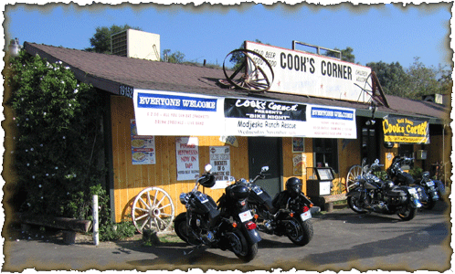
Cooks Corner
From Cooks Corner it was another 15 minutes on some dirt road to reach Coto De Caza.
When I arrived on the location I could not believe my eyes. What a beautiful place.
Here are some of the photos from that time:

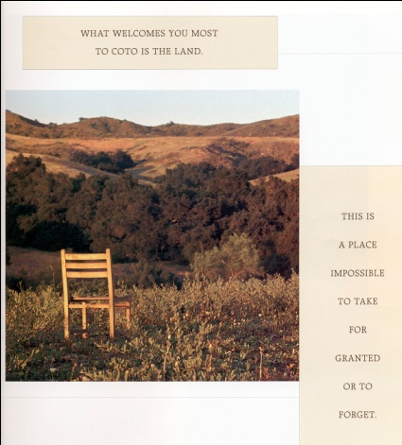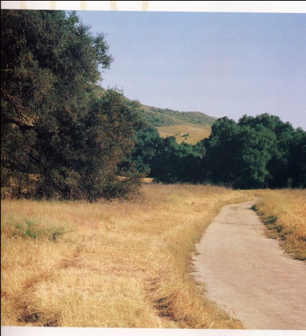
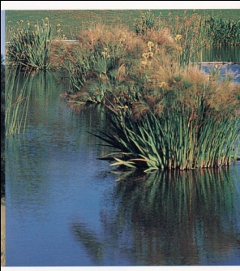
I could not believe what I have seen. I had to pinch myself to make sure I am not dreaming. It is a place where you can go ski in the morning and go to the beach afternoon at 75 degrees temperature. And then in the evening play tennis on fantastic tennis courts.
And in the middle of this paradise, here was the Vic Braden Tennis College:
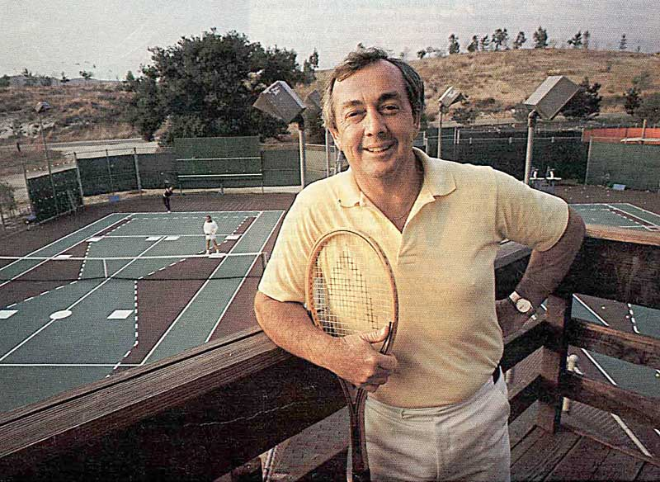
Vic Braden and his Tennis College
We were walking toward a small conference room in Vic’s office and were seating to start discussing some of my projects. Bill Toomey told Vic about our project with the Olympic Committee. At that point I asked Vic if I can call Ann. I had to call her right away. It was around 2PM Coto time.
“Ann, you would not believe this place here. Please jump on a plan tomorrow morning and come here.” “Are you crazy?” she answered. “You must come, please, I found our future home whether we have a job here or not, you must come. This is our future home.” I could see that Vic was hearing my statement. He was smiling. “Gideon, you are welcome here any time.” He made the statement.
We were discussing the future of sports medicine and sports athletics an what ever related to sports until late at night. At about 1AM Bill told me that his wife will kill him if we are not coming back soon. So, this was my second meeting with Vic after meeting with him in Amherst the first time.
Next morning, I drove my rental car to Coto. I found it this time, and Vic and I drove to the Orange County Airport, a very small airport at the time, to get Ann which were arrived the afternoon. Ann thought that I was going crazy, until she saw the same scenery I told her about. “Wow! This is something else,” she remarked. At that point Vic took a photo of us as follows:
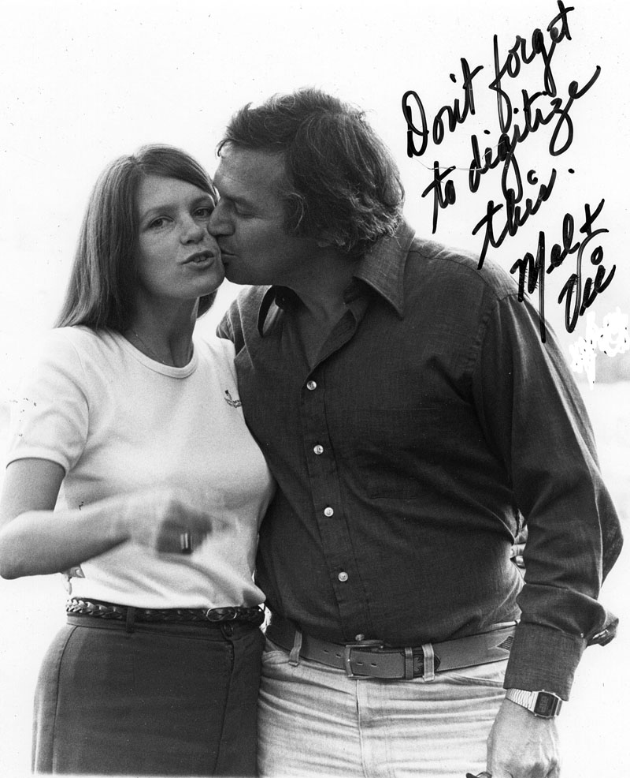
“Don’t forget to digitize this…..” Vic and Melody wrote on the photo when he gave it to me latter on. Well he did not know that he actually started a new life for us.
Vic and I became very good friends. I did some research work for him and we even appeared in some presentations related to Tennis together. Vic asked me: “Gideon, what will take you to move to Coto?” I told him that I would love to move to Coto. However, I have a whole business and number of projects I am working on them in Amherst plus my work at the University. “So, again, what offer we could make for you to move to Coto?”
Vic suggested that we will meet in Coto in the near future again and this time he will bring Mr. Vic Pelmari, the Chairman of the Board of Penn Central company which owned the properties in Coto De Caza.
. Victor Henry Palmieri is a lawyer, real estate financier and corporate turnaround specialist. He was also Ambassador at Large and U.S. Coordinator for Refugee Affairs in the United States Department of State during the Jimmy Carter administration
Born in Chicago, he earned his A.B. and LL.B. from Stanford University. He was admitted to the California Bar in 1954 and was based in Malibu, California. Palmieri was also the chief executive officer of The Palmieri Company, a general management consulting firm that has specialized in large-scale reorganizations and restructurings since 1969

We set the meeting to some day in 1977. (I do not remember exactly the date). I arrived in Coto two days before this important meeting. Vic showed me the property and in fact told me that I could purchase one or two of the new Condominiums which are built as an addition to his Tennis College. He already had 12 Condominiums that owned by the Coto De Caza properties as hotel to people that come to take the one week tennis college with Vic. Now they were building 35 more Condominiums on the properties next to the Tennis College.
We met Mr. Victor Palmieri at one of the Coffee Shop in the area. At that time you had to drive for 25 minutes just to arrive to some place where you could buy food or have a coffee shop. I was very excited and my hands were shaking. This meeting could change my whole life.
We were seated in a round table, Vic, Palmeri and myself. Before we even started to say anything, Mr. Palmeri through on the table a Sports Illustrated magazine and asked in loud voice: “Gideon, How did you do that?”
“What do you mean, Sir? I do not understand?”
He opened the first few pages of the Sports Illustrated magazine:
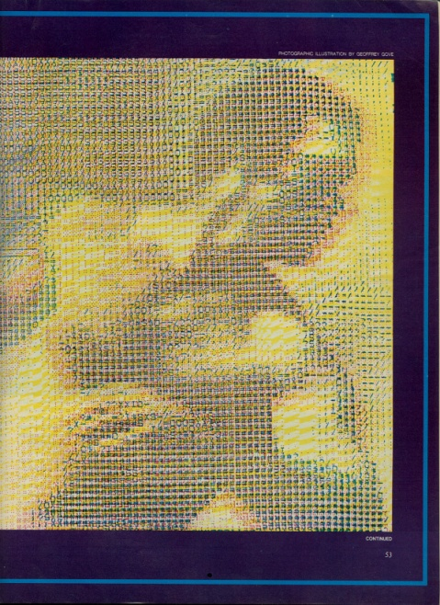
And, he started reading from the next page:
” It took Ariel more than 10,000 hours to program his computer to analyze an athlete's motions.
round Amherst. Mass., colleges run into colleges-the University of Massachusetts, Hampshire, Amherst, Mount Holyoke, Smith-leaving little room for a real town. The population is incessantly changing, fresh ideas flowing through a setting that has a history of assisting clear thought, elegant patterns. Emily Dickinson wrote and is buried here, and Robert Frost's birches are still bending.
Working today in Amherst is a man who would hardly consider himself poetic, but Gideon Ariel has been a leading figure in taking the great raw minds of computers and bringing them to bear on movement. In so doing, he has for the first time let us see the line and meter of human motion. Sport can never be the same.
In the first place, it seems that we have been proceeding on a false assumption. We have believed that trained observers can discern the crucial elements of athletic performance, that coaches can see what their athletes are doing wrong. "The human eye cannot quantify human movement." says Gideon Ariel, ponderously, because he is a big man who threw the discus and shot for Israel in two Olympics, because he still struggles with his Hebrew accent after 14 years in this country, and because that sentence is the foundation of his revolutionary advance. "The important things in performance,
the timing. the relative speeds of dozens of limb and body segments, the changes in centers of gravity-these all must be measured, weighed, compared to be of any use."
Ariel is a natural teacher, reaching always for images so vivid the dumbfounded or skeptical will be forced to see. "Compare coaches with bridge engineers," he says. "Suppose an engineer finishes the bridge and says, 'Wait, remove that beam.' You ask why, and he says, 'I took a survey of 100 drivers, and 75 said it looks better without the beam.' That is how coaches coach. What looks best. But if an engineer did that there would be a lot of cars in the river. And he would find himself in the nuthouse, because he is required to measure the strength of his materials and design against the weight of his load."
People are subject to the same physical laws as bridges. Indeed, Leonardo da Vinci believed mechanical science the noblest, "seeing that by means of it, all animated bodies that have movement perform all their actions." Isaac Newton described the laws of motion in 1700, but not as vibrantly as does Gideon Ariel. "It doesn't matter if you lift a cow. or throw a chair, or punch your girl friend. Everything is according to Newtonian physics."
The problem, until now, has not been that we haven't believed this; it has been that too many things happen too fast for us. The sheer complexity and velocity of a javelin thrower's movement in the final quarter second before release, for example, preclude comprehension of what is going on.
Technology helps. One of the earliest uses of photography was to settle the turn-of-the-century question of whether all four hooves of a galloping horse ever were off the ground at once (they are). In the 1930s, high-speed cameras provided slow-motion photography to offer a clearer view of the action. Dozens of limb and body parts accelerating and decelerating could be seen and measured and charted against one another. Patterns of successful athletes began to appear.
"The better the athlete, the more sophisticated his timing," says Ariel. "The one basic principle of all sports-hitting or kicking balls, punching, throwing, jumping, breaking karate bricks-is a coordinated summation of forces."
But so delicate are the relationships between an athlete's many moving parts that they cannot be assessed simply by looking at the slowest of motion pictures. A process of frame-by-frame, body segment-by-body segment analysis is necessary to make optimum use of cinematography, work that is painstaking, dreary and absurdly time-consuming. Gideon Ariel gave that work to the computer and suddenly the maddening complexity of human motion could be matched by the awesome memory and speed of the machine. Well, not quite suddenly. It took Ariel some 10,000 hours over seven years to create the programs that instruct his computers. Now he offers the sporting world a chance to lift itself from, as he puts it, "the dark ages, a witchcraft business where everything is made of thin air." Over those years, Ariel transformed himself as well, from a carefree discus thrower to a compelling.”
At that point Vic added. If we can do it here in Coto, we are going to take the World as far as Sports Science Center.
“So, how did you do it Gideon. I was seating on the plan in first class and picked up the Sports Illustrated Magazine, on the way to meet you and here you are in a 9 pages spread story about you. How the hell did you do it?”
“Mr. Palmeri, I did not do anything. They did interview me few weeks ago and I did not know when the publication will come out.”
At the time the various magazines including Sports Illustrated would reach the airlines before the general public stance. And this what happened. Mr. Palmeri saw the article before I or Vic saw it. In fact the Discus Thrower on the cover of the story is Bill Toomey throwing the discus in his World Record performance in the Decathlon in the 1968 Olympic Games in Mexico City.
How it could happened that my Friend Bill Toomey that introduced me to Vic, and Vic Braden that introduced me to Mr. Palmieri and Me, seating around the table discussing my move to Coto De Caza with a 9 Pages article written about me in Sports Illustrated Magazine. This sound like a Miracle.
“Well, Mr. Palmieri, what can I say?, I have a fantastic laboratory in Amherst Massachusetts, and have number of projects running currently, I do not know how I could perform with what we got in Coto De Caza.”
“We will build you a laboratory to your request. Tell me what you need.” Mr. Palmieri answered me.
So, I took the napkin on the table and asked for a Pen. Mr. Palmieri gave me his pen and I start drawing the “dream laboratory for Human Performance.” I happened to store this document and here is the original drawing:
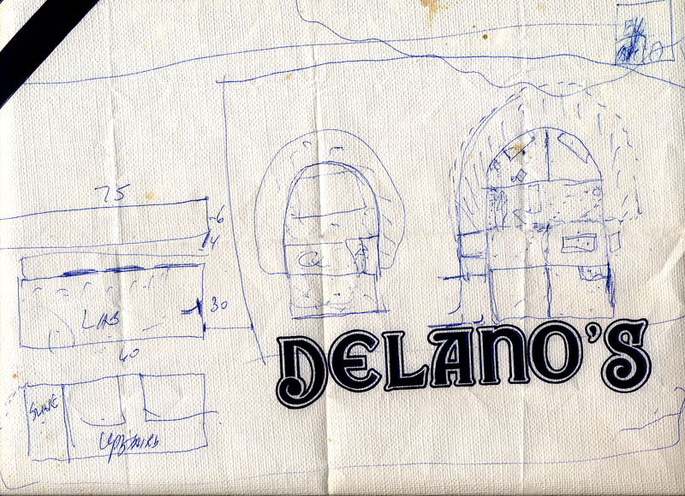
The original drawings for the Coto Research Center
Obviously, I am not an architect. However, the idea was to have two stories building with a track going through the first floor. There would be a general court to use for Tennis research as well as any other sport. The surface should be monitored with sensors so every ball of any kind that hit the ground, a signal would be sent to the main computer which would be the most advance Data General computer exist to date which was the Eclipse-400. Also, special 3D monitors made by Megateck will be installed to present data in 3D in real-time. Special computer room with elevated floor will be installed to allow special air-conditions floor and environment. The upstairs will also have a gym with cardiac equipment to be able to measure Oxygen consumption and other physiological parameters such as E.M.G. etc.
Next to the main Laboratory another building to be built which will contain Ann and my office. And of course, Vic will have his office there if he wish.
One should bear in mind that there were no personal computers at the time and such a laboratory would cost in the Millions.
Well, Mr. Palmieri stopped me for a second and made a comment as such: “Gideon, you are talking here Millions of Dollars.”
I answered immediately saying: “Mr. Palmieri, you asked me to tell you what would bring me here, not how much it would cost. And in addition, I would not want to have a Boss. It will have to be between Coto De Caza and Ariel Dynamics, Co-venture. I will be the Boss of my Research Center.”
Mr. Palmieri was dumbfounded. He probably thought for a minute that he is dealing with a lunatic. But, the Sports Illustrated article and Vic might did it for me. I did not think there is any chance to have this deal. It would cost around 5 Million Dollars to build. (In today Dollars probably 15 Million Dollars).
So, Mr. Palmieri asked: “And if we decided to do it, when do you think we should start?”
I do not know where I had the courage, but, I answered. “Mr. Palmieri, today is Wednesday, how about starting on Thursday, tomorrow.”
Mr. Palmieri looked at Vic. Vic was white as a white wall. Everyone start laughing. It was like a science fiction movie. Suddenly, Mr. Palmieri extend his hand to me. I extend my hand to hold his hand and he said to everyone amazement: “Gideon, this is a deal.”
At that point I made additional statement: Mr. Palmieri, if you are going to bring me here to Coto De Caza and build me the Research Center, I will bring the Olympics in 1984 to Coto.”
“Gideon, please stop it.” Mr. Palmieri raised his voice slightly. “Please don’t start a science fiction of the whole meeting we are in.”
“No science fiction, I am going to bring the Olympic competition to Coto De Caza, mark my words.”
After we abort the meeting, latter on, Vic told me that I almost blew the whole idea with my “ridicules statement”. I did not comment anymore. But in 1984, I did bring the Olympics to Coto. The Modern Pentathlons was performed in Coto De Caza. I will tell more about it later on.
Now I really did not know if this is a dream or reality. I called Ann at Amherst and told her to prepare to move to Coto. I told her it was a 5 Million Dollars Hand Shake contract. “No way” she declared. “Okay Ann, lets our attorney start working on the deal”.
I had dinner with Vic and we were planning our research center. We decided to call it: The Coto Research Center.
Of course, now we moved to reality and the attorneys drew up the contract between Coto De Caza and Ariel Dynamics. Here is part of it: (Many “boiler plate pages are not included in this book). However, the essential of the contract shown in the following partial document.
COTO DE CAZA SPORTS RESEARCH CENTER
JOINT VENTURE PARTNERSHIP AGREEMENT
THIS JOINT VENTURE PARTNERSHIP AGREEMENT is made this day of May , 1978, by and between Coto de Caza Development Corporation, a California corporation (herein referred to as "CDCDC"), and Computerized Biomechanical Analysis, Inc., a New Hampshire corporation (herein referred to as "CBA"). CDCDC and CBA are each referred to herein as a "Partner" and are collectively referred to as the "Partners."
RECITALS:
CDCDC operates a 5,000 acre residential and recreational facility known as Coto de Caza in Orange County, California ("Coto de Caza"), a major portion of which is devoted to tennis, equestrian, and other athletic activities. CBA is engaged in the sports research and analysis business, conducting biomechanical analysis of human performance in industry and athletics.
CDCDC and CBA desire to establish a joint venture partnership for the purpose of conducting a sports research and analysis business at Coto de Caza, upon the terms, covenants and conditions set forth in this Agreement.
NOW, THEREFORE, CDCDC and CBA hereby agree as follows:
- Name. The name of the Partnership shall be: COTO RESEARCH CENTER
- Place of Business. The principal place of business of the Partnership shall be at Coto de Caza, 22000 Plano Trabuco Road, Trabuco Canyon, Orange County, California 92678.
- Term. The Partnership shall commence as of the date of this Agreement and shall continue until December 31, 1987, unless the term of the Partnership shall be extended by mutual agreement of CDCDC and CBA or unless the Partnership shall be sooner terminated in accordance with the provisions of Paragraph 12 below. In the event CDCDC and CBA mutually agree to extend the term of the Partnership beyond December 31, 1987, CBA and CDCDC shall execute a supplement to this Agreement amending this Paragraph 3.
- Purposes. The Partnership is formed for the purpose of conducting a sports research and analysis business at Coto de Caza, with the primary purpose of engaging in biomechanical analysis of human performance in athletics. The Partnership shall engage in such other sports research activities as the Partners shall from time to time jointly determine.
- Capital Contributions. Neither Partner shall be required to contribute cash or any other property to the capital of the Partnership. The Partners shall, however, be required to provide the following for the use and benefit of the Partnership:
- (a) CDCDC Obligations.
- (i) Use of Facilities. CDCDC shall permit the Partnership to use (when completed) the tennis stadium/ research court and the office/classroom building planned for construction at Coto de Caza during 1978 (herein referred to as the "New Facilities"). The New Facilities shall be used jointly by the Partnership, the Vic Braden Tennis College and other CDCDC activities on a sharing basis to be agreed upon by CDCDC and the Partnership. The Partnership shall not be required to pay rent for its use of the New Facilities, but the Partnership shall reimburse CDCDC for a proportionate share of the maintenance, utility, insurance, security and other expenses incurred or paid with respect to the New Facilities. CDCDC shall also permit the Partnership to use other existing and future CDCDC facilities at Coto de Caza on terms and conditions to be agreed upon from time to time.
- (b) CBA Obligations.
- (i) Expertise and Business Property. CBA shall provide to the Partnership its technical expertise in computerized biomechanical analysis and generally in the analysis of human performance in athletics and other activities. To this end, CBA shall allow the Partnership to use CBA's computers and other equipment, CBA's computer programs and other software, and CBA's customer lists and other marketing data (all of which is collectively referred to as "CBA's Business Property"). CBA shall also cause its present employee, Dr. Gideon Ariel, to become the full-time employee as Director of the Partnership pursuant to the Employment Agreement referred to in Paragraph 9 below. The Partnership shall pay to CBA as the annual rent for its use of CBA's Business Property the sum of TWENTY SEVEN THOUSAND DOLLARS ($27,000.00), which rent shall be payable annually on March 1 of 1980, 1981, 1982, 1983 and 1984. No annual rent shall be payable for periods after March 1, 1984. The Partnership shall be responsible for all maintenance, insurance and other recurring expenses associated with the Partnership's use of CBA's Business
(ii) Ongoing Contracts. CBA shall assign to the Partnership those ongoing contracts and work in progress of CBA which the Partnership desires to accept and the Partnership shall perform the work required thereunder. (CBA shall in no event be required to assign to the Partnership CBA's royalties from CITC for prior shoe design, royalties from prior design and development of CBA's computerized exercise machine and proceeds from the book entitled OPTIMUM and a book presently in preparation with the tentative title of U.S. OLYMPIC HEALTH AND FITNESS MANUAL.)
- Profits and Losses. The net profits and net losses of the Partnership shall be allocated equally between the Partners.
- Distributions. Distributions of cash to the Partners shall be made only upon the mutual agreement of the Partners and in amounts proportionate to each Partner's share of profits and losses.
- Management of the Partnership. Except as otherwise expressly provided in this Agreement, each Partner shall have equal rights in the management of the Partnership and its business. Any act in contravention of this Agreement or which may subject the Partners to liability in excess of $5,000 shall, however, require the consent of both Partners.

Now, I had to tell Dr. Dardik where I am going to be. In fact I thought immediately that Coto could become also a training center for our ideas we had for the Olympic Committee as I was describing in previous chapter.
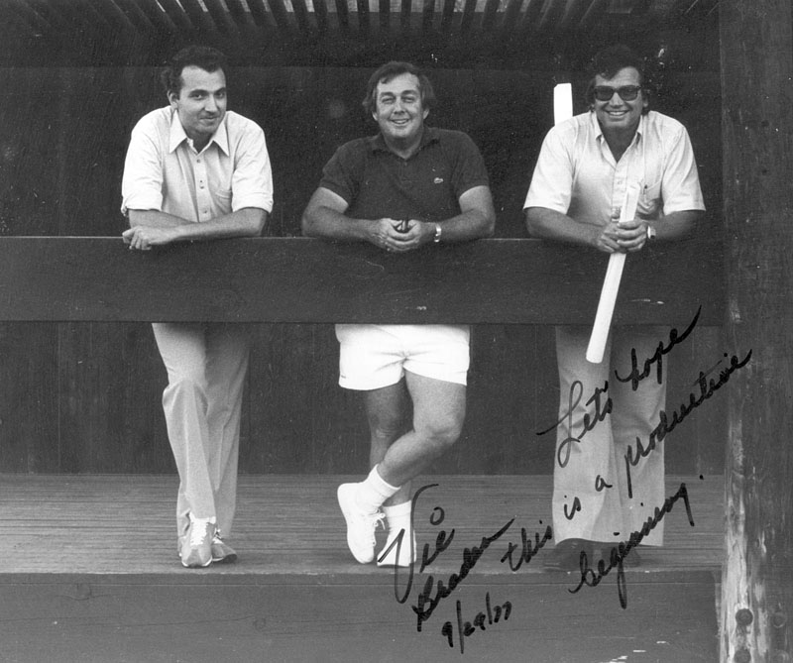
Dr. Dardik, Vic Braden and Me with the Research Center drawings in my hand
I did purchased two Condominiums. One to live in and the other for visitors and athletes.

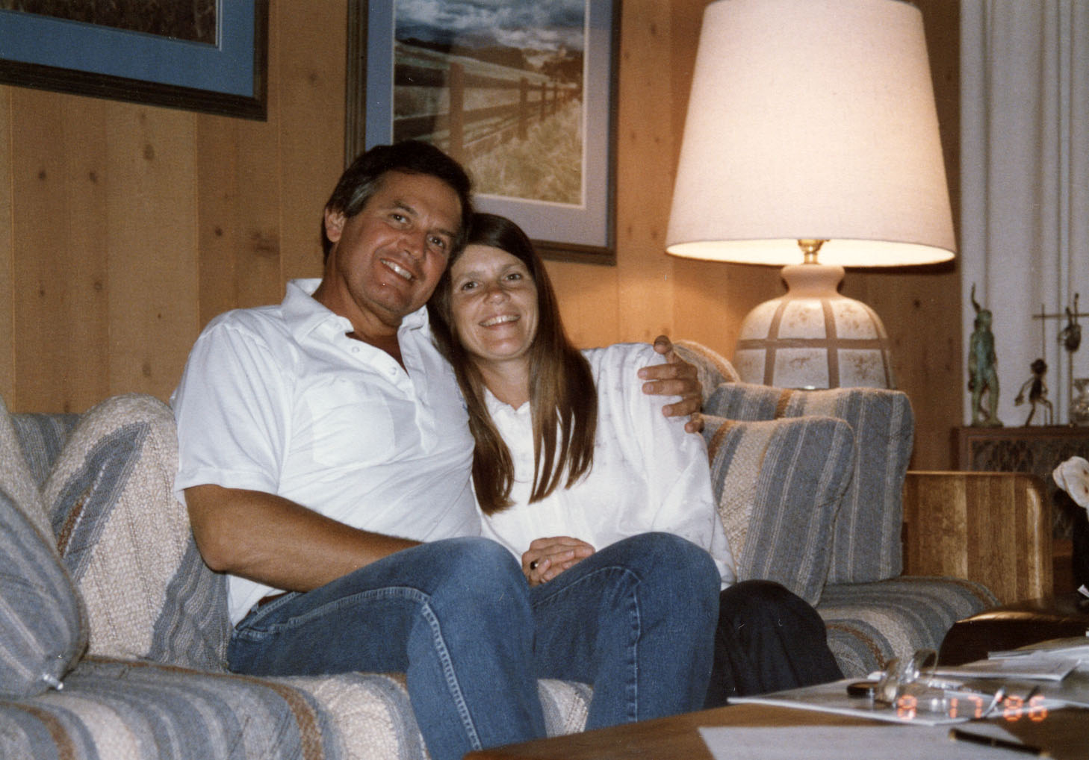
Our new Home at Coto De Caza
And our most loyal family member Ringo:
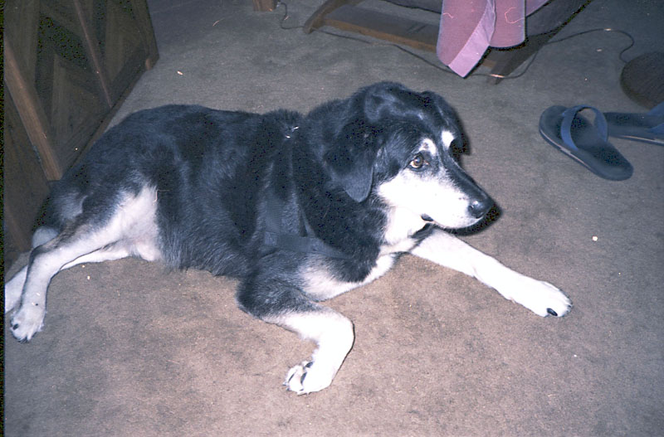
Ringo

It seems as if dreams came through. To build the most advance sports research center in the World with the most advance technology. It took more than a full year to build. The builder was Mr. Tom Valentine. We became friends and this really helped to add all kinds of additions which no one saw in the planning period. It became the most advance Sports Research in the World. Below are some of the phases of development.

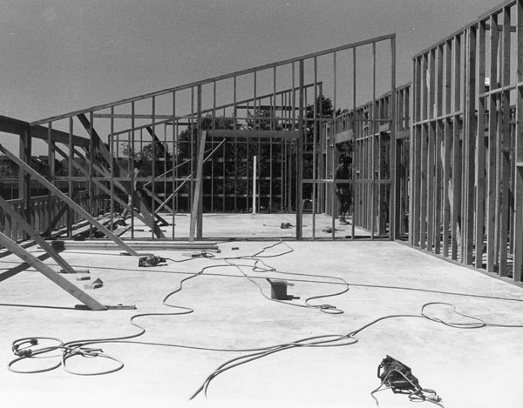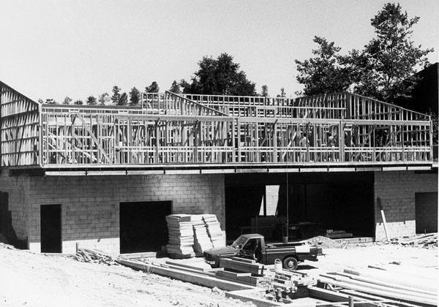
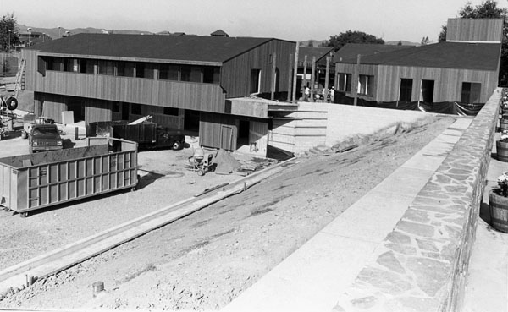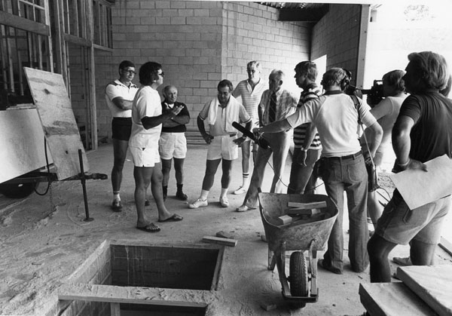

The cost was enormous but worthwhile. In the end we got the most beautiful buildings in the most beautiful place:
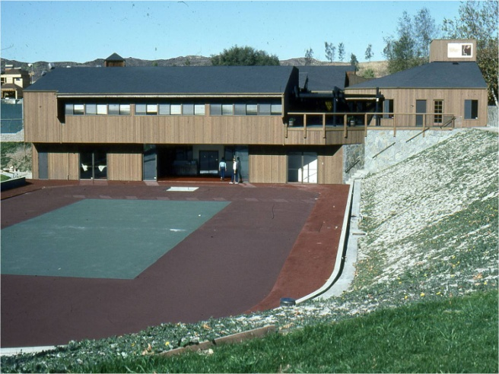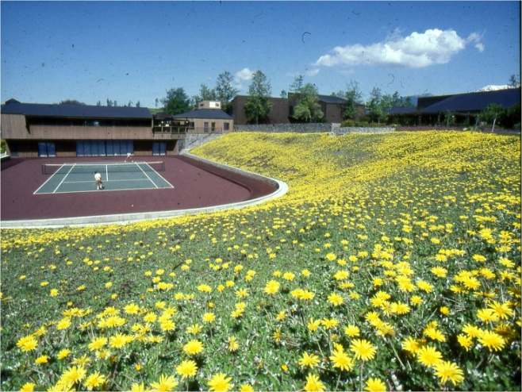
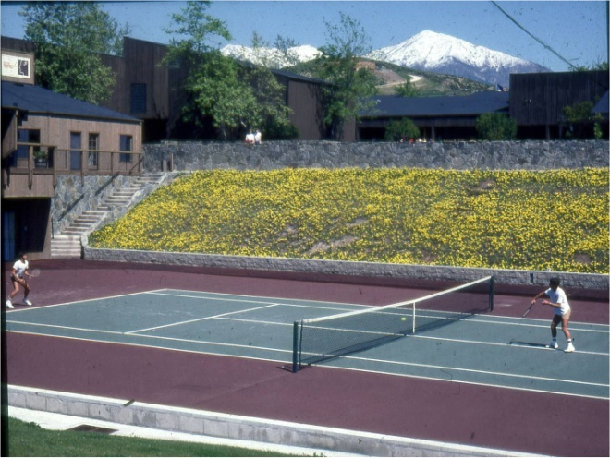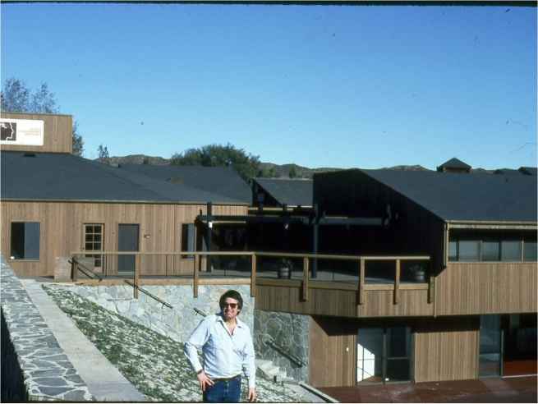
The Coto Research Center at its inception

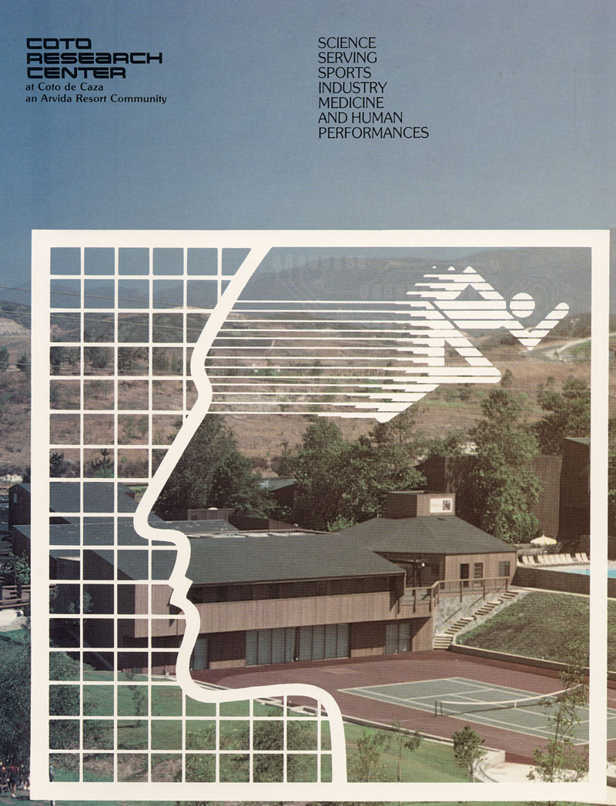

But as they said, “don’t judge a book by its cover.” The content of our research center was awesome. Multi Million Dollars computers and graphic terminals. Best high speed cameras. Eight force platforms on the track and in the laboratory. Here are some of the photos.

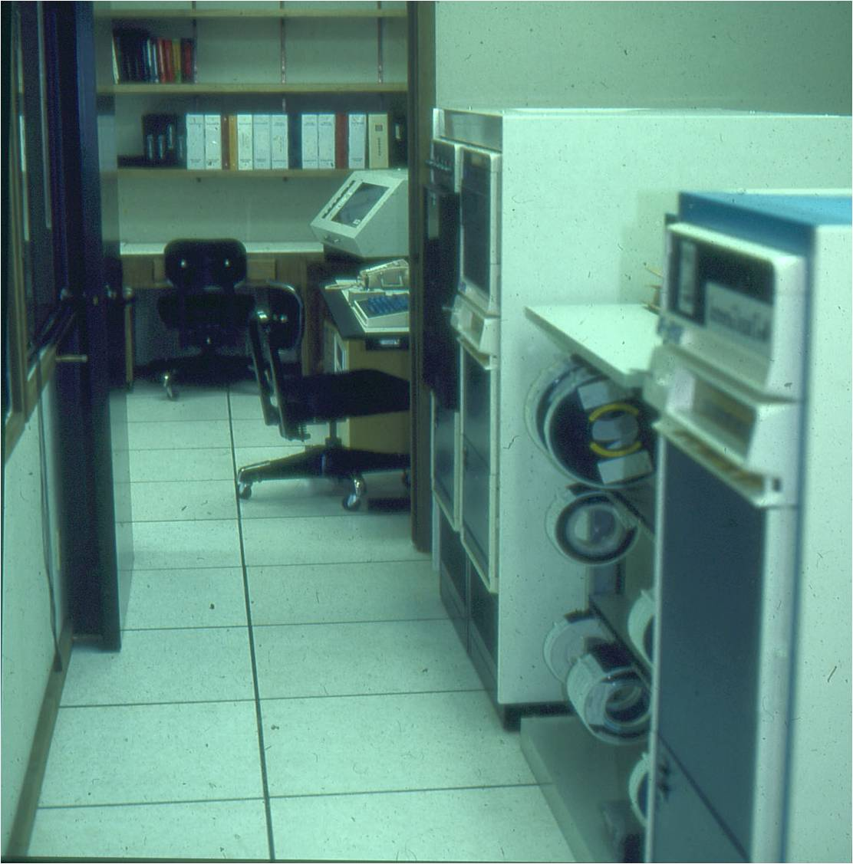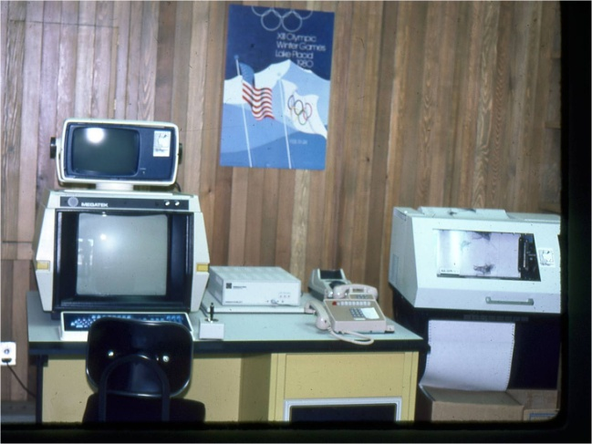
Most advance Data General computer system and most advance Megatek graphic terminal
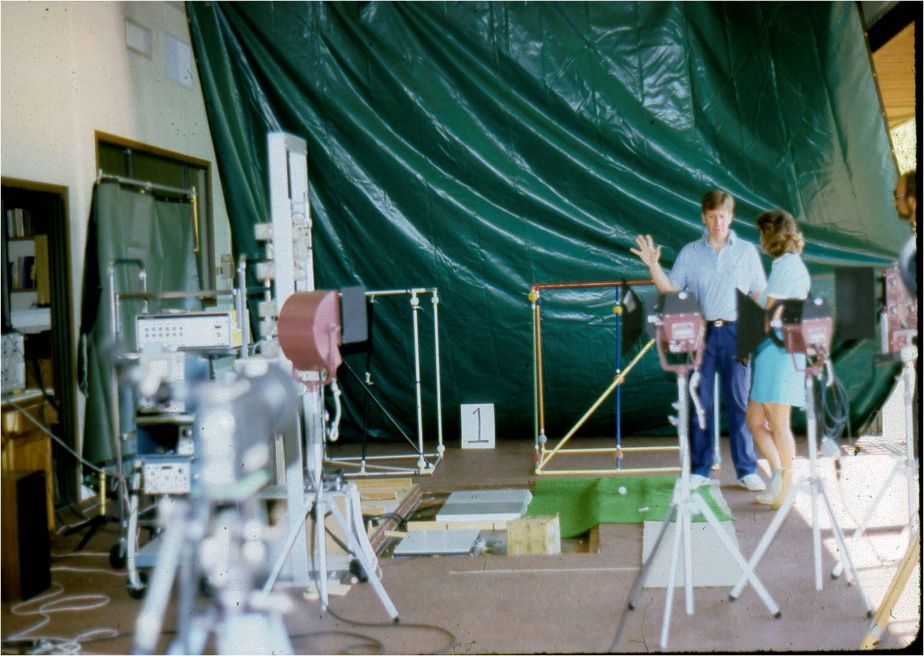
Downstairs, array of force plates and area for data collection

On the court we would collect data on playing from all viewing angles:
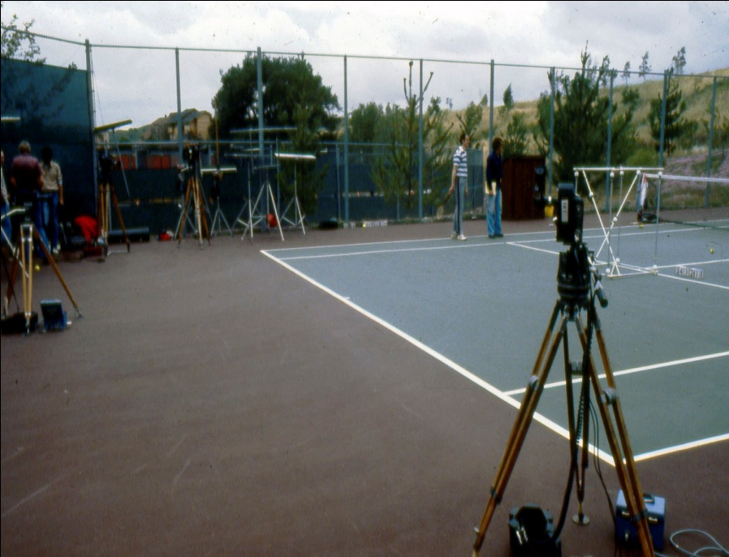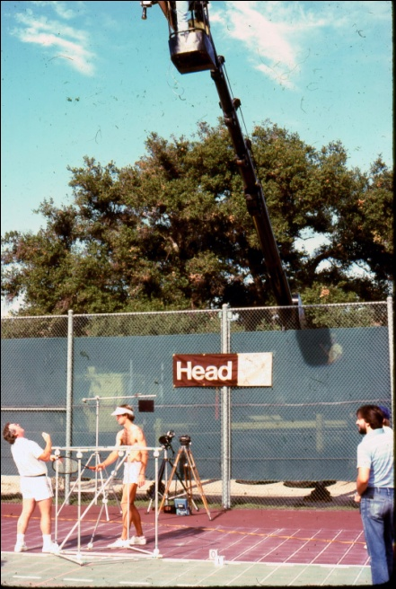

We also brought some of the equipment we have designed to measure impact on shoes and measure and simulate forces inside the shoe. Also, a very sophisticated material tester that we designed in the past to measure shock absorption of mats and other material.

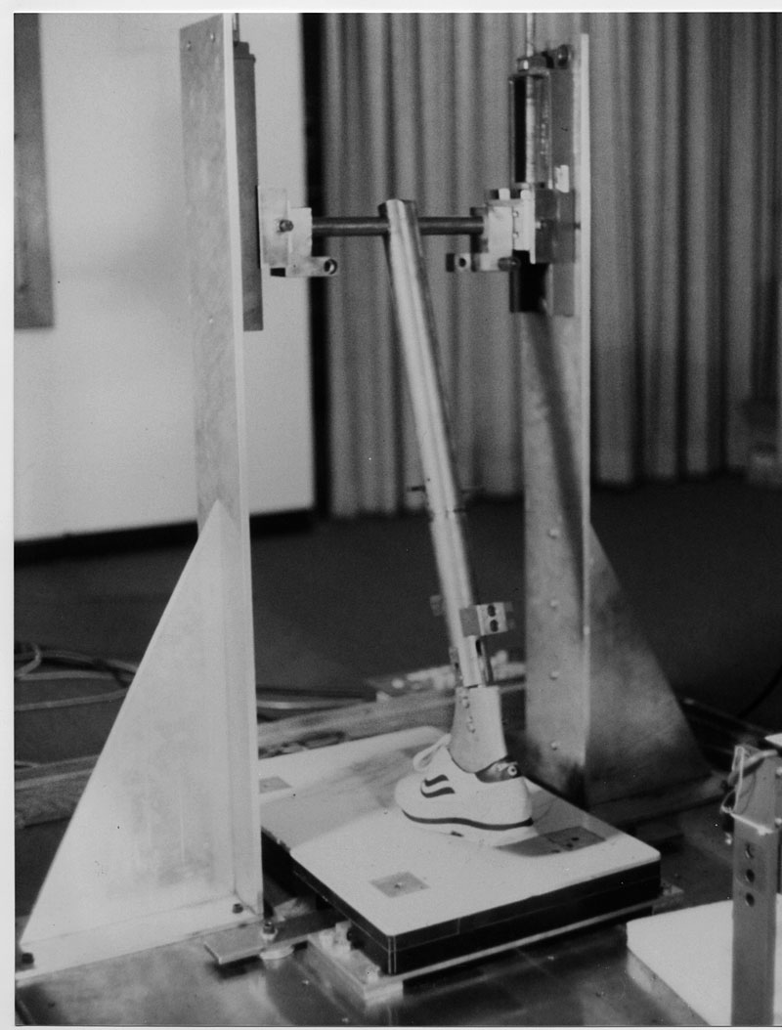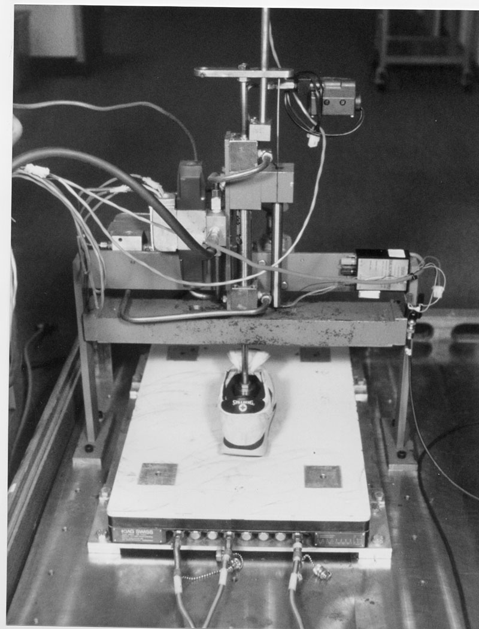
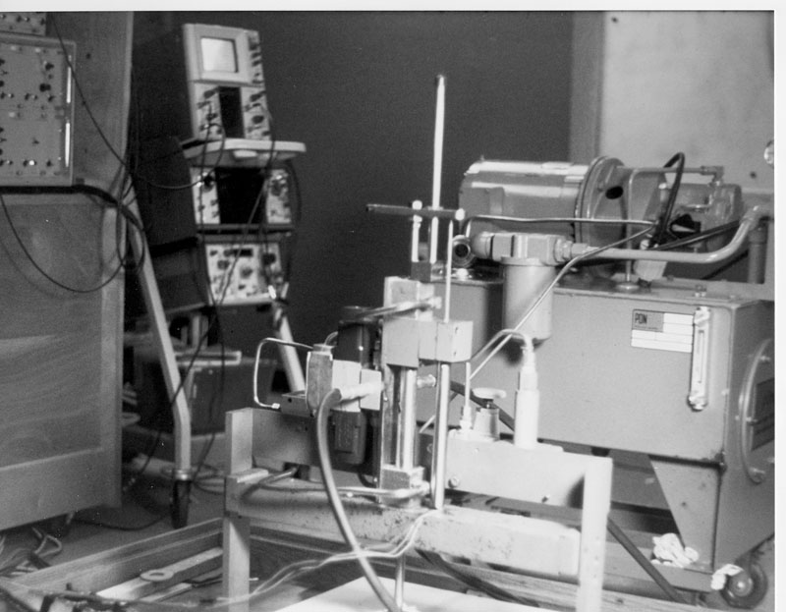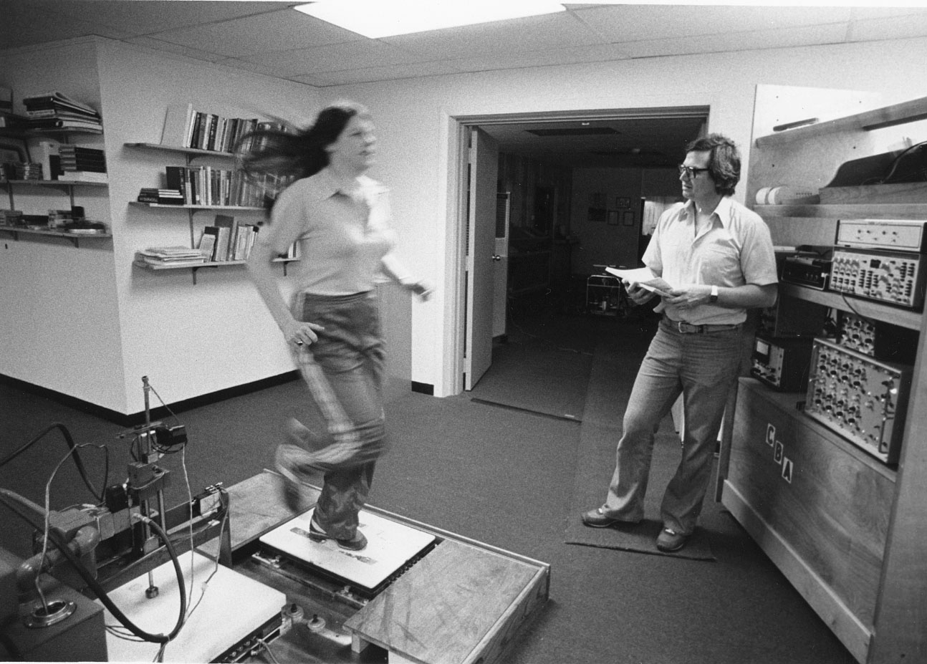
Various instruments we brought from our lab in Amherst

Our operation started immediately upon completion of the construction and installations of the equipment. The Media got every excited about us and many articles in various magazines and journals were written about us. We received amazing amount of free advertisement by the excitement of the Media about us.
With the projects that we brought from our Laboratory in Amherst at C.B.A. and the new projects we received we had more than 30 projects to deal with right from day one.
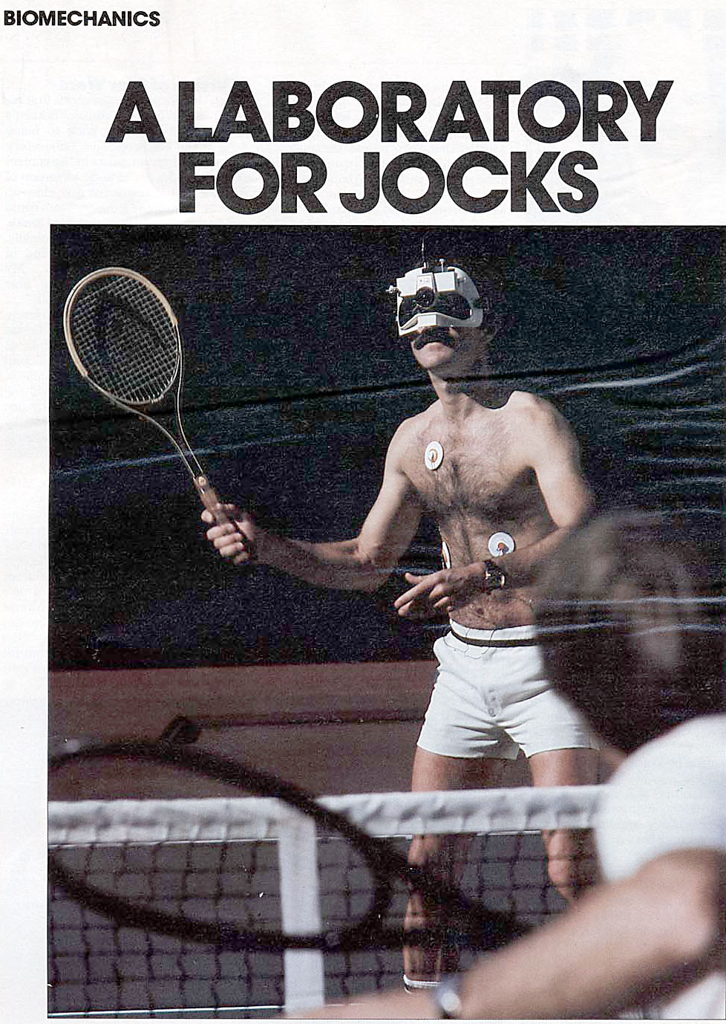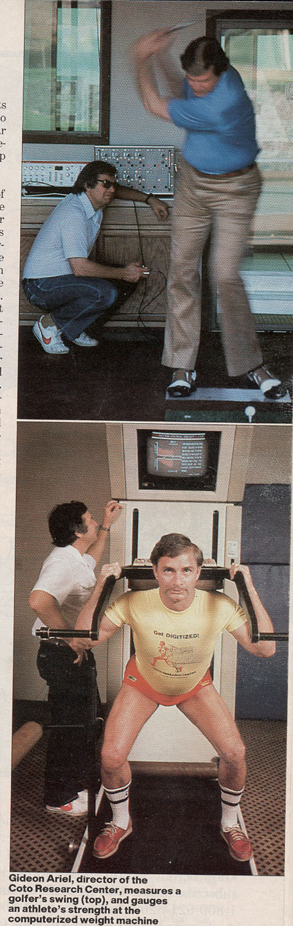

They called us “Laboratory for Jocks”. But if they just knew that most athletic shoes, Golf Clubs, Tennis Balls, Artificial Surfaces, Golf Balls, Tennis Rackets, Astronauts suits, Exercise Machines, Nursing Shoes, and so many more products were all designed and tested in the Coto Research Center and previous to the Center at the C.B.A. laboratory in Amherst, Massachusetts.
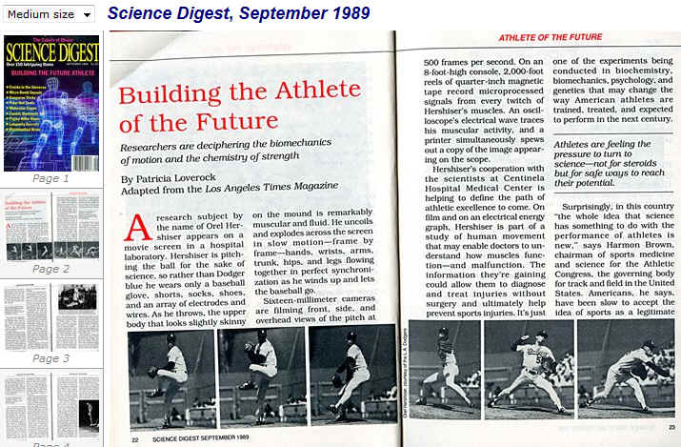

In the following, I will describe some of these studies we performed specifically in the Coto Research Center.

One of the first project we were working on was with the Vic Braden Tennis College. The Vic Braden College was independent of the Coto Research Center and actually reside in different facility close by. People from all over the World came to the Vic Braden Tennis College to improve their game. In addition, a very famous pros such as Arthur Ash and Jimmy Connor would come often to visit with Vic. At that time we would collect data and analyze the strokes to find any advantages and disadvantages in their strokes.
Arthur Robert Ashe, Jr. (July 10, 1943 – February 6, 1993) was a professional tennis player, born and raised in Richmond, Virginia. During his career, he won three Grand Slam titles, putting him among the best ever from the U.S. Ashe, an African American, is also remembered for his efforts to further social causes.
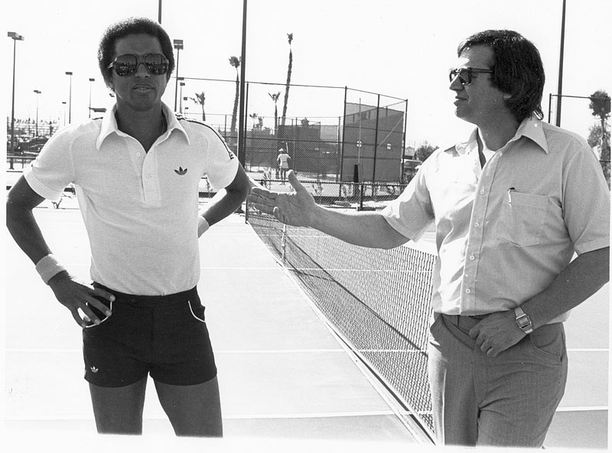
With Arthur Ash
With Jimmy Connor we had a whole project to try to improve his serve. In fact we did improve his serve from about 70 Miles per hour to over 90 Miles per Hour.
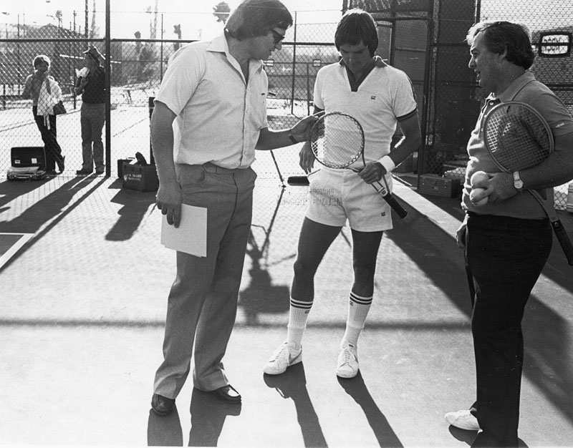
With Jimmy Connor
James Scott "Jimmy" Connors (born September 2, 1952, in East St. Louis, Illinois, also known as "Jimbo") is an American former World No. 1 tennis player. He held the top ranking for 160 consecutive weeks from July 29, 1974, to August 22, 1977 (record at that time), and an additional eight times during his career (a total of 268 weeks). He won eight Grand Slam singles titles and two Grand Slam doubles titles with Ilie Năstase and was the mixed doubles runner-up with Chris Evert at the 1974 US Open. Connors also won three year end championship titles including two WCT Finals on the WCT tour and one Masters Grand Prix on the Grand Prix Tennis Circuit. He is a former coach of Andy Roddick, the winner of the 2003 US Open. Connors himself was coached by Pancho Segura, since age 16.
Although Connors never won the French Open, his victory at the 1976 US Open came during the brief period (1975–77) when that tournament was held on clay courts. Connors is, therefore, one of only five men (Mats Wilander, Andre Agassi, Roger Federer and Rafael Nadal are the others) to have won a Grand Slam singles title on grass courts, hard courts, and clay courts.
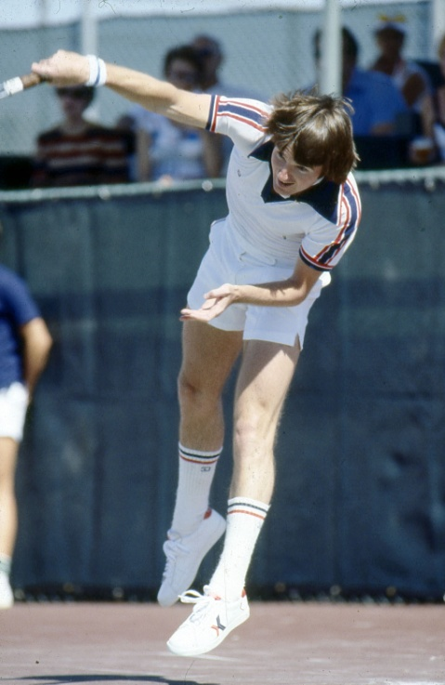 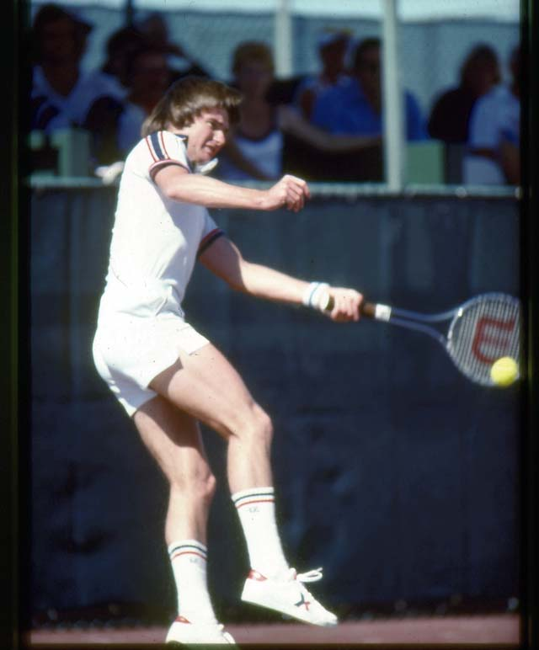
Jimmy Conore
One of the project we developed was to be able to program a throwing machines to simulate the actual the tennis ball velocity, angle and spin of a particular tennis player. For example, by collecting hundreds of shots from Jimmy Connor we could determine for each shot the speed of the ball, the angle of the ball and the spin on the ball. Than, we were able to program a special throwing machine to simulate these shots. All that was done automatically by our computers.
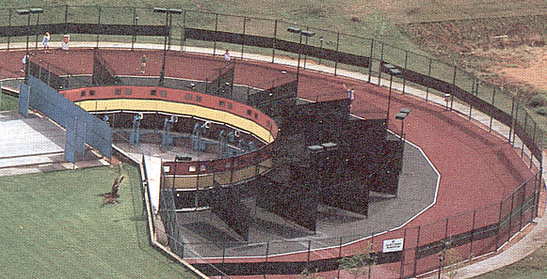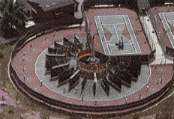
Programmable tennis ball throwing machine to simulate actual flights of the tennis balls.
Each lane in the above photo had a throwing machine which was programmable to simulate a particular shot. Imagine that you play against you neighbored in the community and he is “killing” you on the back hand. What if you hire one of our pros to video you playing with him and every back hand shot is saved in a computer memory after digitizing it from the video. Then, you assigned one lane on the programmable throwing machine and every shot from the machine is one of your Neighbor backhand. You practice against your neighbor while he is not there and he does not know about it. The next weekend you are “killing” him on his backhand shot. This was one of our early project. In addition, we developed a Reaction Time Machine, that indicate your reaction time to particular condition on the court. The whole training in the Vic Braden Tennis College became computerized running by intelligent machines.
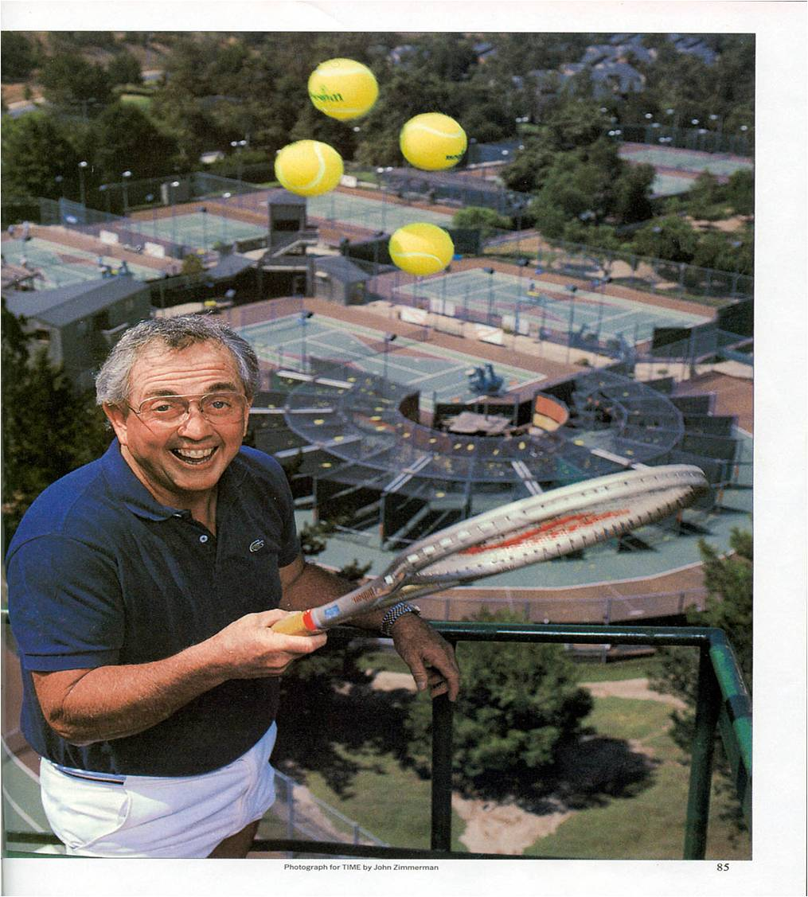
Vic Braden and his Computerized Tennis College that we installed
We have analyzed and helped Thousands of athletes from all over the World. I cannot include many of the studies here for a obvious reason. The scope of this book would not permit that. However, I will cover few of the interesting studies. One study was requested by the famous tennis player Jimmy Connor. Jimmy had a problem with his feet which developed blisters and had problem in his serve which was too slow. We collected allot of data at his game and on the lanes and analyze them in the regular way which included digitizing the data and work through our special computer programs to come with the results. The reader should bear in mind that this was 1979, and there were no personal computers or advance electronic devices as of today. What used to take for us at that time hours, taking us today only few minutes.
Our staff was only few scientists. But extremely efficient and dedicated. Here they are:
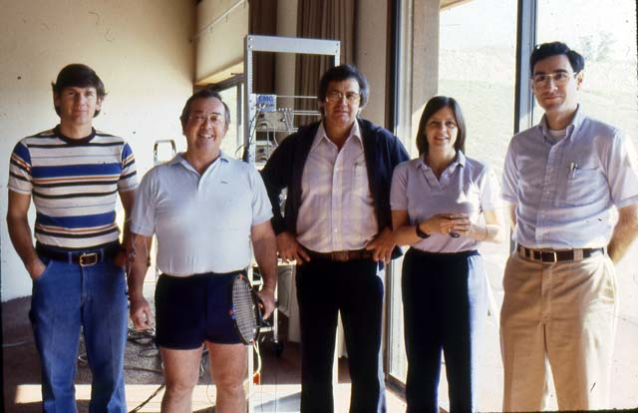
Dany, Vic, Me, Ann and Alan. Jeremy worked from Amherst and still there
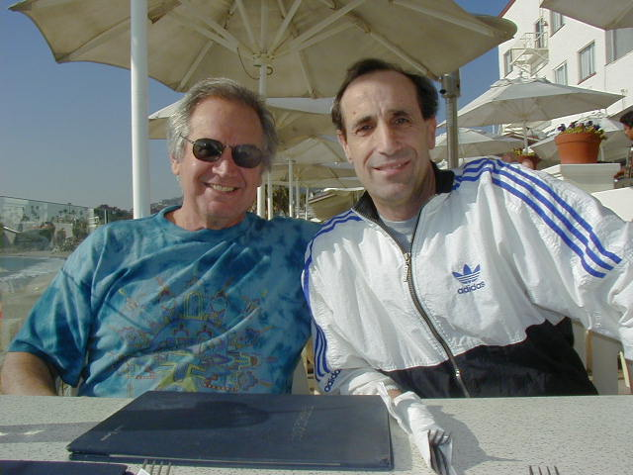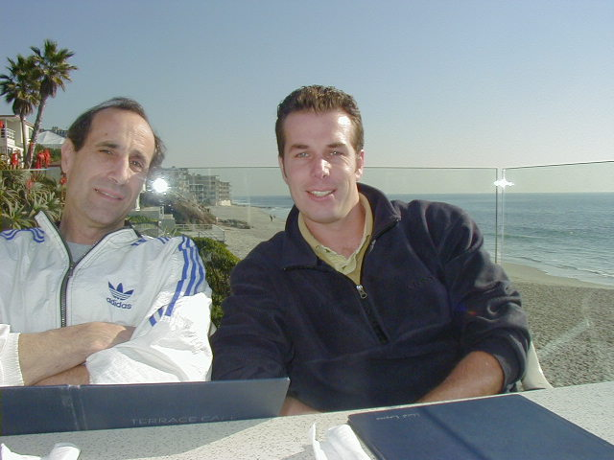
The other significant Geniuses team members: Jeremy and Rudolf
So here it is the study of Jimmy Connor and it is an example how we analyze any of the athletes in any of the sports. The only differences are the criteria that you measure. In tennis I measured the speed of the racket, in the discus throw I measure the speed of the release of the discus and many other physical parameters which are all basically Newtonian Mechanics.
In physics, classical mechanics is one of the two major sub-fields of mechanics, which is concerned with the set of physical laws describing the motion of bodies under the action of a system of forces. The study of the motion of bodies is an ancient one, making classical mechanics one of the oldest and largest subjects in science, engineering and technology.
Classical mechanics describes the motion of macroscopic objects, from projectiles to parts of machinery, as well as astronomical objects, such as spacecraft, planets, stars, and galaxies. Besides this, many specializations within the subject deal with gases, liquids, solids, and other specific sub-topics. Classical mechanics provides extremely accurate results as long as the domain of study is restricted to large objects and the speeds involved do not approach the speed of light. When the objects being dealt with become sufficiently small, it becomes necessary to introduce the other major sub-field of mechanics, quantum mechanics, which reconciles the macroscopic laws of physics with the atomic nature of matter and handles the wave-particle duality of atoms and molecules. In the case of high velocity objects approaching the speed of light, classical mechanics is enhanced by special relativity. General relativity unifies special relativity with the Newton's law of universal gravitation, allowing physicists to handle gravitation at a deeper level.
The term classical mechanics was coined in the early 20th century to describe the system of physics begun by Isaac Newton and many contemporary 17th century natural philosophers, building upon the earlier astronomical theories of Johannes Kepler, which in turn were based on the precise observations of Tycho Brahe and the studies of terrestrial projectile motion of Galileo. Because these aspects of physics were developed long before the emergence of quantum physics and relativity, some sources exclude Einstein's theory of relativity from this category. However, a number of modern sources do include relativistic mechanics, which in their view represents classical mechanics in its most developed and most accurate form.
The initial stage in the development of classical mechanics is often referred to as Newtonian mechanics, and is associated with the physical concepts employed by and the mathematical methods invented by Newton himself, in parallel with Leibniz, and others.
So, the physics is very simple, however to data collection require high speed cameras, digitizers and computers.
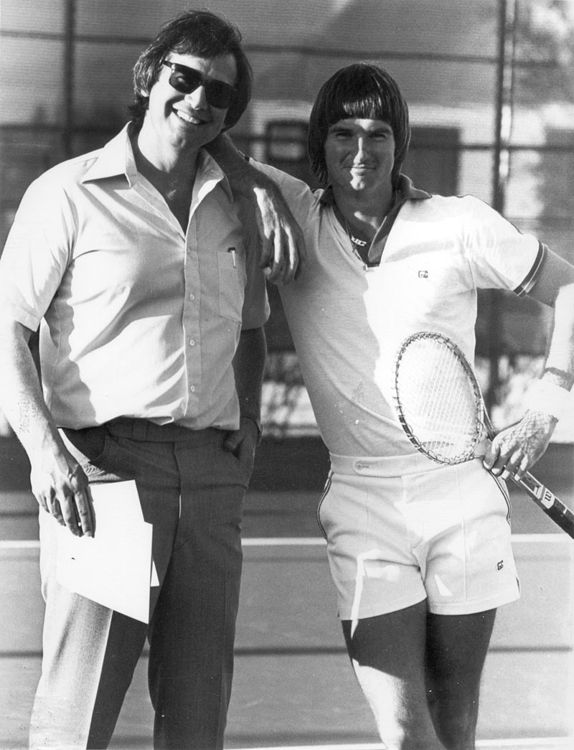
With Jimmy Connor
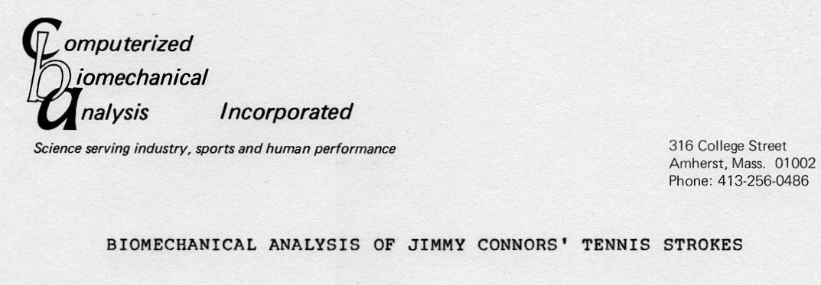
Biomechanical analysis were conducted on various tennis strokes performed by Jimmy Connors. These analyses were needed in order to determine causes for his current foot problems and subsequently to develop shoes to assist in alleviating these difficulties. Conversations with Connors and his manager, Mr. Joe Roundtree, revealed that Connors suffers from a profusion of blisters and foot pain. Inspection of his feet disclosed unusual foot structure of unknown etiology.
There seems little doubt that these foot difficulties are aggravated by the result of excessive stresses encountered during the tennis game. The purpose of the present research was to quantify these stresses and, based on the findings, to design tennis shoes specifically for Connors.
METHOD
Photographic data was obtained both during a tournament and at a special filming session in Palm Springs, California. High speed motion pictures were taken simultaneously from four (4) different cameras placed perpendicular to each other. A camera suspended from a cherry picker provided top view pictures of the
various tennis strokes. The cameras were placed in planes
orthogonal to each other to allow views from all angles. The
film speed was adjusted to 200 frames per second. Films were
taken of various tennis strokes such as the serve, forehand, backhand, volley, and several moves, such as running at acute angles, in order to "get a ball". Special close-up films were obtained to facilitate examination of the shoes during the various motions. These close-ups were synchronize with the total
body analysis. These films were interpreted through several
analytic techniques: visual observation, frame counting, and
computerized biomechanical analysis. Tables and graphs were
generated to determine patterns of motion which characterized Connors' performances.
For the computer analysis, the films were projected upon a translucent 36 x 36 inch glass screen. Joint centers of the body were digitized every frame for information of the location of each joint center of the body throughout the particular motion. This digitizing process involved touching the projected joint centers with a sonic stylus. The emitted sound waves were converted into X-Y coordinates and automatically fed into the computer. As each frame was digitized, joint centers were projected onto a graphic display screen and connected by lines to form stick figures. The complete movement was recreated in stick figure form on the screen where examination and corrections, if needed, could be made.
Motion analysis programs were then executed. Kinematic and kinetic analysis was utilized to measure both the stresses on the foot and the forces of the foot on the ground in order to determine a better shoe design. In addition, biomechanical analysis was performed to determine efficiencies and deficiencies in Connors' various strokes.
RESULTS
The study focused both on the footware itself and on various tennis stokes. The analyses examined the following:
- Shoes
- Stoke analysis:
- Serves
- Forehands
- Backhands
Shoe analysis:
In general the films revealed that Connors' motions appear to be extremely abnormal, unconventional, and at many times spastic. Some of the more pronounced characteristics are briefly described in the following points:
- He moved backwards without changing his body-net
orientation. Running backwards while facing the net forced
the foot to land on the lateral toe sole edge instead of the medial ball.
- When moving forward, he stopped his motion by landing on the flat of the toe bumper.
- During directional changes, he dragged the trailing foot of the toe bumper.
- He was constantly in motion and rotated on the medial
balls of the feet.
- During the serving motion, initially he rocked backwards onto the sole edge of the heel of the support. He then
shifted support from the lateral to medial toe areas and often braced his body on the toe bumper.
- Connors' foot was unstable within the shoes he was
wearing. He often landed on the medial edge of the heel and his heel tended to drift over the shoe.
The biomechanical analyses revealed unusual foot utilization. As can be seen in the pictures, Connors hit his toes during directional changes, scraped the ground with high forces with his feet, and during some of his running-jumping landings, reached forces equivalent to six (6) times his body weight. At these particular impact angles, the stresses inside the shoe reached high magnitudes. The shoes that Connors is currently
wearing do not provide sufficient support for these force levels and permit the forces to be transmitted inside the shoe causing severe problems.
Photographs 1 to 14, taken from the original high speed film, illustrate various critical foot placements which
contribute to Connors' foot problems. Photographs 1, 4, 5, 8, and 11 illustrate Connors striking the surface with forces which were calculated, in some cases, to be as high as 350 pounds. Pictures 4, 7, and 10 show exaggerated eversion with supination which placed great stress on the metatarsals. Picture 12 typified the extensive pronation observed during directional changes. These various pictures demonstrate the excessive forces, which were calculated from the high speed film data, and are subsequently transmitted to the feet. In addition to the high stresses which the body must encounter through the shoe-foot force transmission, the excessive stress and foot motion inside the shoe is probably the primary factor causing the plethora of blisters.
Proposed design of new tennis shoes for Connors:
Based on the biomechanical anlaysis previously described, Connors shoes should be designed to prevent excessive stress and internal friction in addition to protecting against the high impact forces associated with the normal running and jumping inherent in his tennis game. The following recommendations for the prototype are based on the calculated forces obtained in the
biomechanical study:
- Since Connors hits the tip of his shoe with large
forces, the shoe should include a specially designed toe box reinforcment engineered from plastic or perhaps light weight metal in order to shield the toes. In other words, a type
of "safety toe" without the heavy weight usually found in industrial safety footwear.
- Within the special cap or toe box, some type of
cushioned sponge insert should be included to minimize transmission of shock to the toes.
- The excessive pronation and supination Connors created
while changing directions indicate a radial sole design. Since stability is an extremely important factor in a radial design, it is recommended that a deep lateral "groove" be included. This give will allow conformation of the sole to the foot when it is subjected to the pressure of body weight during shifts in position. This compressive ability will
supply additional stabilization and support.
- The surface of the sole should be designed to minimize
rotational friction. Small indentations in the sole should accomplish the desired effect.
- Stability of the foot within the shoe should be
increased. A double lace system or perhaps a zipper-strap
closure (patent pending, CBA - March, 1979) is recommended to minimize foot movement inside the shoe.
6. The heel should be elevated 1/2 inch to reduce achilles
tendon stresses and improve stability in the "hard to get shots" which demand extended or stretching stances.
Serve Analysis:
Biomechanical analyses were performed on Connors' serve. Low ball velocities are indicative of inefficient body mechanics. The maximum ball velocity was recorded at 72 miles per hour which is well below the average ball velocities among professional male tennis players. The analysis revealed that Connors can increase the ball velocity to more than 100 miles per hour with some modifications in his swing technique.
Figure 1 is the computer graphic output of the initial portion of the serve and shows the ball toss, racquet swing, and the body shift. At the time of impact, Connors was stretched onto the toes of both feet. There were many other instances when
he left the ground completely so that, at impact, he was
airborne. This loss of or reduction in ground contact reduced
his hitting power by 10 percent. Figures 2 and 3 illustrate
several positions before and after impact when Connors' position was vulnerable and ineffective due to his unstable stance.
Figure 4 illustrates the angular velocities of the serving arm segments. It is interesting to note that the forearm reached a higher peak velocity than that generated by the racquet. This
relationship is caused by the loss of angular momentum due to the
poor contact with the ground. However, the time relationship
between the segments is excellent. The figure shows that the
hand, forearm, and upper arm are in-phase just before the ball impact, which occurred between Position 56 and 57, when the racquet reached maximum velocity. However, if Connors had maintained better contact with the ground, the racquet velocity would have nearly doubled and the impact force would have been much greater.
Figure 5 illustrates the displacement of the center of gravity during the serve. As can be seen, the vertical component height remained relatively constant, a characteristics of good tennis players. However, the horizontal displacement of the center of gravity crossed the baseline, at approximately Position 34, indicating that the center of gravity was forward of the front foot and, from this time, Connors was "falling forward". It is amazing from a biomechanical point of view, that although Connors had poor contact with the ground at Position 50, the height of the center of gravity did not change. This factor contributed to accuracy since he was able to hit the ball without having to readjust his arm or racquet position. Figures 6 and 7 illustrate the linear velocity and acceleration of the center of gravity.
Recommendations:
In order to increase ball velocity or power it is
recommended that a more solid base of support be maintained with the ground until contact is made with the ball. This could easily be accomplished by allowing the ball-racquet impact to occur a few centimeters lower than the point that is presently being utilized. For improved accuracy, the trunk segment should be stopped sooner so there is less body shift forward.
Forehand analysis:
Figure 8 illustrates the computer graphic output for the
forehand. Figure 9 presents a few positions before, during, and
after impact. Figure 10 shows the racquet and arm velocities.
As can be seen in these figures, in contrast to the serve, Connors utilized his body mechanics and developed excellent power on the racquet rather than losing force due to a poor, unstable base.
The racquet velocity reached nearly 4000 degrees per second compared with 2200 degrees per second in the serve. The trunk and upper arm maintained approximately constant velocities and served as a guide to the swinging motion. The forearm and the hand functioned as a unit in a tracking rather than a ballistic motion. However, the efficiency was high regardless of the tracking technique so that Connors achieved good racquet power at impact.
Figures 11 to 13 show the displacements, velocities, and
accelerations of the center of gravity components during the forehand stroke. The results revealed that Connors elevated his body during the swing thus enabling him to put top spin on the ball. However, as can be seen in Figure 11, the velocity of the
motion upward was stable and constant. The horizontal displacement of the center of gravity was toward the front foot; however, it always remained behind the front foot ground contact point. Because the swing was performed from a stable position the efficiency and power was greater than that produced during the serve.
Backhand Analysis:
Figures 14 to 17 present the computer graphic outputs of the backhand stroke and Figure 18 illustrates the velocities for the racquet and body segments. As in the forehand, Connors utilized a tracking motion with the forearm and hand segments functioning as guides rather than for ballistic, whipping actions. The forearm was particularly stable during this stroke.
The displacements, velocities, and accelerations of the center of gravity components are illustrated in Figures 19 to 21. Although there was a greater shifting in the horizontal component than was observed in the forehand stroke, Connors kept his center of gravity behind the front foot thus providing a stable hitting base.
SUMMARY
- Biomechanical analyses were performed on Connors' tennis strokes. A specially designed shoe was proposed to
significantly reduce the stresses on his Feet.
- Specific stroke analyses revealed that the serve
technique was deficient in several areas. The forehands and backhands were found to be highly controlled, efficient movements.
We received letter of appreciation from Jimmy Connor Mother:
March 27, 1979
Dr. Gideon B. Ariel
Computerized Biomechanical Analysis Incorp. 316 College Street
Amherst, Mass. 01002
Dear De. Ariel:
Upon receipt of the report which you prepared for Jimmy I would like to lake this opportunity to thank you so very much and also tell you how impressed I am with you and the report.
Both, Jimmy and I look forward to the end results, and will certainly keep in touch.

And then we send recommendation for the shoes:
Mr. Joe Roundtree Tennis Management Suite 302
400 Mansion House
St. Louis, MO 63102
Dear Joe:
Enclosed are the reprints you requested and several copies of the output results of the computerized fitness report. I will send you the input request questionaire for the fitness report under separate cover.
The report about Jimmy's playing and proposed shoe design
was sent to your address to the attention of Ms. Gloria Connors. I hope you will, find the biomechanical analysis informative and helpful. The report⁻ has been sent to the people at CITC and at Pony in order to design shoes to help alleviate, if not solve, the problem with blisters. It may be that a second, modified design will be necessary but we will first have to see how he
adjusts to the newly designed shoes. It is certainly an enjoyable and challenging problem, but I believe we have the diagnostic and quantitative tools to solve the problem.
If you have any questions or comments about the report or the fitness profile, please let me know.
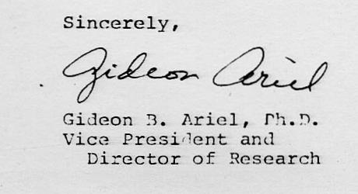
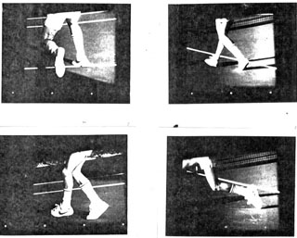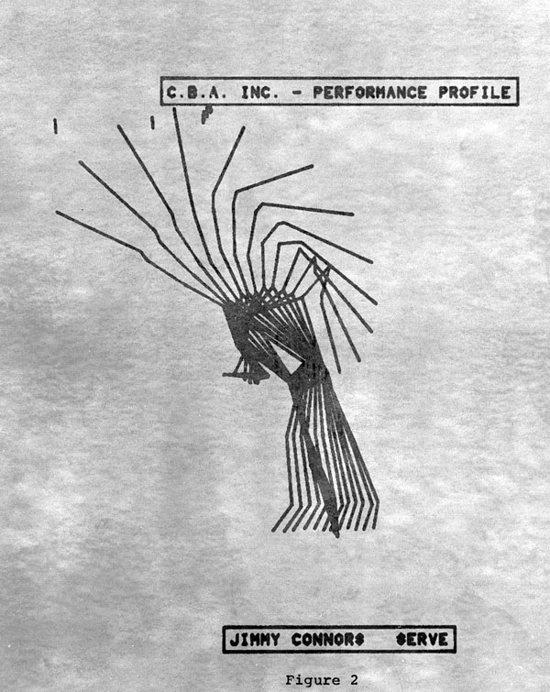

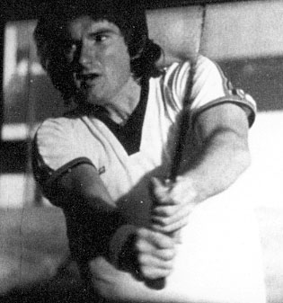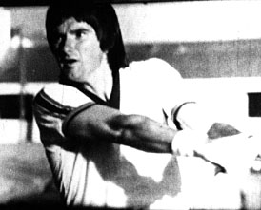

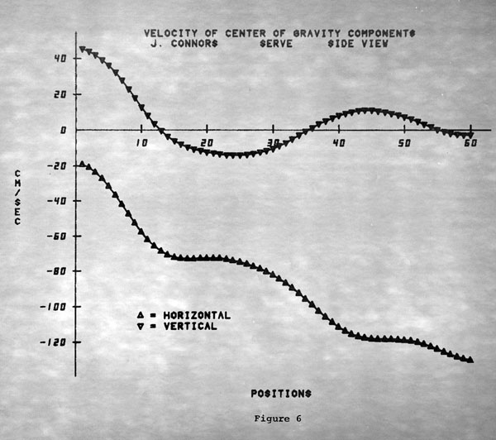
Selected images, stick figure and graph from vast amount of data
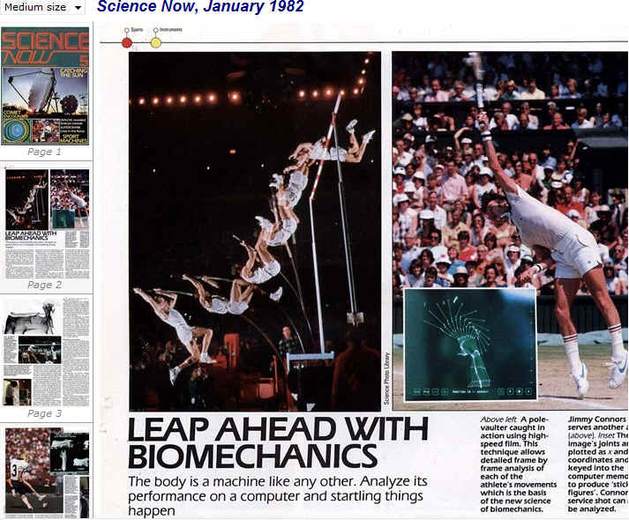
Hundreds of famous tennis players visited our Laboratory at the Coto Research Center. Here are some figures of few of them:
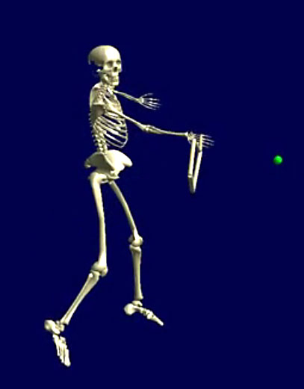 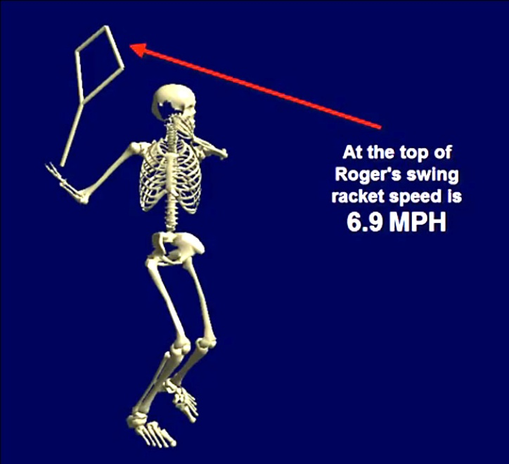
Henning Federrer
Our background in studies with Spalding, AMF and Wilson Sporting good brought us additional studies to Coto. Particular Wilson Sporting Good was nice to us. We analyzed every Golf Club and every Tennis Racket Wilson Sporting Good manufacturer to that date. I am sure that allot of our research studies are still incorporated into the equipment today.
With having Vic Braden on our end and our background in Tennis equipment we basically were the World leaders in the current knowledge in Tennis.
Here our article we provided to Wilson Sporting Good of the “Current Research and knowledge in the Tennis Game.”
CURRENT RESEARCH IN TENNIS
Gideon B. Ariel, Ph.D.
Vice President and Director of Research
M. Ann Penny,Ph.D. President
CURRENT RESEARCH IN TENNIS
With the popularity of tennis expanding at a rate beyond imagination - some reports estimate over 40 million Americans now play - a better understanding of the mechanics of the game becomes more and more of a necessity. Tennis is not a ball, a racket, and a player that can be considered separately, it is a series of interactions between the ball and the racket, the ball and the surface and the racket and the player. Because of this, there are many misconceptions about the game and the contribution of each component.
Consider first the ball/surface interaction. Balls
are tested during manufacture using a bounce test which is based on attaining a certain coefficient of restitution, i.e., ratio of velocity after impact to that before. Extensive studies of the mechanics of ball/surface impact show that the coefficient of restitution actually varies quite a bit under actual playing conditions depending on velocity, angle of approach and playing surface. Thus while all balls meet the same specifications on the drop test, they react quite a bit differently under actual conditions. The main reason for this is that the drop test is simply a normal (perpendicular) impact while under game conditions friction and changes in angular and linear momentum (mass times velocity) all have an effect. It was found that the friction forces involved were quite high which meant that a basic conservation of energy approach is not viable. The force and torque data obtained during testing showed that during the impact rolling, sliding, and skipping all occurred. In some cases it could be seen that the ball would be sliding and skipping at the same time, i.e., while sliding, a small part of the area of the ball in contact with the surface would vibrate, or skip.
The ball/racket interaction tests provided a new, and sometimes completely different, insight into the mechanics of the game. A series of tests were performed in which tennis balls were fired into rackets held by a simulated hand grip. The balls varied in construction and inner pressure while the rackets varied in frame stiffness and string tension. Ball residence time on the racket was measured as was peak force and change in momentum. The residence time varied between 3.6 and 4.2 milliseconds. Since human reaction time is approximately 130 milliseconds, it is not the ball on the racket which is felt but rather the rackets reaction to the impact. When the ball leaves the racket, the racket head has just begun to move. Up until approximately 10 milliseconds after impact only the strings have deflected. After that the frame deflects and then vibrates with an amplitude of about one inch.
By analysis of the data obtained it was also discovered that ball residence time (time in contact with the racket), peak impact force and change in momentum did vary independently with changes in ball construction, ball pressure, frame stiffness and string tension. Peak
impact force, for instance,would increase as string tension increased for a ball with normal internal pressure but would decrease as string tension increased for a low pressure ball. Many other such characteristics were discovered involving ball and racket design which led to the conclusion that the ball and racket cannot always be considered independantly. Thus design changes made in balls in order to produce better surface rebound can produce completely opposite effects in different rackets.
The third area of study was that of the player/racket interaction. Much research is needed in this area because of the injuries and ailments common to many tennis players such as tennis elbow. Biomechanical analyses were performed to determine the effects of the ball/racket impact on the players themselves. The first thing discovered was that the shear forces in the elbow that result are triple the original impact force. In addition, they occur so fast that the muscular and connective tissue cannot react and are therefore unable to function as shock absorbers, resulting in traumatic effects on the tendons and the ligaments.
When a player is moving about on the court, he/she must absorb nearly five (5) times the body weight in the knee and ankle joints. Thus players weighing 150 lbs subject their knees and ankles to forces up to 750 lbs. Tennis shoes and courts, then, must be designed to have the correct energy absorption, compressive stiffness and recovery rate needed to protect the players.
In general, traumatic effects result from the repetative shocks caused by the running and jumping motions associated with tennis. To reduce exposure to these shocks, practice devices should provide the opportunity to improve tennis skills while simultaneously lessening the stresses related to the game.
One well recognized term in tennis is the "sweetspott" on the racket. The term refers to the center of percussion of the racket and can be calculated mathematically quite readily. It is usually found to be on the string somewhere between the center of the strings and the throat of the racket. This is a result of assuming the pivot point to be at the handle. Analysis of high speed film, however, has shown that the handle-wrist-hand connection is a fairly rigid one and that the pivot point is actually the shoulder. Using the whole arm as the system then results in a center of percussion slightly above the wrist.
The studies performed showed that there is much to be understood yet about the interrelationships of the various components that make up the game of tennis. Further study and research will lead not only to improved equipment but, hopefully, to decreased risk of injury.
The following photos show collection data on the muscular responses to impact of the tennis ball on the racket. And, the effective muscular action on the racket utilizing Electro- Myography (E.M.G.).
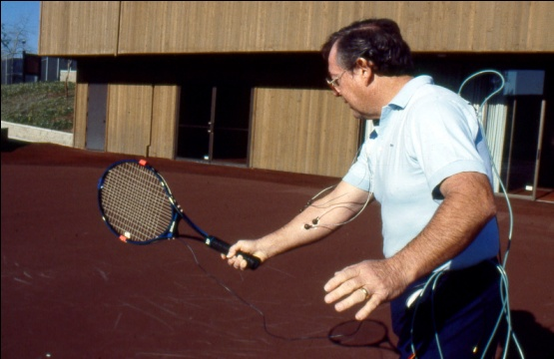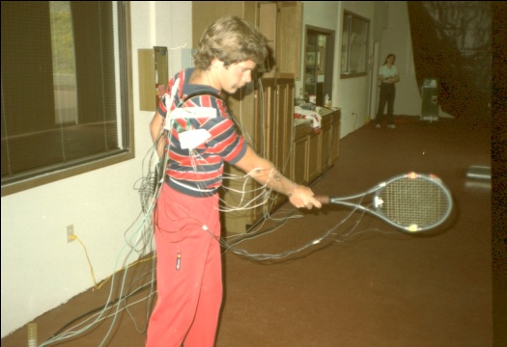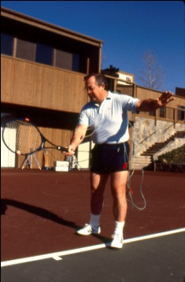
With the notoriety that we received, the new quadrennial Olympic Sports Medicine Committee met in the Coto Research Center:
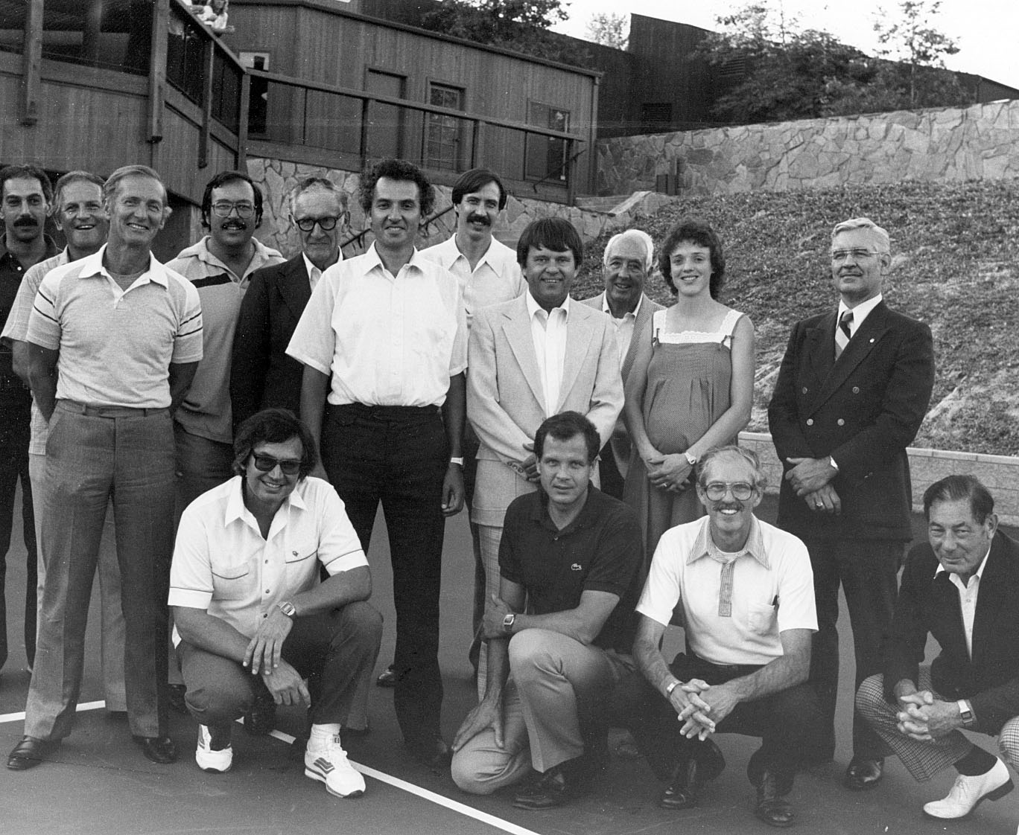
The U.S. Olympic Sports Medicine Committee 1980-1984
I was appointed for additional 4 years as serving as the Chairman of Biomechanics.
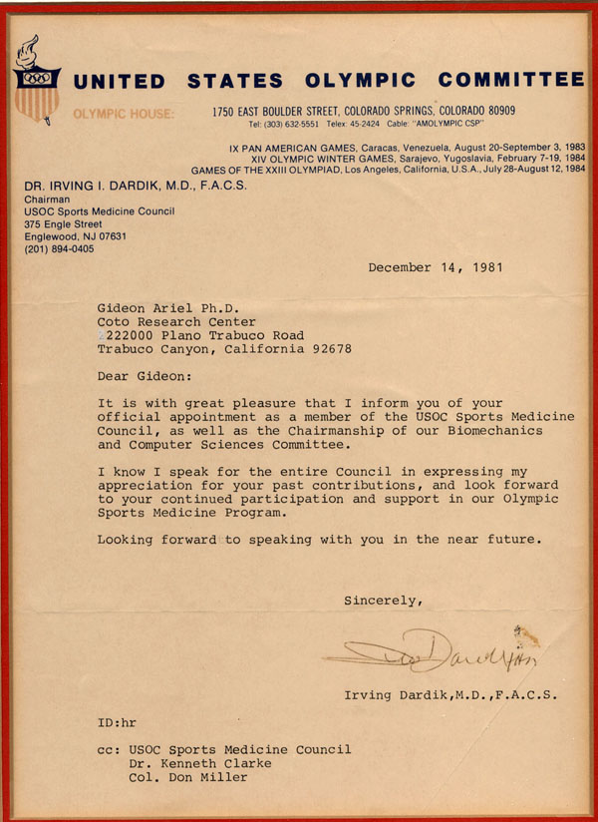
Here is the text:
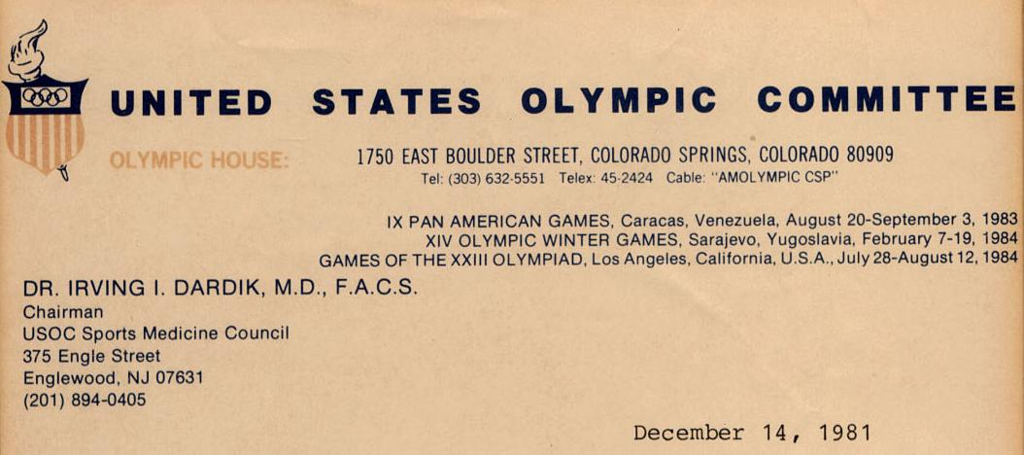
Gideon Ariel Ph.D.
Coto Research Center
222000 Plano Trabuco Road
Trabuco Canyon, California 92678
Dear Gideon:
It is with great pleasure that I inform you of your
official appointment as a member of the USOC Sports Medicine Council, as well as the Chairmanship of our Biomechanics
and Computer Sciences Committee.
I know I speak for the entire Council in expressing my appreciation for your past contributions, and look forward to your continued participation and support in our Olympic Sports Medicine Program.
Looking forward to speaking with you in the near future.
cc: USOC Sports Medicine Council Dr. Kenneth Clarke
Col. Don Miller
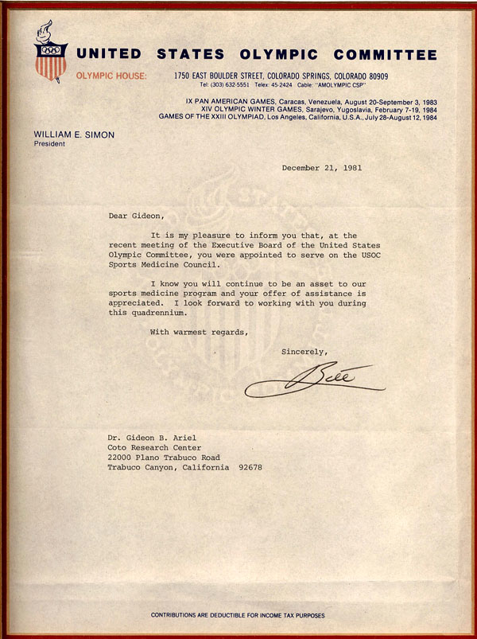
Text Read:
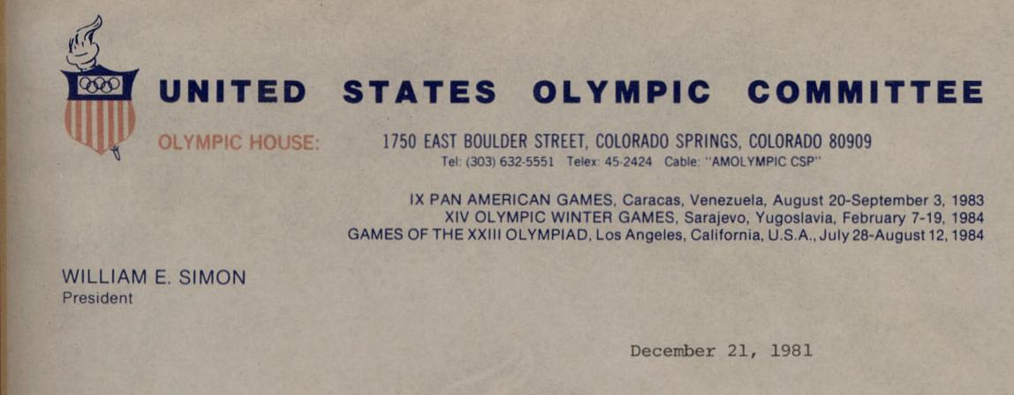
Dear Gideon,
It is my pleasure to inform you that, at the recent meeting of the Executive Board of the United States Olympic Committee, you were appointed to serve on the USOC Sports Medicine Council.
I know you will continue to be an asset to our sports medicine program and your offer of assistance is appreciated. I look forward to working with you during this quadrennium.
With warmest regards,
Dr. Gideon B. Ariel
Coto Research Center
22000 Plano Trabuco Road
Trabuco Canyon, California 92678

And the Coto Research Center was designated as an Olympic Training Site:
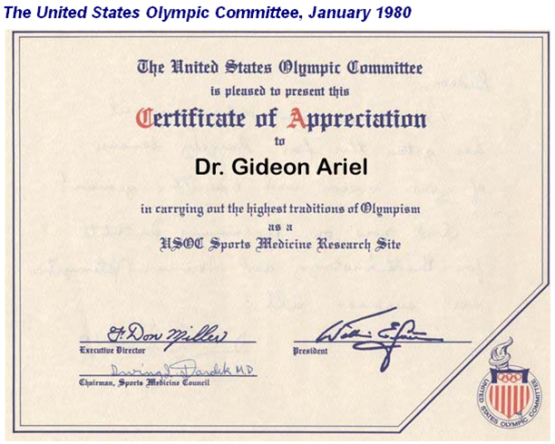
At that point I had the first contact with the Organizing Committee to select venues for the 1984 Olympic Games in Los Angeles. Could I get one of the sports to come to compete in Coto De Caza?
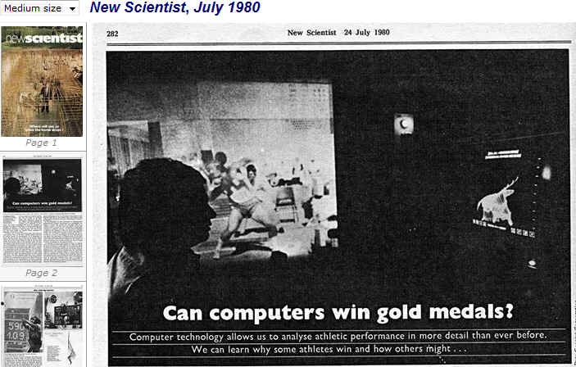
Well, it was all depends on decision by one person: Dick Surgent.

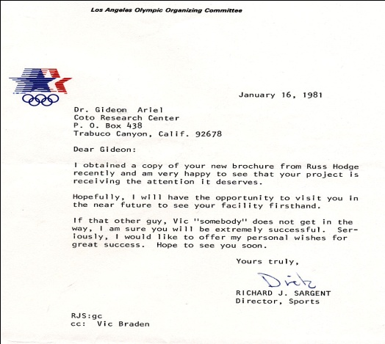
The text read as follows:
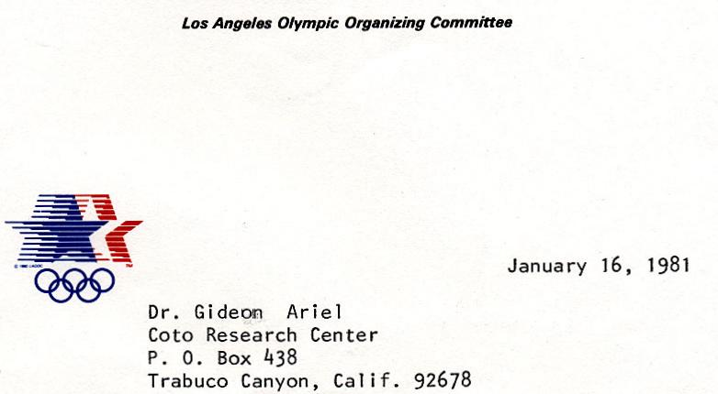
Dear Gideon:
I obtained a copy of your new brochure from Russ Hodge recently and am very happy to see that your project is receiving the attention it deserves.
Hopefully, I will have the opportunity to visit you in the near future to see your facility firsthand.
If that other guy, Vic "somebody" does not get in the way, I am sure you will be extremely successful. Seriously, I would like to offer my personal wishes for great success. Hope to see you soon.
Yours truly,
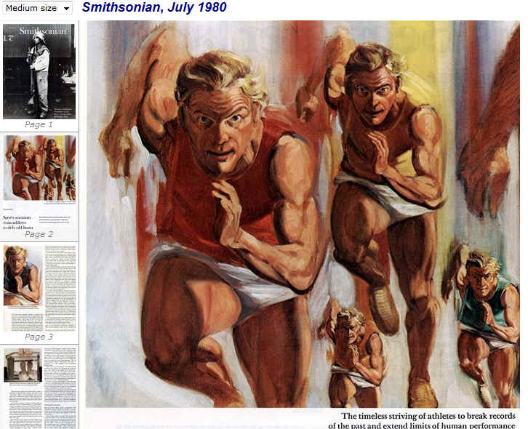
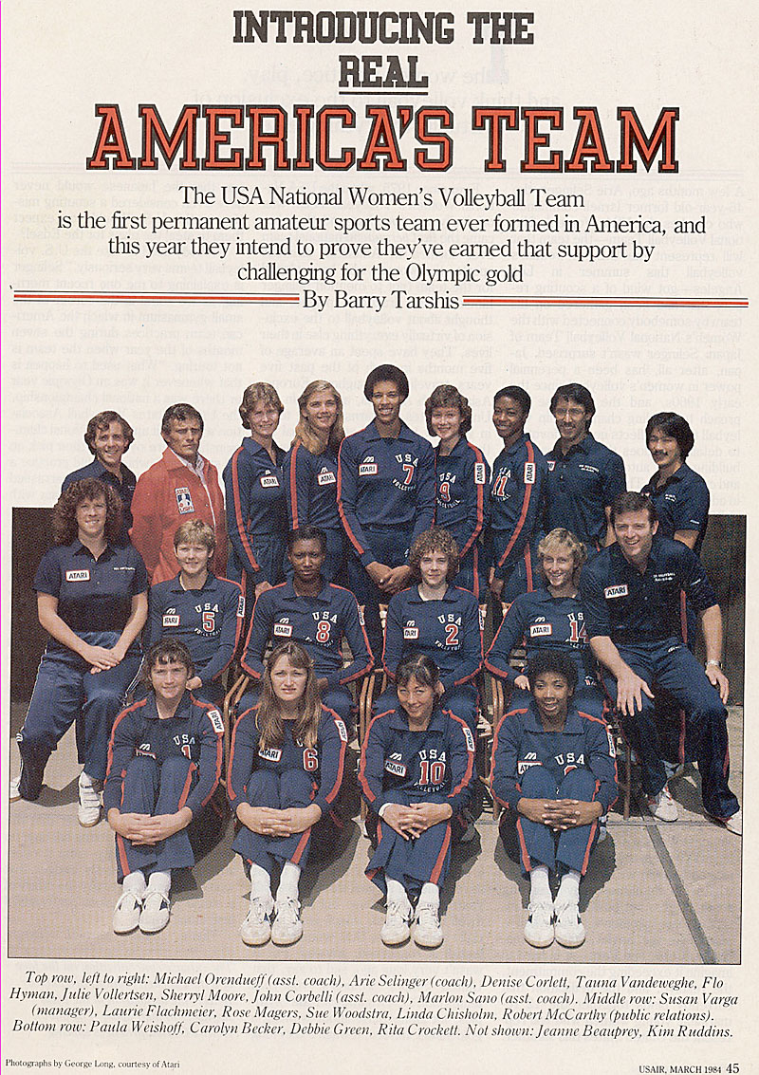
In 1977, the US Women Volleyball team moved to Colorado Spring Training Center. While being the Chairman of Biomechanics I met Dr. Ari Salinger, the head coach for the team. We have discussed many of the skills necessary to develop and training methods etc. The US Women team was ranked 45th in the World.
At that time, in 1977, the training center was still under development. The girls were housed in a Military Barrack where each 4 girls had a room. The facilities were in the end of the hall to have them share. The dinning room supply regular meals but not programmed specifically for performance. Also, Colorado Spring is 7000 feet altitude which could be good for long distance running training but not conducive for volleyball training.
Regardless, Dr. Salinger did a fantastic job. The team became better and better. But, still not a medal contender by any means.
I asked Dr. Salinger, who became my friend by that time, to write a wish list for training for his team. I asked him to direct the letter to Dr. Dardik, the Chairman of the Sports Medicine Committee.
And this what I received:
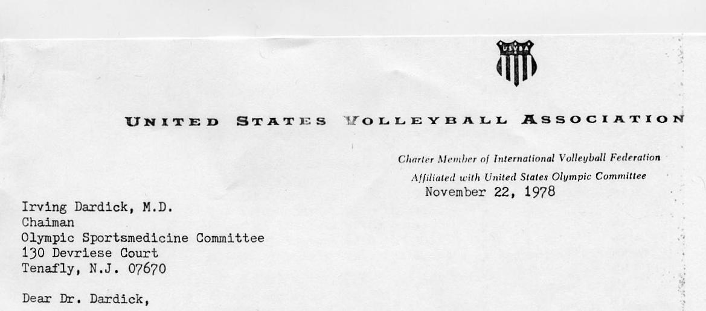
The USA Women's National Volleyball Team has been training at the Olympic Training Center in Colorado Springs since March 1978. The team undergoes a very intensive training program, 6 hours per day, 6 days per week, all year round. The main goal of the program is to secure qualification for the 1980 Olympic Games in Moscow.
To facilitate the program's success, I need to call upon the help of the Olympic Sportsmedicine Committee in the following areas:
- Biomechanical analysis of techniques
- Strength program
- Evaluation of physical conditioning parameters
- Psychological consultance
- Flexibility program
Without objective information and experts' consult the Women's Volleyball Team will fall short of achieving its maximum potential.
The following is a tentative schedule for initiation and implementation of programs in the above mentioned areas.
Biomechanics
Stage 1. Pilot study to asses the feasibility and value of computorized analysis of certain techniques in volleyball. This stage was accomplished during the months of July - November, 1978, by Dr. Gideon Ariel.
Stage 2. In depth analysis of spiking, blocking and passing techniques. Parameters to be measured:
Spiking
A. Approach
- Proportions and sizes of approach steps
- Relationships between the speed of approach and height of jump and the speed of the ball after contact.
- Path of the Center of Gravity
- Arms swing forward and backward, straight arms or bent arms
B. Take Off
- A Hop versus Step Close take off
- Pressure applied by each foot
- Body's angles at knees, ankles and hip
- Coordination between arm swing and legs extension
- Horizontal and vertical velocities
- Psychological Consultance
- The special training situation of the volleyball team requires the constant
- availability of a sport psychologist expert at the Training Center and also, during competition.
- Flexibility Program
- Flexibility is instrumental to high quality performance in any type of athletics. Effective flexibility program needs to be an integral part of the dayly routine practice, 30-40 min. per day. Therefore, residency of an expert at the training center is required.
C. Flight Phase
- Displacement of body's Center of Gravity
- Velocity of body's Center of Gravity
- Acceleration of body's Center of Gravity
- Angle of flight
- Coordination between arms (left and right) and legs before
and after contact with the ball
- Speed of the ball after contact
- Height of contact with the ball
- Height of body's Center of Gravity at contact with the ball
D. Speed of Ball After a High and Low Sets
- Before and after contact
- Comparison speed of balls for different sets, set by different setters
Blocking
Comparison Between the Speed, Displacement of Center of Gravity and Height of Three Blocking Techniques For Individual and Group Block.
- The Shuffle techniques
- The Cross Step and Hop techniques
- The Turn and Cross Step techniques
Stage 3. Defensive Techniques (pilot study)
- Assesment of individual reaction time
- Measurement of speed of body movement while extending for spiked ball
Stage 4. Comparison between techniques used by the USA players and by other top international volleyball players
Time Table
Stage 1. Accomplished
Stages 2 & 3.
- December 13, 1978 - Data collection in Colorado Springs.
- December 18 - December 24, Data processing and analysis. The data analysis will be made at the Computorized Biomechanical Analysis Laboratory, 316 College St. Amhurst, Mass. by the coaching staff under the supervision of Dr. Gideon Ariel.
Stage 4. Data collection at the Pan American Games, July 1979.
Strength Program
The volleyball program needs an expert consultance in the development of a sound and reliable weight training program.
Evaluation of Physical Conditioning Parameters
During the months of June and August, the volleyball team undertook physiological testing at the Sportsmedicine Laboratory in Colorado Springs, US Olympic Training Center. Additional tests should be made at the following dates:
- 27-29 December, 1979 •
- 3-5 March, 1979
- 10-12 April 1979
- 25-27 June 1979
(to be completed)

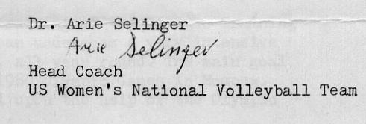
Copies: Dr. Gideon Ariel
Albert M. Monaco
I have discussed these requirement with Dr. Dardik and both agreed to meet with Colonel Miller to see how we can achieve these goals.
The description of the Women Volleyball life in Colorado Spring was covered in the following article:
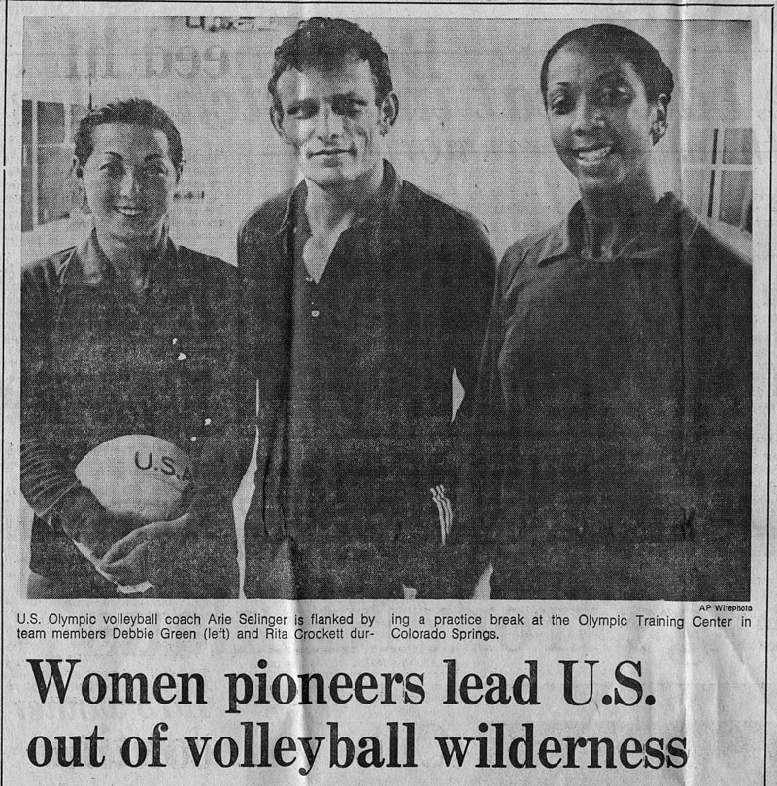
By Skip Myslenski
Chicago Tribune Press Service
COLORADO SPRINGS—In March of 1978, two dozen women moved into quarters here they would soon be calling The Compound and began their lives as pioneers. "We're an experiment," Rita Crockett says now as she sits on the front steps of Building 13 at the Olympic Training Center. She is 21, a college dropout, and one of those two dozen —a member of the United States women's volleyball team. "I guess you could call us guinea pigs."
Never before had the United States brought a national team together so early; never before had a national team been offered the training advantages customarily granted its competitors throughout the world. Its challengers in Japan, Korea, Cuba, Russia, and Hungary had lived and practiced together for over a decade, but until now this country had been satisfied ,with doing no more than throwing strangers together at the final moment and then telling them to play.
The results, of course, have been disastrous. In 1964, the first time their game was an Olympic sport, they finished fifth in a field of six; four years later, they finished eighth in a field of eight; in 1972 and 1976 they failed even to qualify for the Games, and their status was so low that other countries refused to send their finest squads to America compete.
But things have changed. "We have," says Arie Selinger, the coach whose regimen has caused that change, "improved from nothing."
"IT'S DIFFERENT," says Debbie Green, a teammate of Crockett's. "The hard part is being away from home. I'm an only child and very close to my parents. Then, living together with so many girls, living in one room sharing a bathroom, well, it's Efferent."
"For me, like before I moved here, I'd been living in a high-rise apartment, so this was a lot different," says Crockett. "But we've already achieved our big goal, being qualified to go to the Olympics. Debbie and I were talking about it last night. She's been doing this for six years. I've been doing it for two. All for what? For six matches."
"But you don't always think just of the matches," says Green. "Even if I quit right now, I couldn't say I've wasted my time. This has made me more confident as a person. I've been around the world more than once"—and she smiles—"though once would have been enough."
"WE'VE BEEN to places we never dreamed of going," says Crockett. "Russia, China, places we would never have seen. It's helped me become a lot stronger, too. Mentally strong."
"Stilt, after practice, sometimes it's, OK, lets's go back to The Barracks and get homesic':,' " says Green. "You miss things."
"Like boyfriends," says Crockett.
"Saturday nights are the hardest," says Green.
"You're in your robes, writing letters," says Crockett. "You write and write and write."
"So you get mail back," says Green. "People say, 'Why are you doing this? You're crazy. I'd never do that,' " says Crockett. "I have a lot of friends who don't understand that volleyball has to come first in my life. But my family's been great, my boyfriend's been great. We might have gotten married this s^{u}mmer. But he said, We can always get married. You can't always go to the Olympics.'
"My goal has been to go to the Olympics, and I figured this was my last chance and I could go to school later," says Green. "But right now I'm counting the months until it's over. We've just put so much time into it."
SO HAS ARIE Selinger. He is a taut, gaunt man who was born 42 years ago in the Jewish ghetto of Krakow, Poland. During World War II he and his family successfully hid from the Nazis for two years, but they were finally caught and then shipped to the concentration camp called Bergen Belsen. In 1945 he was stuffed inside a boxcar, headed toward an execution site, when the train was captured by American soldiers who liberated the prisoners.
He and his mother moved to Palastine, where he served in the military and competed as a sprinter, long jumper, pentathlete, and volleyball player on Israel's national teams. He later coached men's club teams and that country's national women's team before moving to the U.S. in 1969 and enrolling at the University of Illinois, where he earned a Ph.D. in the physiology of exercise. In 1975 he was named coach of the women's team here, and last year he, his wife, and one of their daughters moved into the barracks across the path from the one that houses his players.
HE IS NOW in one of his rooms, buried in an easy chair, regularly lighting and sucking deeply on filtered cigarets. "Take the top teams in the world," he is saying. "Korea. China. Cuba. Russia. Japan. Peru. They're all working the same system, they're all practicing six hours a day, six, seven days a week. If you want to get to the top, you must penetrate these teams.
"How? You assume we have an edge in talent. What is it? Ten per cent? Fifteen per cent? That's not enough to beat these teams, so you have to come close to doing as much as they do. Japan works eight hours a day. We work seven. This is the logical approach. We have to do it or we're out of it.
"People tend to say, 'Look, we don't have to be like other countries.' That's true. But if we're going to compete internationally and in the Olympics, to send them without preparation is not good, either. You get the argument that we're trying to develop sport monkeys, that they're not going to school. I don't understand that.
"People can accept a person practicing the violin eight hours a day, but they can't accept a person practicing athletics eight hours a day. I don't know why. So, sure, it's been a constant battle, a constant fight to improve."
In the end of 1979, I had a serious conversation with Ari Selinger. I told him: “Ari, to earn a medal in the Olympics, you cannot do it from Colorado Spring.” “I know” Ari replay and made sure he telling me that I am working against my own committee by advocating such a statement.
So, I told him. “Ari what if I will show you a place where you can prepare the girls for Gold Medal?” “Where?” Ari asked. And I have told him about my new research center in Coto De Caza. I told him that I will fly him to show him the place.
The next week Ari came to visit with me at Coto. His eyes were open wide. He could not believe it. I showed him the new court that will be his for training, I showed him my computerized exercise machines and the motion analysis system in operation. I showed him studies I have done before on volleyball. Ari was very implressed. But now the “64 Millions Question” came. “How and who will finance it? Obviously, the US Olympic Committee will not allow me to move here with 14 girls.”
I told him that first he need to tell me if there is a chance for him to move and then I will make the necessary arrangement. He agree.
And here I started working on this idea. I was doing some work with the Mizuno corporation. I was working with them on protection pads and shoes for various sports. And I had to visit with them in Japan.
Ari also met in Japan with Mr. Mizuno who own the company in volleyball turnaments.
My idea was as follows: What if I will suggest to Mr. Mizuno in Japan the possibilities that the American Women Volleyball team will wear their shoes and cloths during international tournament and if qualifying, during the Olympics.
I discussed the idea with Ari, and here is one of his letters:
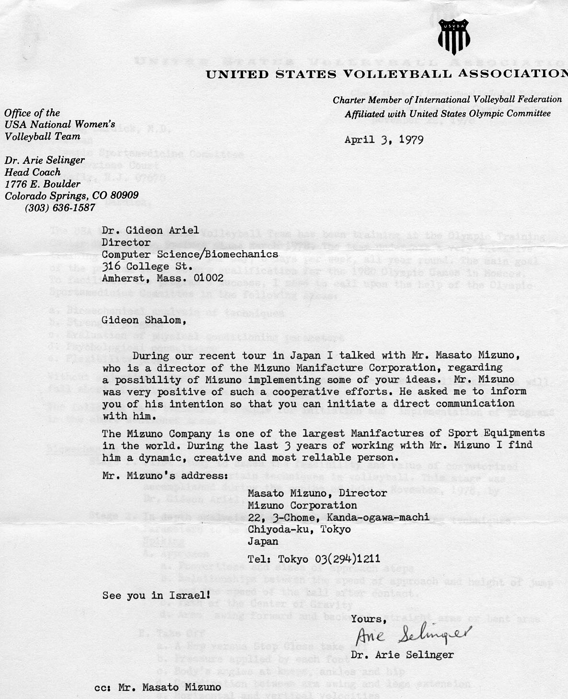
The text read as follows:
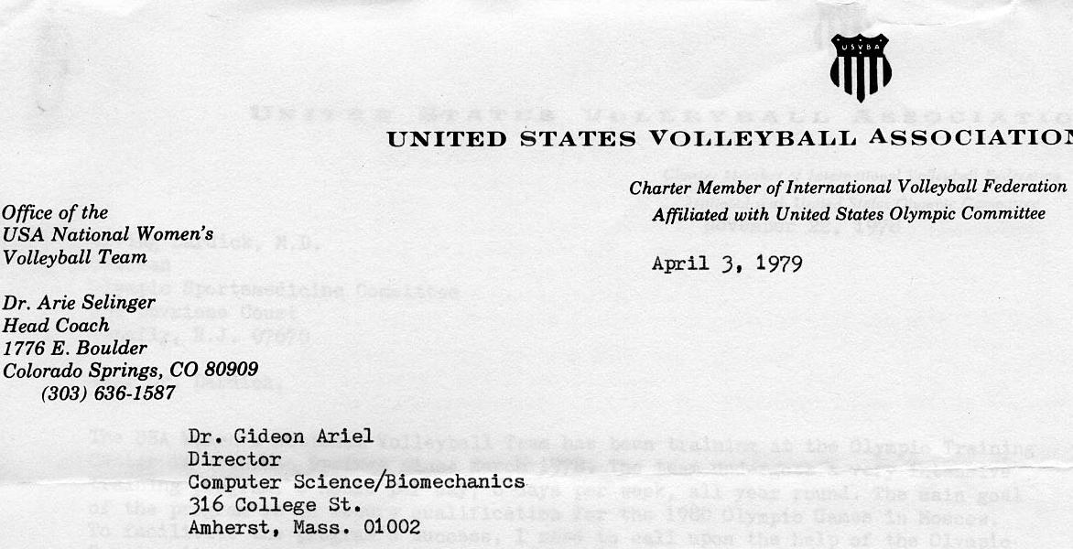
Gideon Shalom,
During our recent tour in Japan I talked with Mr. Masato Mizuno, who is a director of the Mizurio Manifacture Corporation, regarding
a possibility of Mizuno implementing some of your ideas. Mr. Mizuno was very positive of such a cooperative efforts. He asked me to inform you of his intention so that you can initiate a direct communication with him.
The Mizuno Company is one of the largest Manifactures of Sport Equipments in the world. During the last 3 years of working with Mr. Mizuno I find him a dynamic, creative and most reliable person.
Mr. Mizuno's address:
Masato Mizuno, Director
Mizuno Corporation
22, 3-Chome, Kanda-ogawa-machi Chiyoda-ku, Tokyo
Japan
Tel: Tokyo 03(294)1211
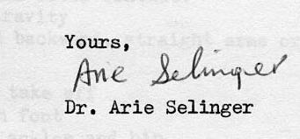

The idea was as follows:
Mizuno will finance the move of the Women US Volleyball team from Colorado Spring to Coto De Caza. I will provide the hosing in Coto in my Condominiums. Mizuno will finance the whole project up to the 1984 Olympic Games in Los Anageles.
The players always will wear the Mizuno cloting and when necessary will integrate it with the Olympic uniform but always will have the Mizuno emblem on the athletic uniform.
The Mizuno corporation went for the deal and signed a contract with Dr. Ari Selinger. The next week after the signing, Ari rented a bus and the whole team came to Coto.
This was a shock. I got in big trouble. But I only said to my defense. “Do you want a Gold Medal in Women Volleyball? This is the only way to do it”. I was not fired. The girls were with us here in Coto for the next 4 years.
Here is the article describe their new life in the Coto Research Center:
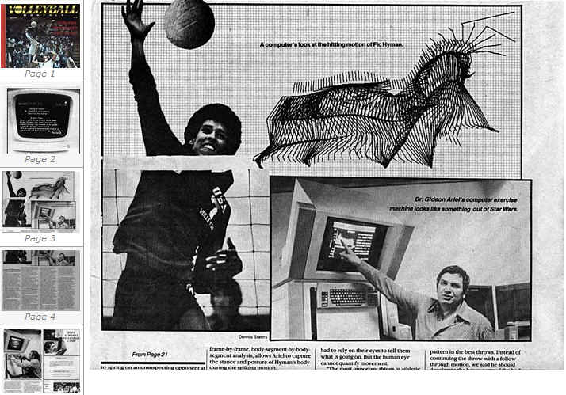
A few months ago, Arie Selinger, the 46-year-old former Israeli commando who coaches the USA Women's National Volleyball Team-the team that will represent the U.S. in women's volleyball this summer in Los Angeles-got wind of a scouting report that had been gathered on his team by somebody connected with the Women's National Volleyball Team of Japan. Selinger wasn't surprised. Japan, after all, has been a perennial power in women's volleyball since the early 1960s, and the Japanese approach to building championship volleyball teams reflects no less devotion to detail than does their approach to building, say, automobiles, cameras, and computers. They like to plan years in advance and leave little to chance.
What did give Selinger pause, however, was the depth of detail in the report. For not only had the Japanese charted the strengths and weaknesses of every young woman currently playing on the USA National Team, they'd scouted the top collegiate talent as well, and even got the book on a handful of talented juniors-anybody, in other words, who stood even an outside chance of representing the U. S. in next summer's Olympic women's volleyball competition. 'One thing about the Japanese," Selinger says, less in anger than in bemusement and admiration. "When they're committed to something, they don't fool around."
Ah so. Then again, Arie Selinger doesn't fool around, either. For whatever commitment may be fueling the National Women's Volleyball Team of Japan as it prepares for the 1984 Olympics and, while we're on the subject, whatever commitment may be driving some of the other powerhouses in international women's volleyballteams like the Soviet Union, China, Korea, Cuba, and Peru-it is hard to imagine it exceeding the commitment, the resolve, and the dedication that currently binds together the 12 remarkable young women who will represent the United States this summer.
Ever since 1975, when the USA National Women's Volleyball Team was originally put together and thus became the first permanent national team ever formed in American amateur sports, the women who have played for the team (not to mention Selinger himself) have practiced, played, and thought about volleyball to the exclusion of virtually everything else in their lives. They have spent an average of five months in each of the past five years traveling throughout Europe, Asia, South America, and within the United States on barnstorming tours in which it has not been unusual for them to play as many as 28 matches in 28 consecutive days. When they are not traveling, they train eight hours a day, six days a week (okay, they only train for half a day on Saturday) and they do so with a dervish-like intensity. And because they are "amateurs," in an "amateur" sport, they receive no salaries as such-only room, board, and a modest sum for expenses each month to cover such luxuries as personal clothing, suntan lotion, and long-distance phone calls to families and boyfriends. Nobody on the team, in other words, is here for the money, and because most Americans don't even know we have a national women's volleyball team they are certainly not on the team for personal glory. They're on the team fQr one basic reason: to win an Olympic gold medal for the U.S. in women's volleyball.
Now had there not been the Olympic boycott in 1980 (which Selinger and the rest of the USA Women's National Team, by the way, bitterly opposed), it is conceivable that the team might have achieved its goal three and a half years ago in Moscow, but let us not dwell on the past, which isn't especially bright where U.S. women's volleyball is concerned, anyway. For it wasn't very long ago, sad to say, that United States women's volleyball teams didn't even qualify for the Olympics, let alone think about winning a gold medal. Indeed, it wasn't very long
ago that the Japanese would never have even considered a scouting mission in the U.S. Would you expect them to steal the plans for the Edsel?
"Nobody used to take the U.S. Volleyball teams very seriously, " Selinger is explaining to me one recent morning, as we stand in the corner of the small gymnasium in which the American team practices during the seven months of the year when the team is not touring. "What used to happen is that whenever it was an Olympic year or there was a national championship, the United States Volleyball Association would wait until the national championships were over and then pick an 'all star' team, which would practice a few weeks and then get embarrassed anytime they had to play a team with any sort of national program, like Japan or the Soviet Union."
Selinger is a solidly built, impressive looking man of medium height who has chiseled features and striking blue eyes, and who usually carries with him the vaguely reflective, slightly pained expression of a person who is walking around with far too many things on his mind. No wonder. Coaching a women's volleyball team that travels five months a year and trains almost daily the rest of the time is every bit as technically, logistically, and psychologically demanding as coaching a professional basketball team, except that Selinger has to do it with a skeleton of an administrative staff-the manager, Susan Varga, doubles as the trainer. It wasn't until earlier this year that the team had anybody working full time on promotion or publicity-and it operates with a total yearly budget that wouldn't be enough to pay the salary of a single player on most professional basketball teams.
That's under normal circumstances The intense concentration on the face ofRita Crockett (bottom two photos) reflects the dedication of the team members to their sport. Top photo, Denise Corlett practices spiking.
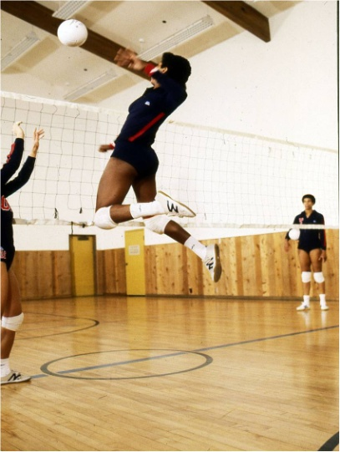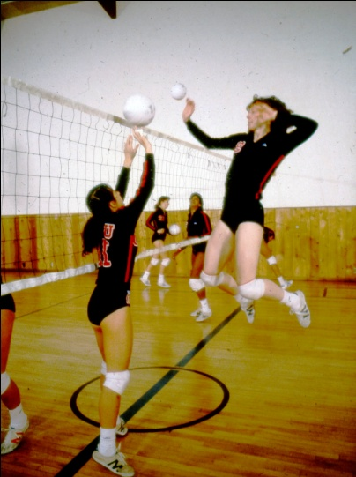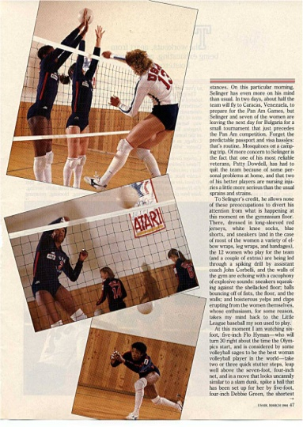
The girls were training on my Computerized Exercise Equipment every day for 4 years. The average increase in vertical jump was around 6 inches and in some cases 8 Inches.
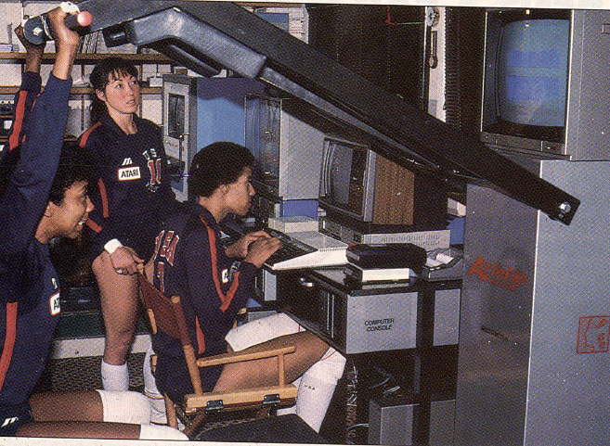
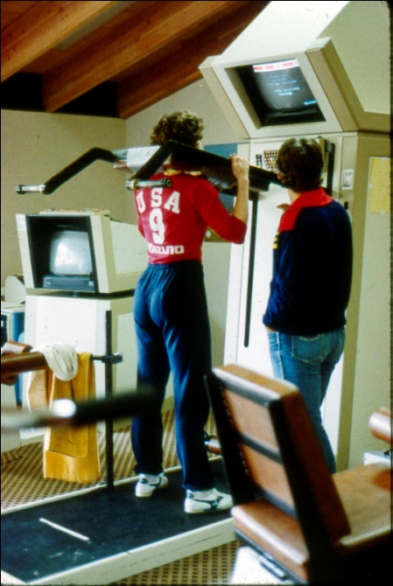
Training on the Computerized Exercise Equipment
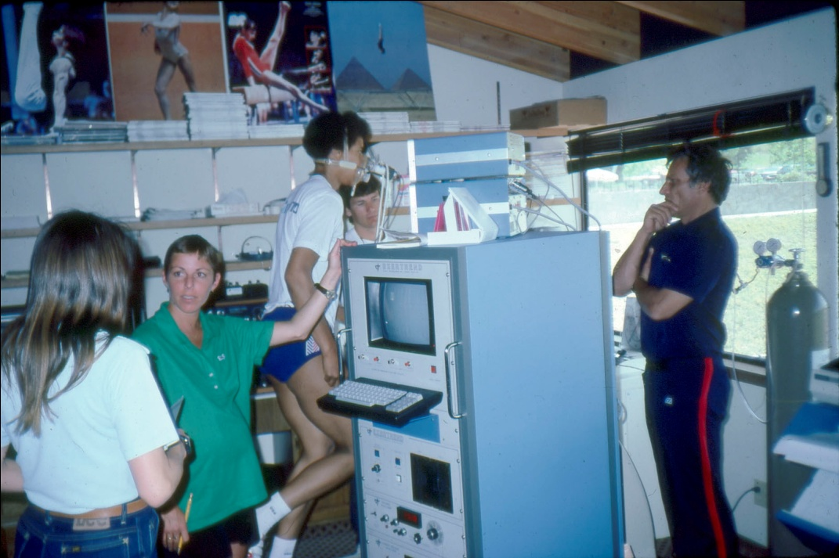
Measurement of Cardio-Vascular parameter and Oxygen Consumption.
The girls were running the equipment by themselves and learned how to digitize their motion. Than we would have conferences to discuss the results with Ari and determine on our next move.
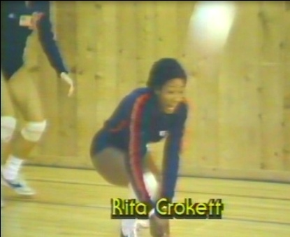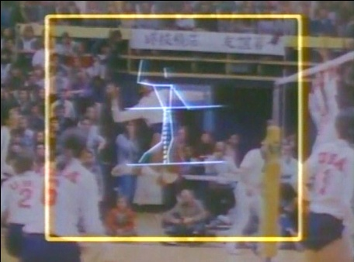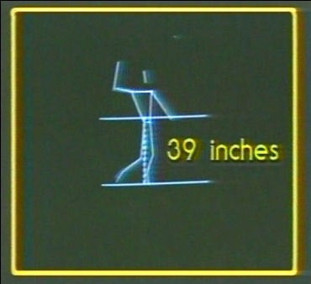
Four years of effort, and from rating of 45 to rating on first in the World. In the Olympics the team won the Silver Medal after losing at the final to China.
We beat the Chinease team in the Quorter Final easy. But we lost in the Final when we had to play against them again. Why? Because they got our “secrete”. We had a secrete that the World did not know and we beat all the teams in the World. We were the World Champions in 1983 and 1984. What was the “Secrete”. I will tell you now.
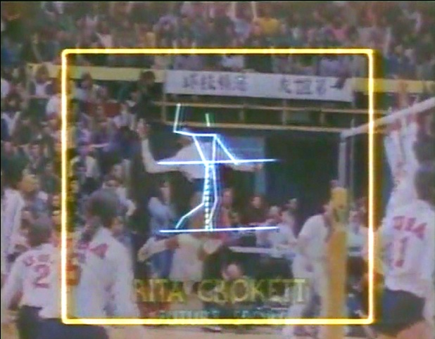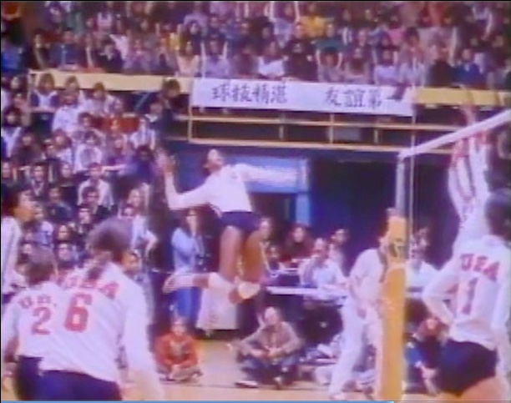
Coach Dr. Ari Selinger and Me and my Biomechanical research team travel all around the World and we collected data on all the teams in the World. We would go to World Championship and collect data on all the teams. Russia, Cuba, Peru, Brazil, Japan, China and any country that would participate. Then, we would digitize the data into the computer in a way that we knew any move a team would do under certain condition.
We divided the court to 36 squares and each square had its own number. The following figures show only two of many hundreds:
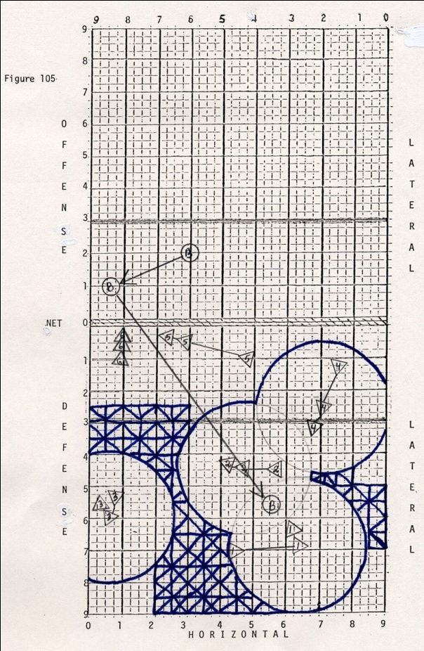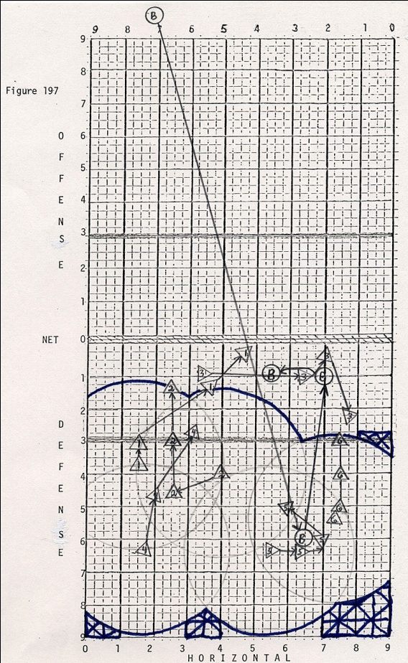
Our software calculated under any condition what the opposite team would do. In Volleyball, you cannot wait for the ball to be spiked, or hit. You need to be in a position to predict where the ball will come since the time from hit to the ground is only .2 second or so. By knowing how the teams move and how they arranged themselves we would know what they will do when we “pretend” to spike. In addition we would learn about their movement on the field as the following figures show:
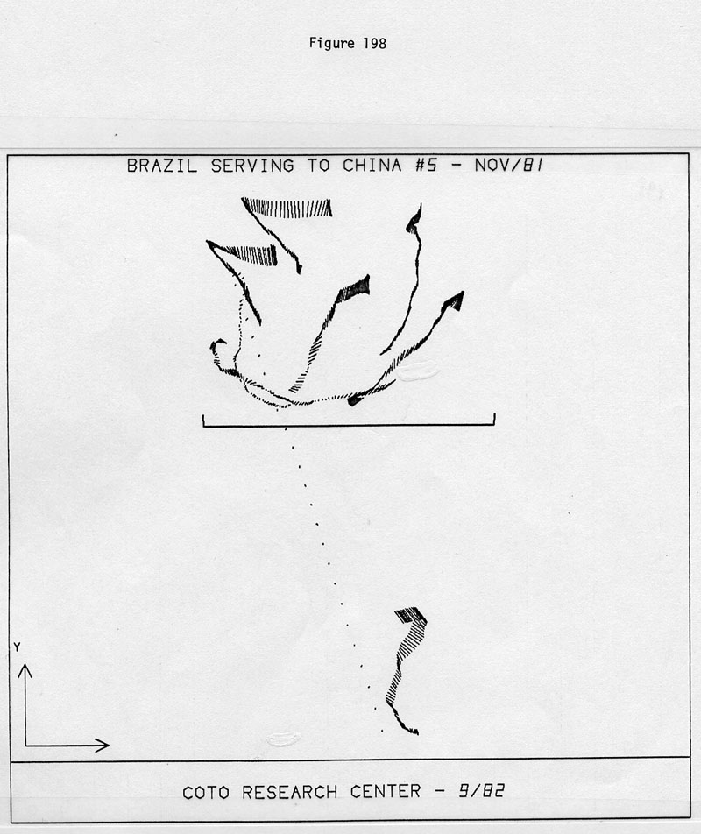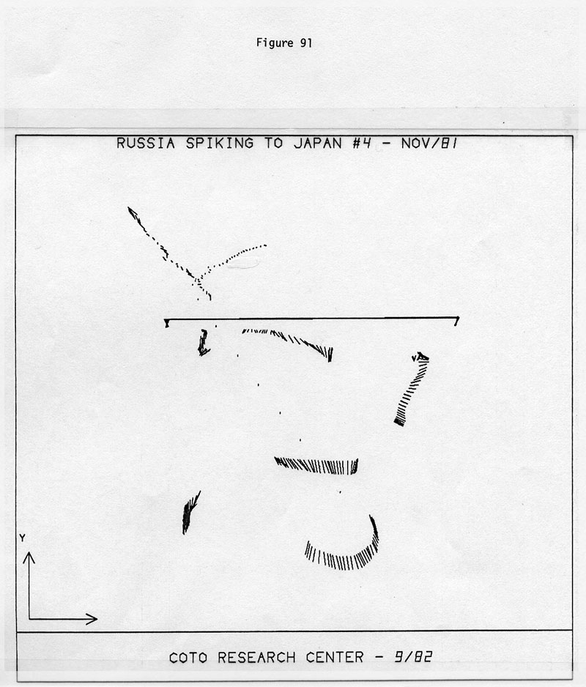
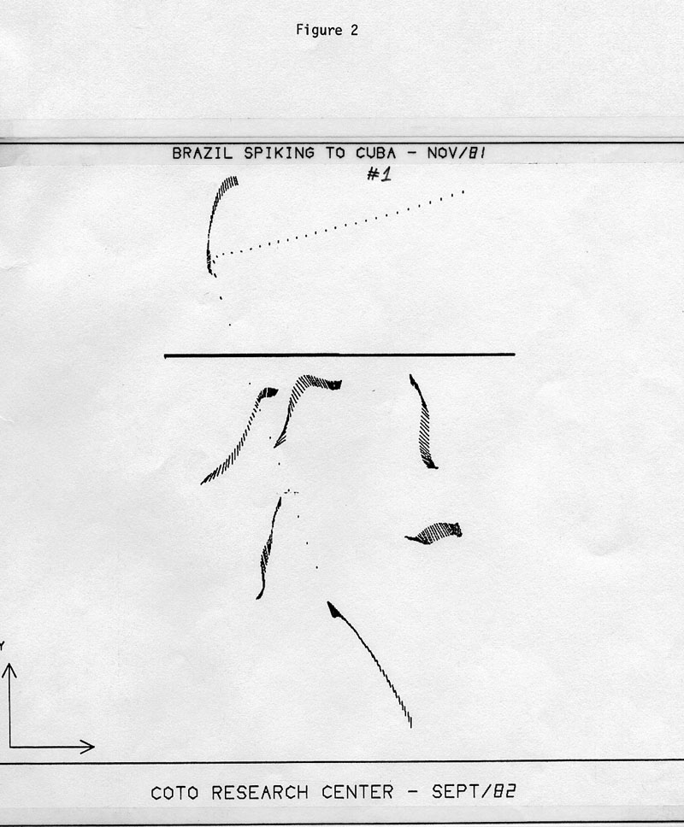
Under any condition, we would know what the opposite team is going to do. It is like playing poker against someone and have a mirror behind him.
In addition, we would train on the court in Coto with a machine that simulated every spike or shot that was known form the data. We had a sheets hanging from the ceiling and we would project video and films from the real game and play against the silhouette on the sheets. In fact, Ari would speed up the projector so effectively we were playing against simulated faster team from reality. When our girls than played against these teams, they would comment how slow they were in that day.
This is the way we won the World Championship and almost won the Gold Medal. We used the state of the art technology that the Coto Sports Research Center could provide to get the most advantage over our opposing team. We did not have the DNA like the Chinese, for Volleyball, but we did have the technology.
It was not cheap to run the Coto Research Center. Allots of expenses. However, we had enough projects with large corporation to be very successful.
One of the corporation that financially we benefited the most was Wilson Sporting Good. They were really nice to me. With all the work that I did for them in Amherst and with all the innovations that I have introduced them to, they gave us many projects and paid very well for it.
Here are some of the projects:
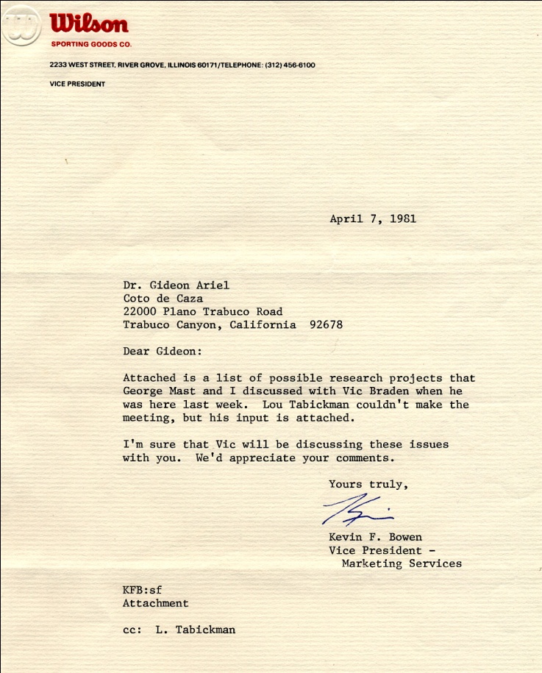
April 7, 1981Dr. Gideon Ariel
Coto de Caza
22000 Plano Trabuco Road
Trabuco Canyon, California 92678
Dear Gideon:
Attached is a list of possible research projects that George Mast and I discussed with Vic Braden when he was here last week. Lou Tabickman couldn't make the meeting, but his input is attached.
I'm sure that Vic will be discussing these issues with you. We'd appreciate your comments.

Research Issues 4/2/81
Racket Sports
- Cobra weight
What is the optimal weight/balance for the existing Cobra oversized racket.
0_..• Racket Sweet Spot Size
What is Sweet Spot and how can we measure it in the lab? There are many theories but not many facts.
- Improved Racket Feel
What frequencies are important to racket feel? What frequencies contribute to tennis elbow? Answers to either of these questions could result in dynamic new products.
- Improved Racket Durability Test
How can we speed up racket durability testing? Is our current system really predictive?
Wo Racket Weight Discrimination
We currently manufacture our rackets to exacting weight specifications. Are our standards too strict? Can A players really distinguish between small differences in weight?
- Oversized Racket String
There is a brand of racket string designed specifically for oversized
rackets. To what degree does this string contribute to playability.
411¹-* Ladies' Racket
What factors are really important in the design of a ladies' racket.
- Tennis Ball Accuracy
We believe the Wilson ball is the most accurate/controllable. How can we prove it? This information could be used to develop better products as well as being an advertising claim.
₀4. • Racquetball String
- What is the optimal string tension for racquetball rackets?
- There is a brand of string designed specifically for racquetball racquets. Does it make a difference?
Research Issues 4/2/81
Golf
dt • Golf Grip Shape
We know power lock grip gives a better grip because it allows the small finger to grip more tightly. Is there an optimun grip shape and size for golf clubs? Marketing value if successful would be substantial.
- Golf Grip Hardness
What grip durometer gives the optimum combination of feel and control? 4,4¹- • Golf Club Feel
The primary factor in the choice of a set of clubs is feel. What determines feel and how can we affect it.
- Equal Length Golf Clubs
We have reason to believe that a set of clubs where all the shafts are of equal length will lead to a more consistent and accurate swing. Is this true?
- Golf Club Optimization
What is the optimal loft, tie, and offset for a set of golf clubs?
- Ladies' Club
What factors are really important in the design of a ladies' club
- Golf Ball Sound
What frequency groups are important to making a golf ball sound pleasant? Is it a noise versus sound problem, an amplitude problem, or a duration problem? An understanding of this area would help in the development of
a perceived longer ball, or improving our existing balls. This area could also spill over into club design.
We have performed hundreds of studies to Wilson Sporting Goods during 7 years association with them in the Coto Resarch Center. Here are some abstracts of these studies:
Wilson Sporting Goods
RESEARCH/CONCEPTS GROUP
PROJECT: Tennis ball-racket impact study.
OBJECTIVE: To study the effect of tennis ball and racket parameters on the impact dynamics and subsequently the performance of the ball and/or racket.
BENEFITS: A better understanding of the role of the ball and racket parameters during the actual impact. This is basic information on the relationship between the physical properties (measurable) of the product and the behavior of the product in play.
DISCUSSION: This project compliments the tennis accuracy study. In this case the details of the impact will be studied as compared to the details after the impact in the accuracy test. (A micro vs a macro analysis of the impact.) The same parameters will be varied in both cases. In this study the question will be, "why does?" instead of, "how does?". For example, in the accuracy test we will determine how the accuracy is affected by string tension. In this study we will determine why the string tension causes the ball to behave as it does. If those kinds of questions can be answered, we will be able to specify the physical properties of a component to yield a given performance. At the very, least we should carry the analysis far enough so the effects of changes in a parameter can be used to predict the direction of change in behavior and ultimately performance.
WILSON SPORTING GOODS
RESEARCH/CONCEPTS GROUP
PROJECT: Player response to racket handle shape.
OBJECTIVE: To determine the effect of the shape of the racket handle on the nerve/muscle response of the player and how this relates to the subjective reaction of the player.
BENEFITS: To provide the bases for a handle shape design that has been demonstrated to produce a preferred feel (both subjective and instrumented).
DISCUSSION: This is a continuation of the racket vibration damping experiment. The player will be instrumented in the same manner. The first phase will be to generate nerve/muscle responses as they relate to handle configurations. The next phase will be to relate the measured responses to the subjective reaction of the player. An attempt will be made to optimize the shape to give a "preferred feel". The cross sectional shape of most rackets have only subtle differences. Almost all rackets maintain the shape along most of the length of the handle. Is is known that certain players (usually very good players) have "customized" their handles. This involves sanding down the material under the grip or building up selected areas under the grip. Feel is undoubtedly a complex relationship of several factors. The contribution of each needs to be investigated and this is one attempt.
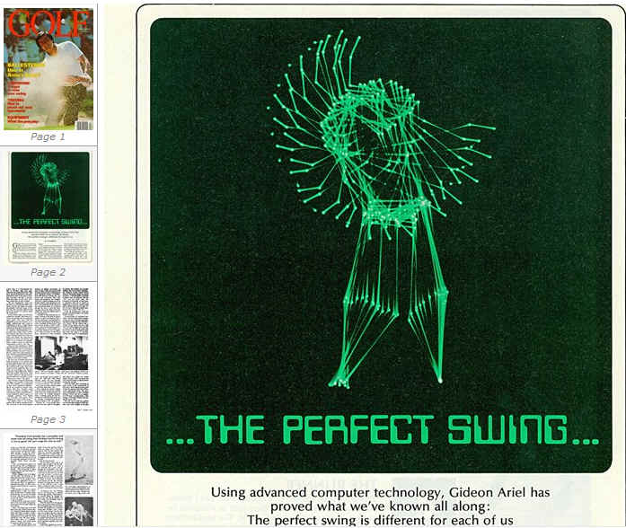
WILSON SPORTING GOODS RESEARCH/CONCEPTS GROUP PROJECT: Putting study.
OBJECTIVE: Determine the factors which affect both line accuracy and distance accuracy when putting and attempt to quantify the results.
BENEFITS: Guidelines will be established for design criteria of putters as they relate to a given ball construction.
DISCUSSION: There is almost and infinite number of putter designs and putting techniques. There must be some common factors or at least a range of properties. We know that most putters fall within a certain weight range. Any type of dynamic characterization is avoided (even swing weight). If we divide the putting strokes into two categories (rotate the shoulders or rotate the wrists) we can narrow the study to a manageable scope. The moment of inertia of the putter about the shaft axis and about the above mentioned rotation axis will need to be categorized. The COR of golf balls at low speeds has a wider range, based on construction, that at high speeds. The first phase will be to measure the "good" putters (actual clubs) and note the putting technique most widely used with the respective putters. The second phase will be to vary the parameters of the putter and note the affect on the distance and line accuracy.
The work on the putters lead us to an amazing idea. We called it the “Magic Putter.”
Based on the studies of putting we came with the following information:
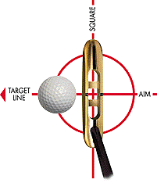

The Magic Putter. The revolutionary putter that was invented on scientific principles and proven by extensive biomechanical tests.
This smartly made golf putter's weight (center of gravity) is carefully calibrated so that when you use it, it's like an extension of your arms. And the whole system (including your arms from sholders down and the putter) moves like a single pendulum.
Read about the scientific biomechanical study that validates this phenomenon and prove to yourself the efficacy of this new hi-tech tool. Take one with you to the golf course and prove it to yourself.

Neuro-muscular and Biomechanical
Basis of Putting
Gideon Ariel Ph.D.
The golf game consists of two distinctive skills in delivering the golf ball to its target. One is the Swing from the T which required force velocity and power as well as level of accuracy. The other skill is the skill of putting which require high level of accuracy. High level of accuracy require an efficient Neuro muscular control. The swinging of the club itself, require an efficient Biomechanical technique which will allow the Neuro muscular system to execute the movement in a way that will result in high level of accuracy.
The purpose of this document is to review the Neuro muscular basis for control movement and how it could be applied to golf putting.

The basics:
As early as the 1700's Galvanni studied the movements of frog muscles and saw that they contracted when electrically stimulated. He deduced that electrical current must be involved in the normal muscle contraction process. While chemical mechanical interaction operates muscles, any understanding of movement requires an appreciation of biocybernetics, the study of control and communication in humans. The overall apparatus is called the central nervous system. Its headquarters is the brain which, at a mere three pounds, in an incredible hive of activity. Ten billion cells, about the same number as there are stars in our galaxy, engage in an electrochemical operation that , in conjunction with other body parts, permits us to see, hear, reason, imagine, create, love, hate, move and be aware of exactly which process we are involved in through the capacity to incorporate feedback into the operation.
The building block of the system is a specialized nerve cell known as a neuron. Bundles of neurons are organized into larger entities labeled nerves. These serve as gateways to speed a constant stream of information from eyes, ears, nose and other areas to the neurons of the brain, which evaluate the data in light of evolution and individual experience. They also barrage another set of special neurons, known as motor neurons, with signals. Motor neurons within the brain and at the target sites control the movement of muscles. Input for motor neurons comes form other neurons and receptors via a connecting link known as a synapse. Pathways for signals of motor neurons lie along the spinal column. Motor neurons cause muscle fibers to contract. But the action in which a muscle fiber ceases to contract in which it relaxes or lengthens does not occur because of some signal to the motor neuron. Rather, it is the absence of any signal which orders the fiber to contract that allows the tissue to relax.
The intricate programming that coordinates this choreography of continuous balance resides in the brain and central nervous system and directly responsible to the Putting movement. This network relies on continuous feedback, much as the modern automobile of today. No matter how frail, the modern driver can control a vehicle with a flick of a wrist or ankle which triggers sophisticated mechanism that assist in steering, braking and shifting. These mechanisms have sensors that measure some physical variable and use the "feedback" mechanisms of this kind controlling physiological functions without any mental effort on our part. Some of these sensors control muscle tension and others measure responses to changes in muscle length.
For example, if a person is asked to flex an elbow steadily against a load, a sudden unexpected increase in the weight, that causes his elbow to extend, calls up a larger contraction of the biceps muscle to sustain the load. Conversely, a decrease in load brings a relaxation of the biceps. The control of muscular contraction is very sophisticated and highly programmed. Take, for example, a person's signature. Whenever John Smith signs hi name, it always comes out the same and different from what any other person can write, even if trying to sign the name of John Smith. Even if Mr. Smith uses chalk and signs his name on a blackboard, the signature appears the same though he used different muscles that those employed in writing on paper. The individuality remains.
In this complex handwriting movement there is a preprogrammed control mechanism. Optimum performance depends on the control efficiency. It does not matter how strong the muscles are or how well the metabolism is. The control of these processes is the most important factor.
In the process of Putting, in addition to the motor control the person must think on a particular behavior and adjustment to the environment. In Putting the brain must execute complex computing functions to generate and control extremely sophisticated behavior. Sometimes, this ability to think in addition to motor control, can causes inhibition to our control mechanism.
The fineness of control depends upon the number of motor nerve units per muscle fiber. The more neurons, the finer the ability to maneuver, as in the case of the muscles that operate the eye. When their are fewer motor nerve units involved, the action becomes grosser. The individual muscle fibers that make up a muscle contract and relax in an elaborate synchronization. The arrangement permits them all to arrive at a peak of action simultaneously. Synchronization of muscle firing is critical for optimizing particular movement such as in the Putting. In the power events, such as in the drive swing, it is extremely important that the muscle action be simultaneously activated to optimize the force. This is done by the central nervous system sending signals to the individual muscle fibers. However, in the Putting movement, control is more important.
Lack of synchronization in the Drive Swing results in lesser force and poorer performance. On the other hand, in the Putting a synchronization is important since fewer fibers are needed to maintain the action. The question is how does the brain adapt to the requirements? The answer relies on the great number of approximations that seem to add up to the correct signal. The brain achieves its incredible precision and reliability through redundancy and statistical techniques. Many axons carry information concerning the value of the same variable, each encoded slightly differently. The statistical summation of these many imprecise and noisy information channels result in the reliable transmission of precise messages over long distances. In a similar way, a multiplicity of neurons may compute on roughly the same input variables. Clusters of such computing devices provide statistical precision and reliability orders of magnitude greater than that achievable by any single neuron. These computations results in fantastic number of signals which some of them end up in the other neurons which stimulate the muscles for movement. The signals which stimulate the muscles create muscular contraction which depends on many factors. THE IMPORTANT FACTOR TO CONSIDER HERE IS THAT THE MORE BODY'S SEGMENTS ARE INVOLVE, THE GREATER THE NEURONAL POOL TO COMPUTE FROM !!!

Movement
What are the elementary requirements of movement? The first is muscle; the second, a signaling system that makes muscles contract in an orderly manner.
To begin with, not all muscles work in the same way. Consider the muscles of the human eye and arm. Eye muscles must operate with great speed and precision in quickly orienting the eyeball to within a few minutes of arc. At the same time, eye muscle does not have to compete with such external demands as swinging a club. The fine control needed in eye movement calls for a high innervation ratio (the ratio of the number of neurons with axons terminating on the outer membrane of muscle cells to the number of cells in the muscle).
For eye muscle,the innervation ratio is about one to three, which means that the axon terminals of a single motor neuron release their chemical transmitter to no more than three individual muscle cells. (A motor neuron is one whose cell body is in the spinal cord and whose axon terminates on muscle cell membrane.)
In contrast to this high innervation ratio, the axon terminals of a single motor neuron that innervates a limb muscle, such as a biceps, may deliver transmitter to hundreds of muscle fibers. The muscle may, therefore, have a low ratio of one to many hundreds. As a result, the output of the motor unit in limb muscle - the input twitch caused by a single impulse that releases transmitter from the terminals of a singe motor neuron - is correspondingly coarse.
THIS FACT IS VERY SIGNIFICANT IMPORTANCE TO PUTTING SINCE THE MORE BODY'S LIMBS ARE USED THE COARSER IS THE CONTROL !!!
Our movements are generated different ways depending on the level of skill we are enabling to use. In Putting the golf club, golfers recruit their muscles different in different time of their activities depending on the level of skill that they acquired. The motor program is constantly changing to be able to produce efficient movement. Different instructions to he muscles must come from the nervous system, but since the different combinations of different muscles result in the same movement, the internal model is not simply instructions to specific set of muscles. Somewhere in the nervous system we formulate a model of movement which is not related to its muscular means of achievement. Another words, the optimal motor control of skilled movement such as in the Putting, is generated by higher motor program controlled in our central nervous system.
THE MORE SEGMENTS WE MUST CONTROL IN A SKILLED MOVEMENT, THE MORE COMPLICATED IS THE CENTRAL NERVOUS SYSTEM MODEL !!!

Biomechanics
Biomechanics is an integration of the two disciplines of biology, "bio", and physics, "mechanics". it recognizes that allo bodies on earth, animate and inanimate, are affected in the same way by gravity and provides a better understanding of performance. The additional factors which must be included to more accurately assess motion for the biological entities include such things as bone capacity, neuromuscular coordination, and physiological atttributes. From the understnding of eah component will come greater apreciation fot eh integrated result that is called biomechanics.
In addition to the control by the nervous system, the human body is composed of linked segments, and rotation of these segments about their anatomical axes is caused by force. Both muscle and gravitational forces are important in producing these turning effects which are fundamental in body movements in all sports and daily living. Pushing, pulling, lifting, kicking, running walking, Putting, and all human activities are results of rotational motion of the links which are made of bones.
In all motor skills, muscular froces interact to move the body parts throuhg the activity. The displacement of the body parts and their speed of motion are important in the coordination of the activity and are also directly related to the forces produced. However, it is only because of te conrol prvided by the brain that the muscular forces follow any particular displacement pattern, and without these brain controls, there would be no skilled athletic performances. In every planned human motion, the intricate timing of the varying forces is critical factor in successful performances.
In Putting, the accurate coordinatiion of the body parts and their velocities is essential for maximizing performances and accuracy. This means that the generated muscular forces by the various fibers must occur at the right time for optimum results.
In characterizing the Putting movement, it involve contraction of hundreds of thousands of muscle fibers which are synchronized to produce coordinated activity. The more segments involve the greater the complexity of this dynchronized activity. The more body's segments involve in the Putting activity, the more muscular forces interact with inertial forces which resulted from the movement of the limbs. In addition, since the limb is connected to the shoulders and the trunk, the movement of these segments effect the movement of the limb and therefore effect the muscular contraction. That means that there is no pure limb movement BUT ONLY IN ISOLATION OF THE LIMB!!!

Purpose of the Present Study
Base on the previous scientific facts, it was deems reasonable to test the hypothesis, if minimizing the number of body's segment involve in the Putting movement will contribute to the accuracy of the putt.
Since each body's segment involve in movement contribute significantly to the neuro-muscular pool of activity, eliminating a segment will simplified the neuro-muscular computation of the system.
For this purpose, a special Putter was designed to allow a new technique where by the person hold the putter in a way where the swing is performed by a pendulum action of one arm.
The person is standing toward the target and the putter is held with one arm where the second arm just support the club in a position. The movement of the putter initiated by bringing it as a pendulum backward to certain position and swung forward. Forces are produce by the anterior flexors of the arm only. All other movements by the trunk, hips, and other arm are eliminated.
The purpose of the present study was to demonstrate biomechanically the effect of this technique in eliminating movement by not contributing segments of the body and compare it to the traditional method of putting.
This study examined the effectiveness of a golf putter prototype and a traditional blade putter on the joint action necessary to complete a medium distance putt. A kinematic analysis of the upper body joints and torso actions was performed to determine if the putting technique utilized with the experimental style putter could reduce the joint action variability needed for the execution of a putt.

Methods
Video graphic records were taken from a frontal and a 45 degree side view of 6 experienced golfer performing putts with a conventional and an experimental putter. The experimental putter was designed such that the putter’s blade was positioned in front and perpendicular to the shaft of the putter. This blade redesign resulted in the golfers supporting the golf club shaft along the anterior surface of their arm while crouched and facing the cup. This repositioning permitted the sighting of the cup with a frontal view rather than the traditional tilted side view.
The subjects were permitted practice trials until they felt comfortable using each putter. Three putts with each putter from the same distance and position from the cup were performed outdoors at a golf club in California and videotaped at the rate of 60 fields per second.
A 3-dimensional reference cube using 11 fiducial points was placed in the field of view of both cameras simultaneously in order to convert the video images to real life scale. The third trial using each putter was selected for kinematic analysis and the camera view from each videotape was digitized using an Ariel APAS performance analysis system.
The 23 coordinates digitized included the following data points: the left foot, left ankle, left knee, left hip, right hip, right knee, right ankle, right foot, left hand, left wrist, left elbow, left shoulder, right shoulder, right elbow, right wrist, right hand, top of grip, club head, top of head, chin, right eye, left eye, and ball. The 2 camera views were synchronized by identifying the ball contact frame. Then the 2 synchronized camera views were transformed into real scale coordinates and the data point endpoint coord-inate positions were smoothed using a quintic spline function with a error value of 2.
The computer simulated motions of each putt for the two styles of putter used by the 6 golfers (12 total trials) were viewed to determine the frame that the end of backswing and ball contact occurred. The intersegmental joint angles for the shoulder, elbow, and wrist joints at the frame for the end of the backswing and ball contact were determined along the xy plane about the z axis and along the zy plane about the x axis. The xy plane of motion (z axis) identified the amount of flexion/extension occurring at these joints while the zy plane of motion (x axis) determined the amount of abduction/adduction occurring.

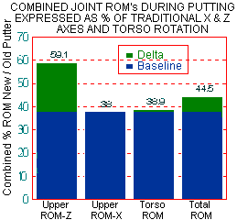
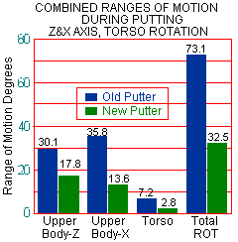
The angular displacement (difference) between the backswing and contact positions represented the range of motion (ROM) occurring at the joints during the putting movement about the z and x axes. The sum of the shoulder, elbow, and wrist ROMs in the particular planes were identified as the upper body ROM about either the x or z axis. The change in the shoulder orientation taken from an overhead view for the backswing and contact frames represented the spinal rotation experienced by the torso during putting.
The total of the joints of the upper body ROMs summed in the zy plane and the shoulder rotation represented the body movement that would produce lateral movement (right/left) from the desired putting line. The sum of the upper body ROMs along the xy plane (z axis) produced by flexion / extension of those joints would produce the forward/backward motion of the club head needed to strike the ball and push it towards the hole.
A ratio between the ROMs found for the new putter and the old traditional putter was determined to show the percentage of reduction in the joint’s ROM that resulted from the new putter design. A ratio less than 1 or 100% would indicate that the prototype putter reduced the amount of motion necessary to complete the putt, thus making it more efficient and more likely to have less human error introduced while putting. The length of the putting stroke was measured from the backswing position to ball contact.
The effective putting radius for the traditional putter was determined by the displacement between the vertebrae at the base of the chin to the club head and the new style putter’s effective putting radius was between the shoulder joint and the club head.
The golfer’s viewing angle represented the orientation of the eye plane in respect to the horizontal in the direction of the hole. If the eye plane was found to be 90 degrees then the head would be tilted sideways in respect to the horizontal. An 90 degree viewing orientation would result in the stereoscopic perspective being more sensitive to vertical deviations while an 0 degree or horizontal positioning would detect lateral putting errors.
The following findings were determined for the kinematics of the putting techniques utilized when putting with a traditional and experimental putter prototype.

Subjects
Four males and 2 females served as putting subjects for this study. The males’ mean weight was 73.0 + 2.9 lbs and mean height was 173.0 + 19.1 inches, while the female golfers’ mean weight was 67.5 + 2.1 lbs and their mean height was 131.5 + 33.2 inches.
Putting Joint Actions
Intersegmental joint angles were determined for the shoulder, elbow, and wrist at the end of the back swing at contact. The joint angle difference between these two positions represented the joint ROM along the xy plane (z axis) or zy plane (x axis).
Motion along XY Plane (Z axis)
The traditional putting technique exhibited 15.4 degrees of flexion along the xy plane at the shoulder joint, 6.8 and 7.95 degrees of movement at the elbow and wrist joints, respectively. The summed ROMs resulted in 30.1 degrees of motion (flexion / extension of the upper body (See Table 1 & Figure 2). The new putter design afforded 9.9, 3.5, and 4.4 degrees of motion (flexion / extension) along the xy plane at the shoulder, elbow, and wrist joint, respectively.
Statistical analysis using a related t test found the wrist and total upper body motion to be statistically different at the .10 level of significance (See Table 2). The new putter design utilized 59% of the putting motion required by a traditional putting technique (See Figure 3). This smaller ROM required to complete the forward / backward movement would indicate that the new putter design produced a more efficient putting stroke to push the ball while reducing the joint ROM variability and likelihood for error.
Motion along ZY Plane (X axis)
The traditional putting technique utilized 4.7, 13.4, and 17.8 degrees of motion along the zy plane for the shoulder, elbow, and wrist joints. In contrast, the experimental putter required 3.3, 1.3, and 8.9 degrees of motion at the shoulder, elbow and wrist (See Table 3 & Figure 4).
Statistical analysis found only the elbow to demonstrate a significantly different joint action (p=.017) when comparing the two putting techniques (See Table 4). The putting technique using the experimental putter required only 9.9% of the elbow ROM that was used by the traditional putter. This reduction in motion was due to the elbow being placed while extended behind the club shaft hanging alongside the trunk in the new putting technique and during the traditional technique the elbows are partially flexed or extended while forming a putting triangle between the shoulders, upper arms, and forearms. The triangle is pitched away from the torso in order to provide the necessary swing clearance. Since the new putting technique requires about 1 degree of motion at the elbow joint to putt while the traditional movement requires 13.4 degrees, there is a significant reduction in the potential variability or error (See Table 5).
The upper body combined motion in the zy plane (x axis) represented by the sum of the shoulder, elbow, and wrist joint ROMs were 35.8 degrees for the traditional and 13.6 degrees for the new putting technique.
Again, a significant (p=.035) reduction in the upper body motion occurred while using the experimental putter to accomplish the same putt. The new putting technique required only about 38% of the joint motion employed with a traditional putting style
The amount of rotation of the shoulder/torso was calculated from an overhead perspective. The torso rotation about this axis was 7.2 degrees and 2.8 degrees for the traditional and experimental putting techniques (See Table 3, Figures 4,5, & 6). The new putting technique stabilized the shoulder girdle and the shoulder joint provided the impetus of propulsion while the traditional putting style used significantly greater (p=.033) trunk rotation to putt the golf ball. The new putter required only 39% of the trunk rotation needed by the traditional putter.

Total Body Range of Motion
The total body ROM represented the sum of the upper extremities’ ROMs about the z and x axes and the torso rotation. No lower body joint actions were calculated because during a pilot study only about 1 degree of ROM occurred at each joint while putting, thus the lower body contribution was considered negligible. The traditional putting technique utilized 73.1 degrees of combined motion while the experimental putter required 32.5 degrees of motion (See Tables 4 & 5). This new putter needed only 34% of the joint motion required by the traditional putting technique (See Table 6, Figures 6 &mp; 7) and the differences were statistically significant at the .006 level.
Summary Joint ROM Information
The new style putter significantly reduced the upper body ROM, shoulder rotation, and total body motion needed to execute a successful putt when compared to the traditional putter. This reduction of putting movement needed to use the experimental putter would indicate that it uses more efficient putting mechanics while reducing the potential for variability / error in the lateral direction of the putt. Therefore, the new putter may be viewed superior in its kinematic efficiency.
Following are complete sets of research data in various multimedia formats that can be downloaded from our FTP site. Just click on the particular item of interest to download it. (Note: FTP downloads do not interrupt your browsing activities).

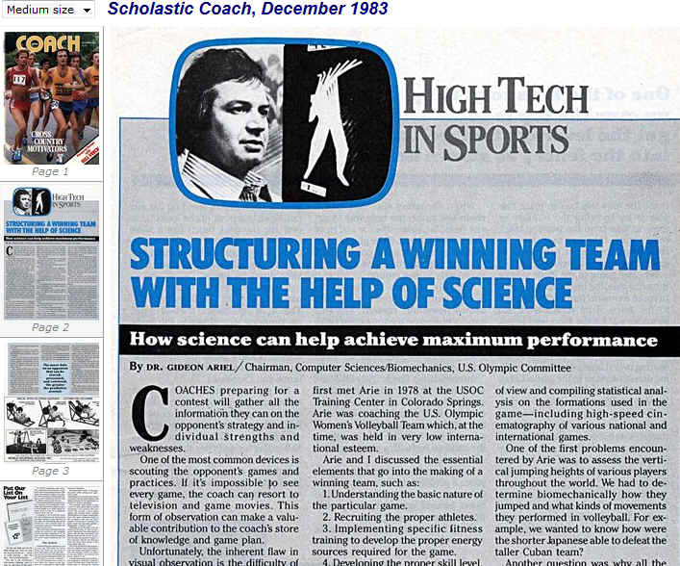

WILSON SPORTING GOODS
RESEARCH/CONCEPTS GROUP
PROJECT: What makes a football easy to pass?
OBJECTIVE: To determine the affect of the parameters of a football on its "spiralability" (thrawability).
BENEFITS: To produce a football that is easy to pass and therefore more acceptable for touch football.
DISCUSSION: Touch football is primarily a passing game. Not everyone can throw a good spiral. The criteria for the current NFL football includes more than just passing critria for out of shape, small hand untrained weekend stars. It is anticipated that the weight, weight distribution (moment of inertia), size and shape are the primary factors. It should be noted that all these are interrelated. A procedure must be developed to evaluate the "spiralability".
WILSON SPORTING GOODS
RESEARCH/CONCEPTS GROUP
PROJECT: Ball-bat impact study.
OBJECTIVE: To study the effect of ball parameters on the coefficient of restitution (COR).
BENEFITS: To reduce the development time to produce a product with specific performance properties.
DISCUSSION: There is a basic lack of knowledge of the fundamental properties of balls as they relate to performance. The relationship of the COP of the center of a ball is not related very closely to the COR of the end product; i.e., the role of the windings, adhesive and cover are unknown. That begs some data on the COR of the ball as it is built from the inside out. Only then will it be possible to relate the process controls to the end product. Existing COR measurements are made by impacting the ball against a flat plate. The game is played with a bat. Bats have various diameters. Are some bats (wood, aluminum, composite) better matched to certain ball? How is CDR affected by spin? Does the COR vary more with spin for one construction? Both the ball and the bat are moving at impact. A careful study of the role of the body will be required before realistic simulations can be executed. However, it is anticipated that a realistic simulation can occur based on our knowledge of similar problems in tennis.
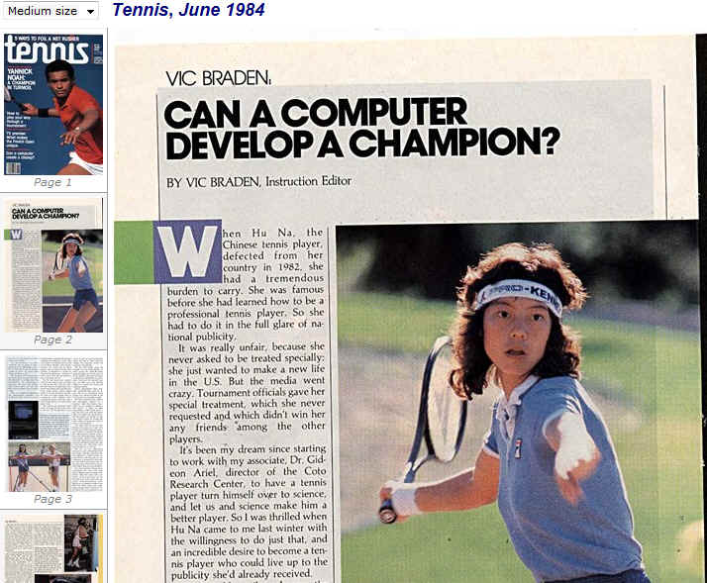
WILSON SPORTING GOODS
RESEARCH/CONCEPTS GROUP
PROJECT: Tennis performance study.
OBJECTIVE: Correlate power and/or control with quantitative racket physical properties.
BENEFITS: Better match of racket features to targeted market.
DISCUSSION: The properties of the racket that translate into power and/or control are probably readily measurable. It is anticipated that torsional modulus, bending modulus, hoop stiffness and the moments of inertia are the primary physical parameters involved. String tension is also a factor but since it has an effect on the other properties it may not be necessary to make an independent measurement. The idea is to establish a range of values which will yield a desired product. Since the properties are not independent, they must be treated as such.
WILSON SPORTING GOODS
RESEARCH/CONCEPTS GROUP
PROJECT: Biomechanical golf swing analysis.
OBJECTIVE: To determine the effct of golf club parameters on the ability of the golfer to hit the ball as desired.
BENEFITS: Provide true game improvement golf clubs based on solid data as opposed to loosely applied convential wisdom.
DISCUSSION: Although the primary objective in selling a golfer a new set of clubs has always been the "promise of performance", the term "game improvement" club is a recent addition to the jargon of golf. The exact definition of game improvement is a bit elusive. For example, the 1200 GE irons and the new Dynapower II irons are both classified as game improvement. The former have been shown to be the most accurate on the market and the latter's claim is probably limited to being relatively easy to get the ball in the air. (This may bring some enjoyment to the golfer but does not necessarily mean his game will improve.) In the shaft area, there is some conventional wisdom that says a given flex is best for the better golfers, etc. There are, in fact, very little test data to substantiate the claims.
The procedure would be to analyze the motion of a "standard" golfer. (We cannot use Iron Byron because it does not take into account the entire swing and it does--not have any "feel". The golfer would actually hit balls in as natural of a settig as possible and still allow good film to be shot. The primary data from the film would be the displacement vs time for the club head, the left hand and several (three at the most) points along the shaft. The orientation of the club face at impact would also be useful. From these data, the velocity and acceleration can be calculated. Since we are interested in matching the clubs to the golfer and not in changing the golfer⁻, we will not need to analyze the motion of all the body segments.
The first part of the experiment will be to use one club, a #4 iron for example, and record the swing for different shaft flexes, different flex point shafts and swing weight variations. The second part involves sets of clubs (at least the 2,4,6,8). The consistency of the swing for different set matching concepts (Dynamic Gold, Braly, constant moment of inertia) will be compared. This study represents about 20 different situations. Each one should be filmed at least twice. Selecting the "standard" golfer will require some pre-filming evaluation. We may want to use more than one
WILSON SPORTING GOODS
RESEARCH/CONCEPTS GROUP
PROJECT: Racket vibration damping
OBJECTIVE: To relate the frequency spectrum of the vibrations set up in a racket to those that produce the negative sensations to the player (aggravate tennis elbow).
BENEFITS: To reduce the "bad" vibrations transmitted from the racket to the player's arm and therefore provide the basis from which we can produce rackets with good feel without sacrificing performance.
DISCUSSION: Although the "feel" and playability of the racket are related to the stiffness, the frequency spectrum of the vibrations set up in the racket is responsible for the sensation that aggravates tennis elbow, for example. It is proposed that we instrument both a racket and the human arm that holds the racket. The desired result is to relate the frequencies generated in the racket to the nerve/muscle reaction in the arm. In this way we evaluate the most effective use of materials and/or construction to produce a good "feel" or at least a better relative feel. There may be some frequencies that are not important to the feel but may be very important to the durability of the racket. The frequency data on the rackets can also be used in the durability studies.
One of the “wildest” study with Wilson was research the flight of Golf Balls. This was amazing projet:
The reason why golf balls have dimples is a story of natural selection. Originally, golf balls were smooth; but golfers noticed that older balls that were beat up with nicks, bumps and slices in the cover seemed to fly farther. Golfers, being golfers, naturally gravitate toward anything that gives them an advantage on the golf course, so old, beat-up balls became standard issue.
At some point, an aerodynamicist must have looked at this problem and realized that the nicks and cuts were acting as "turbulators" -- they induce turbulence in the layer of air next to the ball (the "boundary layer"). In some situations, a turbulent boundary layer reduces drag.
If you want to get deeper into the aerodynamics, there are two types of flow around an object: laminar and turbulent. Laminar flow has less drag, but it is also prone to a phenomenon called "separation." Once separation of a laminar boundary layer occurs, drag rises dramatically because of eddies that form in the gap. Turbulent flow has more drag initially but also better adhesion, and therefore is less prone to separation. Therefore, if the shape of an object is such that separation occurs easily, it is better to turbulate the boundary layer (at the slight cost of increased drag) in order to increase adhesion and reduce eddies (which means a significant reduction in drag). Dimples on golf balls turbulate the boundary layer.
The dimples on a golf ball are simply a formal, symmetrical way of creating the same turbulence in the boundary layer that nicks and cuts do.
WILSON SPORTING GOODS
DEPARTMENT OF RESEARCH & DEVELOPMENT
Research/Concepts Group
PROJECT: Golf ball/club impact and flight study
OBJECTIVE: To study the effect of golf ball parameters on the initial
speed, spin and launch angle due to the ball/club impact.
The golf ball remains in contact with the club for about 0.5 msec when it is hit with a driver. During that time, the club face moves approximately one inch. We want to examine what happens to the ball during the impact. That means we must be able to "look" at the event several times during the 0.5 msec contact time. We also need to see a few frames after contact to determine the speed, spin and launch angle.
We propose to examine a minimum of five (5) different balls that are hit with a minimum of two (2) different clubs. In addition, we would like to examine four (4) different variations of the same ball for the driver hit only. We would also like to hit a given ball with three different drivers. That amounts to 15 different trials. We probably should anticipate that some of the trials will have to be repeated.
For this study, the balls may be marked with highly reflecting paint. We discussed possible schemes of marking the balls so we can determine the local strains during the collision.
Wilson will provide the mechanical swinger (and operator), balls (with markings on them) and clubs. Coto will provide the camera(s), lights and film.
It is anticipated that the filming will take place at the Coto Research Center. We discussed the possibility of having the ball teed up on the force plate. I'm not sure what that will tell us. We also talked about filming the event with an IR camera. I'm not sure of the response time for these cameras.
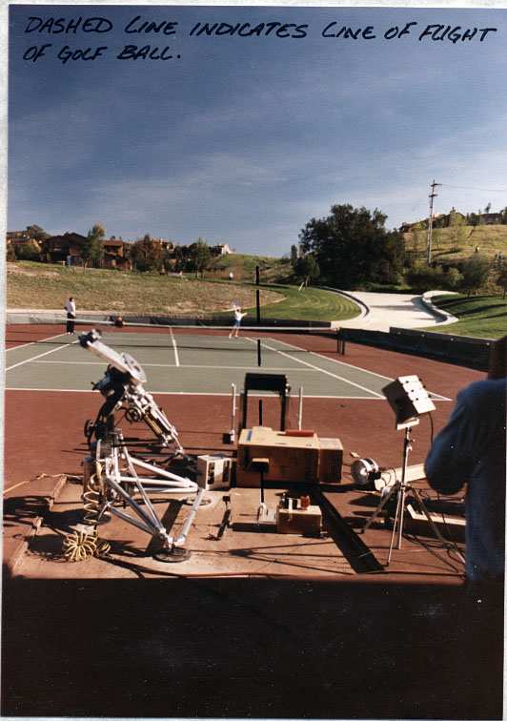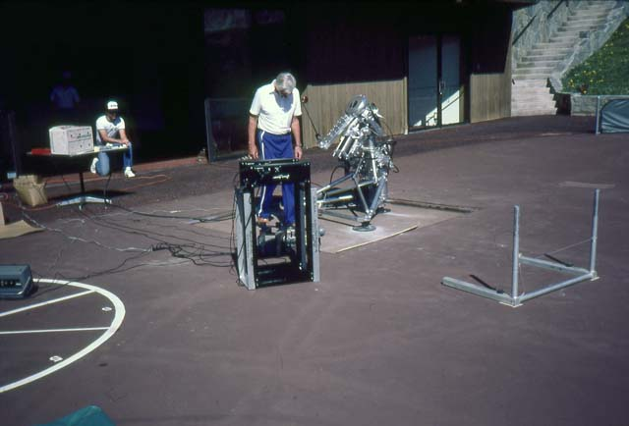
Golf Swing Machine
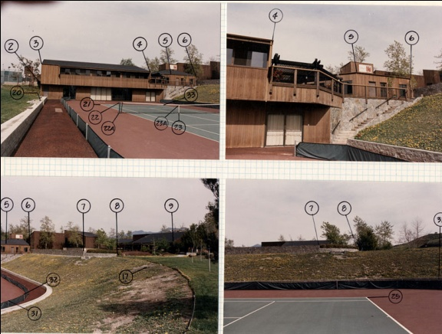 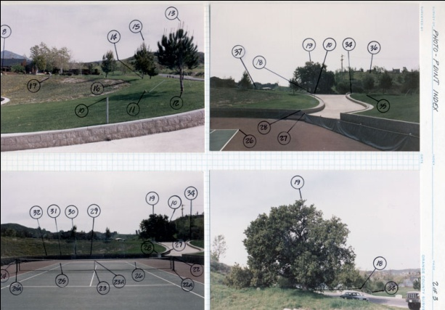
Field Calibration for Golf Balls Flight
We had to design a machine that “whack” the golf ball like in a real swing and then trace the flight over 200 to 400 yards. This was a big project and very profitable for us as well as great information for Wilson sporting Good in manufacture Golf balls until today.

With the Women Volleyball team in Coto De Caza I was able to convince Mr. Dick Sergeant from the Los Angeles Organizing Committee for the Los Angles Olympic Games of 1984, to bring the Modern Pentathlon event to Coto De Caza.
As I promised to Mr. Palmieri in my meeting with him, I did bring the Olympics to Coto De Caza in the 1984 Olympic Games in the event of Modern Pentathlon.
The Coto Research Center was “almost” the home of the throwers Olympians. They would come here often to train and analyze to improve their performance. They all broke their records. The following photos are some of the gathering at the Coto Research Center.
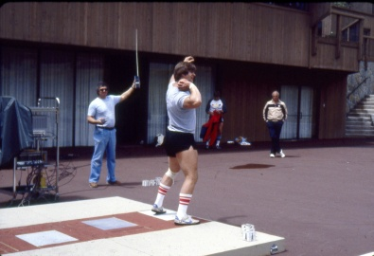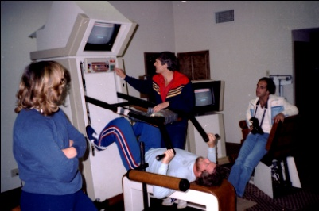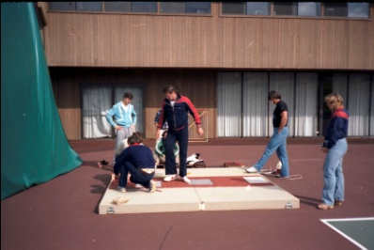
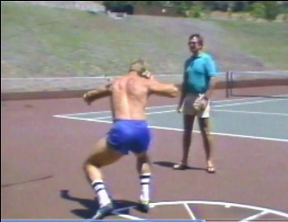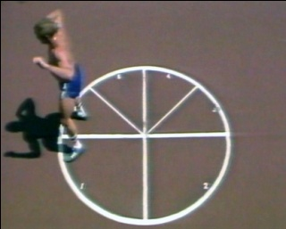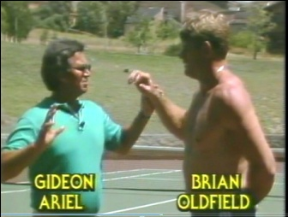
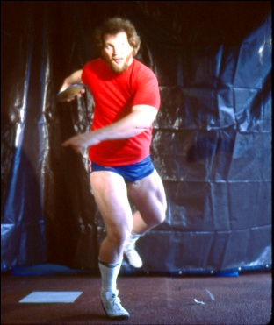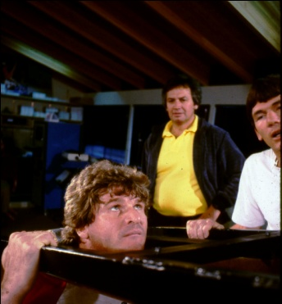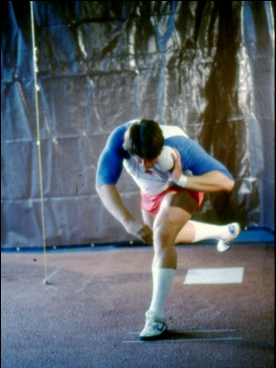
Ben Placknett Brian Oldfield Dave Laute
One just can imagine the “parties” in our Coto Research Center when the handsome “Tarzans” came to train while the gorgeous Women Volleyball athletes reside at the same time at my Research Center. They used to joke that the Richter Scale was more than 10….
Here are some of the gathering photos:
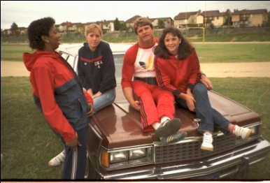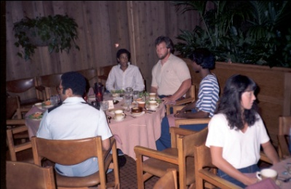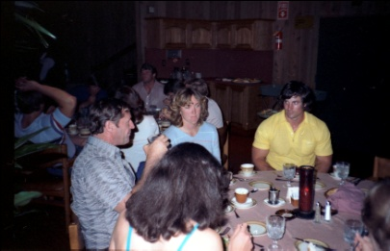
We have performed Thousands of analysis on Athletes and equipment. We were involve with almost any Olympic Sport as can be seen from just selected some of the photographs:
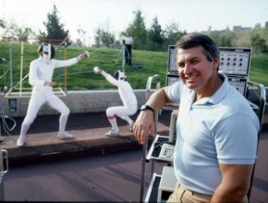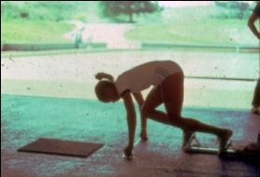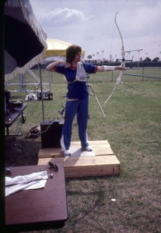
Here are some of the famous athletes that visited with us at the Coto Research Center:
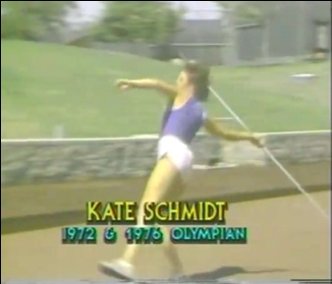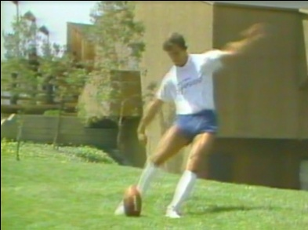
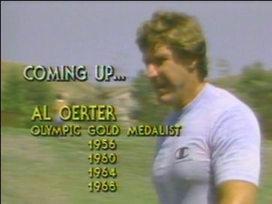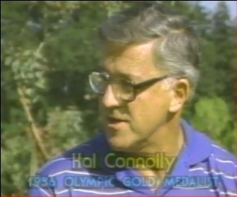
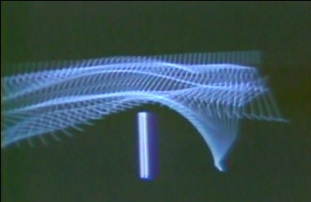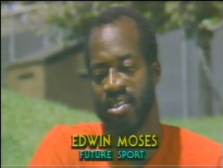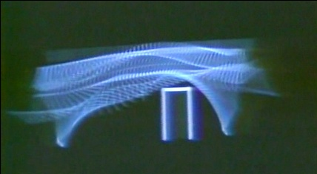
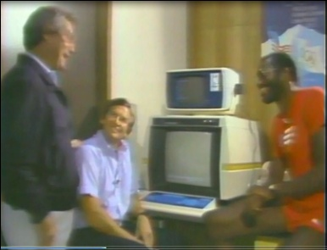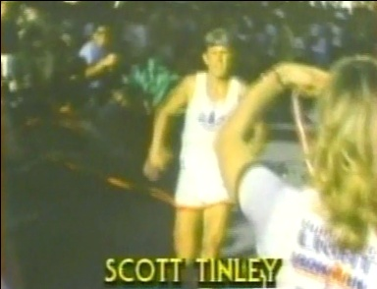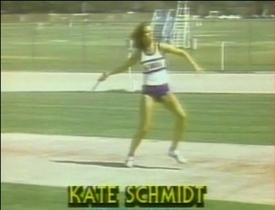
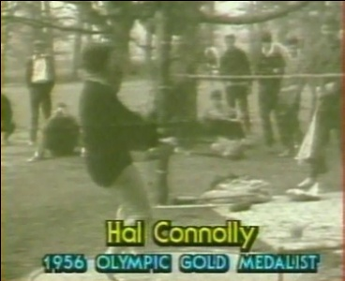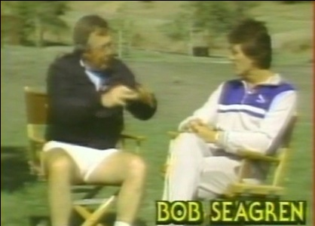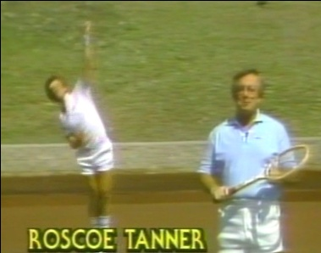
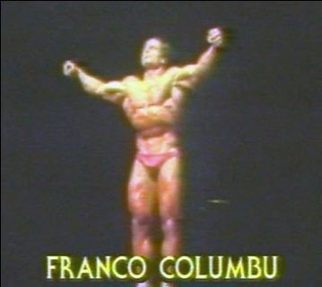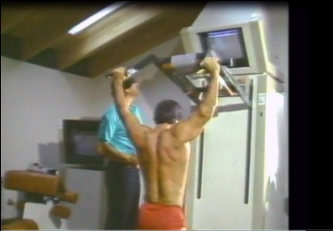
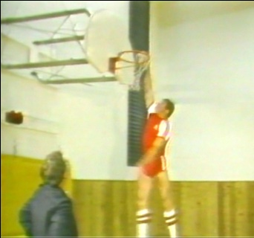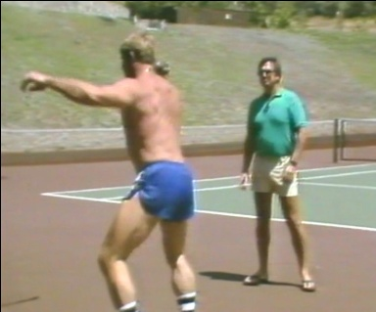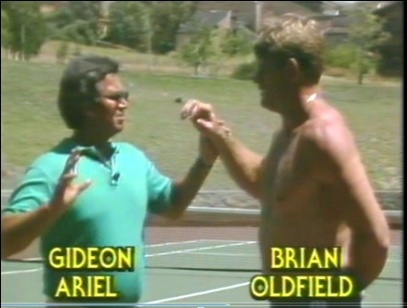
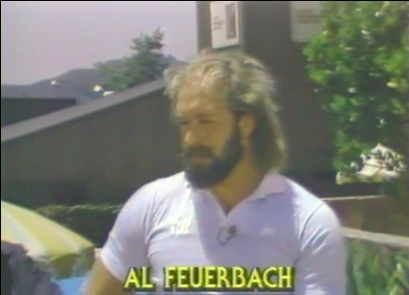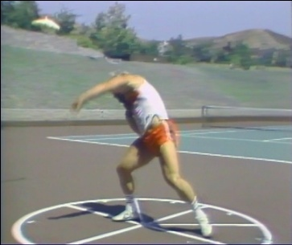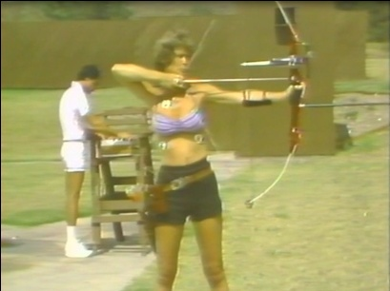
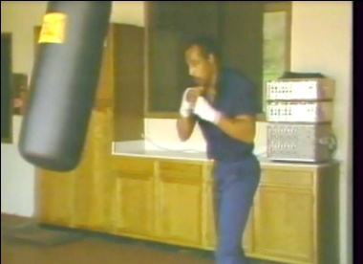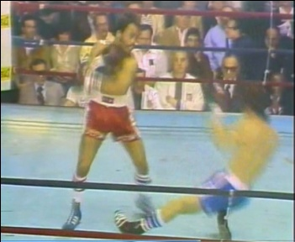
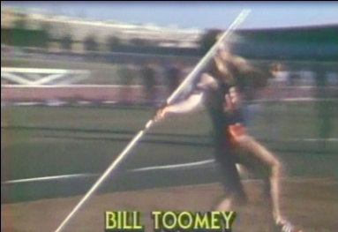
It was so great to work with all these athletes and corporation. We used to work on the average 18 hours each day 7 days per week none stop. We really loved it. However, technology changed. Equipment change and athletes changed.
When the IBM Personal Computer (IBM 5150) was introduced to the world 25 years ago, it was dramatically clear to most observers that IBM had done something very new and different. Here you had a large company, steeped in tradition, that had been willing and able to set aside its "business as usual" methods to produce in volume a highly competitive, tiny computer of top quality, intended for both consumers and businesses. And IBM was able to do all that and roll out its first PC in just one year.
It wasn't that long before the August 1981 debut of the IBM PC that an IBM computer often cost as much as $9 million and required an air-conditioned quarter-acre of space and 60 people to run and keep it loaded with instructions.
The IBM PC changed all that. It was a very small machine that could not only process information faster than those ponderous mainframes of the 1960s but also hook up to the home TV set, process text and store more words than a huge cookbook -- all for a price tag of less than $1,600.
Though personal computers of various types had been spawned by and built for hobbyists, IBM's new offering was also a business tool with advanced features to immediately make it a very attractive offering for a variety of users. The announcement of the IBM Personal Computer signaled the company's determination to compete in the emerging and growing segment of the information processing industry in which PCs were soon to become general business machines.
In short, the introduction of the IBM Personal Computer a quarter-century ago set a worldwide personal computing standard and helped to establish a multibillion-dollar industry.
Lowe picked a group of 12 strategists who worked around the clock to hammer out a plan for hardware, software, manufacturing setup and sales strategy. It was so well-conceived that the basic strategy remained unaltered throughout the product cycle.
Don Estridge, acting lab director at the time, volunteered to head the project. Joe Bauman, plant manager for the Boca Raton site, offered manufacturing help. Mel Hallerman, who was working on the IBM Series/1, stepped forward with his software knowledge and was brought in as chief programmer. And so it went. As word spread about what was going on, talent and expertise were drawn in.
Estridge decided early that to be successful and to meet deadlines, the group had to stick to the plan: using tested vendor technology; a standardized, one-model product; open architecture; and outside sales channels for quick consumer market saturation.
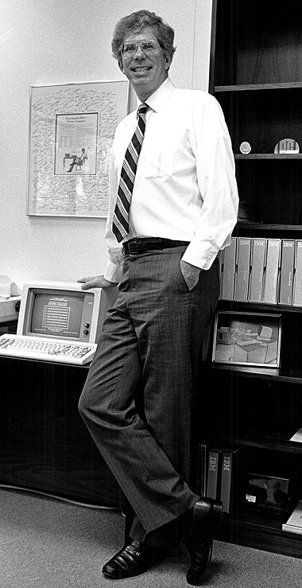
Don Estridge - IBM PC executive
Philip (Don) Estridge was serving as the IBM vice president, manufacturing, when he died in a plane crash, along with his wife, Mary Ann, on August 2, 1985. IBM's president and chief executive officer John F. Akers said at the time: "Don Estridge was a man of vision whose skill and leadership helped guide IBM's personal computer business to success. He had a very bright future in our business. He and Mary Ann will be greatly missed by all their friends and colleagues."
Don Estridge visit the Vic Braden Tennis college in 1981. I gave him a full presentation how our system work on the Data General. In the conversation he interrupt me for a second and asked me: “Can your system work on the new IBM PC?” Without knowing the detail, I responded: “Of course.”
IBM sent us 10 new PC prototype computers that even did not have hard disk but only disketts and we start working on the $100,000 project they offer us with a bonus promise that if we finish the project before the 1984 Olympics the bonus will double the price of the project.
Jeremy and Alan were assigned 100 percent of the time to the project with all the additional staff they required. In 1983, we finished the project and not only we got paid the full amount and the bonus, IBM decided to fly the whole Volleyball team including me and my staff to Boca Raton Florida to their major company meeting to present the APAS system on the IBM PC and to perform an exhibit volleyball game for all the executives. This was incredible meeting and allot of fun. However, one IBM rule had to be accepted: No drinks of any alcohol allowed. This was okay since none of us were drinking alcohols anyway and for sure not the volleyball team.
Moving to the Personal Computing changed our life in the Coto Research Center. Now, you could perform the same complicated analysis that we did on the expensive Data General Equipment you could perform in your office or home. You did not need the expensive payment to us to do the job. The companies could buy an IBM PC and do it in house job which they liked much better for security of information reasons.
Here how our PC system was looking:
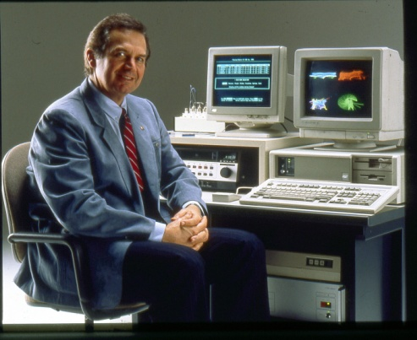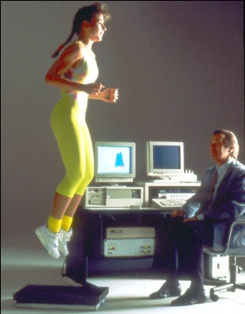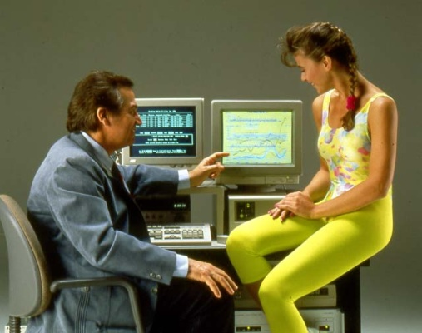
What was costing one Million Dollars or more, suddenly cost only $3000 or less.
I knew that our business model have changed forever. We were gearing to a new model:
How about we will sell our software to be implemented on the customer computers? Or we will sell them our system running on the IBM PC computers? It took time to adjust, but, in the next Chapter I will describe how we dealt with the situation. Our personal “Industrial revolution” came through. We had to deal with it in 1987.

