Chapter 19: The Wedding

This Chapter could be a whole book by itself. How can I cover 42 wonderful years in few pages?
It was a miracle. How could these two infants do so much together for so many years? And stayed together now for 42 years. Study together, love together, work together, travel together and have so much fund together, for 42 years none stop.
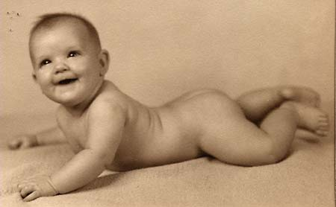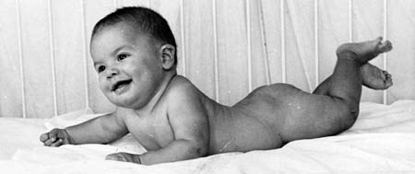
Ann Gideon
I met this girl when she was 25 years old and I was 30. She slammed the door at me when I tried to visit my professor. But, her look was something else.
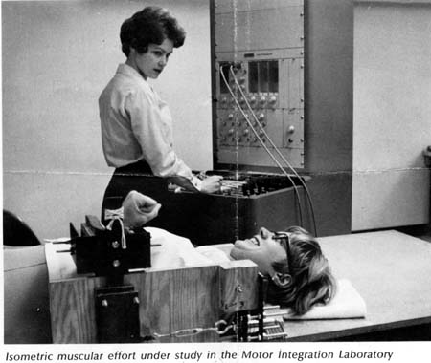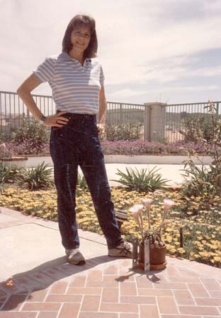
She was a beautiful smart blond that always was the best student in the graduate classes I attended with her. Took us long time to be friends due to mutual friends of ours that introduced us to each other. From then on, we were sort of bond together. Not as lovers in the beginning, but as a real friend. Then, latter on, more then two years latter, we became lovers and friends. When I had any troubles in school or in my personal life, I would come to see Ann to take care of my problems. She would talk with me and cook for me and go out with me. I would tell her my stories on all my girls friends and my problems in my personal life with my wife at the time. Ann even would take care of my 5 years old daughter Geffen when her Mother would live her with me and I had hard time to take care of a 5 years old.
There would be no reason for Ann ever to be my real girlfriends. I was sort of a “play boy” dating many beautiful girls and tied up with divorce procedures with crazy dreams all the time. But, I guess she liked me for some reason I do not know until today.
This book in its first 18 Chapters would not be possible without Ann. She did everything for me. She even typed and corrected my dissertation for my Ph.D. Without her I would never complete my Ph.D. My English until today is not as good as should be. Even this chapter will have to go through scrutiny of Ann’s blessing before it would be ready for print. And the fact that she approved this Chapter is amazing story by itself when you find all the content. There is nothing in my life that I have done after meeting Ann that Ann did not have great influence on the results. When I got in troubles, she would find a way to get me out of troubles. When I did not know what to do, she told me what to do.
One of the most amazing things in our 42 years together is that we have never have a fight. We never argued about anything. We would discuss many things on a daily basis but never argued. When it came to voting for our government, and me as an Israeli was very aggressive in my opinions how to run this country it would end up as follows: “Ann please do me a favor and go to vote for me.” “who do you want me to vote for you?” “The same person you choose for yourself.” This was my answer. I trusted her so much. I had an opinions, but the end results had to be Ann’s decisions. I was the ideas and dream Man. She was the reality Woman.
So, everything you read so far in our book is really our life story. I had few facts that I left out. Important events that I did not know how to insert them in. I had some love affairs in my Middle Life Crises. Yes, Middle life crises. How this could happen with a wonderful girlfriend I had such as Ann. I do not know. I cannot explain it. One of this affair was with a beautiful lady, her name is Merry. There is no doubt that we loved each other when I was 51 Years old and she was 21 Years old. I met her in my work in NASA.
This was not a secrete. I told Ann about her. I could not ever lie to Ann, she would catch the lie in few minutes. I did not try to hold anything from Ann. I do not know what happened to me. At the age of 51 with so much life and experience with Ann I suddenly become attractive to a 21 years old, beautiful blond. She was a Texan ¼ American Indian. While working in NASA, one evening she asked me if I know how to dance “Two Steps”. I told her that I do not know what she is talking about. She offer to teach me the dance in one of the Cowboys club. I learned the dance and the “teaching” lasted 13 years and produced 3 beautiful daughters.
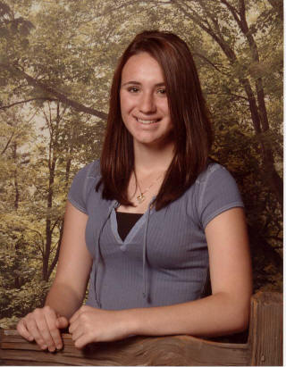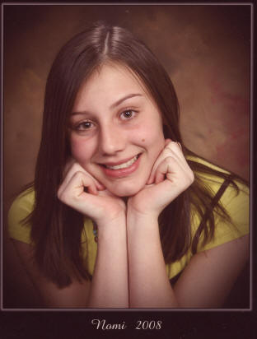 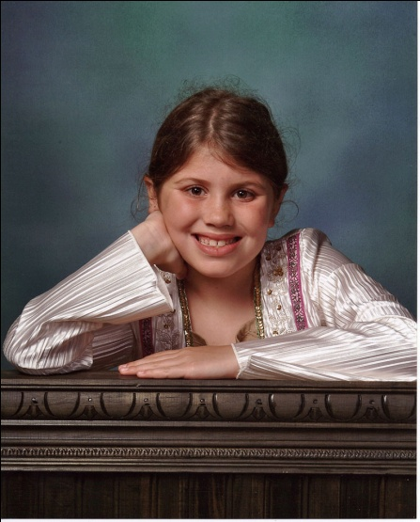
Tova Nomi Ilana
I did not married Merry and told her from day one that I have a girlfriend and will never live her I mean Ann. “So what do you want from me?” She asked me many times and my answer was always the same: “I do not know; if I knew I would be a Hollywood producer and not a Biomechanist.”

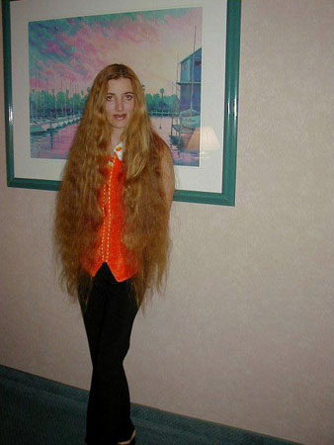 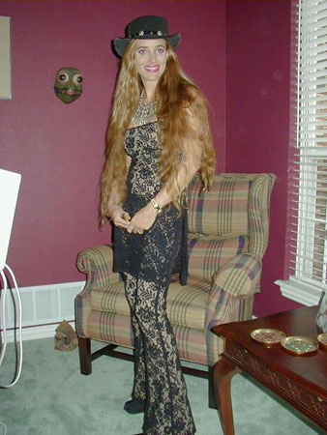
Merry
Well the subject of this part of my life will be in another Chapter. But I wanted to emphasize that with all this “running around” Ann never left me. I do not know why. For sure I do not deserve her.
My daughters had a rough time with the family situation. They lived with me for a while in La Jolla where I purchased a house for Merry and the kids in the ALS company time. However I would live in Coto with Ann and come to visit. However, the kids had the best of everything else but family. I took them around the World and I loved them as much as they also loved me. They had the best cloths the best books and the best living accommodation. When Merry decided that this is enough and moved back to Texas, I bought her another house with 20 acres land in a beautiful small town of Holliday. I would fly back and forth between California and Texas to see my kids which I love very much.
And what about my daughter Geffen that now grew up and went to college. Ann took care of her also. Here is when she graduated from college and in her Wedding. Unfortunately, Geffen died from Leukemia at the age of 30.
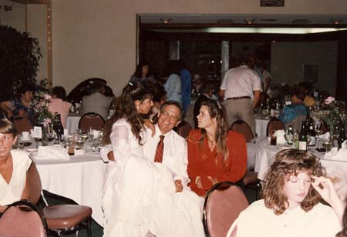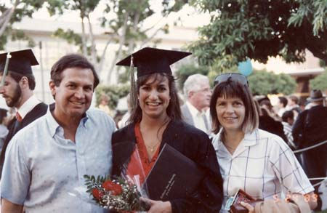
It was hard for Ann to go through all that, needless to say. But she absorbed it and in fact became great Mother to my kids. She thought them how to dress, how to read, how to behave. We would go to all the parks in California together. Disney, Animal Park, Adventure, Universal Studio, Lego Land, and any park you know of, the kids were there many times.
How Ann could do all this is beyond me. I was worried to go to psychologist to ask for advice, since I would worry this psychologist will end up going to a psychiatrist. (Just a joke). It was strange, but life kept going and it did not affect my love to Ann or Ann’s love to me. We would travel around the World and do what we like to do.
As you read in the previous chapters all the projects Ann and I had to do together. It was allot of fun as you can see in the following photos:
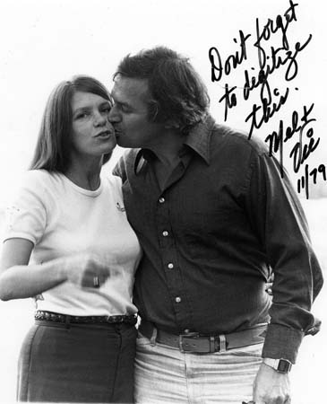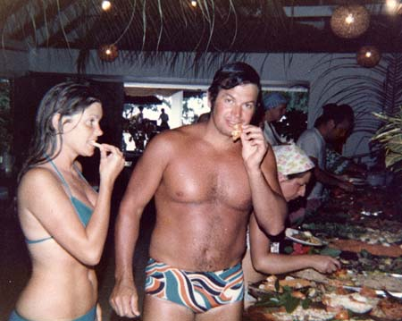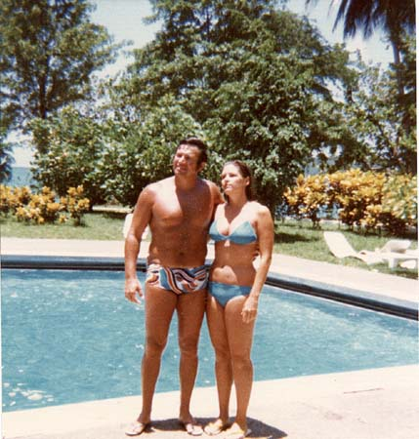
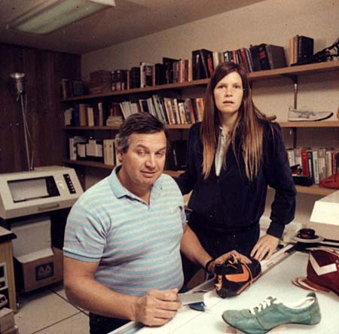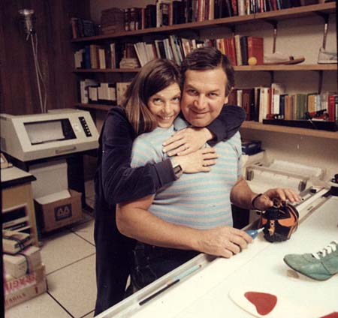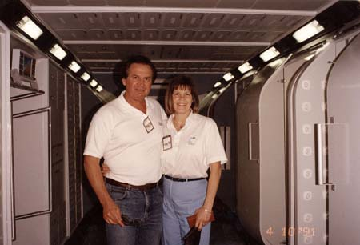
Traveling all around the World:
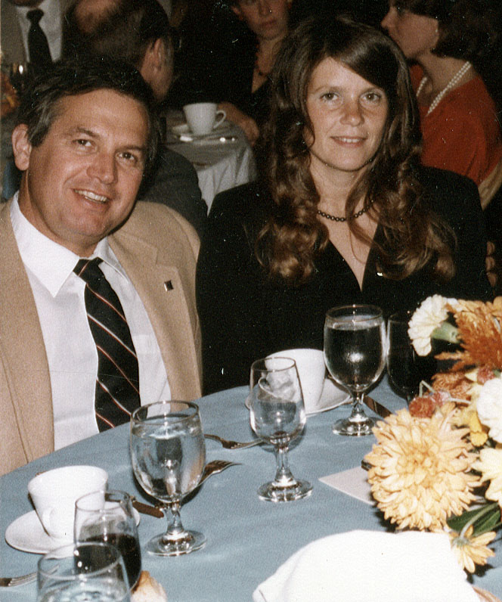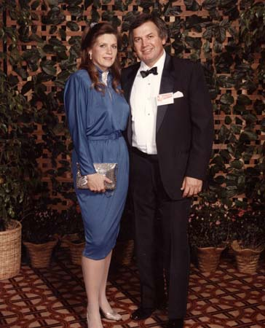
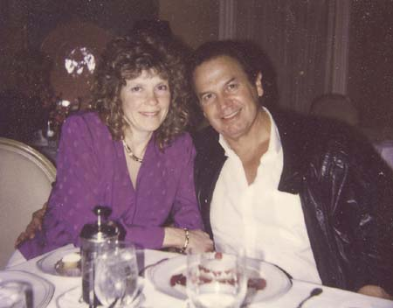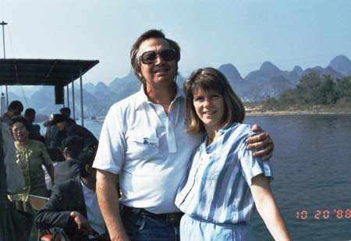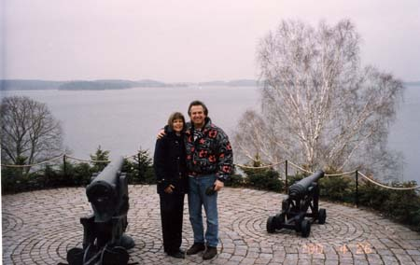
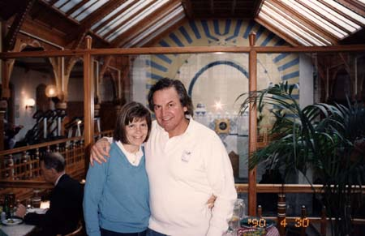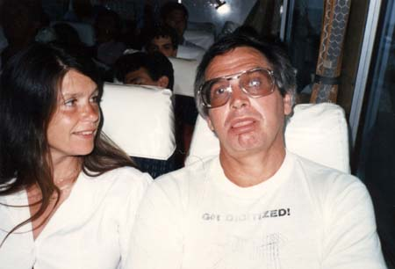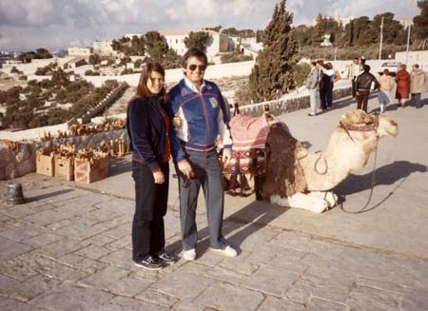
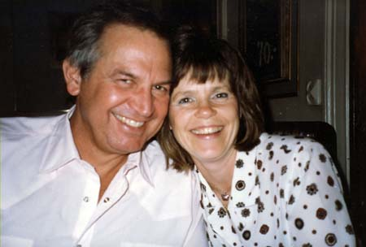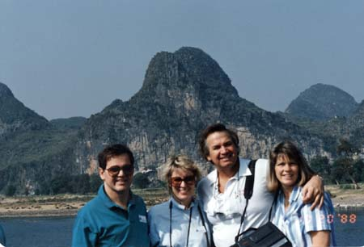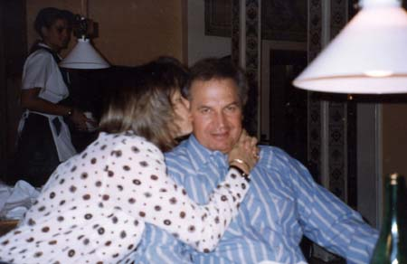
And always in love:
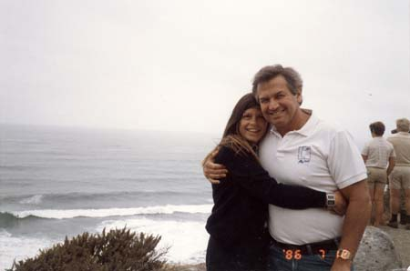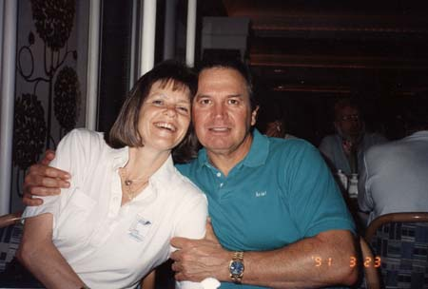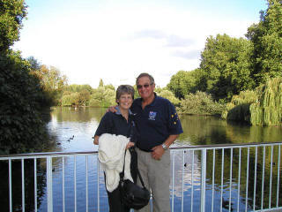
Throughout the years it was amazing to me how Ann did take care of my kids. She would teach them how to read. She would teach them how to dress. She washed their cloths fix their food took them around the World with me. Even took them to the Olympic in Beijing China. We have Thousands of photos throughout the years but here are only few:
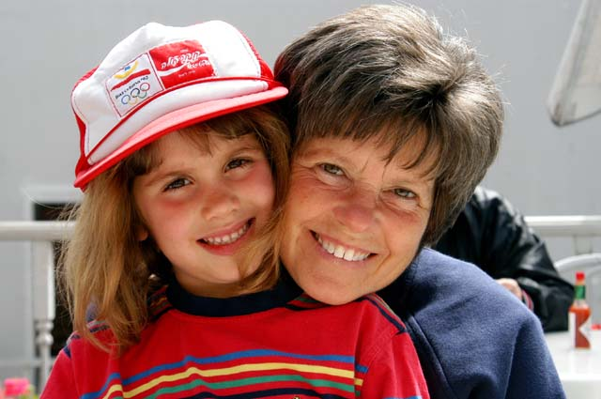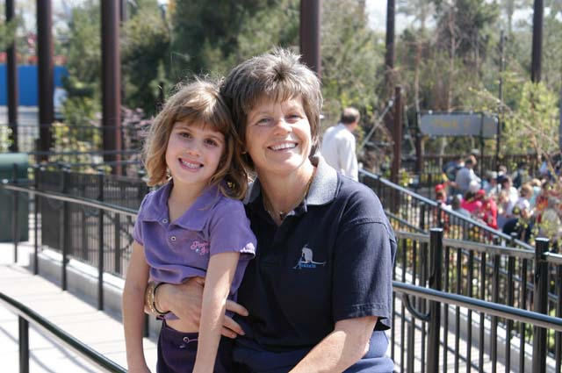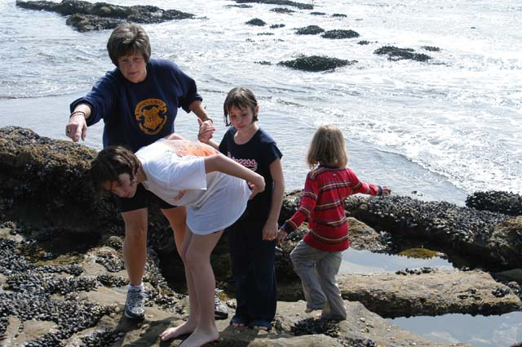
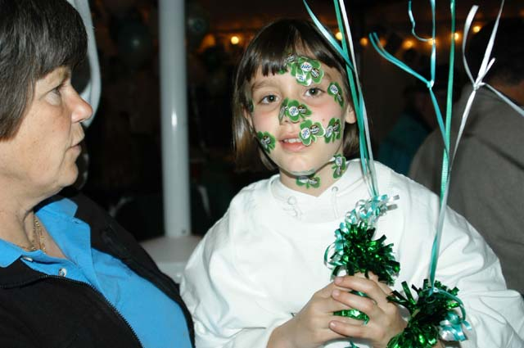
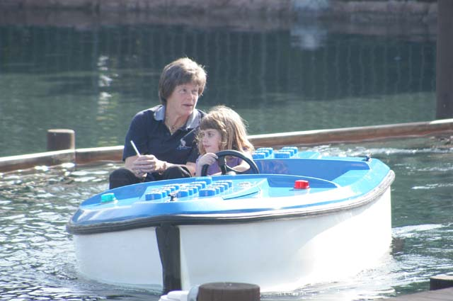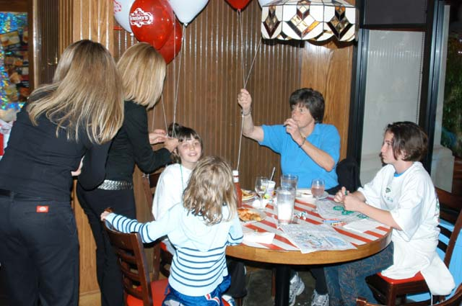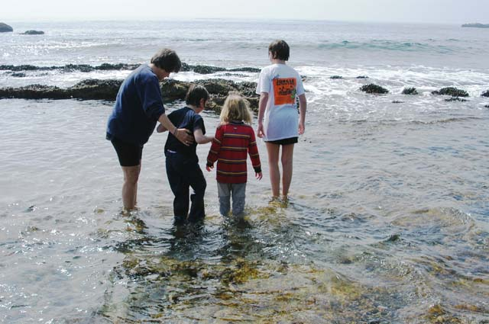
Now it was 35 years from the time Ann and I met. She is still my girlfriend watching the parades of other Women in my life. She paying all the bills, she take care of my kids when they come to visit with me every holiday. And she is taking care of me. It is if I am the only thing in her life. Hard to understand and highly appreciated and feel like one of the biggest Ass Hole in the World.
What can I do about it? I was thinking for years, months, days, hours.
Ann always loved to Travel. She particularly loved South Africa. She loves the animals. We have been in South Africa for few times throughout the years. We both loved it and have one of our best friends in Johannesburg.
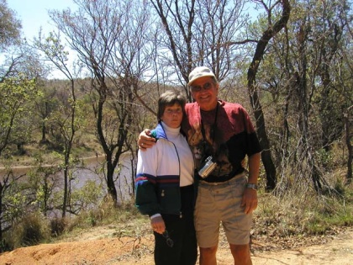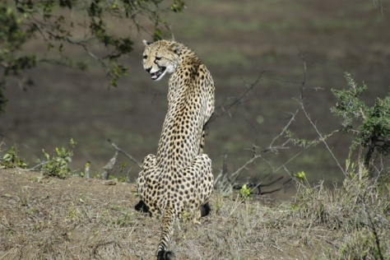
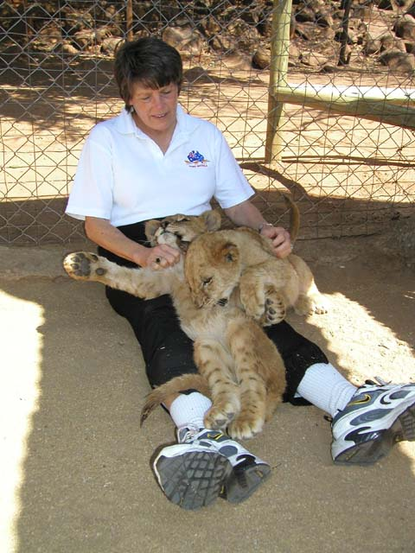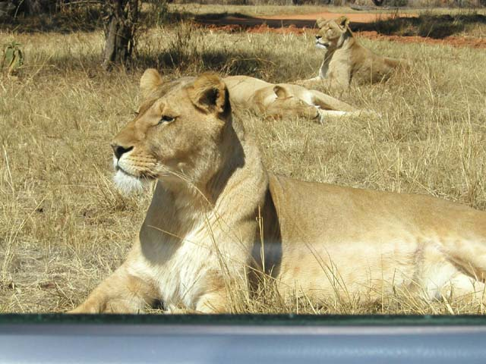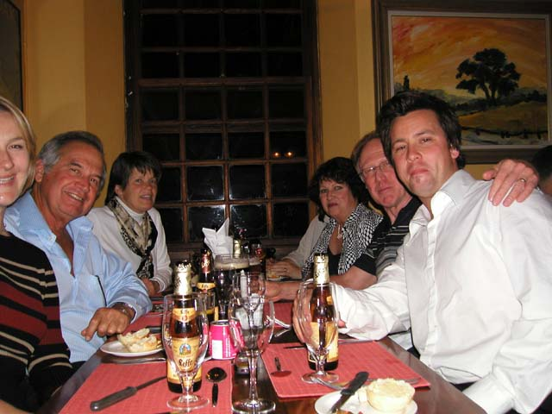
Among the wonderful locations in South Africa, Ann love a particular location called Singita:
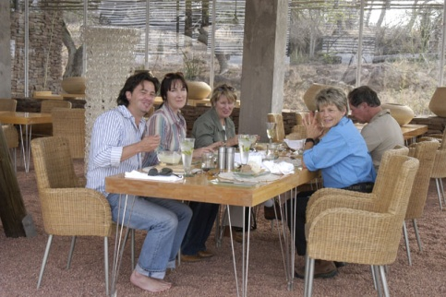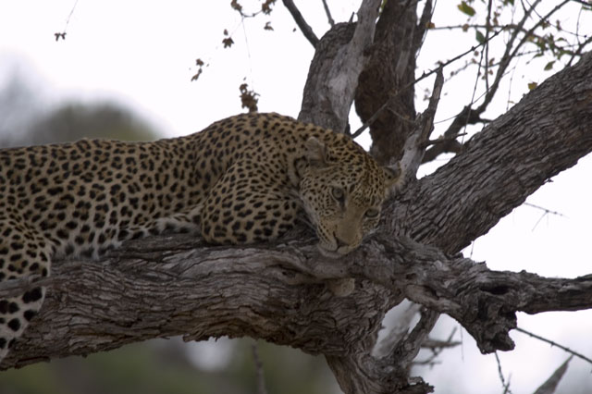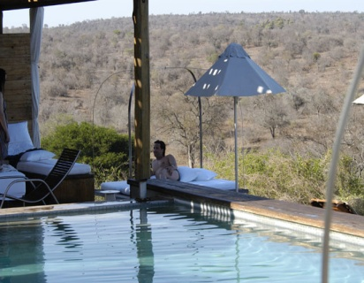
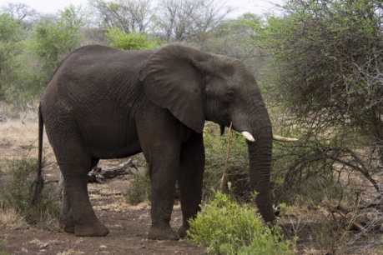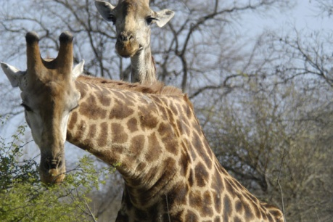
Singita is an incredible place where there are no fences and the animals are totally free. Ann loved this place.
While were visited in South Africa probably the 10th time, I met with my good friend Tony which is also the distributor of my technology in South Africa. He sold numbers of Exercise Machines and motion analysis of mine to various Universities and Olympic Training Centers.
In one of our meeting over a large glass of South African beer I suddenly, out of the blue told him: “Hay Tony, what if I will ask Ann to Merry me in Singita?” Tony thought it is a fabulous idea. We decided to keep it in secrete. I even did not tell it to my good friend Bob Wainwright who was with us on this trip.
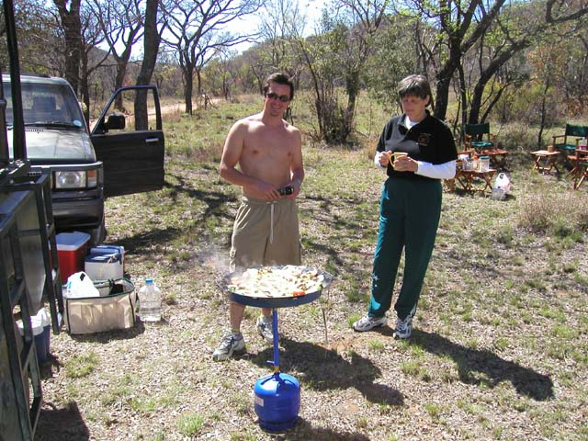
Tony and Ann – Cookout in Mabaliguae
Tony introduced me to his jeweler by the name Salomon. I wanted to design a very special ring for Ann. I designed a ring consist of 3 rings with each ring has 12 Diamonds while one ring has only 11 a total of 35 Diamonds each representing one year of waiting for this event. In the middle of the ring I inserted 4 Karate Tanzanite stone which is very special and very unique in one Mind in the World.
Mr. Solomon did a fantastic job and I got the ring. Now I need to arrange the proposal event. Singita was the perfect place for it. There was a great restaurant in the field where all the animals, Elephants, Giraffes, Lions , Zebras, Cheetahs and others walking free outside.
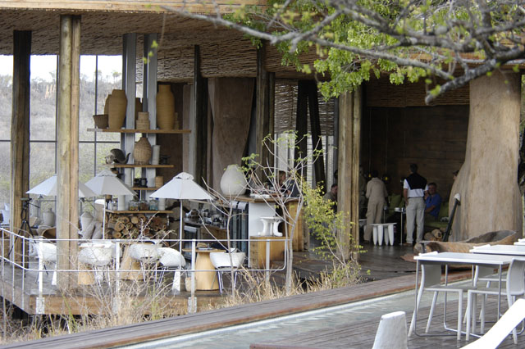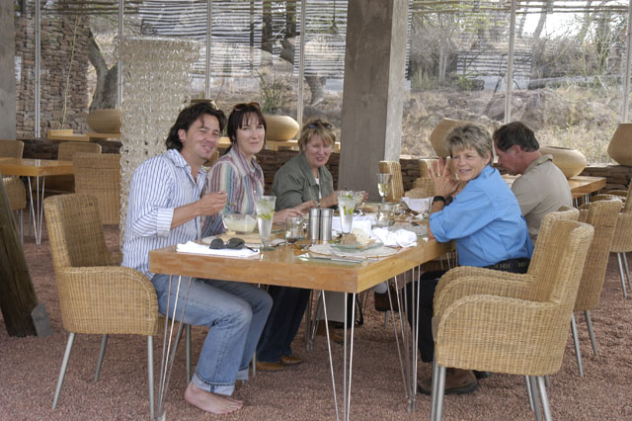
Singita
For the afternoon, I plan with the restaurant to play the ABBA song “I do I do” when I give the them the signal. We were all there. Bob and tony and other friends. The music started and we had few drinks while watching the beautiful animals walking around. There were particular to Giraffes that wanted to know in detail what is going on.
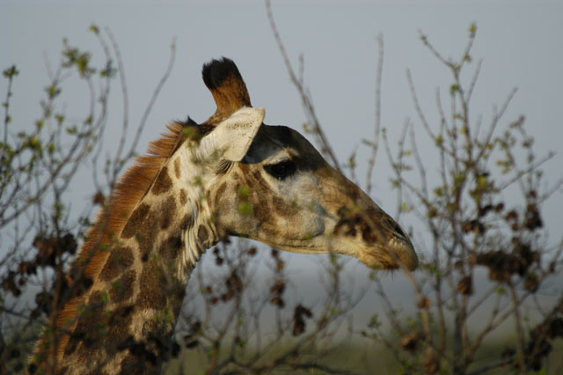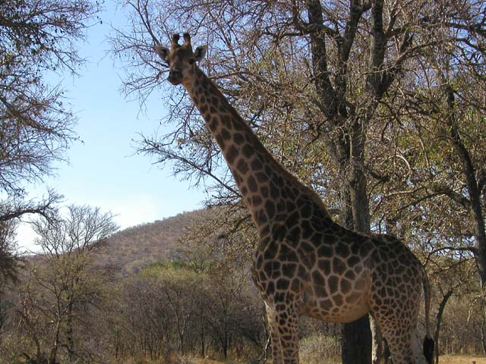
They were so close you could touch them. Also, two Cheetahs decide to join us.
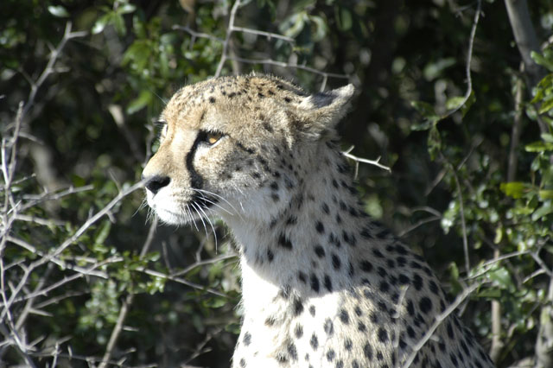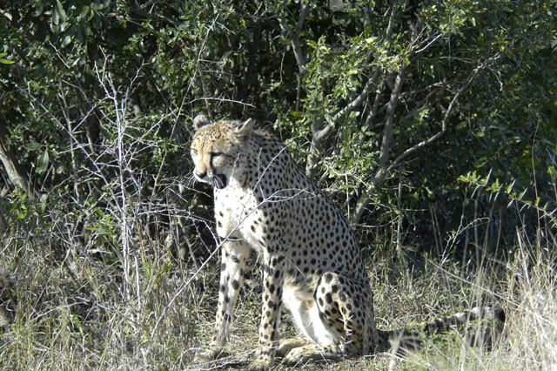
The ABBA music was going on. Bob was sleeping on side. Terrible jetlag he had. I looked at Ann and asked her to dance with me. “Dance? We did not dance for years.” She replied. “Ann please, one dance, look on the animals they would love to see us dance.” Okay, she agreed and walk slowed toward me. There were many people in the restaurant-bar outside and they all were very happy to see us dancing. I was hiding the ring in its box in my pocket. God forbid if Ann would find it prematurely.
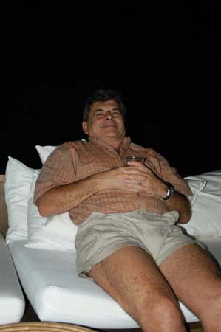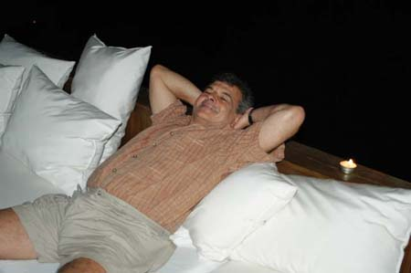
Bob watching us dancing but knows nothing on what is coming
Suddenly, the part of “I Do I Do I do” came and I dropped on my knee and said:
“Ann would you marry me?” “What are you doing?” she said. “you are embarrassed me, stopped it!” “People look, stop it!” “Ann I mean it, would you marry me?” “Gideon please stop embarrassing me.”
“Ann, my knees killing me…” I said. “Okay I will marry you. Get up.”
I got up and kissed her on the cheek. Here are the photographic development that Tony who was the only one that knew about it, too. By the way, Bob comment in loud voice: “Holly Shit!!!” He could not believe it.
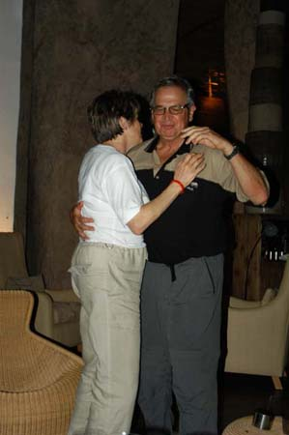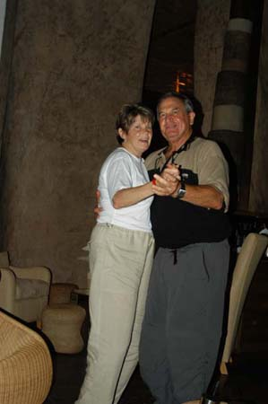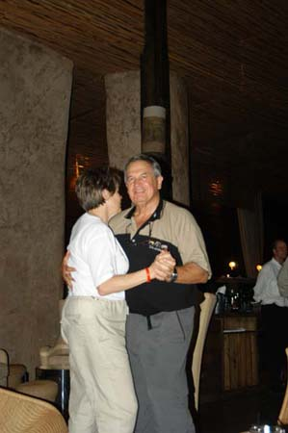
In few seconds our life will change
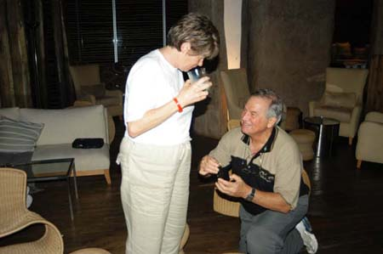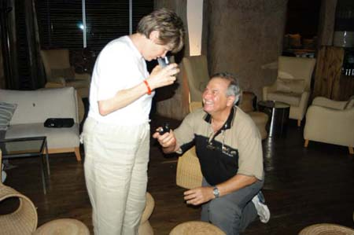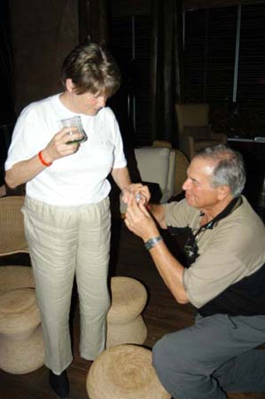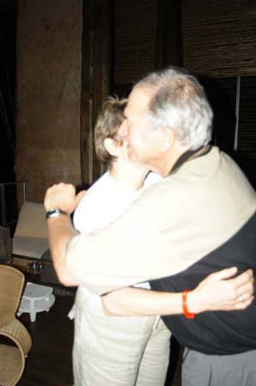
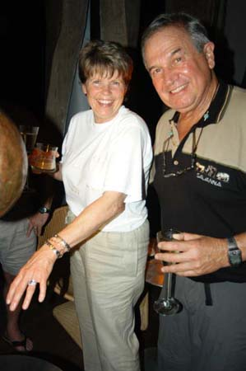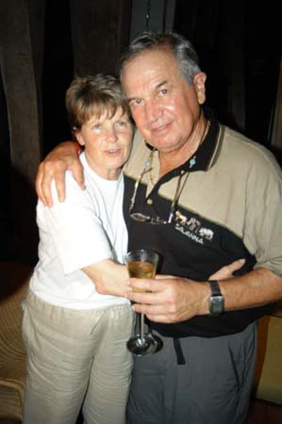
People could not believe what they see. Some were crying some ran to congratulate us. Bob had few more Amarulas. These are strong South African liquored drink. Ann was in shock for a whole week. But, we had a great time. Now we needed to plan the wedding.
We decided that we were way too fat at the time. These travel made I eat like pigs and we both gained about 20 Lb. (9 Kg.). We needed few months for that.
Upon our return we started our diet. Basically refrain from Carbohydrates. We both loosing 1 Lb a day if we stop consuming carbohydrates. Ann check for a date. We decided we will get married at the Ritz Carleton in Laguna Beach. One of the most beautiful hotel in the World.
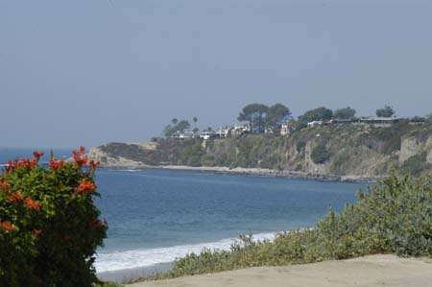
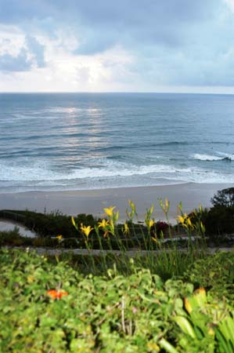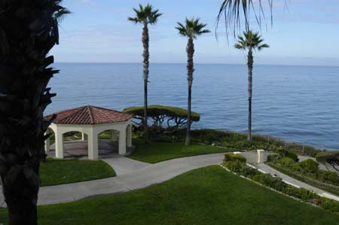
Views from the Ritz in Laguna Beach
Ann started planning the wedding. We checked on Google when the weather was most promising and the least chance for rain. The date was set to October 17th 2004. No rain for this date during 30 consecutive years.
When you get Married at the Ritz, you must hire wedding coordinator. You cannot just plan your wedding. The Coordinator must plan and organize it for you. Our coordinator was Barbara. In the first meeting with Barbara, she showed us all the locations that can be qualified for wedding. Of course, I selected a marvelous site and we planned the special meal and entertainment. At the end of the meeting, Barbara asked me if I have any more questions. So, I told her. I have one request. As we can see the marvelous site with the pacific ocean in the background. Could we change it to a Cemetery instead….for a moment she was quiet and looked at me in disbelief and then we all burst into laugh.
At that time Microsoft introduce the Multimedia version 10. I knew that now you can stream video directly to the net if you have an IP address. All I needed is a T1 line and I could program the video to be stream to a specific IP. So, I requested a T1 line from the Ritz. They did not know why I need it, but let me have it.
We had 8 months before the wedding date. And we did lost 30 LB each. We invited 35 of our best friends. People form South Africa, from Japan, From Brazil, from Peru, the rest from the US East and West Coast.
Ann was selecting a book for each of our 35 visitors according to their character which we knew so well. Also, we made each couple separate and seat separate among “new friends” around huge square table made of many tables.
The Wedding usually start outside with the Chupah. Kind of a tent that the Jews using. We also had our old time Rabi come to married us.
And, what happened? It was purred rain. First time at that date in 30 years. Barbara suggested that we will move inside the restaurant. I resist. I told her, if God wants to make us wet we will all be wet. I think God was listening to me. 10 minutes before the ceremony the Sky opened up as if we are in biblical time.
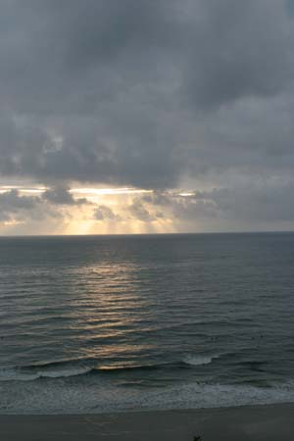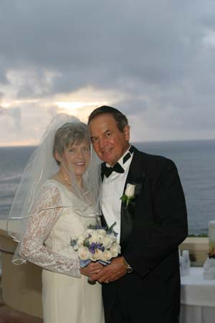
Sky was opened up and the rain that was falling all day long stopped for our wedding
Now it was for the Rabi to make it official. Each photo worth 100 words as they say:
First the Rabi asked us why we love each other so much? And here what we said:

Our Rabbi asked us: "Why do we love each other?"

Here are the answers:
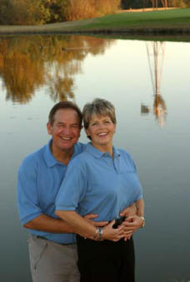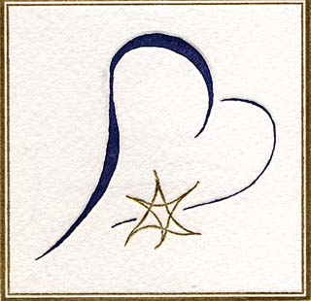

My Gideon
Adorable, loveable, funny, intelligent, fantastic, and charming. This is Gideon. This is the man I love. Why do I love you? I wont count all the ways, but there are two important ones: you make me laugh and you make me think.
You are always thinking, which is admirable, but its the way that you consider things that makes you special. Its not just the obvious method or the way everyone else approaches a problem; you consider many different alternatives and then conclude that logic always prevails. Youre intuitive, reasonable, and creative. Remember when you were flying on the KC 135, or the Vomit Comet as its frequently called? You concluded that the expensive device which NASA had purchased to determine when the plane speed equaled that of gravity, was subject to extreme vibration problems. So you held a pencil until it floated and used that to begin the zero gravity experiments. Logic prevailed and the simplest technique worked. If you dont know the mathematical solution to a problem, your intuition and experience will suggests a rationale. Invariable, theres mathematician or physicist who derives formulas that verify your idea as accurate. You always say that you are a talent integrator, but for that, you must be smart enough to know what you want integrated and who has the right talent.
You have always loved to study: biomechanics led you to computers which directed your thinking to software; physiology developed into the study of how the body moves; film cameras became digital cameras and that led to the complex integration of cameras, computers, printers, scanners, and finally digital photography. You have always been a student with depth. Now, youre stretching your mind by adding history and the theater! After three years at Christ Church, Oxford University, youre beginning to love history (Im so excited about that!!). In addition, youve added London theater to your learning list!
Travel doesnt necessarily require thinking, but we always study and learn where ever we go. Originally, we were working and added the fun, leisure parts to the business. In recent years, we have historical and geographical overlays to each place we go and expand our minds while were there.
Theres never a dull moment with you. I read that a person laughs at something that is unexpected. You are always doing and/or saying the unexpected! You make silly jokes, funny faces, tell stories about experiences, and say outrageous things. Your smile and the twinkle in your eyes are infectious. I never know what funny thing youre going to do next or say so Im surprised and amused every day. Just walking through the airport will be a trip of humor for you. You have that funny little walk that cracks me up every time. You have such a clever mind and a quick wit so that you can always make a joke any time, place or circumstance.
They say that a Sabra, a native Israeli, is hard on the outside and soft on the inside and this description fits you perfectly. You can be firm, confident, and determined. We started our biomechanical business when we were graduate students with only $5.00 and a great idea! With charm and charisma, you convinced many large, well-known companies to hire us to do their R&D testing. For example, in a study on sound, we had a world-renowned violinist playing his instrument in front of our office wearing only his concert shoes and underwear. During an experiment to ascertain if there was a product defect by the manufacturer, we had gymnastic teams doing stunts on force platforms to measure the landing forces. We even had an extensive project to test feminine hygiene products. Somehow you convinced even the most skeptical company executives that we could help them improve their products.
On the soft side, you are a very sensitive, emotional individual. You can cry at movies, events, places, and for people. You also have a special capacity to know the best thing to do in a difficult situation. I remember the time we were waiting in line at John Wayne Airport for a flight to the East Coast. In line ahead of us were a young Marine and his wife. When it was their turn to buy his ticket, the airline counter agent refused to accept the young soldiers check. The Marine and his wife plead their case that the airlines assured them his check would be accepted with his military ID. He was on his way home to see his mother before being deployed overseas. Unfortunately, the agent refused to take the check and the plane was scheduled to depart before he could go to the bank for a cashiers check. We listened to the discussion, until you turned to me and we knew exactly what to do. You told the airline agent that we would pay for the Marines ticket. The Marine, his wife, the airline agent, and the people in line behind us were astonished at your offer. The Marine was so thankful and appreciative and gave us the check for the ticket price. Then you purchased your own ticket and left for your trip. Subsequently, we called the bank, verified that the check was good, and then we tore it up.
Thirty-five years ago, I was surprised after being your graduate school friend for two years, when the proverbial light bulb came on over my head and I discovered that I loved my best friend and fellow student. Since then, Ive loved you will all my heart, my mind, and my being. Each and every day I tell you that I love you more than yesterday. I dont know how its possible to love you more each day, but I do. You make me a better person than I am without you, you give my world vast dimensions of joy, creativity, and happiness, and you let me love you. You are my love and my life.

To my Darling and Life Partner: Ann
I wish words could be seen three dimensionally. The third dimension is the unseen feeling that I wish I could express and do not have enough words in that dimension to say it.
From the first time I saw you working in the Motor Integration laboratory at the University of Massachusetts, I knew that there was something in your soul which was unexplainable. I was in awe, when you were able to answer all the difficult questions by our Statistical Professor when the rest of the class looked at you with surprise. I remember approaching you, without ever knowing your name, and asked you how you knew the answers, and what did you do to know them. You answered me with an expression like Go to the library and find for yourself. Wow, I thought! Who is that girl? The beautiful blond with the great body, wearing a mini skirt, who blew me off like that?
I was so lucky to be officially introduced to you later at the University by our dear mutual friend, Jim Sallidas. I remember he told you: THIS is crazy Gideon. You responded with: Oh, this is the crazy Gideon that you have been telling me about for such a long time? I was so lucky to be crazy then and I continue to be crazy about you.
So, 35 years have passed and what a life we have had together. We studied together, we traveled together, we created together, we invented together, we laughed and cried together. So, in 35 years there is nothing that we havent done together. It would take books to describe all our experiences and we havent reached the end yet. We are just starting now.
Now 35 years later, I love you more than ever for all the reasons that made me fall in love with you in the first place and all the other fantastic qualities you had and still have. As I said before, I love you more than words can say because there are no words to describe all the wonderful things about you and the marvelous life we have together.
My darling, I am so lucky to have you and thank God that He blessed me with you to share my life.

I love you
Gideon

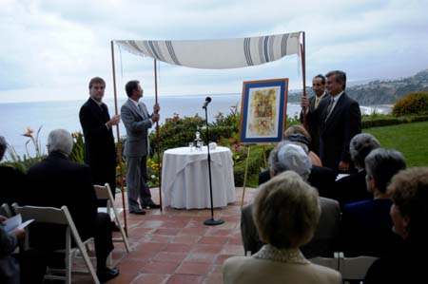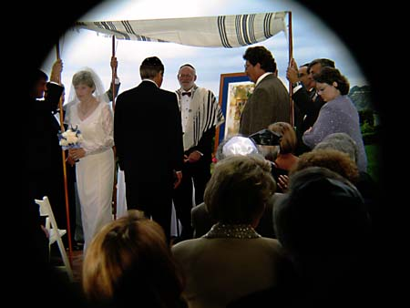
The Chupah
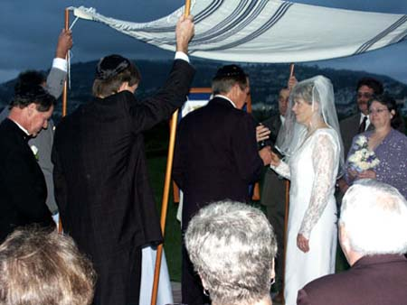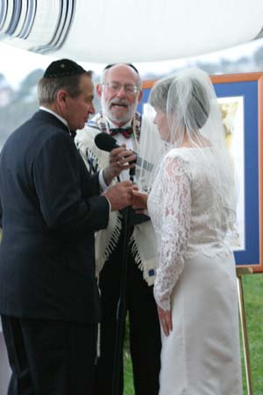
The commitment – finally after 35 years together
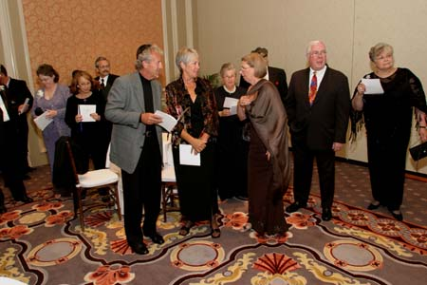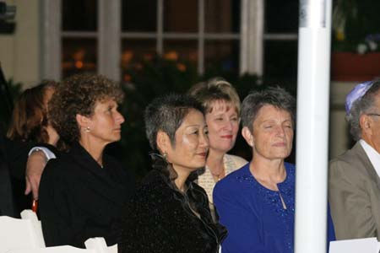
Our Friends
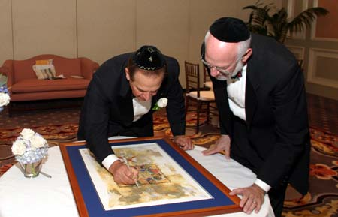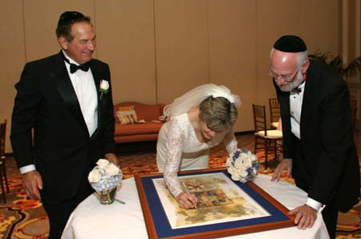
Our contract for life – Signing the Ketubah
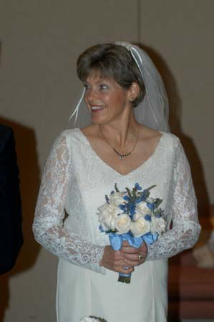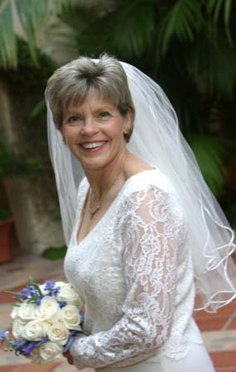
Beautiful Ann, always was and always will be
And now we all were going to the dining hall for the great meal. Ann did organized everything. For a minute I did not know if I marry Ann or Marry Barbara which followed Ann’s instructions. The “Tail was wagging the dog”….
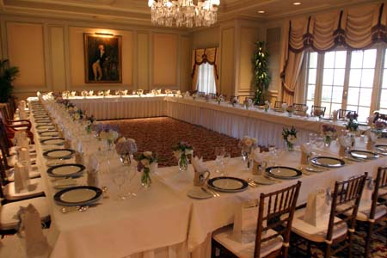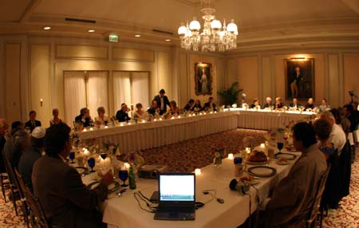
Before During
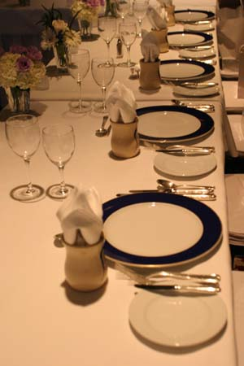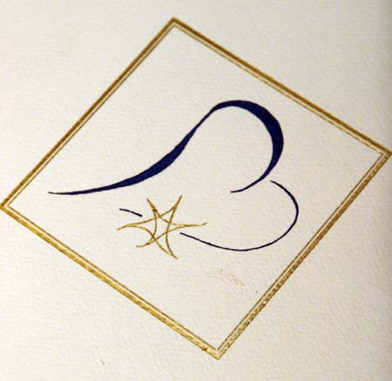
So, this is the story of our marriage. It could be a whole book by itself. But, I had to include it in my book. It cannot be book written by me without Ann.
