Chapter 21: My Daughters

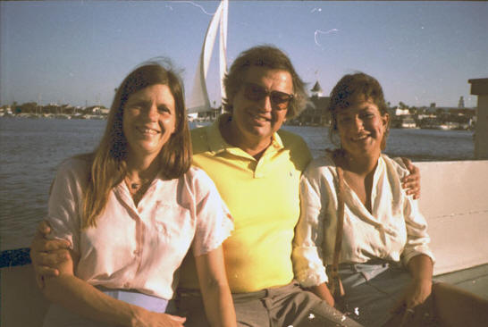

During my life, I was blessed with four beautiful daughters. They came into this world at different points in my life. My first daughter, Geffen, was born, as you know, the day I left for the Tokyo Olympic Games in October 4th 1964. Geffen grew up with Yael and I during my student life in Wyoming, a little bit in Amherst, and later on she was with Ann and I in California. During the first few years of her life, I would take her to school every day since her mother did not have a driving license. We also enjoyed our time together, playing games in the summer camps when Yael and I worked as counselors in Colorado.
Here are some photos of our early years in Wyoming and also when I attended the University of Massachusetts:
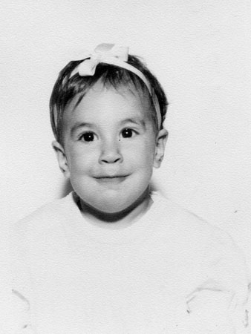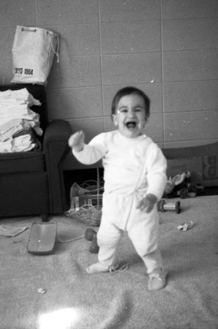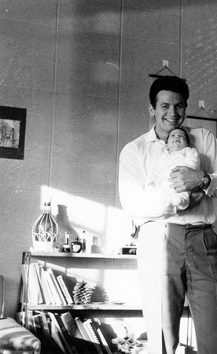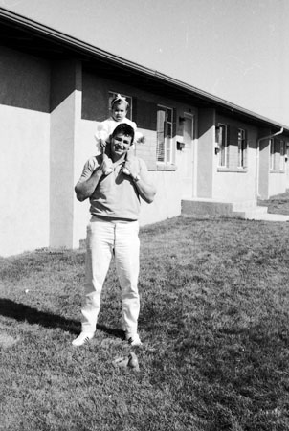
Life was not easy, since Yael could not work and I was a student. We did not have very much money, to say the least. Thanks to our jobs in the summer camps, we got through.
Here are some photos of Geffen in the summer camp:
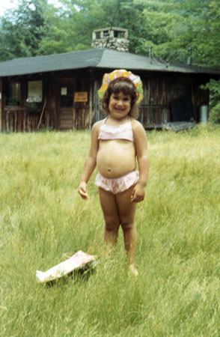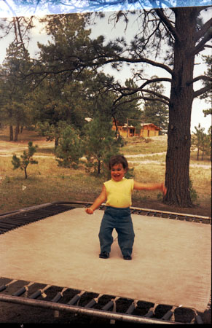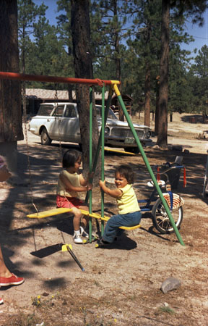
At that age, Geffen was very easy to handle. She was a very special girl -- happy most of the time and well behaved.
In 1966 we moved to Amherst and I would take Geffen to kindergarten every morning before going to the University. Yael still could not drive and this was a big limitation on our mobility.
Here are some photos from 1966 in Amherst:
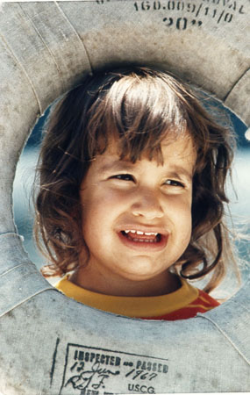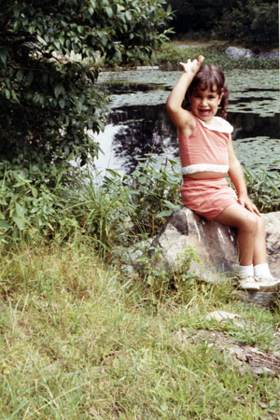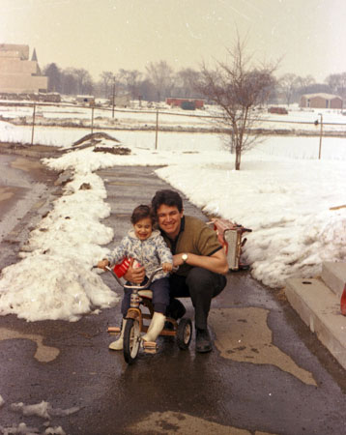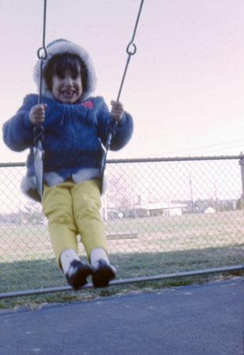
Geffen had a fantastic time with me. I would take her out almost every day to play. We really loved each other.
1968, and 1969, I started working on my Ph.D. degree but that did not stop me from seeing her as much as I could. Geffen had a lot of friends with whom she played and learned with. At that time Yael and I had an apartment in a student resident dormitory. Yael got a job as a “House Mother” and this brought us some additional income. But the relationship between Yael and I kept getting worse and worse and I am sure this affected Geffen in some way.
Here are photos of Geffen at 4 and 5 years old. In 1969, I introduced Geffen to Ann who was my friend at the time. Yael and I had separated but were not divorced yet. It was a hard time for Geffen, but I was with her on a daily basis and she loved it.
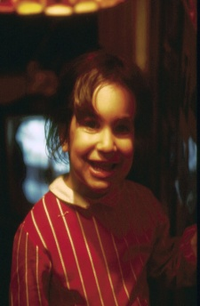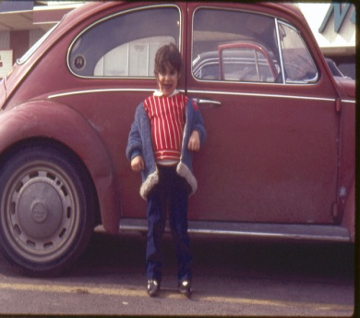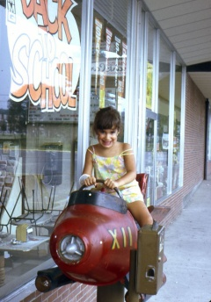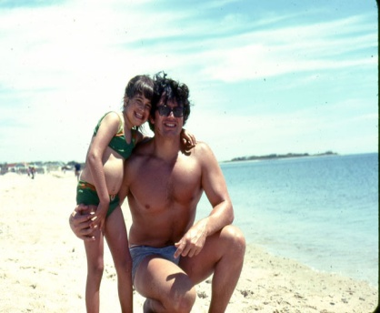
Every year, Yael and I made sure Geffen’s birthday was a special event. Here is her 4th year birthday:
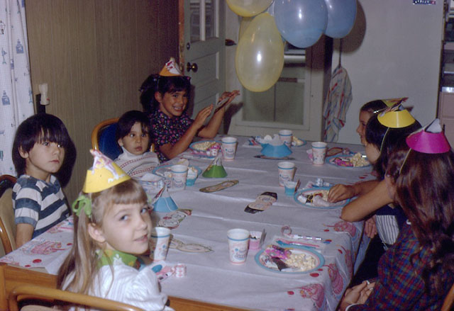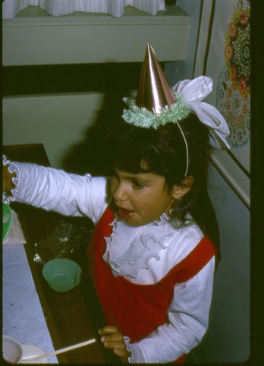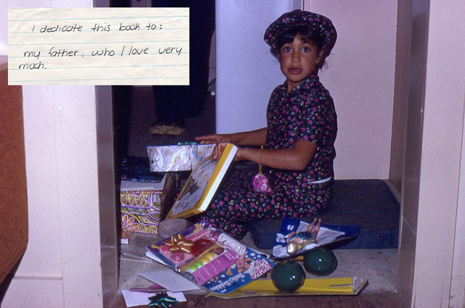

When I went to visit Geffen, I would teach her to read and show her math and other subjects since she was about to go to first grade. At that period I purchased my house in Belchertown and Geffen would come often to visit us. Ann would take care of her and Ann and Geffen got along together very well.
Here is Geffen on the lake in front of my house in Belchertown. She wrote the message on the photo:
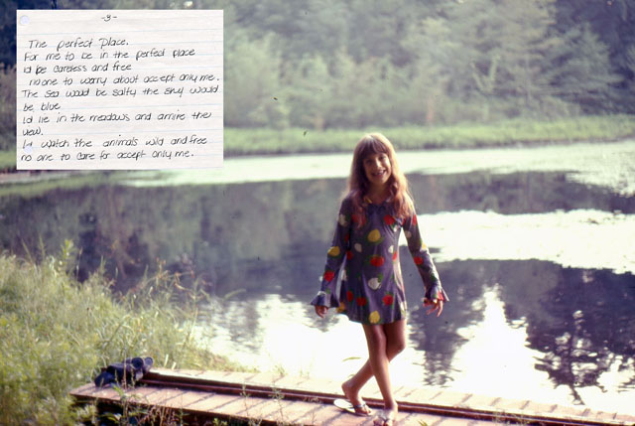

Here are Geffen’s birthdays in 1972 and 1973 when she was 8 and 9 years old:
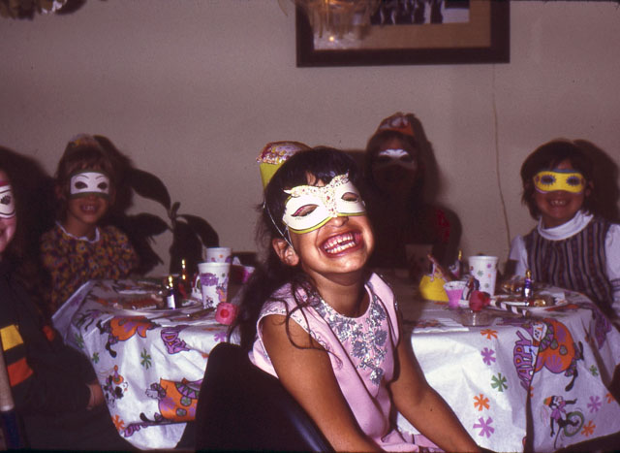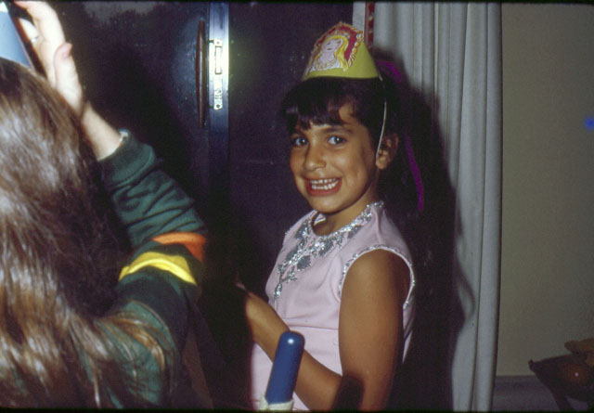
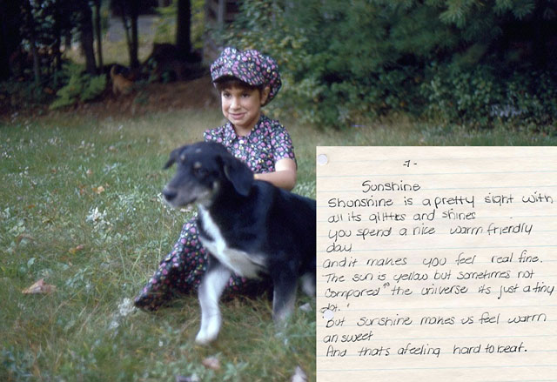
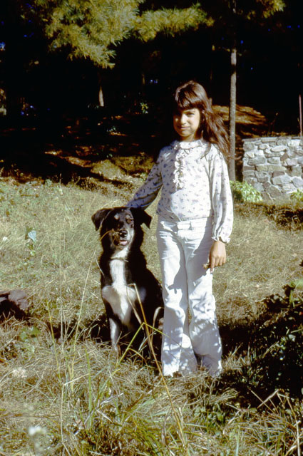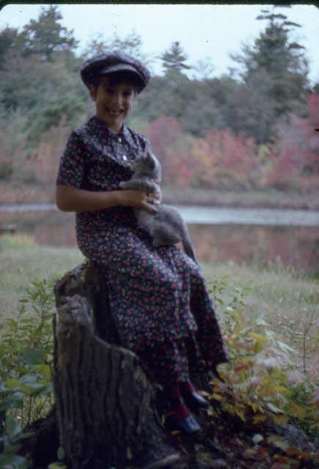
Geffen thought my house on the lake in Belchertown was a little paradise where she could play with the animals, Ringo and the cat, Melech, and she could swim with me. It was a place full of magic and she loved prancing around.
In 1972, Yael decided to move to California. Our divorce was finalized and she took Geffen with her. The divorce was not simple and a source of a lot of discontent between us. Geffen did not have any choice but to be with her mother who took her away. I am sure this was hard for her.
Yael did not make it easy for Geffen and I to have any communication once they moved. In 1975, I started going to California when I met with Vic Braden and began planning the new Coto Research Center. I bought two condominiums and was living in both Massachusetts and California. At that time I would meet more often with Geffen whom I would pick up at her house in Los Angeles.
Here are some of the photos with Vic and myself at Coto:
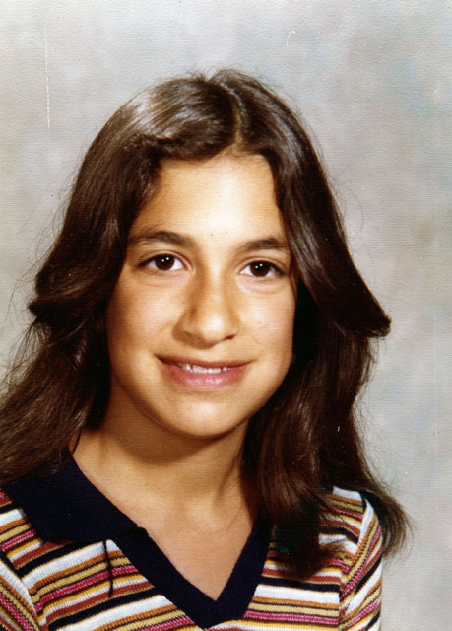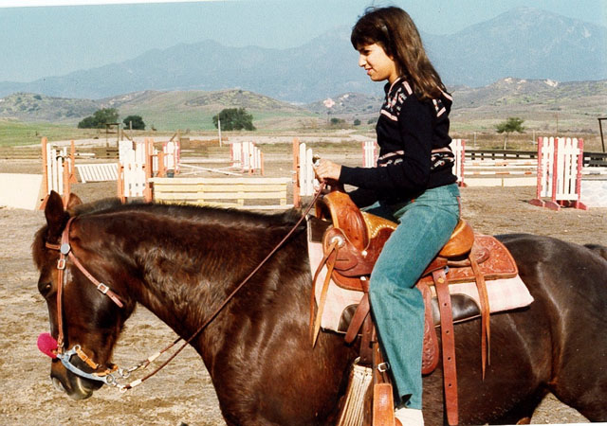
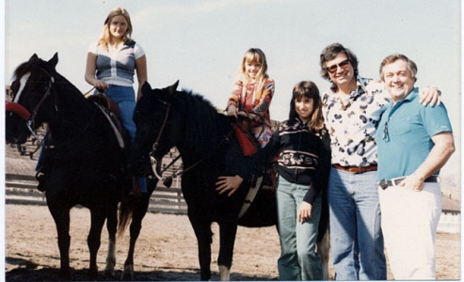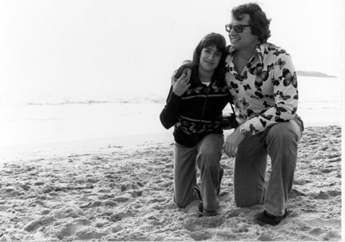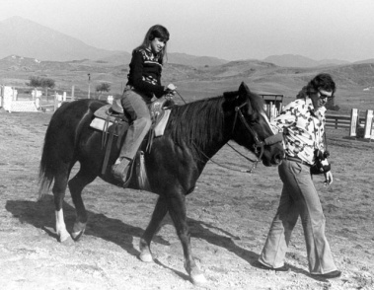
We had a wonderful time together at Coto. Here is a photo from 1978 with Vic Braden:
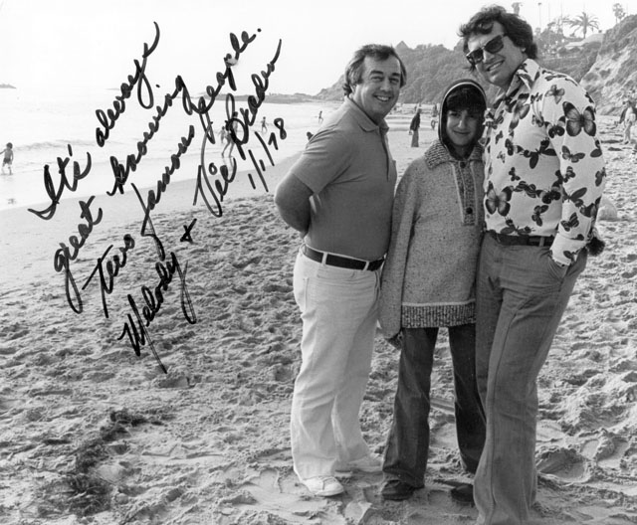
You can see from the photo how much we loved each other. Geffen loved the beach. We used to go to Laguna Beach in the morning and stay the rest of the day and then go have dinner together in one of the wonderful restaurants at Laguna Beach.
In 1978 on my thirty-third birthday, Geffen wrote me the following poem/book. It is still the best present I have ever received in my life:
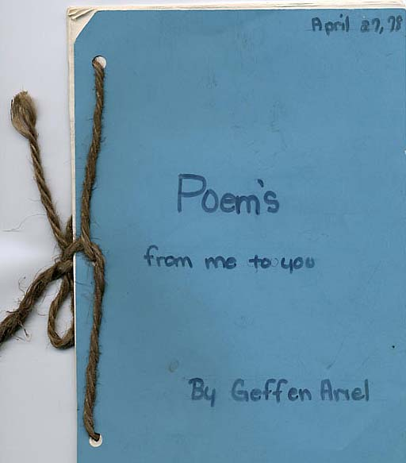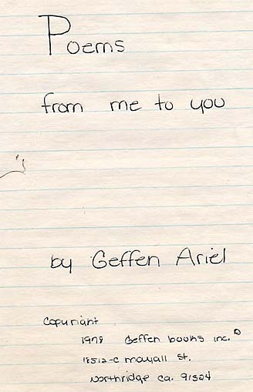
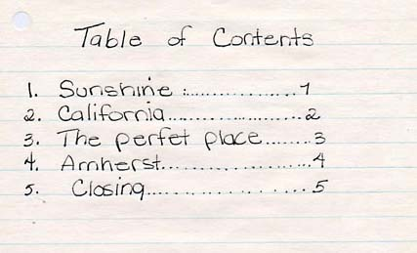
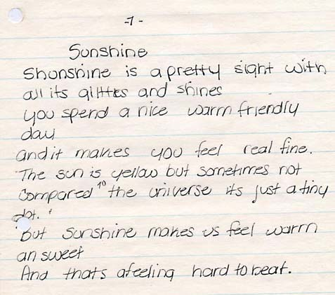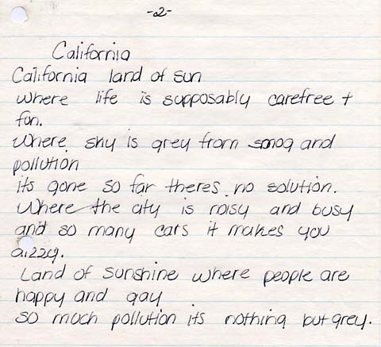
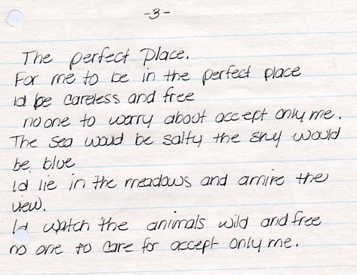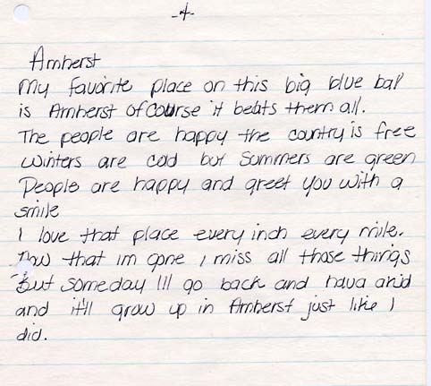
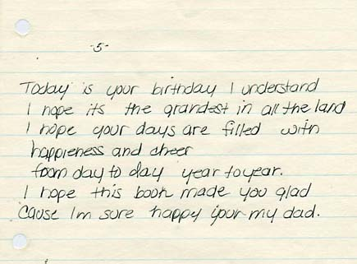
What could any father ask for more? Geffen was appreciative of any moment with me and I was appreciative of any moment with her.
Geffen grew up, finished high school and continued onto college at California State at Long Beach. Here are some of the more recent photos in the early 80’s:
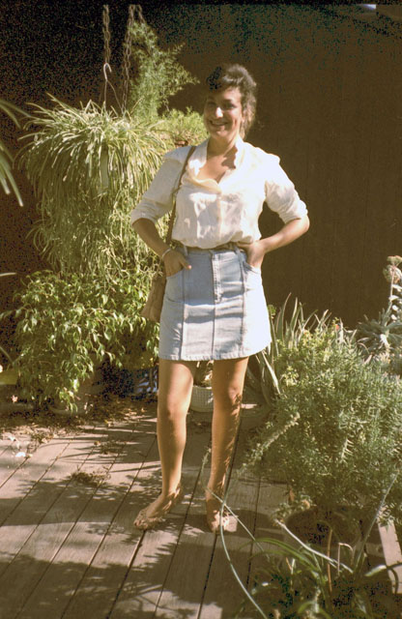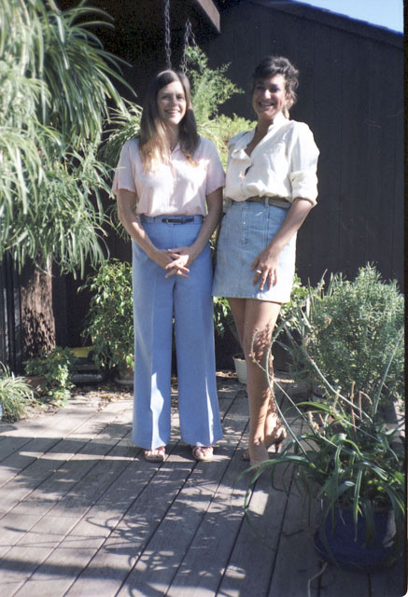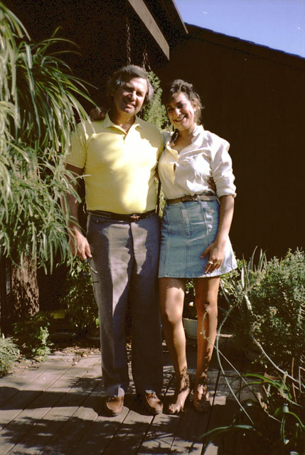
She was a very good student. I rented an apartment for her in Seal Beach right on the ocean where she loved to walk and jog around.
Geffen met her first serious boy friend, John, and after a while they decided to get married. John worked as a plumber and could support them. However, of course, most of the expenses were paid by Ann and I. Here are some photos from the wedding:
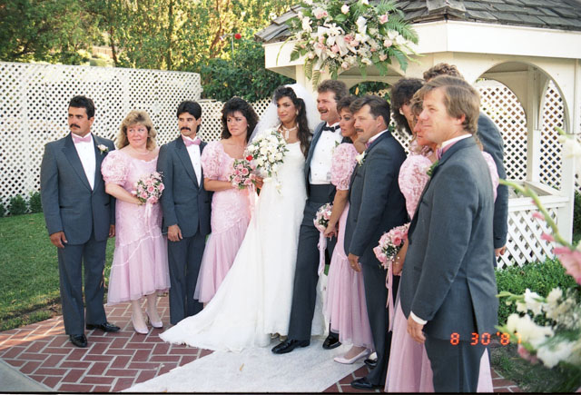
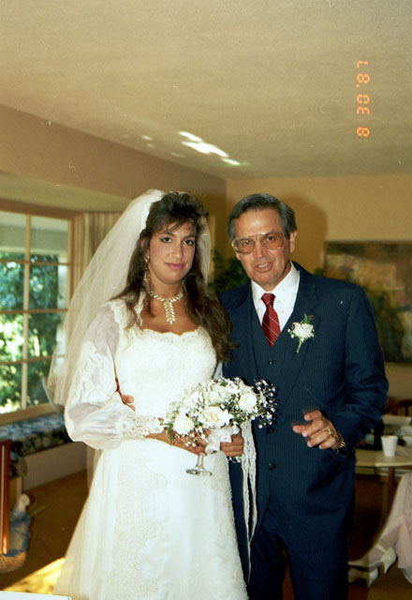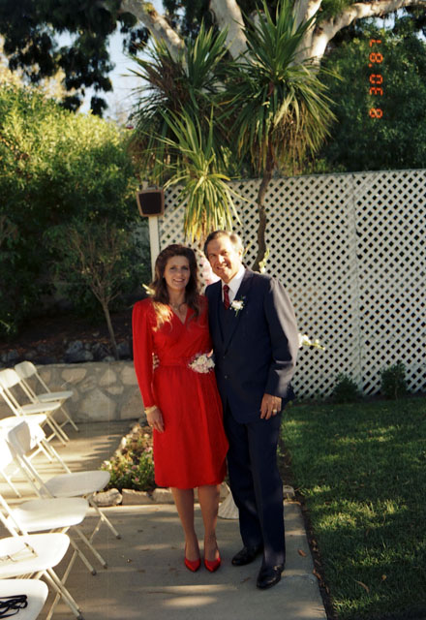
John and Geffen had a great time together for a while. Geffen was finishing her first degree in microbiology at the University.
Geffen’s graduation was close to the Jewish Seder in 1989. We had a beautiful seder with her and her husband John, and also we attended her college graduation party, when she achieved her Bachelors of Science degree.
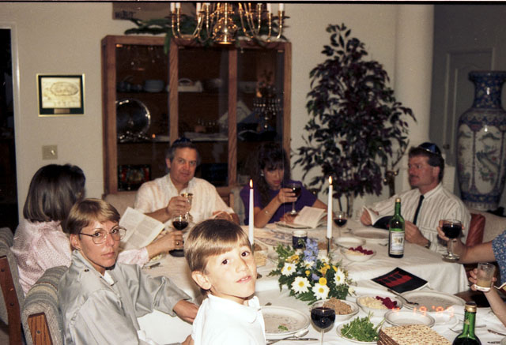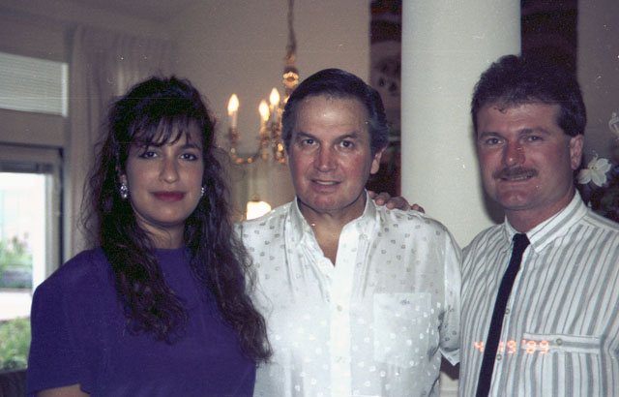
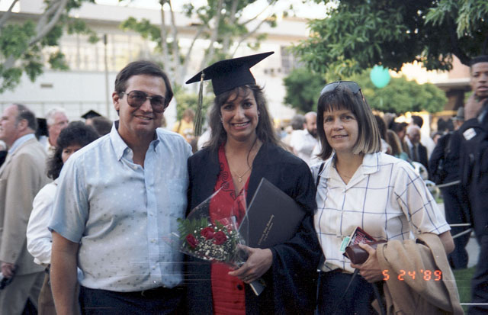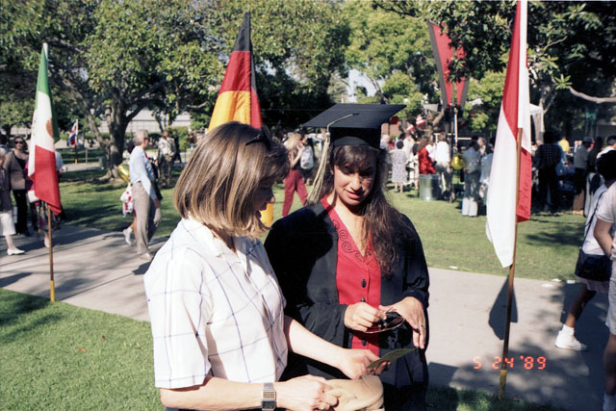
Now she was ready to go to graduate school to study toward her Ph.D. Her first plan was to get her Master’s Degree in Microbiology.
In 1989, I was working at NASA and that was when I met Merry, the mother of my other 3 daughters. At the beginning, this relationship was very casual so I never mentioned it to Geffen, even though Ann always knew.
In 1991 I took Geffen to Hong Kong where Ann and I were presenting at one of the conferences. Again, it was a seder date and we three found one of the seders in the city. No one knew anyone at this seder, but these were “lost Jews” who look for a Seder and found one organized by the local Synagogue. Here are some of the photos:
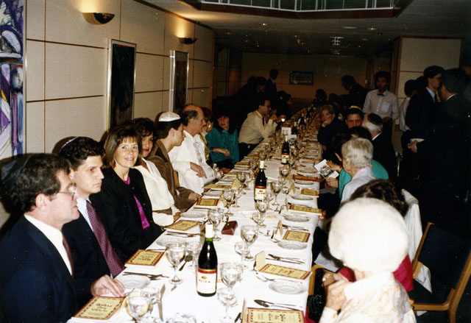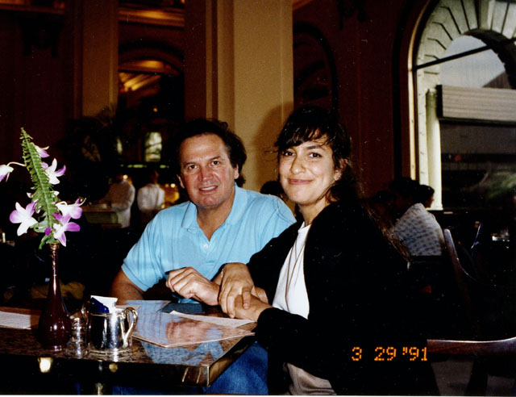
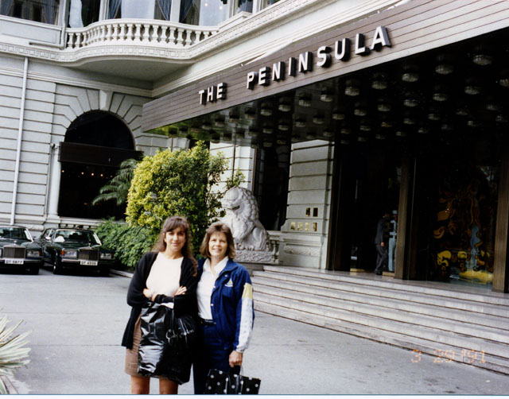
Geffen and I travelled a lot. One time I took her to Hawaii as you can see in the following photo:
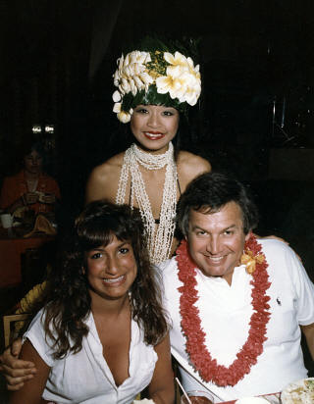
In graduate school, Geffen did exceptionally well. She was working on a project relating to nutrition and cancer. This project involved her having to handle radioactive agents. Here Geffen is in her graduate school laboratory when Ann and I visited her:
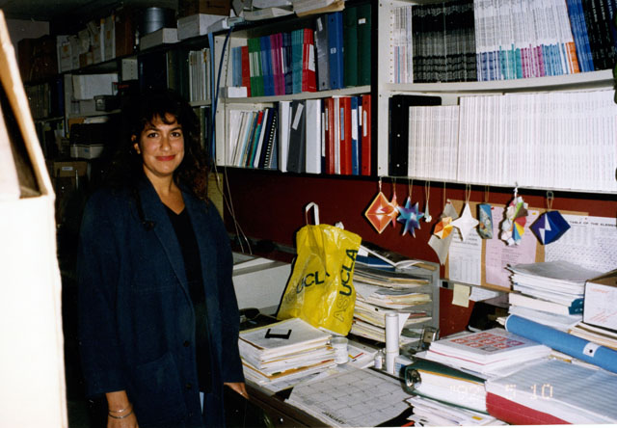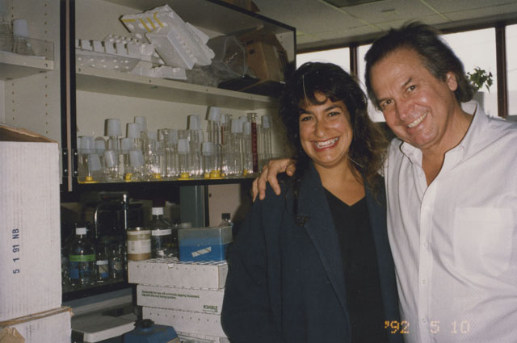
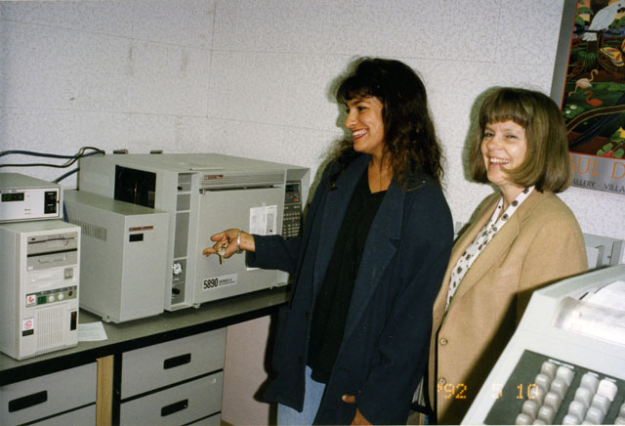
Ann and I were wondering about the safety of this laboratory.
Well, Geffen completed her Master’s degree and while she was working on her Ph.D., she got sick with leukemia. I have no doubt that the chemicals she was dealing with caused it. While she was struggling with her disease, she met her “new” sisters, Tova and then Nomi. Here is one of the only photos of her with them:
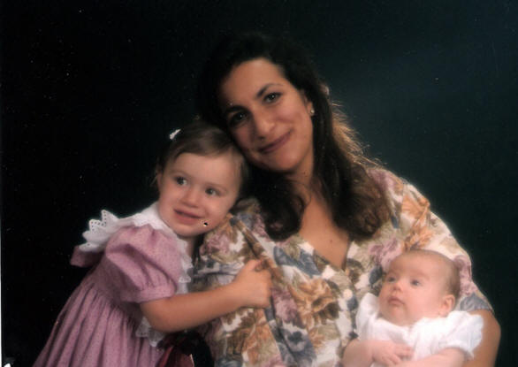
At this time, Geffen’s marriage also came to an end and she divorced. She met a new man by the name of Chris and married him but she was already very sick. Here are some of the photos of the marriage. Yael, Merry, Tova and Nomi were there also:
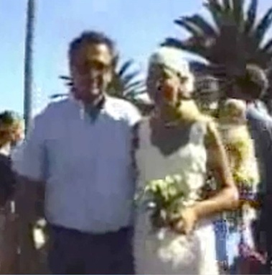
The cover on Geffen’s head is due to the surgery she had to have. The next photos are with Merry, Yael, Tova and Nomi while they were still babies:
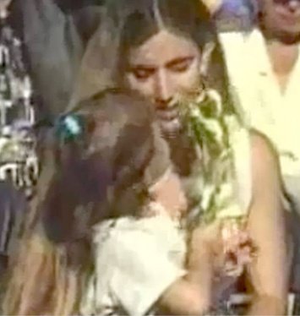
Merry with Tova Yael, Tova and Merry Merry with Nomi
This marriage did not last long since Geffen was so sick to begin with. Most of their time together was spent with her in the hospital.
Ann and I tried to save her in any way we could including finding a blood donor. Here is the letter Geffen wrote to her blood donor while she was in the City Hope Hospital in California:

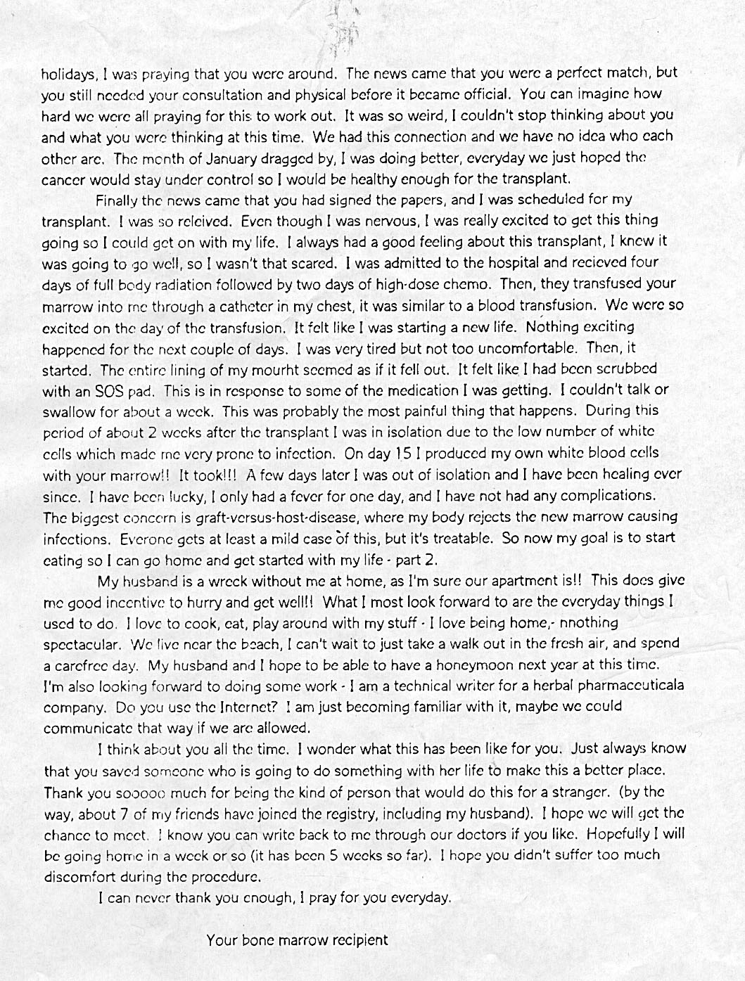
Geffen start recovering since the transplant was successful. But stupidly, one weekend her mother took her out of isolation to a mall to buy her some clothes. Geffen, with her immune system so low caught the simple measles, a children’s disease, which killed her in one week.
Geffen died at the age of 30, in August of 1995. She was a wonderful child all her life. Her life was about to be saved, but this irresponsible act of her mother’s killed her.
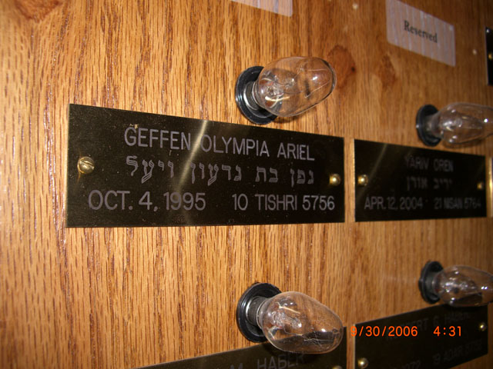
Geffen memorial in the Bnei Zedek Synagoge

Meanwhile I had this crazy relationship with Merry and I was still involved with Ann. Everyone knew about each other. But now I also had a daughter, Tova, and Merry decided to leave Texas to be closer to me in La Jolla.
Life was not easy. I was like a “ping pong” ball running back and forth from Coto De Caza to La Jolla. I would stay with Merry while I was doing business with my ALS Company in La Jolla. This relationship resulted in two more daughters: Nomi and Ilana.
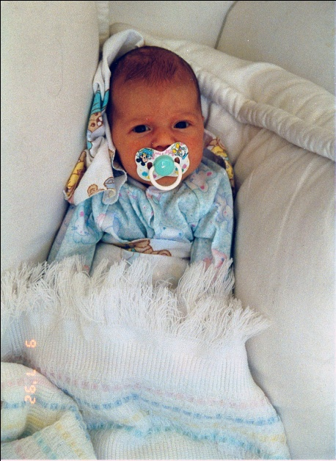 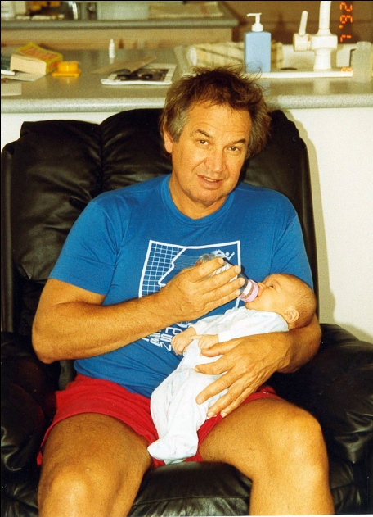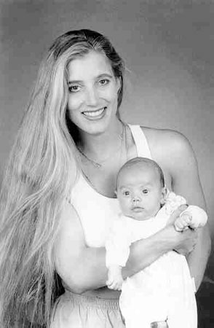
Tova
I was as good a father as I could be. I provided every means to make these girls have the best of the best. Merry had an easy life and I supported her 100 percent. In addition, I sent her to the University of California in San Diego (UCSD) where she earned a B.S. degree in psychology.
Our family was not normal, but the children had everything they needed to grow up healthy – a mother and father, attention and love. The kids did not know about Ann as a girlfriend, but only as a friend. When they used to come to visit with me in Coto, Ann would move to our office house, and the girls and I stayed in my living house by ourselves.
My three daughters grew to be very beautiful girls and were very good in school.
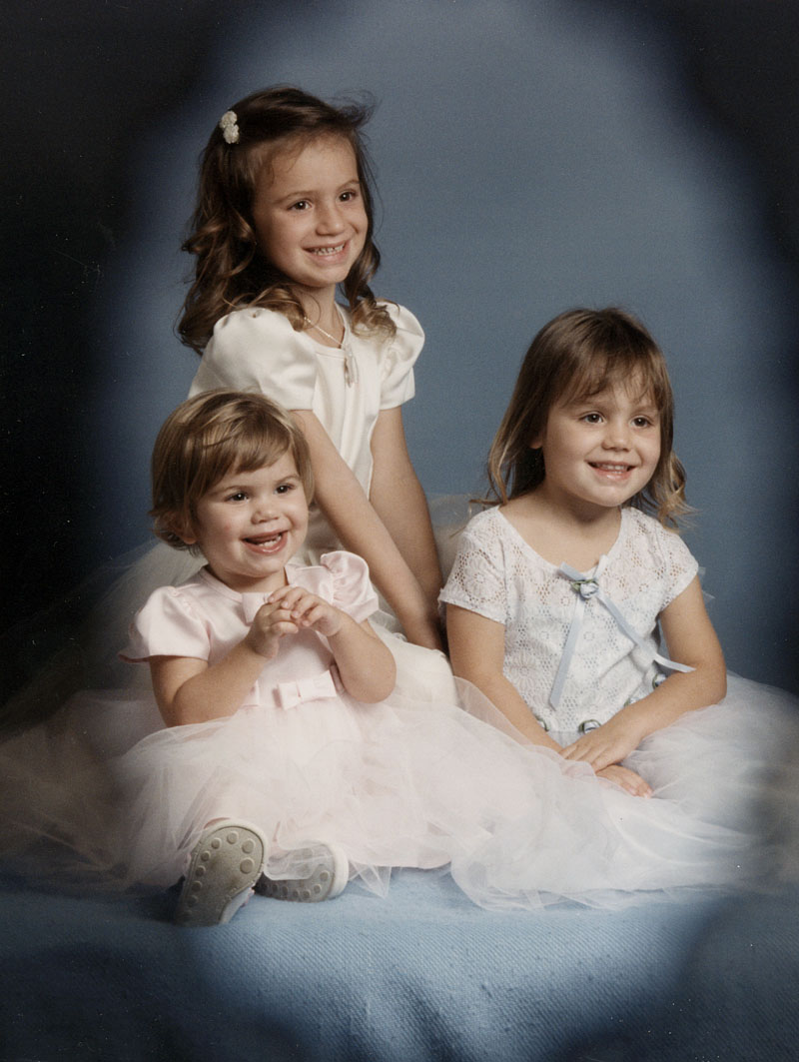
Tova, Nomi and Ilana
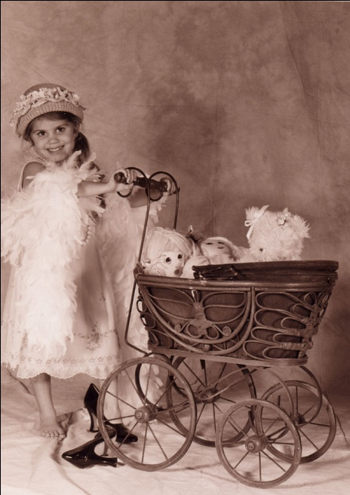
Tova Nomi Ilana
One day, Merry decided that enough is enough with this kind of relationship and she took the kids and moved back to Texas. I bought her a house in Holliday Texas and each of the girls had their own room and they all went to the local school. I visited with them every month, flying from California. It was a difficult emotional life for everyone.
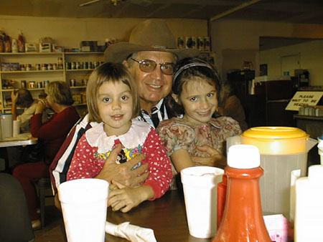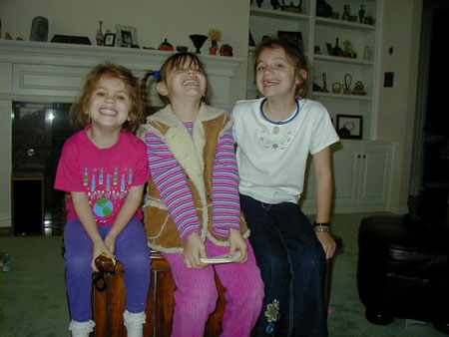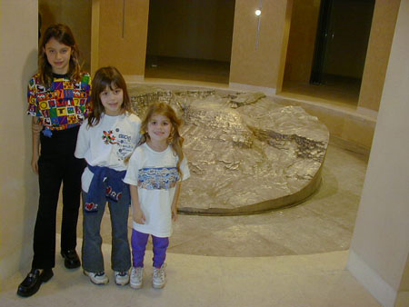
Life in Texas
The kids did great in Holliday, Texas. But Merry could not take this kind of part-time relationship with me any longer. So she started going out with another man. Lloyd owned a huge dairy farm and was very wealthy. Eventually, Merry married Lloyd, after he divorced his wife of 40 years. So, Merry ended up with another man over 20 years older than her. This was an improvement, since I was 27 years older then she!
My relationship with Merry lasted 13 years. I was relatively relieved at the new life Merry had chosen for herself where she was in a committed relationship and married. However, the kids now had to live a new lifestyle with a new man in their house whom they never liked and it began creating emotional problems. Tova started to be very resentful toward me. When she came to visit me, a few times I had to send her back home before the vacation was over. However, Nomi and Ilana continued to love their father and we had a strong relationship. All the kids loved Ann who taught them how to dress, how to eat, how to read and many basics of life. She was more a mother to them than their own mother who was a bit of a wild child.
My daughters grew to be extremely smart girls, like their older sister, Geffen:
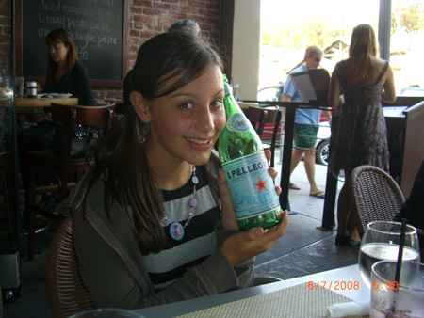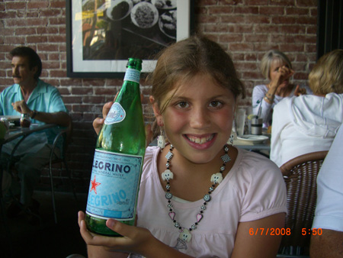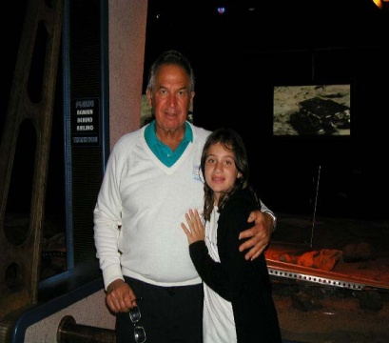
Nomi Ilana Tova
Today, Tova is almost 19 years old and going to Texas Tech University. Nomi spent one year in California at the prestigious Besant School in Ojai but decided to go back to Texas. Today she is 17 years old and going to 11th grade in her High School. Ilana is 16 Years old and coming to live with us next year and attend the Besant school in Ojai California.
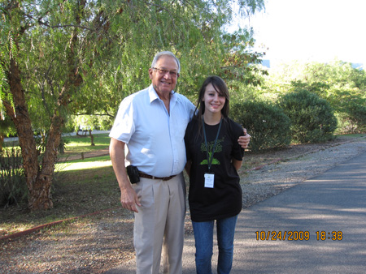

Nomi, my second, is a special case. She traveled with me to various countries. She had her computer at a very young age. Any toy she wanted, she got. She is exceptionally intelligent and creative.
Coto De Caza, one of the most beautiful places, offered Nomi a great place to grow up during her visits from Texas.
She always integrated fun with studying. “Study with Daddy” was a daily requirement for her.

I wanted Nomi to go to an excellent school, and she wanted to go, too. She wanted to get out of Texas and improve her mind. So we got her an appointment meeting at Besant Hill School, a school with an exceptional track record for college preparation and for improving the minds of children.

Appointment Meeting at Besant Hill School
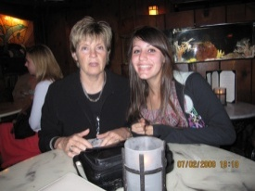

One of the requirements for admission to Besant Hills was a one page essay. This is Nomi’s essay which shows how much she, too, wanted to grow her wings to fly:
Do you ever have that feeling to just start from a new beginning, forget the past, and push forward to a change that will affect the course of your life? I know everyone had that feeling maybe at least once in their life. I know I have.
Many people think it’s silly for a simple song to change your views on everything, to change your thoughts on many things, but I just found this “simple song” a while back and it brightened my view on my future. The name of this fantastic song is called “Second Chance” by a band named Shinedown. This song is very popular in the states, and it personally had a huge impact on me and my life.
While I lived in a small dairy town in Texas, I felt so excluded from the real world, so lost and beat up by other people. Although they weren’t physically beating me up, mentally I felt so different and “out of it” that I thought I shouldn’t even be around. I felt so…stuck. Everyone lived on or very near a dairy. I knew that if I stayed there my whole life, I would become something I do not want to look forward to…either a dairy farm worker or follow a life path exactly like every woman in that town.
My different views on things stuck out through the town, and it came to the point that even my own mother didn’t want me to be different, just to blend in with the rest. I know some people can accomplish that, but that is practically impossible for me. I guess I think a different way than they do. Truthfully, I was miserable there. It was impossible to just be myself without being criticized for it. I couldn’t even dress in the manner I wanted because of all the criticism I generated.
That’s when I knew I had to get out of that place. The song “Second Chance” starts out, “my eyes are opened wide”, and that represents the moment I realized that I had to break out of that prison. Every day in my old home moved by so slowly and it was very hard to just get through, as the next line in the song is “by the way, I made it through the day”.
Throughout this piece of music, the lyrics just reflect my life and how I had to break free from the strict boundaries. I wanted to just…be myself.
This got me through so much and helped give me hope for a new start. The main line in the song is “sometimes goodbye is a second chance”. Saying goodbye to my old dairy town gives me a second chance for a new clean start and a new life to begin.
I wanted my mom and step-dad to realize that this is my life and they can’t control my personality and the way I am. In “Second Chance” it says just that.

Tell my mother
Tell my father
I’ve done the best I can
To make them realize
This is my life
I hope they understand
I’m not angry I’m just saying

That sometimes goodbye is a second chance
This song has touched me so deeply because whenever I felt the need to get away, I would listen to this song. The music and the sentiments would help me through the problems that were troubling me at that moment.
It helped me react to the situation. Every holiday I come visit my dad in California. This holiday I decided, was going to be permanent. I’m not going to spend my days miserable. I had to move on and away from the whole situation. So ‘long Texas.
This song of course didn’t completely change my whole life by itself, but it had a significant impact. It provided a view for the future and it pushed me to think of myself and how I wanted to just express my personality to the world. Now I’m in California and free to be myself. I had to get out of there and I did.
California, and especially Besant Hill School, would help me express myself. Be myself. Love myself. I’m not only introducing California to my life, I’m introducing myself to my life. My new life.
We were lucky. Nomi was accepted.

One concern I had was whether Nomi would be able to sustain the level of school rigorousness since she would be joining the 10th grade without having been at Besant for her 9th grade. Nomi studied very hard. At Besant Hill School you have classes during the day and then every evening there is a mandatory study hall from 7PM to 9PM. Nomi did great!
For the fall grades she received all A’s.
Sadly, Nomi decided to go back to Texas and leave Besant. I wrote her the following letter, but this letter would speak to all my daughters, and maybe to all daughters everywhere, who don’t realize how much we parents want the best for them:
Hi Nomi,
I think we have trouble communicating some times! I read your list of things that you said I want you to do. However, you were doing all of those same things in Texas. You read books, made good grades, participated in sports, had friends. I was happy about your accomplishments in Texas particularly your academic successes, the music award, your participation in drama. All of those things, and more, made me very happy and proud of you.
Now you are doing even more things in a school that seems, to me, to be even better than the one you attended in Texas. Obviously, when you achieved the commendation level of 7 out of 7 during the awards ceremony, I wasn't the only one who thought you were good. I was proud of you then as I had been before and hope to be in the future.
Our disagreement is not about what you are doing, but your future. Most kids your age go to school, play sports, read books, hang w/their friends. This is normal teenage behavior. Most parents want, plan, hope, push, and encourage their children to study, get good grades, and set good colleges as desirable targets. I am not unique in wishing, hoping, and encouraging you to go to a good high school so you can get into a good college.
The reason for my encouraging you to excel is NOT for me it is for YOU. I have already been to high school, college, and graduate school. "Been there, done that" as they say. However, along the way, I have learned, and all statistics back me up, that you MUST have a good education to sustain yourself in the future. Even you have pointed to the current economic problems in the US and around the world. However, all the statistical evidence is that the people with higher educational accomplishments have experienced less negative financial impacts. The people who have suffered the most by losing their jobs are the ones without education. It's the lowest level of workers who are suffering the most; the ones at the top have had less impact.
I have heard your desire to be happy and that you don't have to be "filthy rich" to achieve success. First of all, you don't have to be rich to be happy. But you can be rich AND be happy. What you do have to consider is that without money, you can't have a house, car, food, clothes, and all of the other "fun" things that go with the family and happiness you plan for your future. You can have a "little" money, a "lot" of money, or somewhere in between and have all of the necessities of life. But to have a steady stream of income you need a job and a good education will help you provide the "tools" to have what you want in your life.
Another of my considerations is your interests. From the age of approximately 15 to 25, people are searching for what is good for them. The luckiest person in the world is the one who wakes up every morning burning with love of their job! The majority of people have to get up early, prepare breakfast, pack their lunch, go to work. There they spend the whole day working for someone else, maybe getting a few 10 minute breaks, and then home for the evening. At home, it's preparing dinner and probably watching TV until bed time. This routine continues endlessly. For some people, this is enough. For others, there is a thrill for what they do every day. Unfortunately, it takes many starts and stops to find what is good for the individual. One day, they want to be a soccer coach, then a veterinarian, next an airplane pilot, and the interests continue to change throughout the educational and maturation process.
I realize that most of what I say here will be ignored or rejected. However, I am telling you that everything I have done and continue to do for you is for YOU. As I said before, I don't need to worry about high school or college. I also don't need anything from you. Ann and I have taken care of ourselves up until now and we have prepared everything for our "old age". I don't need anything from you. What I do have is experience to share with you. You can either accept or reject it. Just remember that what I tell you is just for YOU, not for me.
Because you are 15 and can see the world only from that perspective, you have no idea how gifted you really are. Obviously, Besant thought so as well or you would not have received the good grades and commendations. Ann recognized this when you were only 5 years old! You have so many talents and strengths. I am not trying to put pressure on you when I encourage you to go to a good high school and a good college. I am trying in the only way I have to provide you with every chance to cultivate your natural talents. I don't put pressure on you to be the best; I already think you are the best! I don't put pressure on you to make good grades, you already do that! I only try to give you every opportunity to reach your potential. I am so proud of everything you have done. I know you are good, I don't know if YOU know how good you are.
Sorry this is so long I know how impatient you must be by now. Just know that I love you and wish you all the best.
Daddy
So, my hope is that Tova will graduate from the University, Nomi will succeed as well as she can in Texas, and Ilana will be with me and do well, as her sister did, in Besant School in Ojai.
These girls mean everything to me. Ann has shown me how intelligent girls can be…and now I am learning it all over again with these three little ones who evolve daily in their studies. As you get older, you realize how family is important. And part of this book is for them, to help them know how their father came from a difficult life and built an extraordinary life. With drive and love, they can -- and will -- do it too.

